|  |
| --- |
| **MINISTRY OF EDUCATION AND TRAINING** |
| **FPT UniverSITY** |

Capstone Project Document

|  |
| --- |
| [Order Application by Location] |
|  |
| |  |  |  |  | | --- | --- | --- | --- | | **<D4Team>** | | | | | **Group Members** | Nguyễn Quốc Đạt | SE04036 | datnqse04036 | | Nguyễn Đại Thắng | SE04441 | thangndse04441 | | Ngô Ngọc Tuyên | SE04335 | tuyennnse04335 | | Mai Gia Tú | SE04012 | tumgse04012 | | Vũ Sỹ Tùng | SE04113 | tungvsse04113 | | **Supervisor** | Lương Trung Kiên | | | | **Ext Supervisor** |  | | | | **Capstone Project code** | OAL | | | |

**Ha Noi, 05/2018**

# Introduction

## Purpose

Introduction chapter introduces the background and initial idea of the Capstone Project. In this chapter, we – the developing team – will provide information about what we have done so far and the reasons for these developments.

Compared to other similar existing solutions, we also show advantages, disadvanstages and risks that our system has to deal with in the future.

## Project Information

|  |  |
| --- | --- |
| Project Name | Order Application by Location |
| Project Code | OAL |
| Project Category | Development |
| Application Type | Application and Website |
| Timeline | From May 2018 to Sep 2018 |

## Team information

### Supervisor

|  |  |  |  |
| --- | --- | --- | --- |
| **Full Name** | **Phone** | **E-mail** | **Title** |
| Lương Trung Kiên | 0983357211 | [kienlt@fpt.edu.vn](mailto:kienlt@fpt.edu.vn) | Lecturer |

***Table 1-1****: Supervisor information*

### Team members

|  |  |  |  |  |  |
| --- | --- | --- | --- | --- | --- |
| **No.** | **Full Name** | **Roll Number** | **Phone** | **E-mail** | **Role In Group** |
| 1 | Nguyễn Quốc Đạt | SE04036 | 0942281296 | [datnqse04036@fpt.edu.vn](mailto:datnqse04036@fpt.edu.vn) | Team Leader |
| 2 | Ngô Ngọc Tuyên | SE04335 | 0964346976 | tuyennnse04335[@fpt.edu.vn](mailto:KhoaNDSE60811@fpt.edu.vn) | Member |
| 3 | Nguyễn Đại Thắng | SE04441 | 01686396395 | thangndse04441[@fpt.edu.vn](mailto:OwokonuSE04494@fpt.edu.vn) | Member |
| 4 | Mai Gia Tú | SE04012 | 0972678655 | tumgse04012[@fpt.edu.vn](mailto:ManhPHSE06191@fpt.edu.vn) | Member |
| 5 | Vũ Sỹ Tùng | SE04113 | 0916606094 | tungvsse04113[@fpt.edu.vn](mailto:ManhPHSE06191@fpt.edu.vn) | Member |

***Table 1-2:*** *Team members’ information*

## Background

Nowadays, Vietnam has become one of the fastest growing countries in the world in terms of Internet usage and applications The number of Vietnamese Internet users have reached 58 million, ranked No.1 in ASEAN as in the number of national domain names, and ranked No.30 worldwide as in the total number of IPV4 addresses. However, Vietnam’s Internet infrastructure has grown unevenly, and there’s a considerable discrepancy in the growth rate between up and coming cities, such as Hanoi or Ho Chi Minh City, and the less-developed cities.

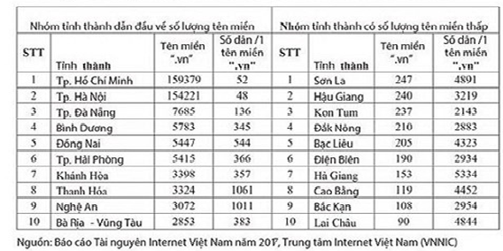

***Figure******1-1:*** *Domain allocation per city in 2017*

In recent years, according to ananalysis conducted by the Vietnam E-commerce Association, Vietnam's e-commerce growth rate in 2017 was 25 percent and this figure is expected to increase during the period from 2018 to 2020. On “We are social” website, mobile connection rate in Viet Nam was 153% off the total population in 2017. 73% of Vietnamese had more than one device, and half of Vietnamese population used mobile devices to communicate with each other. In Viet Nam, the number of grocery stores has constantly increased, and online shopping has not completely replaced physical grocery stores yet. On the other hand, 47% of digital users would buy products via their smartphones in Dec, 2017. In addition, 16% of Vietnamese phone users search for contents based on location from their smartphones. However, there is no e-commerce shopping application/website allowing users to search for products/stores based on their current location.

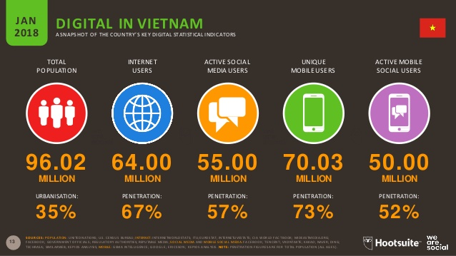

***Figure 1-2:*** *Statistics data on digital trends in Vietnam in 2017*

*(Source: wearesocial.com)*

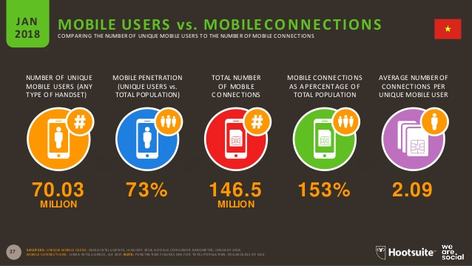

***Figure 1-3:*** *Statistics data on phone and telephone connection in Vietnam in 2017*

*(Source: wearesocial.com)*

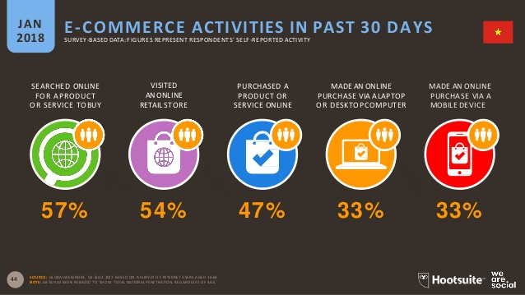

***Figure 1-4:*** *Statistics on online shopping trends in Vietnam in December 2017*

*(Source: wearesocial.com)*

According to the Director of Consumer Behaviour Research of Nielsen INC, e-commerce in Vietnam has not reached its potential due to various concerns about the quality of goods, long shipping times, etc.

Shopping online has some advantages over traditional shopping methods, including convenience, easy payment, and so on. However, it also has many disadvantages, such as; it’s quite hard to check the quality of products, store’s service, and so on

## The Capstone Project’s objective

The aim of this project is to design and develop an E- Shopping Application, in which end users can search for products like housewares, customer goods, and electronics and order it through stores that are in close proximity to their current location. The stores can not only add new products, remove and change the price and promotion of products, but also accept or decline the orders.

## Literature review of existing system

### Name of current system

1. **Shopee**: a shopping application that belongs to Garena – an Internet platform provider based in Asia. This application allows its users to register virtual stores in the system. The end-user can not only search for many kinds of products through Search box or category, but also order these products through these registered virtual stores.
2. **Foody**: a food order application that belongs to Foody Corporation –a corporation based in Ho Chi Minh City. This application allows end users to search for restaurants by food, and find nearby restaurants by user’s current location.
3. **Groupon**: an e-commerce application that belongs to Groupon Inc. This application has the same basic functions like other e-commerce applications such as: search products, order products, register store. However, Groupon app has a unique function, which is to locate nearby store based on user’s current location.

### Strength of existing system

1. ***Shopee***
   * Large community.
   * Colourful, nice user interface, great user experience.
   * Promotion programs are usually appealing.
   * Support web-based platform.
   * Users can comment, rate and report to virtual stores.
2. ***Foody***
   * Large community.
   * Nice user interface, great user experience.
   * Users can comment, rate and report to virtual stores.
3. ***Groupon***
   * Colourful, nice user-interface, great user-experience.
   * Promotion programs are usually appealing.
   * Support web-based platform.
   * Unique function: locate nearby store to user’s current location.

### Weakness of existing system

1. ***Shopee***
   * Managing the virtual stores is difficult.
   * Sources of product aren’t always guaranteed.
   * Long shipping time.
   * Hard to find nearby stores.
2. ***Foody***
   * Foody’s objectives are not in line with those of our application.
3. ***Groupon***
   * User cannot report to virtual stores.
   * The application isn’t available in Viet Nam.

### To acquire knowledge

1. ***Shopee***

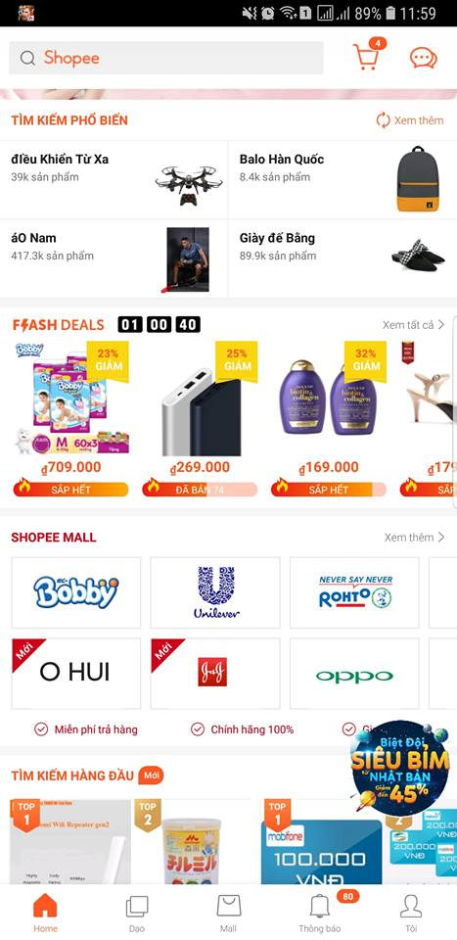

***Figure 1-5:*** *Shopee user interface*

* We can learn more from its user interface; how to arrange components in application screen; how order process works; how to display products, categories, product details in colorful and straightforward layout.

1. ***Grab + Foody***

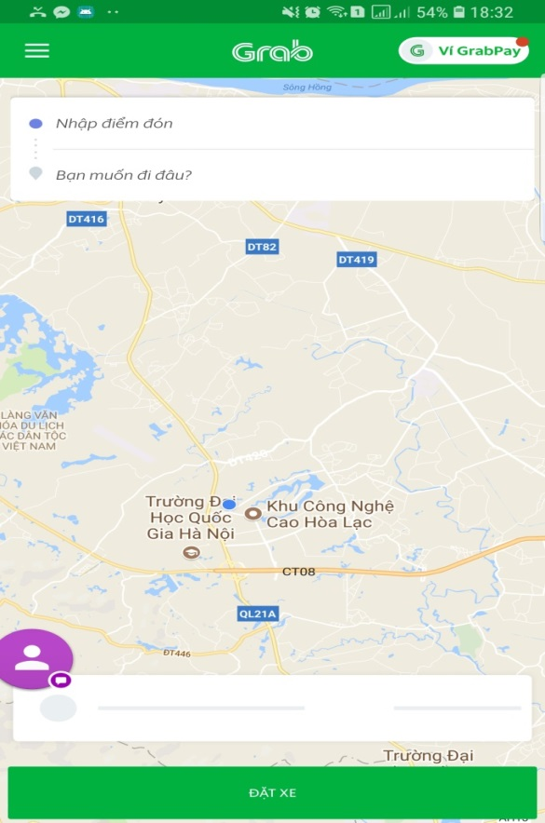 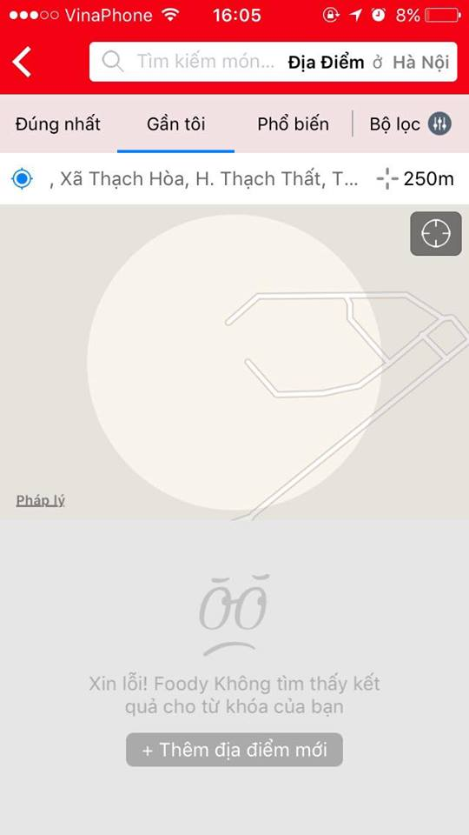

***Figure 1-6:*** *Grab Application user interface* ***Figure 1-7:*** *Foody Applicatin user interface*

* We have learned how the application locates user’s current location, how it identifies nearby target based on user current location in local map, and how it directs users to the target destination.

1. 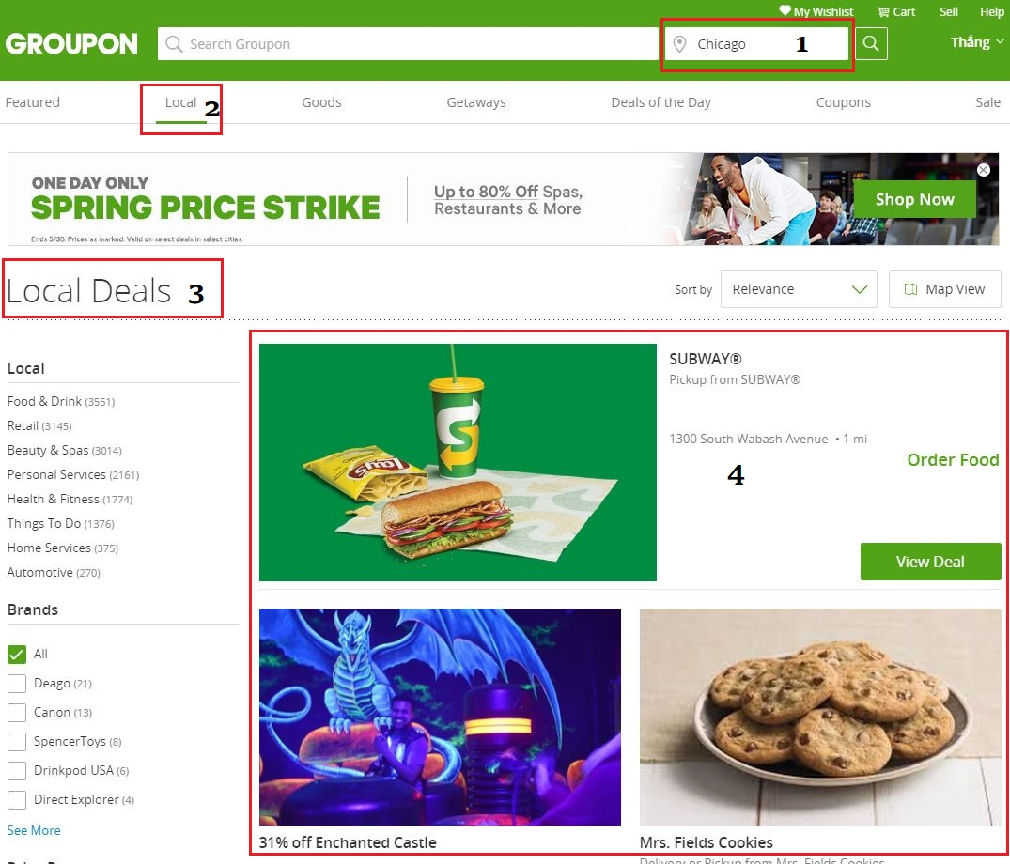***Groupon (Website version)***

***Figure 1-8:*** *Groupon Website user interface*

* We have learned how the application identifies nearby target deals based on the current chosen place (location), how the application identifies the chosen place (location).

## Our Proposal

### Scenario

* Nam is a high-school student in Hung Yen. This May, he would take part in FPT University entrance exam in Ha Noi. So, he decided to arrive to Ha Noi 1 day early to visit Ho Chi Minh museum, Lotte building, so on.
* After visiting Ho Chi Minh museum, Nam had arrived to Lotte building and he felt thirsty. He decided to find a grocery or mini mart to buy a beverage bottle and an ice-cream but he couldn’t. He had walked all the Chua Mot Cot Street; he saw fashion shops, souvenir shops, restaurants but no grocery. Then, he tried to walk all the Dien Bien Street and he got same result.
* This is a typical situation which indicates difficulty in finding grocery or mini mart on strange place where users haven’t even arrived.
* Our project will help end-user finding grocery becomes easy.

### Ideas

* To support end-user can find nearest store which have products they need.
* Minimize the product delivery time to end-user.
* Remove direct payment because the development time is limited. On the other hand, the application finds nearby stores which have the products that users needed to recommend so the distance between end-user and store is usually short. We recommend using COD payment.
* To support end-user to find nearby store based on user’s current location, just in case the user has arrived to unfamiliar places (locations).

### Advantages

* Easy to search (find) products which users need.
* Easy to order products through nearby store based on their current location.
* Easy to register store, but this registration process will be closely monitored.
* Convenient to find nearby store address based on user’s current location when the user has arrived a strange place.

### Disadvantages

* Our project doesn’t have had direct online payment yet.
* Hard to control spam order (in case, after submitting the order requirement, the end users cancel these orders).

### Expectation

* A platform to connect stores with users
* Make user happy when buying products.
* Make the stores easy to advertise, and approachable to user.

# Software Project Management Plan (SPMP)

## Problem Definition

### Name of this capstone project

* + This capstone project is a system which includes a mobile application and a website. This system has been named “3SAO” which means “3 Super Application of Order”:
    - Super-Fast
    - Super-Convenient
    - Super-Saving

### Project Abstract

* + Nowadays, e-commerce, specifically, e-shopping application becomes more popular. Everyone can approach, search and order products via e-shopping application. However, we realize that we have a trouble that end-users might find it difficult to approach nearby stores. They usually search products and order these via system-suggested stories that are usually so far away from them. This could make delivery time so long.
  + We create a system that locates user’s current location or chosen location to help users decrease the delivering time. This system is useful for people who arrived to a strange place/location.

### Project Overview

1. *The Current System*
   * Almost of current systems have not allowed users to find grocery stores which are near by user’s current location.
2. *The Proposed System*
   * A application system that helps end-user to find neareast grocery stores, helps them pay the products directly to avoid being cheated.
   * A application system that helps manufacturers increase accessibility to customers.
   * A application system that helps end-user to receive goods almost immediately as they need.
   * Our application's target customers are mostly urban citizens, however, not those from rural areas
3. *Boundaries of the System*
   * Using Google Map location so our application can not distinguish places in the same location
   * The application has not allowed online payment ye
4. *Development Environment*
   * **JDK 1.8**: The Java Development Kit (JDK) is a software development environment used for developing Java applications and applets. It includes the Java Runtime Environment (JRE), an interpreter/loader (java), a compiler (javac), an archiver (jar), a documentation generator (javadoc) and other tools needed in Java development.
   * **NetBeans IDE 8.2**: An integrated development environment (IDE) for Java
   * **Android SDK (software development kit):** A set of development tools used to develop applications for Android platform. The Android SDK includes the following:
     + Required libraries
     + Debugger
     + An emulator
     + Relevant documentation for the Android application program interfaces (APIs)
     + Sample source code
     + Tutorials for the Android OS
   * **Android Studio 3.1.2**: The official Integrated Development Environment (IDE) for Android app development
   * **Server CentOS 7:** An operating system for server
   * **Tomcat 7.0.76**: An open source implementation of the Java Servlet, Java Server Pages, Java Expression Language and Java Web Socket technologies.
   * **MySQL**: An open-source relational database management system (RDBMS)

## Project Organization

### Project Process Model

***Figure 2-1:*** *Iterative and Incremental software process model*

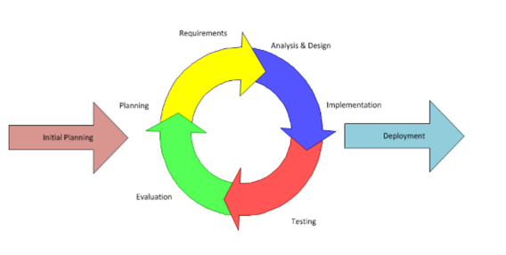

* + Our capstone project uses Iterative and Incremental software process model – a method by which system is developed in small phases in a time and through repeated cycles. Developers can take advantage of this model through reviewing parts of system to change or improve them. It also allows developers to receive feedback to modify the target of the next releases.
  + During the time of doing Capstone project; we divide the process into 2 iterations. Detail information about the iterations is explained in the part of Project management plan.

### Organization Structure

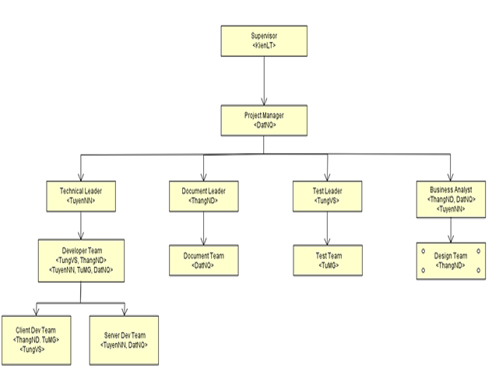

***Figure 2-2:*** *3S Organization Struture*

### Roles and Responsibilites

|  |  |
| --- | --- |
| **Role** | **Responsibility** |
| Project manager | Project manager is responsible to plan, schedule and control the project. He also has to communicate with all the team members to keep them focusing on the final goal. |
| Technical leader | Technical leader is responsible to decide what technologies the project will be using. He works with business analysts to design system architecture and database. Additionally, he supervises other developers working on the project. |
| Document leader | Document leader is responsible to prepare all the documents related to the project. |
| Test leader | Test leader is responsible to plan, monitor and control the testing activities and tasks, including setting up test, evaluating test run and recording test results. |
| Developer | Developers are responsible to develop the actual product, review other developers’ code. They set up, run unit test, receive bugs from testers and fix these bugs. |
| Tester | Testers are responsible to test the product, write test cases for integration, regression and acceptance test phases. They execute these written test cases, log bugs and inform developers |
| Designer | Designer is responsible to design user interface of the product, draw mock-up screens for all user cases before implementing |
| Business analyst | Business analysts are responsible to work with project manager to analyse business domain, define functions and scope of the system. They work as a bridge between business problems and technology solutions. |

***Table 2-1****: Roles and Responsibilities*

### Project Team Member

|  |  |
| --- | --- |
| **Team member** | **Role** |
| DatNQ | Project manager, Developer, Business Analyst |
| TuyenNN | Technical leader, Developer, Business Analyst |
| ThangND | Document Leader, Developer, Business Analyst, Designer |
| TungVS | Test Leader, Developer, Tester |
| TuMG | Developer, Tester |

***Table 2-2****: Project Team Member*

### Tools

|  |  |
| --- | --- |
| **Programming languages** | Android SDK, Java |
| **Framework** | JavaSpring |
| **UML tool** | Astah |
| **Project management tools** | Trello, Microsoft Project Management |
| **Process model** | Iterative and Incremental software process model |
| **Drawing mock-up tool** | Balsamiq Mockups |
| **API Development Environment** | Postman |

***Table 2-3****: Tools and Techniques*

## Project Management Plan

### Tasks schedule

* + Iteration 1: Focusing on developing document,design and basic functions
    - Duration: May, 14th 2018 – August,6th 2018.
    - Content:
      * Identifying group, members and analyzing requirements.
      * Designing, executing and testing basic functions such as: login, register, search products, order products, and add products to store, so on.
      * Do reports.
      * Completing basic functions.
      * Designing, executing and testing advance functions.
      * Continue doing reports.
      * Defining figures of specification about performance (memory, delay time, load time…).
      * Deployment.
  + Iteration 2: Focusing on developing advance functions
    - Duration: August, 7th 2018 – August, 28th 2018.
    - Content:
      * Completing advance functions.
      * Fix bug
      * Optimize code and application performent.
      * Finish reports.
      * Continue doing reports.
      * Defining figures of specification about performance (memory, delay time, load time…).
      * Deployment.

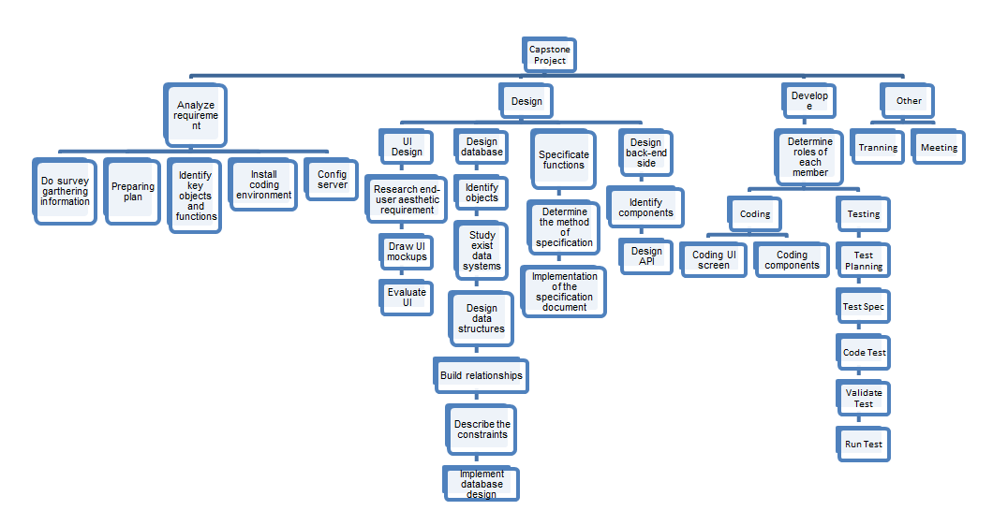

***Figure 2-3:*** *Work Breakdown Structures*

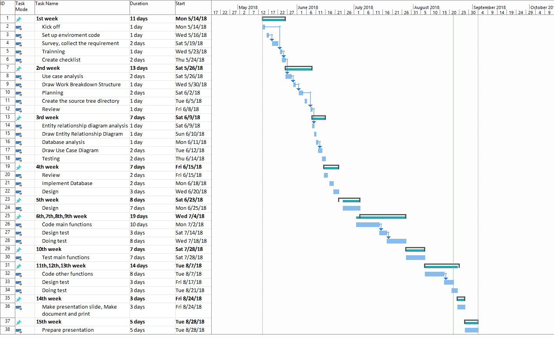

***Figure 2-4:*** *Project Plan*

### Project milestones

|  |  |  |  |
| --- | --- | --- | --- |
| **No** | **Milestone** | **Completion Date** | **Verification** |
| 1 | Project start | 14/05/2018 | Supervisor |
| 2 | Submit report 1 | 04/06/2018 | Supervisor |
| 3 | Submit report 2 | 11/06/2018 | Supervisor |
| 4 | Submit report 3 | 18/06/2018 | Supervisor |
| 5 | Submit report 4 | 25/06/2018 | Supervisor |
| 6 | Submit report 5 | 09/07/2018 | Supervisor |
| 7 | Submit report 6 | 23/07/2018 | Supervisor |
| 8 | Final report | 20/08/2018 | FPT University, Supervisor |
| 9 | Defend project | 04/09/2018 | FPT University, Supervisor |

***Table 2-4****: Project Milestones*

### Meeting Minutes

* + A secretary whom the project manager assigns to will note all the meetings of team. He should write down ideas, contents discussion and notation by following the meeting minutes form below:

|  |  |  |  |
| --- | --- | --- | --- |
| ***Meeting/Project Name:*** | OAL | | |
| ***Date of Meeting:*** | 22/05/2018 | ***Time: (Type)*** | 1 hours / Face-to-face |
| ***Meeting Called by:*** | DatNQ | ***Location:*** | P211 FPT University |
| ***Note Taker:*** | TuMG | ***Time Keeper:*** | ThangND |
| 1. **Meeting Objective**   - Introducing team members  - Setting up working rules  - Choosing name, raising ideas for project  - Other information | | | |
| 1. **Attendance**  |  |  |  |  | | --- | --- | --- | --- | | ***Member*** | ***Roles*** | ***E-mail*** | ***Attendance*** | | Nguyễn Quốc Đạt | PM, Technical Leader, BA | [datnqse04036@fpt.edu.vn](mailto:datnqse04036@fpt.edu.vn) |  | | Nguyễn Đại Thắng | Developer, Designer | [thangnd04441@fpt.edu.vn](mailto:thangnd04441@fpt.edu.vn) |  | | Ngô Ngọc Tuyên | Developer, Tester, BA | [tuyennnse04335@fpt.edu.vn](mailto:tuyennnse04335@fpt.edu.vn) |  | | Mai Gia Tú | Developer, Tester, BA | [tumgse04012@fpt.edu.vn](mailto:tumgse04012@fpt.edu.vn) |  | | Vũ Sỹ Tùng | Developer, Tester | [tungvsse04113@fpt.edu.vn](mailto:tungvsse04113@fpt.edu.vn) |  | | | | |
| 1. **Content**    * Analys ERD.    * Drawing flow-chart to avoid excess data.    * Drawing Use case follow level model.    * Naming the system    * Discussing about category, goods entity    * Discussing about detail plan | | | |
| 1. **Note**   N/A | | | |

|  |  |  |  |
| --- | --- | --- | --- |
| ***Meeting/Project Name:*** | OAL | | |
| ***Date of Meeting:*** | 31/05/2018 | ***Time: (Type)*** | 1 hours / Face-to-face |
| ***Meeting Called by:*** | DatNQ | ***Location:*** | P211 FPT University |
| ***Note Taker:*** | TuMG | ***Time Keeper:*** | ThangND |
| 1. **Meeting Objective**   *<General description about meeting>*  Example:  -Introducing team members  - Setting up working rules  - Choosing name, raising ideas for project  - Other information | | | |
| 1. **Attendance**  |  |  |  |  | | --- | --- | --- | --- | | ***Member*** | ***Roles*** | ***E-mail*** | ***Attendance*** | | Nguyễn Quốc Đạt | PM, Technical Leader, BA | [datnqse04036@fpt.edu.vn](mailto:datnqse04036@fpt.edu.vn) |  | | Nguyễn Đại Thắng | Developer, Designer | [thangnd04441@fpt.edu.vn](mailto:thangnd04441@fpt.edu.vn) |  | | Ngô Ngọc Tuyên | Developer, Tester, BA | [tuyennnse04335@fpt.edu.vn](mailto:tuyennnse04335@fpt.edu.vn) |  | | Mai Gia Tú | Developer, Tester, BA | [tumgse04012@fpt.edu.vn](mailto:tumgse04012@fpt.edu.vn) |  | | Vũ Sỹ Tùng | Developer, Tester | [tungvsse04113@fpt.edu.vn](mailto:tungvsse04113@fpt.edu.vn) |  | | | | |
| 1. **Content**    * Editting Introduction in Report.1    * Making mock-up idea    * Edit database    * Discuss ing about symmetry encryption JSON    * Making situation in Report.1 | | | |
| 1. **Note**   N/A | | | |

***Table 2-5****: Meeting Minutes Template*

### Coding Convention

* + Purpose of coding conventions:
    - Coding conventions create a consistent look to the code. They help readers to focus on content, not layout.
    - Coding conventions enable readers to quickly understand by making assumptions based on previous experiences.
    - Coding conventions facilitate copying, changing and maintaining the code.
  + Because of these reasons, we strictly follow the Convention Styles Guide below:
    - Android SDK :
      * Coding Style : <https://source.android.com/setup/contribute/code-style>
      * Project guidelines:

<https://github.com/ribot/android-guidelines/blob/master/project_and_code_guidelines.md>

XML Naming Convention: <https://jeroenmols.com/blog/2016/03/07/resourcenaming/>

* + - Java Spring:

<https://docs.spring.io/spring/docs/current/javadoc-api/org/springframework/core/Conventions.html>

### Risk management

|  |  |  |  |  |
| --- | --- | --- | --- | --- |
| **No** | **Description** | **Avoidance plan** | **Contingency plan** | **Impact** |
| R1 | Absence/illness of team members | Members have informed the project manager the reason why they are absent and build their own plan to keep up with the work process. | The project manager always has back up plan to avoid effect from the absence and ensure that problem will be solved | High |
| R2 | Conflicts among members | At the beginning, members should clear their roles and responsibilities. | The project manager has to find out the root that caused problem and solve it. Face-to-face meeting is a good method | Medium |
| R3 | Project team member misunderstands requirements | Members have to read requirement specification and related documents carefully. | Making sure that any miscommunication would be resolved. | Medium |
| R4 | Equipment of members is broken. | Members must be careful with their equipment. | Members should use other equipment until the broken one is fixed or buy the new one. | Low |
| R5 | Business problem | Any ideas are welcome but members have to discuss with others and always focus on the reality and possibility. | Making sure that the business logic of any ideas is carefully analyzed. | High |
| R6 | New technologies | Choosing technology based on members’ qualification. All team members must nurture by self-study. | When the technical leader chooses a new technology, he has to explain to all team members about the decision. | High |
| R7 | Lack of knowledge and experiences about source code management | Borrowing books, asking supervisor to gain more knowledge and e-learning | Hold meetings with supervisor to make clear what team will do | High |
| R8 | Lack of data to train | Making plan to train data everyday  Classify | Classify data into some categories and make sure that each category contains enough data. | Medium |

***Table 2-6****: Risk management*

|  |  |  |  |
| --- | --- | --- | --- |
| high  **Probability** |  | R8, R2 | R1, R5 |
| medium |  | R3 | R7, R6 |
| low | R4 |  |  |
|  | low | medium  **Impact** | high |

***Table 2-7****: Probability/impact matrix of risk*

### Communication plan

* + - We made plans for three kinds of meeting:
      * Weekly meeting.
      * Daily discussing.
      * Unscheduled meeting.
    - Weekly meeting: All the members will meet the supervisor weekly on Tuesday at the room P211 Beta Building, FPT University. In every meeting, each member inform other members about what he or she has finished last week, status (fast, on time or slow), issues met and how to solve them. If there is any problems that a member cannot find the solution, all the members will discuss to solve them. Then, the project manager will assign tasks for the next week and estimate time for doing these tasks. All the things that the team has discussed will be written down by the secretary in meeting minutes.
    - Daily discussing: At the endding of every working day, a small review section will be hosted by the project manager. Each member has to review what he or she did yesterday, the problems remained and what need to be done today. By focusing on what each person accomplished and will accomplish, team members know exactly the efforts that they need to be spend on working.
    - Unscheduled meeting: Unscheduled meetings are usually online meetings. It happens when there are important problems need to be solved immediately.
    - Communication channels:
      * Face-to-face meeting.
      * E-mail, Trello: Tracking and saving important tasks and information.
      * Alo Alo: Online talking.
      * Facebook Messenger, mobile phone: Chatting and informal information

# Software Requirements Specifications (SRS)

## Purpose

* + Software Requirements Specifications chapter provides general, as well as specific information of the system. It also describes the functional requirements and non-functional requirements. By following these requirements, our product will perform its intended functionality that can then be used in designing, developing and testing. All members’ work based on the information that has provided in this document.

## User Requirement Specification

* + An application system acting as a bridge between buyers and sellers
  + An application system which provides necessary information about products, stores that are the most convenient for Users to go shopping.

## System Requirement Specification (Specific Requirements)

### External Interface Requirements

#### User Interfaces

* + Application UI is based on Material Design style.
  + UI design is simplified to make it easer for end-users to use the application.

#### Hardware Interfaces

* + The application is made specifically for Android OS, but not for iOS yet.
  + The mobile devices that have Android version 5.1 or above would be suitable to setup our application.

#### Software Interfaces

* + System application uses HTTP protocol to tranfer data.

#### Communications Protocol

* + Our system application uses JSON to communicate between system components.

### System Features

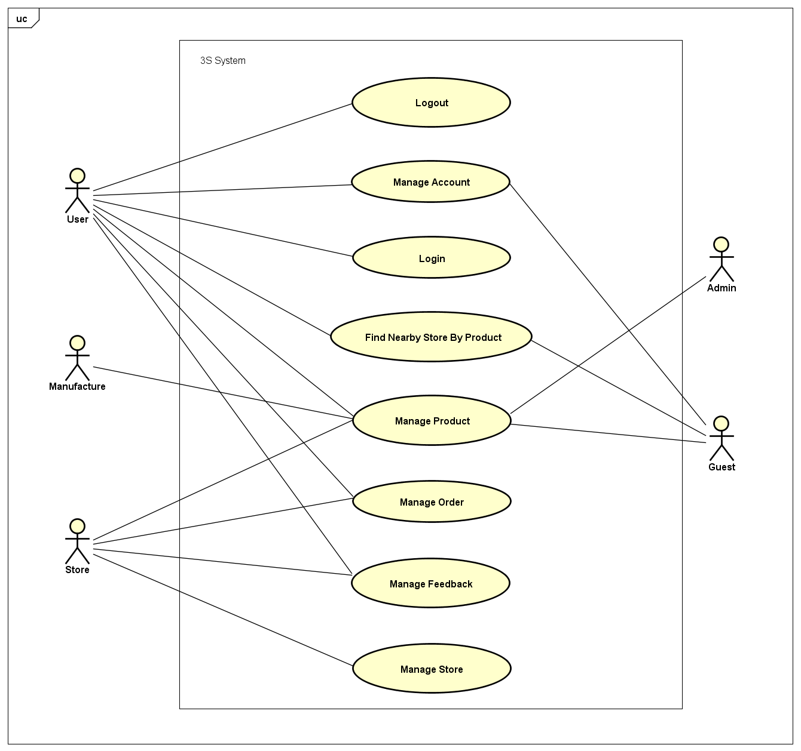

***Figure 3-1:*** *3S System Usecase Diagram*

#### Logout

|  |  |  |  |
| --- | --- | --- | --- |
| UC ID and Name: | **UC-1: Logout** | | |
| Created by: | **ThangND** | Created date: | **May 23th, 2018** |
| Primary Actor: | **User** | Secondary Actor: |  |
| Trigger: | N/A | | |
| Description: | User who wants to log out of application system. | | |
| Preconditions: | **PRE-1.1:** The user has logged in to application system. | | |
| Post conditions: | **POST-1.1:** The user will have logged out of application system.  **POST-1.2:** The user will have accessed to application as Guest. | | |
| Normal Flow: | 1. User opens the application. 2. Home screen is displayed. 3. User clicks on “Người dùng” tab with icon on the right of bottom navigation bar in Home screen.  1. ”Người dùng” screen is displayed with user information function form and “Đăng xuất” button. 2. User clicks on “Đăng xuất” button 3. Redirect to Home screen , user accesses to system as Guest | | |
| Alternative Flows: | N/A | | |
| Exceptions: | N/A | | |
| Priority: | High | | |
| Frequency of Use: | Medium | | |
| Other Information: | N/A | | |
| Assumptions: | Server is stable running.  Internet service is turning on. | | |

#### Login

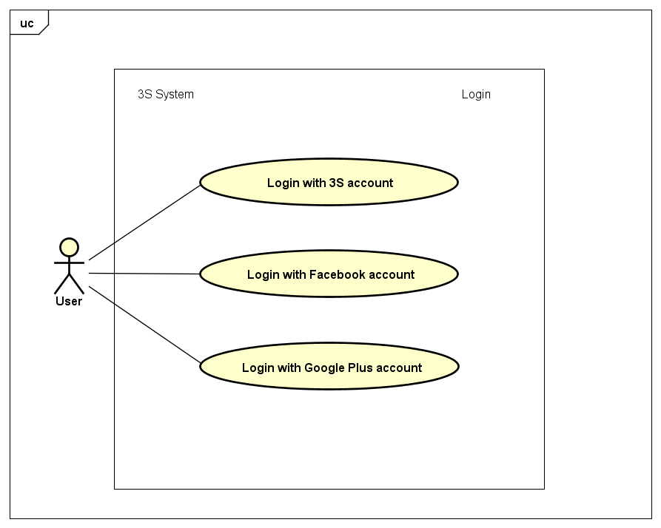

***Figure 3-2:*** *Login Usecase Diagram*

##### Login with 3S account

|  |  |  |  |
| --- | --- | --- | --- |
| UC ID and Name: | **UC-2: Login with 3S account** | | |
| Created by: | **ThangND** | Created date: | **May 23th, 2018** |
| Primary Actor: | **User** | Secondary Actor: |  |
| Trigger: | N/A | | |
| Description: | User who wants to login with Customer’s account. | | |
| Preconditions: | **PRE-2.1:** The user has a 3S account.  **PRE-2.2:** The user had not logged in to application system. | | |
| Post conditions: | **POST-2.1:** The user will have logged in to application system. | | |
| Normal Flow: | 1. User opens the application. 2. Home screen is displayed. 3. User clicks on “Người dùng” tab with C:\Users\Chamander\AppData\Local\Microsoft\Windows\INetCache\Content.Word\user.png icon on the right of bottom navigation bar in Home screen. 4. ”Người dùng” screen is displayed with “Bạn chưa đăng nhập” notification message and “Đăng nhập” button. 5. User clicks on “Đăng nhập” button. 6. “Đăng nhập” screen is displayed. 7. User enters correct username and password into login form, and then clicks on “Đăng nhập” button. | | |
| Alternative Flows: | 1. User opens the application. 2. Displays Home screen. 3. User clicks on “Cửa hàng” tab with icon on the center of bottom navigation bar in Home screen.  1. ” Cửa hàng” screen is displayed with “Vui lòng đăng nhập để xem thông tin cửa hàng” notification message and “Đăng nhập” button. 2. User clicks on “Đăng nhập” button. 3. “Đăng nhập” screen is displayed. 4. User enters correct username and password into login form, and then clicks on “Đăng nhập” button. | | |
| Exceptions: | Incorrect 3S account credentials | | |
| Priority: | High | | |
| Frequency of Use: | High | | |
| Other Information: | N/A | | |
| Assumptions: | Server is stable running.  Internet service is turning on. | | |

##### Login with Facebook account

|  |  |  |  |
| --- | --- | --- | --- |
| UC ID and Name: | **UC-3: Login with Facebook account** | | |
| Created by: | **ThangND** | Created date: | **May 23th, 2018** |
| Primary Actor: | **User** | Secondary Actor: |  |
| Trigger: | N/A | | |
| Description: | User who wants to login with Facebook account. | | |
| Preconditions: | **PRE-3.1:** The user has a Facebook account.  **PRE-3.2:** The user had not logged in to application system. | | |
| Post conditions: | **POST-3.1:** The user will have logged in to application system. | | |
| Normal Flow: | 1. User opens the application. 2. Home screen is displayed. 3. User clicks on “Người dùng” tab with C:\Users\Chamander\AppData\Local\Microsoft\Windows\INetCache\Content.Word\user.png icon on the right of bottom navigation bar in Home screen. 4. ”Người dùng” screen is displayed with “Bạn chưa đăng nhập” notification message and “Đăng nhập” button. 5. User clicks on “Đăng nhập” button. 6. “Đăng nhập” screen is displayed. 7. User clicks on “Đăng nhập với tài khoản Facebook” button. 8. User enter correct Facebook account to Facebook login form. | | |
| Alternative Flows: | 1. User opens the application. 2. Home screen is displayed. 3. User clicks on “Cửa hàng” tab with C:\Users\Chamander\AppData\Local\Microsoft\Windows\INetCache\Content.Word\store.png icon on the center of bottom navigation bar in Home screen. 4. ”Cửa hàng” screen is displayed with “Vui lòng đăng nhập để xem thông tin cửa hàng” notification message and “Đăng nhập” button. 5. User clicks on “Đăng nhập” button. 6. “Đăng nhập” screen is displayed. 7. User clicks on “Đăng nhập với tài khoản Facebook” button. 8. User enter correct Facebook account to Facebook login form. | | |
| Exceptions: | 1. Incorrect Facebook credentials. 2. Facebook account have been logged in on current device. 3. Mobile device has not had accessibility permission to Facebook account. | | |
| Priority: | High | | |
| Frequency of Use: | High | | |
| Other Information: | N/A | | |
| Assumptions: | Server is stable running.  Internet service is turning on. | | |

##### Login with Google Plus account

|  |  |  |  |
| --- | --- | --- | --- |
| UC ID and Name: | **UC-4: Login with Google Plus account** | | |
| Created by: | **ThangND** | Created date: | **May 23th, 2018** |
| Primary Actor: | **User** | Secondary Actor: |  |
| Trigger: | N/A | | |
| Description: | User who wants to login with Facebook account. | | |
| Preconditions: | **PRE-4.1:** The user has a Google Plucs account.  **PRE-4.2:** The user had not logged in to application system. | | |
| Post conditions: | **POST-4.1:** The user will have logged in to application system. | | |
| Normal Flow: | 1. User opens the application. 2. Home screen is displayed. 3. User clicks on “Người dùng” tab with C:\Users\Chamander\AppData\Local\Microsoft\Windows\INetCache\Content.Word\user.png icon on the right of bottom navigation bar in Home screen. 4. ”Người dùng” screen is displayed with “Bạn chưa đăng nhập” notification message and “Đăng nhập” button. 5. User clicks on “Đăng nhập” button. 6. “Đăng nhập” screen is displayed. 7. User clicks on “Đăng nhập với tài khoản Google Plus” button. 8. User enter correct Facebook account to Google Plus login form. 9. Redirect to Home screen. | | |
| Alternative Flows: | 1. User opens the application. 2. Home screen is displayed. 3. User clicks on “Cửa hàng” tab with C:\Users\Chamander\AppData\Local\Microsoft\Windows\INetCache\Content.Word\store.png icon on the center of bottom navigation bar in Home screen. 4. ”Cửa hàng” screen is displayed with “Vui lòng đăng nhập để xem thông tin cửa hàng” notification message and “Đăng nhập” button. 5. User clicks on “Đăng nhập” button. 6. “Đăng nhập” screen is displayed. 7. User clicks on “Đăng nhập với tài khoản Google Plus” button. 8. User enter correct Facebook account to Google Plus login form. 9. Redirect to Home screen. | | |
| Exceptions: | 1. Incorrect Google Plus credentials. 2. Facebook account have been logged in on current device. | | |
| Priority: | High | | |
| Frequency of Use: | High | | |
| Other Information: | N/A | | |
| Assumptions: | Server is stable running.  Internet service is turning on. | | |

#### Manage Order

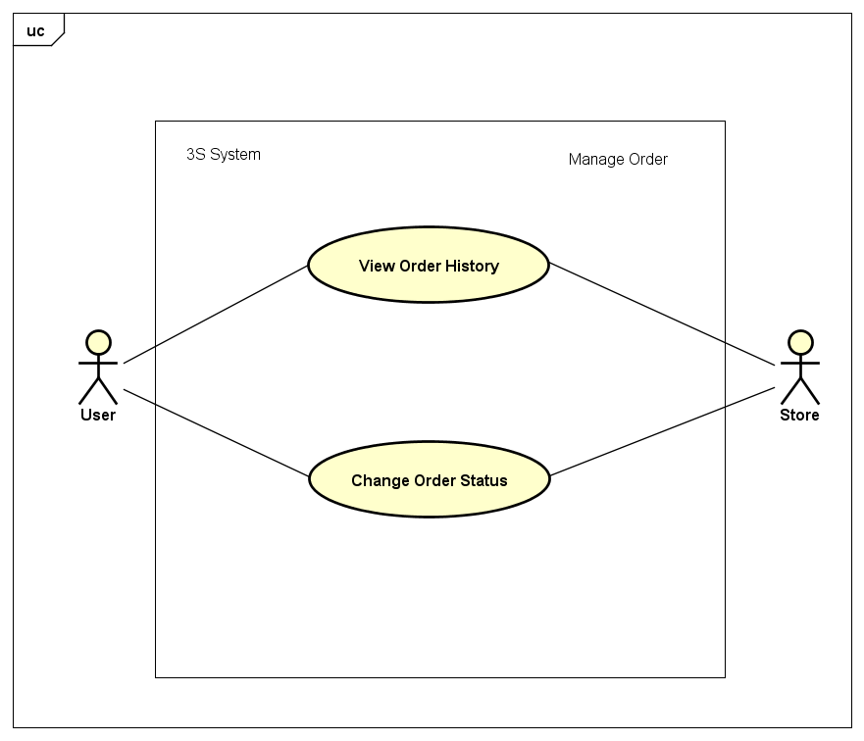

***Figure 3-3:*** *Manage Order Usecase Diagram*

##### View Order History

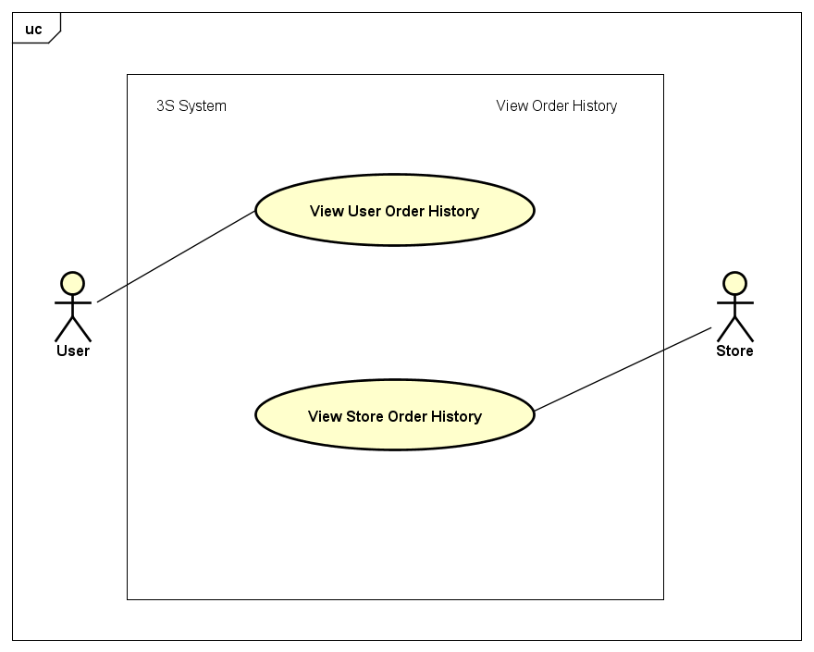

***Figure 3-4:*** *View Order History Usecase Diagram*

|  |  |  |  |
| --- | --- | --- | --- |
| UC ID and Name: | **UC-5: View User Order History** | | |
| Created by: | **ThangND** | Created date: | **Jun 1st, 2018** |
| Primary Actor: | **User** | Secondary Actor: |  |
| Trigger: | N/A | | |
| Description: | User wants to view order history himseft / herseft. | | |
| Preconditions: | **PRE-5.1:** The user had logged in to application system yet. | | |
| Post conditions: | N/A | | |
| Normal Flow: | 1. User opens the application. 2. Home screen is displayed. 3. User clicks on “Người dùng” tab with C:\Users\Chamander\AppData\Local\Microsoft\Windows\INetCache\Content.Word\user.png icon on the right of bottom navigation bar in Home screen. 4. User clicks on “Đơn hàng của tôi” layout button. 5. “Quản lý đơn hàng” screen in User role is displayed with a order list with order information and function buttons. | | |
| Alternative Flows: | N/A | | |
| Exceptions: | User order history list is empty. | | |
| Priority: | High | | |
| Frequency of Use: | Medium | | |
| Other Information: | N/A | | |
| Assumptions: | Server is stable running.  Internet service is turning on. | | |

|  |  |  |  |
| --- | --- | --- | --- |
| UC ID and Name: | **UC-6: View Store Order History** | | |
| Created by: | **ThangND** | Created date: | **Jun 1st, 2018** |
| Primary Actor: | **Store** | Secondary Actor: |  |
| Trigger: | N/A | | |
| Description: | Store wants to view order history. | | |
| Preconditions: | **PRE-6.1:** The user had logged in to application system.  **PRE-6.2:** The user had had a store. | | |
| Post conditions: | **N/A** | | |
| Normal Flow: | 1. User opens the application. 2. Home screen is displayed. 3. User clicks on “Cửa hàng” tab with C:\Users\Chamander\AppData\Local\Microsoft\Windows\INetCache\Content.Word\store.png icon on the center of bottom navigation bar in Home screen. 4. Store clicks on “Quản lý đơn hàng” button. 5. “Quản lý đơn hàng” screen in Store role is displayed with 3 tabs equivalently 3 order statuses which are “Đợi xử lý”, “Đang xử lý” and “Đã xử lý”. | | |
| Alternative Flows: | N/A | | |
| Exceptions: | Store order history list is empty. | | |
| Priority: | High | | |
| Frequency of Use: | High | | |
| Other Information: | N/A | | |
| Assumptions: | Server is stable running.  Internet service is turning on. | | |

##### Change Order Status

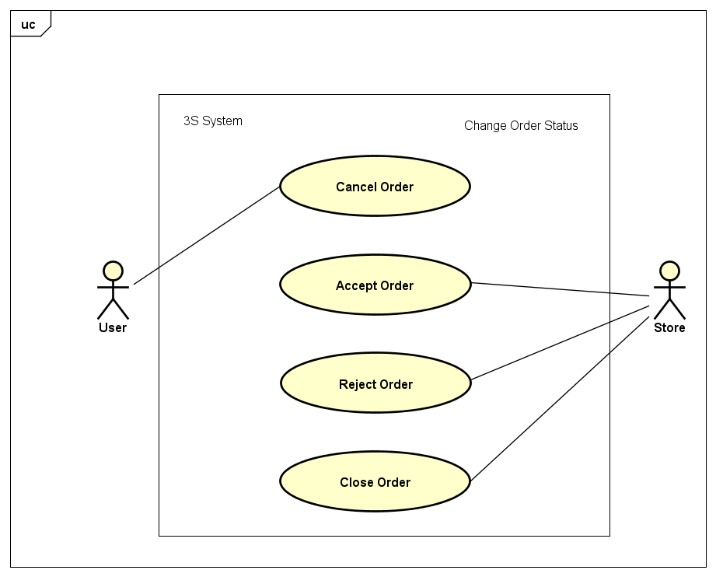

***Figure 3-5:*** *Change Order Status Usecase Diagram*

|  |  |  |  |
| --- | --- | --- | --- |
| UC ID and Name: | **UC-7: Cancel Order** | | |
| Created by: | **ThangND** | Created date: | **Jun 1st, 2018** |
| Primary Actor: | **User** | Secondary Actor: |  |
| Trigger: | User had ordered product yet. | | |
| Description: | User wants to cancel order. | | |
| Preconditions: | **PRE-7.1:** The user had logged in to application system.  **PRE-7.2:** The store had not accepted / rejected this order yet . | | |
| Post conditions: | **POST-7.1:** The waiting order will have been destroyed. | | |
| Normal Flow: | 1. User access “Quản lý đơn hàng” screen in User role. 2. In order with waiting status, user clicks on “Hủy đơn hàng” button. 3. User clicks on “Đồng ý” button in “Hủy đơn hàng” dialog. | | |
| Alternative Flows: | N/A | | |
| Exceptions: | User order history is blank. | | |
| Priority: | High | | |
| Frequency of Use: | Medium | | |
| Other Information: | N/A | | |
| Assumptions: | Server is stable running.  Internet service is turning on. | | |

|  |  |  |  |
| --- | --- | --- | --- |
| UC ID and Name: | **UC-8: Accept Order** | | |
| Created by: | **ThangND** | Created date: | **Jun 1st, 2018** |
| Primary Actor: | **Store** | Secondary Actor: |  |
| Trigger: | N/A | | |
| Description: | Store wants to accept waitting order. | | |
| Preconditions: | **PRE-8.1:** The user had logged in to application system.  **PRE-8.2:** The user had had a store.  **PRE-8.3:** The user had not canceled this order yet. | | |
| Post conditions: | **POST-8.1:** The order will have been accepted by store.  **POST-8.2:** That order’s status will have been changed to processing. | | |
| Normal Flow: | 1. Store access “Quản lý đơn hàng” screen in Store role. 2. In “Đợi xử lý” tabs, store clicks on “Chấp nhận” button which in order detail. 3. Store clicks on “Đồng ý” button in “Chấp nhận đơn hàng” dialog. | | |
| Alternative Flows: | N/A | | |
| Exceptions: | N/A | | |
| Priority: | Medium | | |
| Frequency of Use: | High | | |
| Other Information: | N/A | | |
| Assumptions: | Server is stable running.  Internet service is turning on. | | |

|  |  |  |  |
| --- | --- | --- | --- |
| UC ID and Name: | **UC-9: Reject Order** | | |
| Created by: | **ThangND** | Created date: | **Jun 1st, 2018** |
| Primary Actor: | **Store** | Secondary Actor: |  |
| Trigger: | N/Á | | |
| Description: | Store wants to reject waitting order. | | |
| Preconditions: | **PRE-9.1:** The user had logged in to application system.  **PRE-9.2:** The user had had a store.  **PRE-9.3:** The user had not canceled this order yet. | | |
| Post conditions: | **POST-9.1:** The order will have been rejected by store.  **POST-9.2:** That order’s status will have been changed to done. | | |
| Normal Flow: | 1. Store access “Quản lý đơn hàng” screen in Store role. 2. In “Đợi xử lý” tabs, store clicks on “Từ chối” button which in order detail 3. Store clicks on “Đồng ý” button in “Từ chối đơn hàng” dialog. | | |
| Alternative Flows: | N/A | | |
| Exceptions: | N/A | | |
| Priority: | Medium | | |
| Frequency of Use: | High | | |
| Other Information: | N/A | | |
| Assumptions: | Server is stable running.  Internet service is turning on. | | |

|  |  |  |  |
| --- | --- | --- | --- |
| UC ID and Name: | **UC-10: Close Order** | | |
| Created by: | **ThangND** | Created date: | **Jun 1st, 2018** |
| Primary Actor: | **Store** | Secondary Actor: |  |
| Trigger: | N/A | | |
| Description: | Store wants to reject order. | | |
| Preconditions: | **PRE-10.1:** The user had logged in to application system.  **PRE-10.2:** The user had had a store.  **PRE-10.2:** This order’s status must be processing. | | |
| Post conditions: | **POST-10.1:** The order will have been closed by store.  **POST-10.2:** That order’s status will have been changed to done. | | |
| Normal Flow: | 1. Store access “Quản lý đơn hàng” screen in Store role. 2. In “Đang xử lý” tabs, store clicks on “Đã giao hàng” button which in order detail. 3. Store clicks on “Đồng ý” button in “Đóng đơn hàng” dialog. | | |
| Alternative Flows: | N/A | | |
| Exceptions: | N/A | | |
| Priority: | Medium | | |
| Frequency of Use: | High | | |
| Other Information: | N/A | | |
| Assumptions: | Server is stable running.  Internet service is turning on. | | |

#### Manage Store

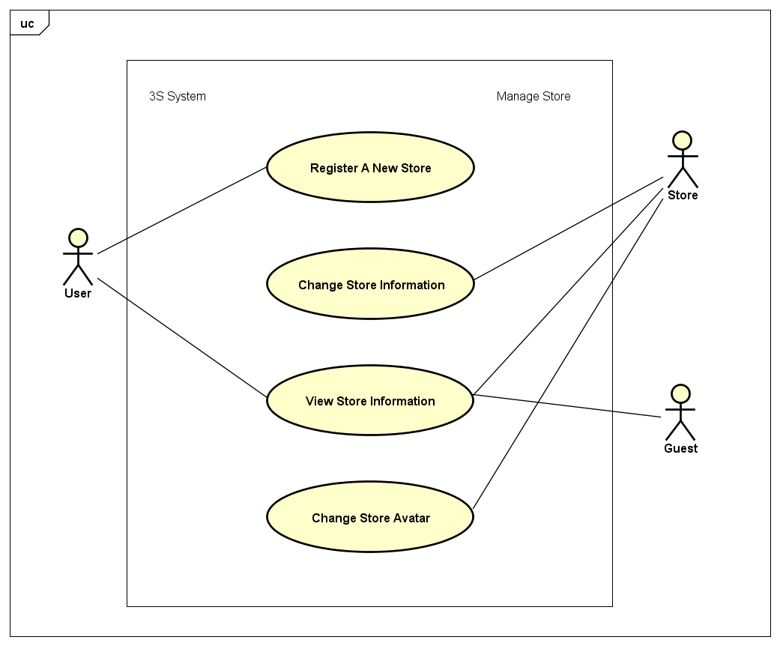

***Figure 3-6:*** *Manage Store Usecase Diagram*

##### Register A New Store

|  |  |  |  |
| --- | --- | --- | --- |
| UC ID and Name: | **UC-11: Register A New Store** | | |
| Created by: | **ThangND** | Created date: | **Jun 2nd, 2018** |
| Primary Actor: | **User** | Secondary Actor: |  |
| Trigger: | N/A | | |
| Description: | User wants register a new store to buy products. | | |
| Preconditions: | **PRE-11.1:** The user had logged in to application system.  **PRE-11.2:** The user had not had a registered store.  **PRE-11.3:** The user has turned on his/her GPS location service in mobile device.  **PRE-11.4:** The current device has allowed application access GPS service. | | |
| Post conditions: | **POST-11.1:** Store will have been registered under user account. | | |
| Normal Flow: | 1. User opens the application with logged in account. 2. Home screen is displayed. 3. User clicks on “Cửa hàng” tab with icon on the center of bottom navigation bar in Home screen.  1. ”Cửa hàng” screen is displayed with “Bạn chưa có cửa hàng” notification message and “Đăng kí cửa hàng” button. 2. User clicks on “Đăng kí cửa hàng” button. 3. “Đăng kí cửa hàng” screen is displayed. 4. Fill out store information form with valid information. 5. User clicks on “Đăng kí” button. 6. Redirect to Home screen. | | |
| Alternative Flows: | N/A | | |
| Exceptions: | * 1. Invalid Store name.   2. Invalid Store phone. | | |
| Priority: | Medium | | |
| Frequency of Use: | Low | | |
| Other Information: | N/A | | |
| Assumptions: | Server is stable running.  Internet service is turning on. | | |

##### View Store Information

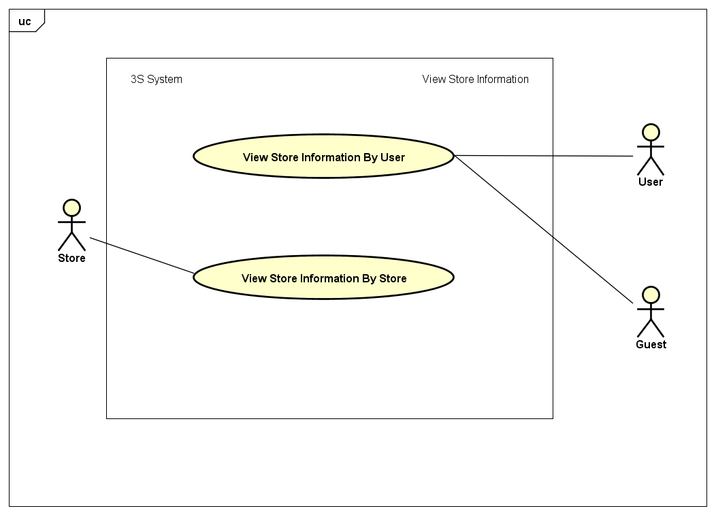

***Figure 3-7:*** *View Store Information Usecase Diagram*

|  |  |  |  |
| --- | --- | --- | --- |
| UC ID and Name: | **UC-12: View Store Information By User** | | |
| Created by: | **ThangND** | Created date: | **Jun 2nd, 2018** |
| Primary Actor: | **User** | Secondary Actor: | **Guest** |
| Trigger: | N/A | | |
| Description: | User wants to view store information. | | |
| Preconditions: | **PRE-12.1:** The user has turned on his/her GPS location service in mobile device.  **PRE-12.2:** The current device has allowed application access GPS service.  **PRE-12.3:** The current device has allowed application access Camera service. | | |
| Post conditions: | N/A | | |
| Normal Flow: | 1. User had found nearby store by product after finishing UC-19 or UC-20. 2. User clicks on store name. 3. “Sản phẩm cửa hàng” is displayed with store name and product list in store. 4. User clicks on store name. 5. “Thông tin cửa hàng” screen is displayed with store information. | | |
| Alternative Flows: | 1. User access “Quản lý đơn hàng” screen in User role. 2. User clicks on store name in order detail layout. 3. “Sản phẩm cửa hàng” is displayed with store name and product list in store. 4. User clicks on store name. 5. “Thông tin cửa hàng” is displayed with store information. | | |
| Exceptions: | User order history is blank. | | |
| Priority: | Low | | |
| Frequency of Use: | Medium | | |
| Other Information: | N/A | | |
| Assumptions: | Server is stable running.  Internet service is turning on. | | |

|  |  |  |  |
| --- | --- | --- | --- |
| UC ID and Name: | **UC-13: View Store Information By Store** | | |
| Created by: | **ThangND** | Created date: | **Jun 2nd, 2018** |
| Primary Actor: | **User** | Secondary Actor: |  |
| Trigger: | N/A | | |
| Description: | Store wants to view store information. | | |
| Preconditions: | **PRE-13.1:** The user had logged in to application system.  **PRE-13.2:** The user had had a registered store. | | |
| Post conditions: | N/A | | |
| Normal Flow: | 1. Store opens the application with logged in account. 2. Home screen is displayed. 3. Store clicks on “Cửa hàng” tab with store icon on the center of bottom navigation bar in Home screen. 4. ”Cửa hàng” screen is displayed with store information, “Quản lý đơn hàng” button and “Sản phẩm cửa hàng” button. | | |
| Alternative Flows: | N/A | | |
| Exceptions: | N/A | | |
| Priority: | Medium | | |
| Frequency of Use: | High | | |
| Other Information: | N/A | | |
| Assumptions: | Server is stable running.  Internet service is turning on. | | |

##### Change Store Information

|  |  |  |  |
| --- | --- | --- | --- |
| UC ID and Name: | **UC-14: Change Store Information** | | |
| Created by: | **ThangND** | Created date: | **Jun 2nd, 2018** |
| Primary Actor: | **Store** | Secondary Actor: |  |
| Trigger: | N/A | | |
| Description: | Store wants edit store information | | |
| Preconditions: | **PRE-14.1:** The user had logged in to application system.  **PRE-14.2:** The user had had a store.  **PRE-14.3:** The user has turned on his/her GPS location service in mobile device.  **PRE-14.4:** The user has allowed application access GPS service. | | |
| Post conditions: | **POST-14.1:** Store information will have been changed. | | |
| Normal Flow: | 1. Store opens the application. 2. Home screen is dispalyed. 3. Store clicks on “Cửa hàng” tab with C:\Users\Chamander\AppData\Local\Microsoft\Windows\INetCache\Content.Word\store.png icon on the center of bottom navigation bar in Home screen. 4. ”Cửa hàng” screen is displayed with store information, “Quản lý đơn hàng” button and “Sản phẩm cửa hàng” button. 5. Store clicks on “Sửa thông tin” button with icon.  1. “Thay đổi thông tin” screen is displayed. 2. Change needed information with valid information. 3. Store clicks on “Lưu thay đổi” button. 4. Redirect to “Cửa hàng” screen with changed information. | | |
| Alternative Flows: | N/A | | |
| Exceptions: | * 1. Invalid Store name   2. Invalid Store phone | | |
| Priority: | Medium | | |
| Frequency of Use: | Low | | |
| Other Information: | N/A | | |
| Assumptions: | Server is stable running.  Internet service is turning on. | | |

##### Change Store Avatar

|  |  |  |  |
| --- | --- | --- | --- |
| UC ID and Name: | **UC-15: Change Store Avatar** | | |
| Created by: | **ThangND** | Created date: | **Jun 2nd, 2018** |
| Primary Actor: | **Store** | Secondary Actor: |  |
| Trigger: | N/A | | |
| Description: | Store wants to change store avatar | | |
| Preconditions: | **PRE-15.1:** The user had logged in to application system.  **PRE-15.2:** The user had had a registered store. | | |
| Post conditions: | **POST-15.1:** The store display avatar will have been changed | | |
| Normal Flow: | 1. Store opens the application with logged in account. 2. Home screen is displayed. 3. Store clicks on “Cửa hàng” tab with C:\Users\Chamander\AppData\Local\Microsoft\Windows\INetCache\Content.Word\store.png icon on the center of bottom navigation bar in Home screen. 4. “Cửa hàng” screen is displayed. 5. Store clicks on “Thay đổi ảnh” button in the top of store avatar 6. Store chooses any one image from device gallery. 7. “Cửa hàng” screen is displayed with 2 buttons which are “Hủy thay đổi” button and “Thay đổi” button in store name layout. 8. Store clicks on “Thay đổi” button. | | |
| Alternative Flows: | N/A | | |
| Exceptions: | N/A | | |
| Priority: | Medium | | |
| Frequency of Use: | Low | | |
| Other Information: | N/A | | |
| Assumptions: | Server is stable running.  Internet service is turning on. | | |

#### Manage Account

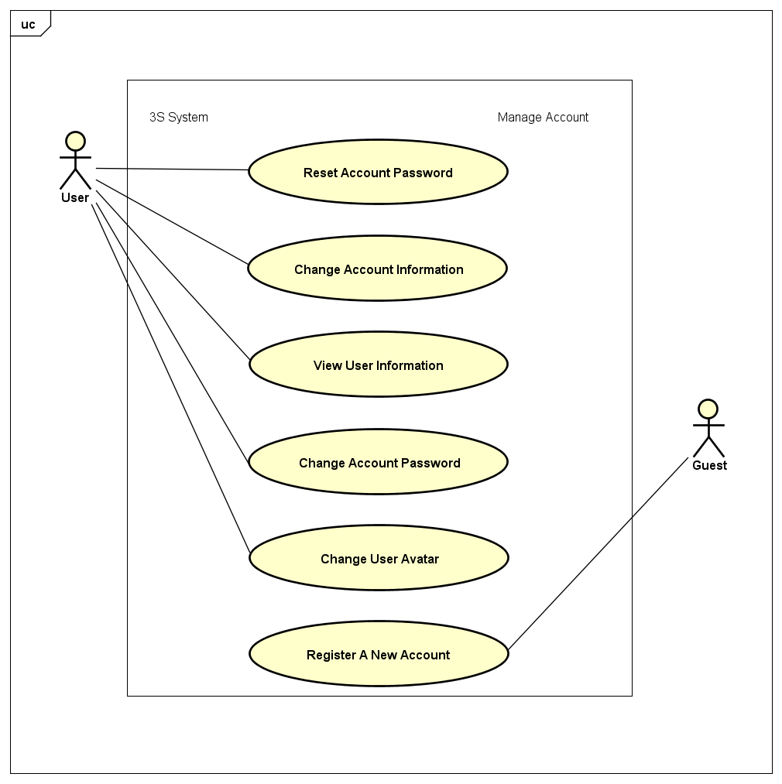

***Figure 3-8:*** *Manage Account Usecase Diagram*

##### View User Information

|  |  |  |  |
| --- | --- | --- | --- |
| UC ID and Name: | **UC-16: View User Information** | | |
| Created by: | **ThangND** | Created date: | **Jun 2nd, 2018** |
| Primary Actor: | **User** | Secondary Actor: |  |
| Trigger: | N/A | | |
| Description: | User wants to view his / her account information. | | |
| Preconditions: | **PRE-16.1:** The user had logged in to application system. | | |
| Post conditions: | N/A | | |
| Normal Flow: | 1. User opens the application. 2. Home screen is displayed. 3. User clicks on “Người dùng” tab with icon on the right of bottom navigation bar in Home screen.  1. ”Người dùng” screen is displayed user information function form and “Đăng xuất” button. 2. Click on “Thông tin tài khoản” layout button. 3. “Thông tin tài khoản” is displayed. | | |
| Alternative Flows: | N/A | | |
| Exceptions: | N/A | | |
| Priority: | Medium | | |
| Frequency of Use: | High | | |
| Other Information: | N/A | | |
| Assumptions: | Server is stable running.  Internet service is turning on. | | |

##### Change Account Information

|  |  |  |  |
| --- | --- | --- | --- |
| UC ID and Name: | **UC-17: Change Account Information** | | |
| Created by: | **ThangND** | Created date: | **Jun 2nd, 2018** |
| Primary Actor: | **User** | Secondary Actor: |  |
| Trigger: | N/A | | |
| Description: | User wants to edit his / her account information. | | |
| Preconditions: | **PRE-17.1:** The user had logged in to application system. | | |
| Post conditions: | **POST-17.1:** The user account information will have been changed. | | |
| Normal Flow: | 1. User accesses to “Thông tin tài khoản” screen. 2. “Thông tin tài khoản” is displayed with user information and “Thay đổi thông tin” button. 3. User clicks on “Thay đổi thông tin” button. 4. Thay đổi thông tin” screen is displayed. 5. User enters needed change information with valid information. 6. User clicks on “Lưu thay đổi” button. 7. Redirect “Thông tin tài khoản” screen. | | |
| Alternative Flows: | N/A | | |
| Exceptions: | 1. Invalid display name. 2. Invalid account phone. 3. Invalid email. | | |
| Priority: | Medium | | |
| Frequency of Use: | High | | |
| Other Information: | N/A | | |
| Assumptions: | Server is stable running.  Internet service is turning on. | | |

##### Register A New Account

|  |  |  |  |
| --- | --- | --- | --- |
| UC ID and Name: | **UC-18: Register A New Account** | | |
| Created by: | **ThangND** | Created date: | **Jun 2nd, 2018** |
| Primary Actor: | **Guest** | Secondary Actor: |  |
| Trigger: | N/A | | |
| Description: | Guest wants to create a new account with User role . | | |
| Preconditions: | N/A | | |
| Post conditions: | **POST-18.1:** The new account had been registered succcessfully. | | |
| Normal Flow: | 1. Guest accesses to “Đăng nhập” screen. 2. Guest clicks on “Đăng kí” borderless button on the bottom of screen. 3. “Đăng kí” screen is displayed. 4. Guest fill out register account form with valid information. 5. Guest clicks on “Đăng kí” button. | | |
| Alternative Flows: | N/A | | |
| Exceptions: | 1. Invalid Username. 2. Invalid Password. 3. Invalid Display Name. 4. Invalid Account Phone. 5. Invalid Email. 6. Re-input password is different from password. | | |
| Priority: | Medium | | |
| Frequency of Use: | High | | |
| Other Information: | N/A | | |
| Assumptions: | Server is stable running.  Internet service is turning on. | | |

##### Reset Account Password

|  |  |  |  |
| --- | --- | --- | --- |
| UC ID and Name: | **UC-19: Reset Account Password** | | |
| Created by: | **ThangND** | Created date: | **Jun 2nd, 2018** |
| Primary Actor: | **User** | Secondary Actor: |  |
| Trigger: | N/A | | |
| Description: | User who had forgotten password wants to reset his / her password | | |
| Preconditions: | **PRE-19.1:** The user had not logged in to application system | | |
| Post conditions: | **POST-19.1** **:** The account password have been changed | | |
| Normal Flow: | 1. User accesses to “Đăng nhập” screen 2. User clicks on “Quên mật khẩu?” button below “Mật khẩu” field 3. “Quên mật khẩu” screen is displayed 4. User enter correct account username to “Tên tài khoản” field 5. User clicks on “Tiếp tục” button 6. User clicks on “Đồng ý” in confirm dialog 7. User receives OTP code via registered phone number 8. User enter valid OTP code to “Mã xác thực SMS” field 9. Redirect “Đổi mật khẩu” screen. 10. User enters new password to “Mật khẩu mới” field and confirm password to “Nhập lại mật khẩu” field 11. User clicks on “Lưu thay đổi” button | | |
| Alternative Flows: | N/A | | |
| Exceptions: | Invalid username  Invalid OTP code | | |
| Priority: | Medium | | |
| Frequency of Use: | High | | |
| Other Information: | N/A | | |
| Assumptions: | Server is stable running.  Internet service is turning on. | | |

##### Change Account Password

|  |  |  |  |
| --- | --- | --- | --- |
| UC ID and Name: | **UC-20: Change Account Password** | | |
| Created by: | **ThangND** | Created date: | **Jun 2nd, 2018** |
| Primary Actor: | **User** | Secondary Actor: |  |
| Trigger: | N/A | | |
| Description: | User wants to change his / her account password. | | |
| Preconditions: | **PRE-20.1:** The user had logged in to application system. | | |
| Post conditions: | **POST-20.1:** The account password will have been changed. | | |
| Normal Flow: | 1. User opens the application. 2. Home screen is displayed. 3. User clicks on “Người dùng” tab with icon on the right of bottom navigation bar in Home screen.  1. ”Người dùng” screen is displayed user information function form. 2. User clicks on “Đổi mật khẩu” layout button. 3. “Đổi mật khẩu” screen is displayed. 4. User entercurrent password to “Mật khẩu hiện tại” field, then enter new password to “Mật khẩu mới” field and “Nhập lại mật khẩu” field. 5. Redirect to “Người dùng” screen with “Thay đổi mật khẩu thành công” notification message. | | |
| Alternative Flows: | N/A | | |
| Exceptions: | 1. Incorrect current password. 2. Invalid new password. 3. Re-input password is different from new password. | | |
| Priority: | High | | |
| Frequency of Use: | Medium | | |
| Other Information: | N/A | | |
| Assumptions: | Server is stable running.  Internet service is turning on. | | |

##### Change User Avatar

|  |  |  |  |
| --- | --- | --- | --- |
| UC ID and Name: | **UC-21: Change User Avatar** | | |
| Created by: | **ThangND** | Created date: | **Jun 2nd, 2018** |
| Primary Actor: | **User** | Secondary Actor: | **Admin - Manufacturer** |
| Trigger: | N/A | | |
| Description: | User wants to change his / her account password. | | |
| Preconditions: | **PRE-21.1:** The user had logged in to application system. | | |
| Post conditions: | **POST-21.1:** The account password will have been changed. | | |
| Normal Flow: | 1. User opens the application. 2. Home screen is displayed. 3. User clicks on “Người dùng” tab with C:\Users\Chamander\AppData\Local\Microsoft\Windows\INetCache\Content.Word\user.png icon on the right of bottom navigation bar in Home screen. 4. ”Người dùng” screen is displayed user information function form. 5. User clicks on “Thay đổi thông tin” layout button. 6. “Thay đổi thông tin” screen is displayed. 7. User clicks on user avatar in top side of screen. 8. User chooses any one image from device gallery. 9. User continues edit user information, then clicks on “Lưu thay đổi” button | | |
| Alternative Flows: | N/A | | |
| Exceptions: | N/A | | |
| Priority: | High | | |
| Frequency of Use: | Medium | | |
| Other Information: | N/A | | |
| Assumptions: | Server is stable running.  Internet service is turning on. | | |

#### Find Nearby Store by Product

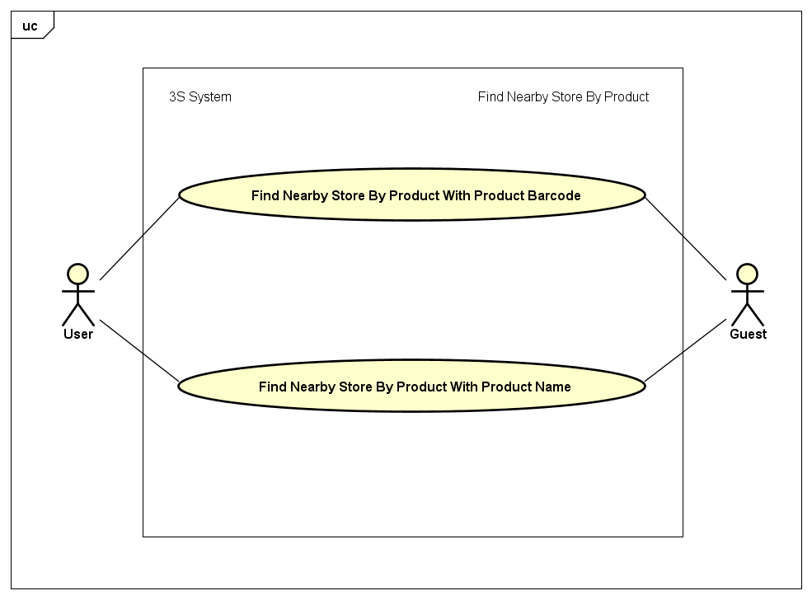

***Figure 3-9:*** *Find Nearby Store by Product Usecase Diagram*

##### Find Nearby Store by Product with Product Barcode

|  |  |  |  |
| --- | --- | --- | --- |
| UC ID and Name: | **UC-22: Find Nearby Store By Product With Product Barcode** | | |
| Created by: | **ThangND** | Created date: | **Jun 2nd, 2018** |
| Primary Actor: | **User** | Secondary Actor: | **Guest** |
| Trigger: | N/A | | |
| Description: | User who wants to find nearby store which have bought needed product via product barcode. | | |
| Preconditions: | **PRE-22.1:** The user has turned on his/her GPS location service in mobile device.  **PRE-22.2:** The current device has allowed application access GPS service.  **PRE-22.3:** The current device has allowed application access Camera service. | | |
| Post conditions: | **POST-22.1:** The user will have found nearby store which have bought their needed products. | | |
| Normal Flow: | 1. User opens the application. 2. Home screen is displayed. 3. User clicks on icon  which is on the right of search bar in Home screen. 4. Scan QR code/ barcode screen is displayed. 5. User scans bar code on product surface. 6. “Tìm kiếm sản phẩm” screen is displayed with product equivalently scanned barcode. 7. User clicks “Tìm cửa hàng” button in product description layout. 8. “Cửa hàng gần đây” screen is displayed with nearby store list | | |
| Alternative Flows: | 1. User opens the application. 2. Home screen is displayed. 3. User clicks on search bar in Home screen. 4. “Tìm kiếm sản phẩm” screen is displayed. 5. User clicks on icon  which is on the right of search bar in “Tìm kiếm sản phẩm” screen. 6. Scan QR code/ barcode screen is displayed. 7. User scans bar code on product surface. 8. “Tìm kiếm sản phẩm” screen is displayed with product equivalently scanned barcode. 9. User clicks “Tìm cửa hàng” button in product description layout. 10. “Cửa hàng gần đây” screen is displayed with nearby store list | | |
| Exceptions: | 1. Barcode is not exist in appication database. 2. No nearby store have user’s needed product. | | |
| Priority: | High | | |
| Frequency of Use: | High | | |
| Other Information: | N/A | | |
| Assumptions: | Server is stable running.  Internet service is turning on. | | |

##### Find Nearby Store by Product with Product Name

|  |  |  |  |
| --- | --- | --- | --- |
| UC ID and Name: | **UC-23: Find Nearby Store By Product With Product Name** | | |
| Created by: | **ThangND** | Created date: | **Jun 2nd, 2018** |
| Primary Actor: | **User** | Secondary Actor: | **Guest** |
| Trigger: | N/A | | |
| Description: | User who wants to find nearby store which have bought needed product via product name. | | |
| Preconditions: | **PRE-23.1:** The user has turned on his/her GPS location service in mobile device.  **PRE-23.2:** The current device has allowed application access GPS service. | | |
| Post conditions: | **POST-23.1:** The user will have found nearby store which have bought their needed products. | | |
| Normal Flow: | 1. User opens the application. 2. Home screen is displayed. 3. User clicks on search bar in Home screen. 4. “Tìm kiếm sản phẩm” screen is displayed . 5. User enters product name to search bar in “Tìm kiếm sản phẩm” screen. 6. Product list equivalently searched product name is displayed in “Tìm kiếm sản phẩm” screen. 7. User clicks “Tìm cửa hàng” button in product description layout. 8. “Cửa hàng gần đây” screen is displayed with nearby store list. | | |
| Alternative Flows: | N/A | | |
| Barcode is not exist in appication database. | 1. Product name is not exist in appication database. 2. No nearby store have user’s needed product. | | |
| Priority: | High | | |
| Frequency of Use: | High | | |
| Other Information: | N/A | | |
| Assumptions: | Server is stable running.  Internet service is turning on. | | |

#### Manage Product

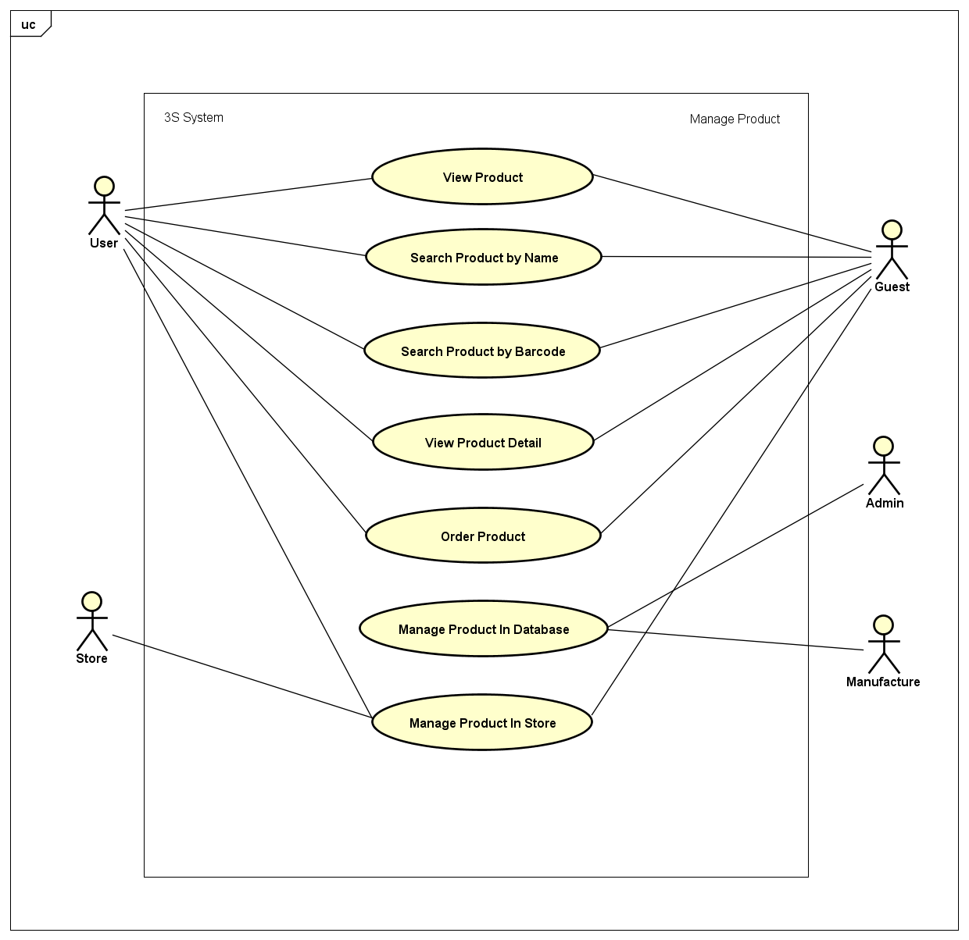

***Figure 3-10:*** *Manage Product Usecase Diagram*

##### Search Product By Barcode

|  |  |  |  |
| --- | --- | --- | --- |
| UC ID and Name: | **UC-24: Search Product By Barcode** | | |
| Created by: | **ThangND** | Created date: | **Jun 2nd, 2018** |
| Primary Actor: | **User** | Secondary Actor: | **Guest** |
| Trigger: | N/A | | |
| Description: | User who wants to search product by product name. | | |
| Preconditions: | **PRE-24.1:** The user has allowed application access Camera service. | | |
| Post conditions: | **POST-24.1:** The user will have found needed product. | | |
| Normal Flow: | 1. User opens the application. 2. Home screen is displayed. 3. User clicks on icon  which is on the right of search bar in Home screen. 4. Scan QR code/ barcode screen is displayed. 5. User scans bar code on product surface. 6. “Tìm kiếm sản phẩm” screen is displayed with product equivalently scanned barcode. | | |
| Alternative Flows: | 1. User opens the application. 2. Home screen is displayed. 3. User clicks on icon search bar in Home screen. 4. “Tìm kiếm sản phẩm” screen is displayed. 5. User clicks on icon  which is on the right of search bar in “Tìm kiếm sản phẩm” screen. 6. Scan QR code/ barcode screen is displayed. 7. User scans bar code on product surface. 8. “Tìm kiếm sản phẩm” screen is displayed with product equivalently scanned barcode. | | |
| Exceptions: | Barcode is not exist in appication database. | | |
| Priority: | High | | |
| Frequency of Use: | High | | |
| Other Information: | N/A | | |
| Assumptions: | Server is stable running.  Internet service is turning on. | | |

##### Search Product By Name

|  |  |  |  |
| --- | --- | --- | --- |
| UC ID and Name: | **UC-25: Search Product By Name** | | |
| Created by: | **ThangND** | Created date: | **Jun 2nd, 2018** |
| Primary Actor: | **User** | Secondary Actor: | **Guest** |
| Trigger: | N/A | | |
| Description: | User who wants to search product by product name. | | |
| Preconditions: | N/A | | |
| Post conditions: | **POST-25.1:** The user will have found needed product | | |
| Normal Flow: | 1. User opens the application. 2. Home screen is displayed. 3. User clicks on search bar in Home screen. 4. “Tìm kiếm sản phẩm” screen is displayed. 5. User enters product name to search bar in “Tìm kiếm sản phẩm” screen. 6. “Tìm kiếm sản phẩm” screen is displayed with product equivalently searched product name. | | |
| Alternative Flows: | N/A | | |
| Exceptions: | Product name is not exist in appication database. | | |
| Priority: | High | | |
| Frequency of Use: | High | | |
| Other Information: | N/A | | |
| Assumptions: | Server is stable running.  Internet service is turning on. | | |

##### View Product Detail

|  |  |  |  |
| --- | --- | --- | --- |
| UC ID and Name: | **UC-26: View Product Detail** | | |
| Created by: | **ThangND** | Created date: | **Jun 2nd, 2018** |
| Primary Actor: | **User - Guest** | Secondary Actor: | **Store** |
| Trigger: | N/A | | |
| Description: | User or Guest or Store who wants to view product detail | | |
| Preconditions: | N/A | | |
| Post conditions: | **POST-26.1:** The user will have found needed product | | |
| Normal Flow: | 1. User accesses to “Sản phẩm giảm giá” screen or “Sản phẩm danh mục” screen or “Sản phẩm thương hiệu” screen or “Sản phẩm chủng loại” screen. 2. Product list is displayed in each screen. 3. User clicks on product name. 4. “Thông tin sản phẩm” screen is displayed with product detail information. | | |
| Alternative Flows: | * 1. User accesses to “Sản phẩm cửa hàng” screen.   2. User click on product name or product image in product detail layout.   3. “Thông tin sản phẩm” screen is displayed. | | |
| Exceptions: | N/A | | |
| Priority: | High | | |
| Frequency of Use: | High | | |
| Other Information: | N/A | | |
| Assumptions: | Server is stable running.  Internet service is turning on. | | |

##### View Product

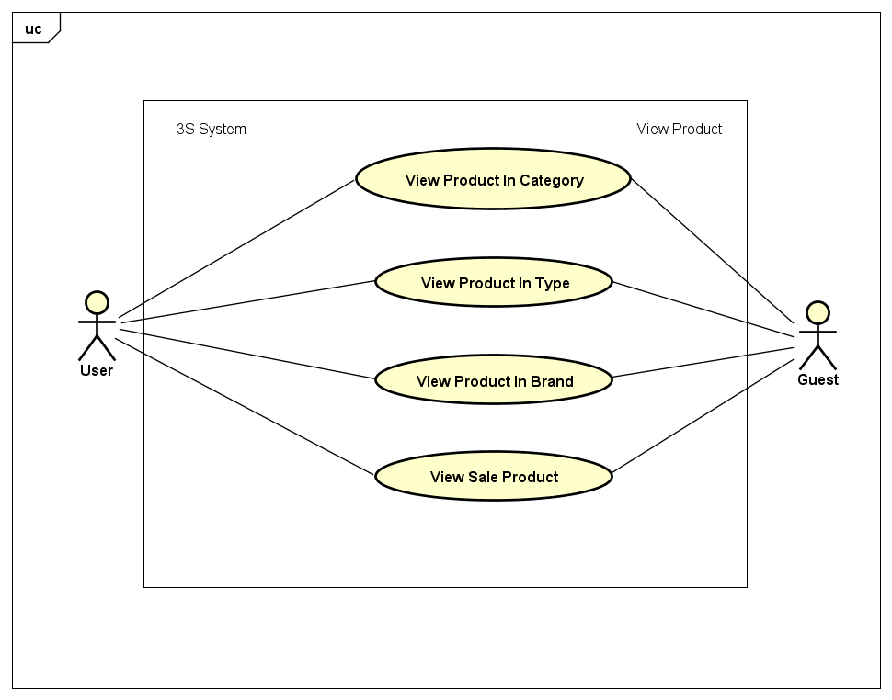

***Figure 3-11:*** *View Product Usecase Diagram*

|  |  |  |  |
| --- | --- | --- | --- |
| UC ID and Name: | **UC-27: View Product In Category** | | |
| Created by: | **ThangND** | Created date: | **Jun 2nd, 2018** |
| Primary Actor: | **User** | Secondary Actor: | **Guest** |
| Trigger: | N/A | | |
| Description: | User who wants to view products in any category. | | |
| Preconditions: | N/A | | |
| Post conditions: | **POST-27.1:** The user will have seen product list of category. | | |
| Normal Flow: | 1. User opens to application. 2. Home screen is displayed. 3. User clicks on “Xem thêm” borderless button in “Danh mục sản phẩm” layout. 4. “Danh mục sản phẩm” screen is displayed. 5. User clicks on any category in category list. 6. “Chủng loại danh mục” screen is displayed with type category list. 7. User clicks on “Tất cả sản phẩm” button which below type category list. 8. “Sản phẩm danh mục” screen is displayed with product listview. | | |
| Alternative Flows: | 1. User opens to application. 2. Home screen is displayed. 3. User clicks on any category in “Danh mục sản phẩm” layout. 4. “Chủng loại danh mục” screen is displayed with type category list. 5. User clicks on “Tất cả sản phẩm” button which below type category list. 6. “Sản phẩm danh mục” screen is displayed with product listview. | | |
| Exceptions: | N/A | | |
| Priority: | High | | |
| Frequency of Use: | High | | |
| Other Information: | N/A | | |
| Assumptions: | Server is stable running.  Internet service is turning on. | | |

|  |  |  |  |
| --- | --- | --- | --- |
| UC ID and Name: | **UC-28: View Product In Type** | | |
| Created by: | **ThangND** | Created date: | **Jun 2nd, 2018** |
| Primary Actor: | **User** | Secondary Actor: | **Guest** |
| Trigger: | N/A | | |
| Description: | User who wants to view products in any type category. | | |
| Preconditions: | N/A | | |
| Post conditions: | **POST-28.1:** The user will have seen product list of type category. | | |
| Normal Flow: | 1. User opens to application. 2. Home screen is displayed. 3. User clicks on “Xem thêm” borderless button in “Danh mục sản phẩm” layout. 4. “Danh mục sản phẩm” screen is displayed. 5. User clicks on any category in category list. 6. “Chủng loại danh mục” screen is displayed with type category list. 7. User clicks on any type category in type category list. 8. “Sản phẩm chủng loại” screen is displayed with product listview in that type category. | | |
| Alternative Flows: | 1. User accesses to application 2. Home screen is displayed 3. User clicks on any category in “Danh mục sản phẩm” layout. 4. “Chủng loại danh mục” screen is displayed with type category list. 5. User clicks on one type category in type category list. 6. “Sản phẩm chủng loại” screen is displayed with product listview in that type category. | | |
| Exceptions: | N/A | | |
| Priority: | High | | |
| Frequency of Use: | High | | |
| Other Information: | N/A | | |
| Assumptions: | Server is stable running.  Internet service is turning on. | | |

|  |  |  |  |
| --- | --- | --- | --- |
| UC ID and Name: | **UC-29: View Product In Brand** | | |
| Created by: | **ThangND** | Created date: | **Jun 2nd, 2018** |
| Primary Actor: | **User** | Secondary Actor: | **Guest** |
| Trigger: | N/A | | |
| Description: | User who wants to view products in any brand. | | |
| Preconditions: | N/A | | |
| Post conditions: | **POST-29.1:** The user will have seen product list of brand. | | |
| Normal Flow: | 1. User opens to application. 2. Home screen is displayed. 3. User clicks on any brand in “Thương hiệu” layout. 4. “Sản phẩm thương hiệu” screen is displayed with product list in that brand. | | |
| Alternative Flows: | 1. User opens to application. 2. Home screen is displayed. 3. User clicks on “Xem thêm” borderless button in “Thương hiệu” layout. 4. “Thương hiệu” screen is displayed with brand list. 5. User clicks on any brand in brnad list. 6. “Sản phẩm thương hiệu” screen is displayed with product list in that brand. | | |
| Exceptions: | N/A | | |
| Priority: | High | | |
| Frequency of Use: | High | | |
| Other Information: | N/A | | |
| Assumptions: | Server is stable running.  Internet service is turning on. | | |

|  |  |  |  |
| --- | --- | --- | --- |
| UC ID and Name: | **UC-30: View Product On Sale** | | |
| Created by: | **ThangND** | Created date: | **Jun 2nd, 2018** |
| Primary Actor: | **User** | Secondary Actor: | **Guest** |
| Trigger: | N/A | | |
| Description: | User who wants to view sale product list. | | |
| Preconditions: | N/A | | |
| Post conditions: | **POST-30.1:** The user will have seen sale product list. | | |
| Normal Flow: | 1. User opens to application. 2. Home screen is displayed. 3. User clicks on “Xem thêm” borderless button in “Sản phẩm giảm giá” layout. 4. “Sản phẩm giảm giá” screen is displayed with sale product list. | | |
| Alternative Flows: | N/A | | |
| Exceptions: | N/A | | |
| Priority: | High | | |
| Frequency of Use: | High | | |
| Other Information: | N/A | | |
| Assumptions: | Server is stable running.  Internet service is turning on. | | |

##### Manage Product In Store

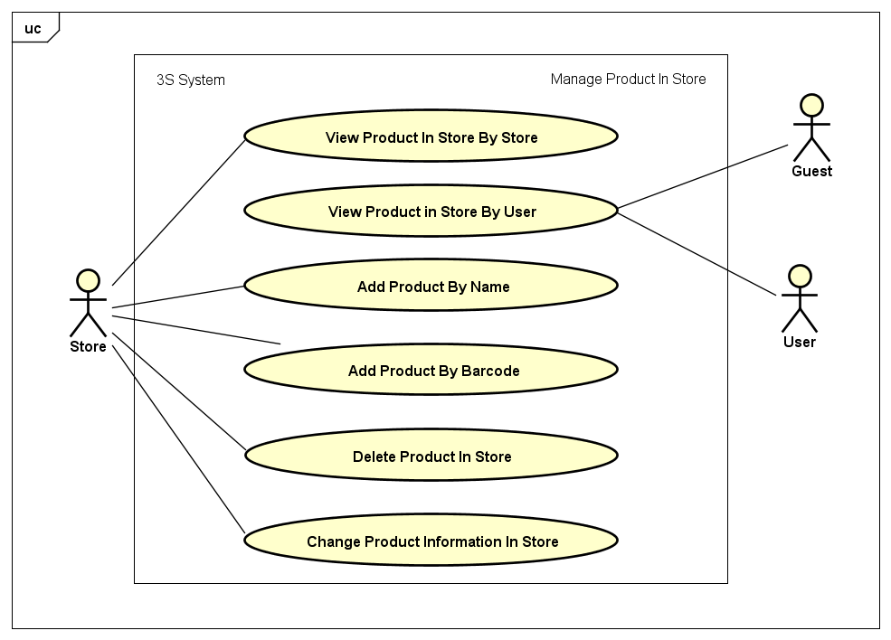

***Figure 3-12:*** *Manage Product in Store Usecase Diagram*

|  |  |  |  |
| --- | --- | --- | --- |
| UC ID and Name: | **UC-31: View Product In Store By Store** | | |
| Created by: | **ThangND** | Created date: | **Jun 2nd, 2018** |
| Primary Actor: | **Store** | Secondary Actor: |  |
| Trigger: | N/A | | |
| Description: | Store wants to view products in store. | | |
| Preconditions: | **PRE-31.1:** The user had logged in to application system  **PRE-31.2:** The user had had a store. | | |
| Post conditions: | **POST-31.1:** The store will have seen products in store. | | |
| Normal Flow: | 1. Store opens to application 2. Home screen is displayed. 3. Store clicks on “Cửa hàng” tab with icon on the center of bottom navigation bar in Home screen.  1. ”Cửa hàng” screen is displayed. 2. Store clicks on “Quản lý sản phẩm” button. 3. “Sản phẩm cửa hàng” screen is displayed with added-to-store product list and “Thêm sản phẩm” button. | | |
| Alternative Flows: | N/A | | |
| Exceptions: | N/A | | |
| Priority: | High | | |
| Frequency of Use: | High | | |
| Other Information: | N/A | | |
| Assumptions: | Server is stable running.  Internet service is turning on. | | |

|  |  |  |  |
| --- | --- | --- | --- |
| UC ID and Name: | **UC-32: View Product In Store By User** | | |
| Created by: | **ThangND** | Created date: | **Jun 2nd, 2018** |
| Primary Actor: | **User** | Secondary Actor: | **Guest** |
| Trigger: | N/A | | |
| Description: | User wants to view products in store. | | |
| Preconditions: | **PRE-32.1:** The user had logged in to application system.  **PRE-32.2:** The user had had a store.  **PRE-32.3:** The user has turned on his/her GPS location service in mobile device.  **PRE-32.4:** The current device has allowed application access GPS service.  **PRE-32.5:** The current device has allowed application access Camera service. | | |
| Post conditions: | **POST-32.1:** The user will have seen products in store. | | |
| Normal Flow: | 1. User opens the application. 2. Home screen is displayed. 3. User clicks on any sale product in “Sản phẩm giảm giá” layout. 4. “Thông tin sản phẩm” screen is displayed. 5. User clicks on store name. 6. “Sản phẩm cửa hàng” screen in User role is displayed. | | |
| Alternative Flows: | 1. User had found nearby store by product after finishing UC-19 or UC-20. 2. User clicks on store name. 3. “Sản phẩm cửa hàng” screen in User role is displayed. | | |
| Exceptions: | N/A | | |
| Priority: | High | | |
| Frequency of Use: | High | | |
| Other Information: | N/A | | |
| Assumptions: | Server is stable running.  Internet service is turning on. | | |

|  |  |  |  |
| --- | --- | --- | --- |
| UC ID and Name: | **UC-33: Add Product By Name** | | |
| Created by: | **ThangND** | Created date: | **Jun 2nd, 2018** |
| Primary Actor: | **Store** | Secondary Actor: |  |
| Trigger: | N/A | | |
| Description: | Store wants to add new product to store category via product name. | | |
| Preconditions: | **PRE-33.1:** The user had logged in to application system.  **PRE-33.2:** The user had had a store. | | |
| Post conditions: | **POST-33.1:** Product will have added to product list in store. | | |
| Normal Flow: | 1. Store opens to application 2. Home screen is displayed. 3. Store clicks on “Cửa hàng” tab with C:\Users\Chamander\AppData\Local\Microsoft\Windows\INetCache\Content.Word\store.png icon on the center of bottom navigation bar in Home screen 4. ”Cửa hàng” screen is displayed. 5. Store clicks on “Quản lý sản phẩm” button. 6. “Sản phẩm cửa hàng” in Store role screen is displayed . 7. Store clicks on “Thêm sản phẩm” button. 8. “Tìm kiếm sản phẩm” screen is displayed. 9. Store clicks on Search button with search icon, enters product name to search bar, then submit. 10. Searched product list which Store had not had yet is displayed. 11. Store clicks on “Thêm vào cửa hàng” button in product description layout. 12. “Đặt giá sản phẩm” dialog is displayed in “Tìm kiếm sản phẩm” screen. 13. Store enters product price to “Giá sản phẩm” field and enters product promotion percent to “Chiết khấu” field. 14. Store clicks on “Thêm tùy chọn”. 15. Confirm dialog is displayed. 16. Store clicks on “Thêm” button to finish adding process. 17. “Thêm sản phẩm thành công” snack bar is displayed in “Tìm kiếm sản phẩm” screen. | | |
| Alternative Flows: | N/A | | |
| Exceptions: | * 1. Product name is not exist in appication database.   2. Invalid product price.   3. Invalid product promotion. | | |
| Priority: | High | | |
| Frequency of Use: | High | | |
| Other Information: | N/A | | |
| Assumptions: | Server is stable running.  Internet service is turning on. | | |

|  |  |  |  |
| --- | --- | --- | --- |
| UC ID and Name: | **UC-34: Add Product By Barcode** | | |
| Created by: | **ThangND** | Created date: | **Jun 2nd, 2018** |
| Primary Actor: | **Store** | Secondary Actor: |  |
| Trigger: | N/A | | |
| Description: | Store wants to add new product to store category via product barcode. | | |
| Preconditions: | **PRE-34.1:** The user had logged in to application system.  **PRE-34.2:** The user had had a store.  **PRE-34.3:** The current device has allowed application access Camera service. | | |
| Post conditions: | **POST-34.1:** Product will have added to product list in store. | | |
| Normal Flow: | 1. Store opens to application. 2. Home screen is displayed. 3. Store clicks on “Cửa hàng” tab with C:\Users\Chamander\AppData\Local\Microsoft\Windows\INetCache\Content.Word\store.png icon on the center of bottom navigation bar in Home screen. 4. ”Cửa hàng” screen is displayed. 5. Store clicks on “Quản lý sản phẩm” button. 6. “Sản phẩm cửa hàng” screen is displayed . 7. Store clicks on “Thêm sản phẩm” button. 8. “Tìm kiếm sản phẩm” screen is displayed. 9. Store clicks on Scan QRCode/ Barcode button with barcode_icon icon. 10. Scan QR code/ barcode screen is displayed. 11. Store scans bar code on product surface. 12. “Tìm kiếm sản phẩm” screen is displayed with search product list which Store had not had yet. 13. Store clicks on “Thêm vào cửa hàng” button in product description layout. 14. “Đặt giá sản phẩm” dialog is displayed in “Tìm kiếm sản phẩm” screen. 15. Store enters product price to “Giá sản phẩm” field and enters product promotion percent to “Chiết khấu” field 16. Store clicks on “Thêm tùy chọn”. 17. Confirm dialog is displayed. 18. Store clicks on “Thêm” button to finish adding process. 19. “Thêm sản phẩm thành công” snack bar is displayed in “Tìm kiếm sản phẩm” screen. | | |
| Alternative Flows: | N/A | | |
| Exceptions: | * 1. Barcode is not exist in appication database.   2. Invalid product price.   3. Invalid product promotion. | | |
| Priority: | High | | |
| Frequency of Use: | Medium | | |
| Other Information: | N/A | | |
| Assumptions: | Server is stable running.  Internet service is turning on. | | |

|  |  |  |  |
| --- | --- | --- | --- |
| UC ID and Name: | **UC-35: Delete Product In Store** | | |
| Created by: | **ThangND** | Created date: | **Jun 2nd, 2018** |
| Primary Actor: | **Store** | Secondary Actor: |  |
| Trigger: | N/A | | |
| Description: | Store wants to delete exist products from product list in store. | | |
| Preconditions: | **PRE-35.1:** The user had logged in to application system  **PRE-35.2:** The user had had a store. | | |
| Post conditions: | **POST-35.1:** Product will have deleted from product list in store. | | |
| Normal Flow: | 1. Store opens to application. 2. Home screen is displayed. 3. Store clicks on “Cửa hàng” tab with icon on the center of bottom navigation bar in Home screen.  1. ”Cửa hàng” screen is displayed. 2. Store clicks on “Quản lý sản phẩm” button. 3. “Sản phẩm cửa hàng” screen is displayed . 4. Store clicks on “Delete” button with deleteicon. 5. Confirm dialog is displayed in “Sản phẩm cửa hàng” screen. 6. Store clicks on “Đồng ý” button. 7. “Xóa sản phẩm thành công” toast message is displayed in “Sản phẩm cửa hàng” screen. | | |
| Alternative Flows: | N/A | | |
| Exceptions: | N/A | | |
| Priority: | Medium | | |
| Frequency of Use: | Low | | |
| Other Information: | N/A | | |
| Assumptions: | Server is stable running.  Internet service is turning on. | | |

|  |  |  |  |
| --- | --- | --- | --- |
| UC ID and Name: | **UC-36: Change Product Information In Store** | | |
| Created by: | **ThangND** | Created date: | **Jun 2nd, 2018** |
| Primary Actor: | **Store** | Secondary Actor: |  |
| Trigger: | N/A | | |
| Description: | Store wants to edit product information . | | |
| Preconditions: | **PRE-36.1:** The user had logged in to application system.  **PRE-36.2:** The user had had a store. | | |
| Post conditions: | **POST-36.1:** That product information will have been changed. | | |
| Normal Flow: | 1. Store opens to application. 2. Home screen is displayed. 3. Store clicks on “Cửa hàng” tab with C:\Users\Chamander\AppData\Local\Microsoft\Windows\INetCache\Content.Word\store.png icon on the center of bottom navigation bar in Home screen. 4. ”Cửa hàng” screen is displayed. 5. Store clicks on “Quản lý sản phẩm” button. 6. “Sản phẩm cửa hàng” screen is displayed . 7. Store clicks on “Edit” button with editicon. 8. “Thay đổi thông tin sản phẩm” screen is displayed. 9. Store enters new product price to “Giá sản phẩm (đ)” field and new product promotion to “chiết khấu (%)” field. 10. Store clicks on “Lưu thay đổi” button. 11. “Thay đổi thông tin sản phẩm thành công” toast message is displayed in “thay đổi thông tin sản phẩm” screen. 12. Redirect to “Sản phẩm cửa hàng” screen . | | |
| Alternative Flows: | N/A | | |
| Exceptions: | 1. Invalid new product price.  2. Invalid new product promation.  3. Product information is not changed. | | |
| Priority: | Medium | | |
| Frequency of Use: | Medium | | |
| Other Information: | N/A | | |
| Assumptions: | Server is stable running.  Internet service is turning on. | | |

##### Order Product

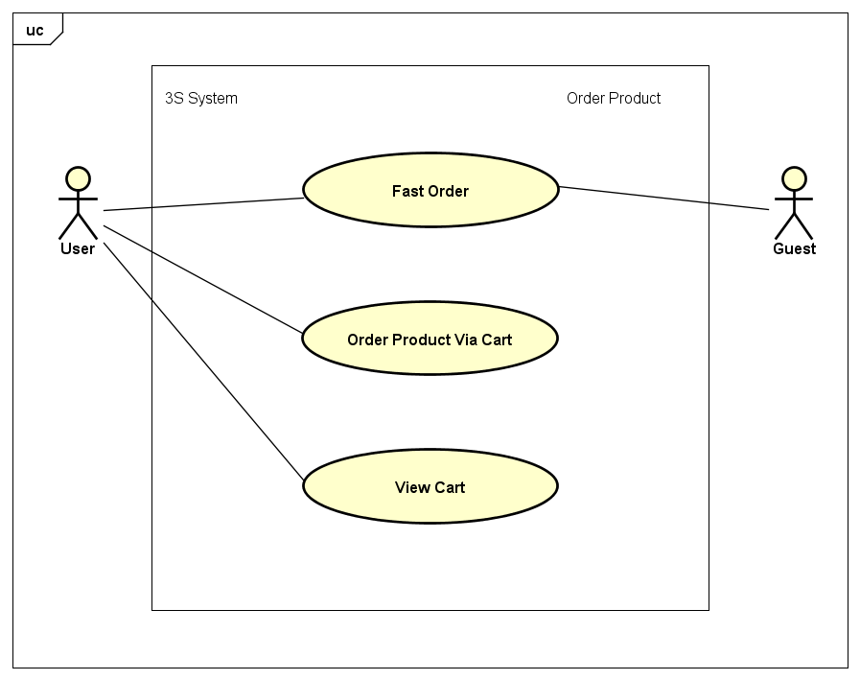

***Figure 3-13:*** *Order Product Usecase Diagram*

|  |  |  |  |
| --- | --- | --- | --- |
| UC ID and Name: | **UC-37: Fast Order** | | |
| Created by: | **ThangND** | Created date: | **Jun 2nd, 2018** |
| Primary Actor: | **User** | Secondary Actor: | **Guest** |
| Trigger: | N/A | | |
| Description: | User wants to order a product via neaby store function. | | |
| Preconditions: | **PRE-37.1:** The user has turned on his/her GPS location service in mobile device.  **PRE-37.2:** The current device has allowed application access GPS service.  **PRE-37.3:** The current device has allowed application access Camera service. | | |
| Post conditions: | **POST-37.1:** That order will have requested to Store. | | |
| Normal Flow: | 1. User had found nearby store by product in UC-19 or UC-20. 2. User clicks on “Đặt hàng” button in store detail layout. 3. “Đặt hàng nhanh” screen is displayed. 4. User chooses number of products. 5. Guest enters name and phone number, but User does not. 6. User chooses delivery time and delivary address. 7. User clicks on “Đặt hàng” button. | | |
| Alternative Flows: | N/A | | |
| Exceptions: | * + - 1. Invalid delivery time.  1. Invalid phone number | | |
| Priority: | Medium | | |
| Frequency of Use: | Medium | | |
| Other Information: | N/A | | |
| Assumptions: | Server is stable running.  Internet service is turning on. | | |

|  |  |  |  |
| --- | --- | --- | --- |
| UC ID and Name: | **UC-38: Order Product Via Cart** | | |
| Created by: | **ThangND** | Created date: | **Jun 2nd, 2018** |
| Primary Actor: | **User** | Secondary Actor: |  |
| Trigger: | N/A | | |
| Description: | User wants to order a product via shopping cart. | | |
| Preconditions: | **PRE-38.1:** The user had logged in to application system.  **PRE-38.2:** The user has turned on his/her GPS location service in mobile device.  **PRE-38.3:** The current device has allowed application access GPS service.  **PRE-38.4:** The current device has allowed application access Camera service.  **PRE-38.5:** The cart must have at least 1 product. | | |
| Post conditions: | **POST-38.1:** That order will have requested to Store. | | |
| Normal Flow: | 1. User had accessed “Giỏ hàng” screen after finishing UC-36. 2. User clicks on “Mua hàng” button. 3. “Đặt hàng” screen is displayed. 4. User chooses delivery time and delivary address for all order from cart. 5. User clicks on “Đặt hàng” button. 6. User chooses delivery time and delivary address. 7. User clicks on “Đặt hàng” button. | | |
| Alternative Flows: | 1. User had accessed “Giỏ hàng” screen after finishing UC-36. 2. User chooses store to checkout order in that store. 3. “Đặt hàng” screen is displayed. 4. User chooses delivery time and delivary address for chosen order. 5. User clicks on “Đặt hàng” button. 6. User chooses delivery time and delivary address. 7. User clicks on “Đặt hàng” button. | | |
| Exceptions: | Invalid delivery time. | | |
| Priority: | Medium | | |
| Frequency of Use: | Medium | | |
| Other Information: | N/A | | |
| Assumptions: | Server is stable running.  Internet service is turning on. | | |

|  |  |  |  |
| --- | --- | --- | --- |
| UC ID and Name: | **UC-39: View Cart** | | |
| Created by: | **ThangND** | Created date: | **Jun 2nd, 2018** |
| Primary Actor: | **User** | Secondary Actor: |  |
| Trigger: | N/A | | |
| Description: | User wants to view his / her shopping cart. | | |
| Preconditions: | **PRE-39.1:** The user had logged in to application system.  **PRE-39.2:** The cart must have at least 1 product. | | |
| Post conditions: | N/A | | |
| Normal Flow: | 1. User opens the application. 2. Home screen is displayed. 3. User clicks on “Người dùng” tab with icon on the right of bottom navigation bar in Home screen.  1. ”Người dùng” screen is displayed user information function form 2. User clicks on “Giỏ hàng” layout button. 3. “Giỏ hàng” screen is displayed. | | |
| Alternative Flows: | 1. User had accessed “Giỏ hàng” screen after finishing UC-36. 2. User chooses store to checkout order in that store. 3. “Đặt hàng” screen is displayed. 4. User chooses delivery time and delivary address for chosen order. 5. User clicks on “Đặt hàng” button. | | |
| Exceptions: | Invalid delivery time. | | |
| Priority: | Medium | | |
| Frequency of Use: | Medium | | |
| Other Information: | N/A | | |
| Assumptions: | Server is stable running.  Internet service is turning on. | | |

#### Manage Feedback

***Figure 3-14:*** *Manage Feedback Usecase Diagram*

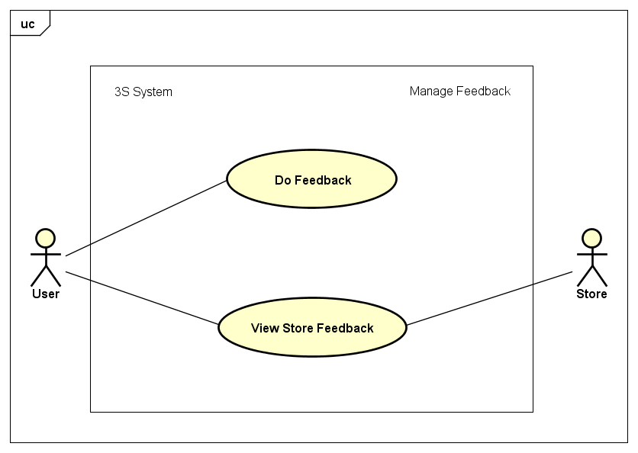

##### Do Feedback

|  |  |  |  |
| --- | --- | --- | --- |
| UC ID and Name: | **UC-40: Do Feedback** | | |
| Created by: | **ThangND** | Created date: | **Jun 1st, 2018** |
| Primary Actor: | **User** | Secondary Actor: |  |
| Trigger: | N/A | | |
| Description: | User wants to rate and feedback Store’s quality service | | |
| Preconditions: | **PRE-40.1:** The user had logged in to application system.  **PRE-40.2:** The user has at least 1 done order.  **PRE-40.3:** That order has not been rated before. | | |
| Post conditions: | **POST-40.1:** That feedback will have been sent to Store | | |
| Normal Flow: | 1. User acccesses on “Đơn hàng của tôi” screen. 2. “Quản lý đơn hàng” screen in User role is displayed with a order list with order information and function buttons. 3. User clicks on “Đánh giá” button in done order detail layout. 4. User enters feedback content form. 5. User chooses satisfied or dissatisfied by click on icon smile or sad. 6. User clicks on “Gửi phản hồi” button. 7. User clicks on “Đồng ý” button in confirm dialog. | | |
| Alternative Flows: | N/A | | |
| Exceptions: | N/A | | |
| Priority: | High | | |
| Frequency of Use: | Medium | | |
| Other Information: | N/A | | |
| Assumptions: | Server is stable running.  Internet service is turning on. | | |

##### View Store Feedback

|  |  |  |  |
| --- | --- | --- | --- |
| UC ID and Name: | **UC-41: View Store Feedback** | | |
| Created by: | **ThangND** | Created date: | **Jun 1st, 2018** |
| Primary Actor: | **Store** | Secondary Actor: | **User** |
| Trigger: | N/A | | |
| Description: | User / Store wants to view store’s feedback hítory | | |
| Preconditions: | **PRE-41.1:** The user had logged in to application system. | | |
| Post conditions: | N/A | | |
| Normal Flow: | <For Store role>   1. Store acccesses on “Cửa hàng” screen. 2. Store clicks on “Xem đánh giá” button. 3. “Đánh giá về cửa hàng” screen is displayed with a feedback list. | | |
| Alternative Flows: | <For User role>   * 1. User acccesses on “Sản phẩm cửa hàng” screen.   2. User clicks on store name.   3. “Thông tin cửa hàng” screen is displayed.   4. User clicks on “Xem đánh giá” button.   5. “Đánh giá về cửa hàng” screen is displayed with a feedback list. | | |
| Exceptions: | N/A | | |
| Priority: | High | | |
| Frequency of Use: | Medium | | |
| Other Information: | N/A | | |
| Assumptions: | Server is stable running.  Internet service is turning on. | | |

### Software System Attributes

#### Reliability

* Some operate under predefined conditions:
  + No Internet: Some information is still show, display screen no internet.
  + The network is disconnected while in use: Notify the user of the disconnection issue.
  + The permission to user GPS service rejected by the user: Some functions can’t be used.

#### Availability

* The application should be available anytime users want to use it.
* Usage frequency: Daily.
* User try logging in 1 account to 2 devides simultaneously, application system will notify and eject the account of device
* Time needed to update the software: Depends on the update and will be notified in detail.

#### Security

* Server has ability to detect DDoS attacks.
* User account password is encrypted by MD5 library when interacting between client and server.
* User access is controlled by account and password system.

#### Maintainability

* It is easy to maintain or change the system due to the fact that it is divided into small parts with the person responsible for each part.
* Server should be developed based on Object Oriented Programming paradigm in order to increase maintainability and extensibility.
* Android application uses MVC model, modular software and component-based development.

#### Portability

* The Android platform offers high portability and flexibility for the application.
* Use Firebase storage provides the convenience of storing photos or files.

#### Performance

* Application front-end uses clever techniques of Glider which is a Google library for Android to minimize the number of costly DOM operations required to update user interface
* Load time of single screen is not more than 3 seconds in standard network environment.

#### Privacy

* Application request access permission before using service in user’s current device
* Users can disallow the access permission in current device

### Software Entity Relationship Diagram or Data Structures

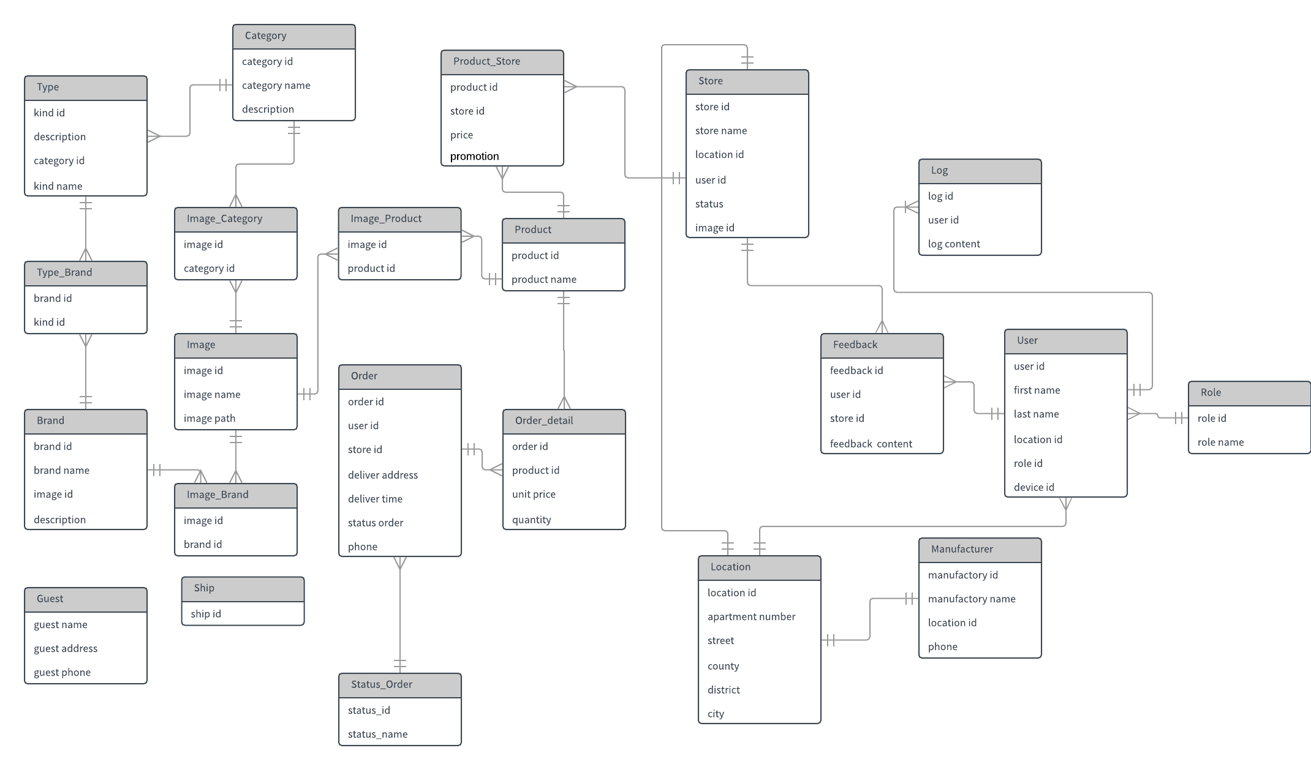

***Figure 3-1:*** *Software Entity Relationship*

# Software Design Description (SDD)

## Purpose

* This chapter is to give the develop team of what the system’s architecture is, and how it should be implemented. Software Design Specification consists of:
  + Design Overview
  + System Architecture Design
  + Component Diagram
  + Sequence Diagram
  + Class Diagram
  + User Interface Design
  + Database Design

## Design Overview

## System Architecture Design

### Choice of System Architecture

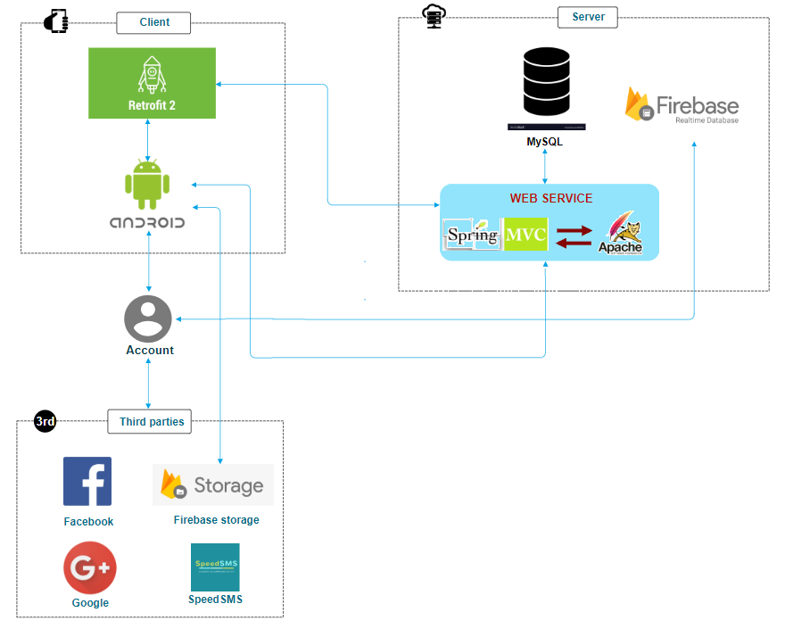

***Figure 4-1 :*** *Architecture Design*

### System architecture explanation

* + Retrofit 2: Automatically convert JSON to Java objects.
  + MySQL: easy to use.
  + Spring MVC: Spring MVC provides a very clean division between controllers, JavaBean models, and views.
  + Firebase: Firebase NoSQL cloud provides a database for real-time applications as a service. This service provides an API for developers, lets you synchronize data and store it in the Firebase cloud.
  + Android platform:
    - Open Source: The Android platform for app development is open source which means it is royalty-free and isn’t restricted to just the Android Market. This gives a lot of liberty and freedom to innovate and be creative. The SDK architecture is a major advantage that permits you to communicate with the community on future expansions of mobile app development. You can install Android apps from any source that increases the possibilities of the platform.
    - Pro-active Testing: The integration of the platform is easy and the SDK lets you install & run your app on the device each time you compile.
    - Popular Platform: 84.7% of mobile devices are based on the Android platform creating a lot of scope for app development’s bright future.
  + Speed SMS: interacts with Retrofit Client.

## Component diagram

### Component diagram of front-end

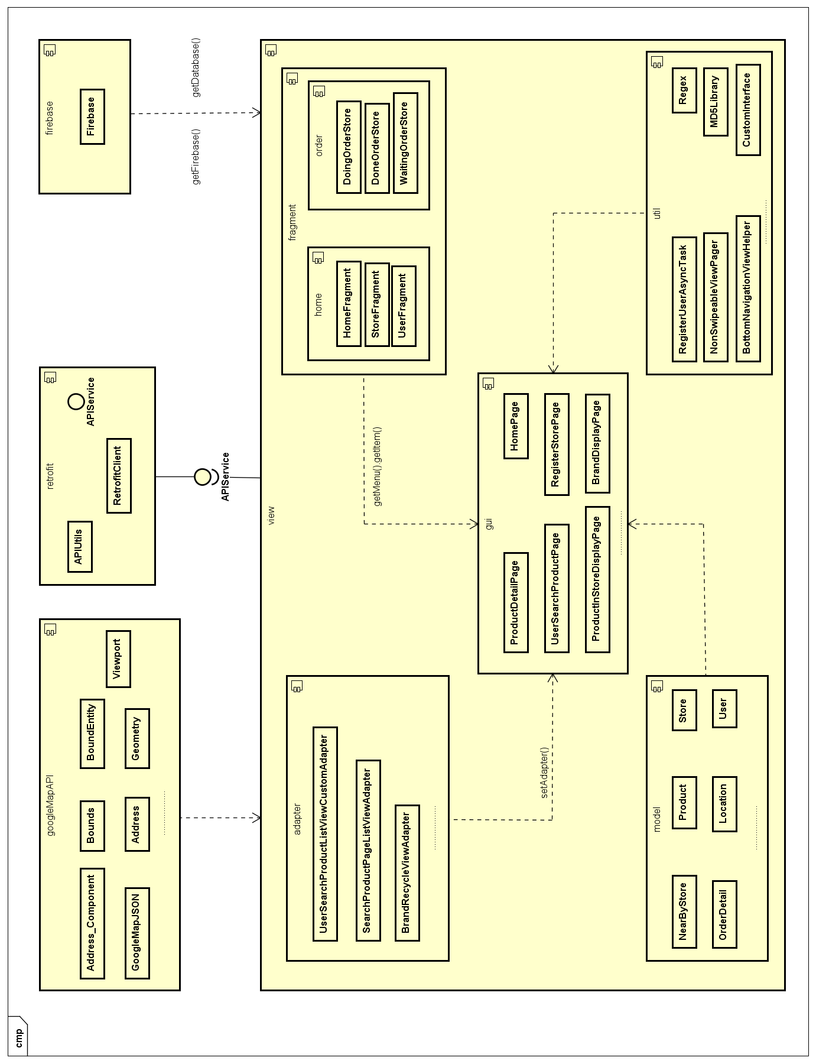

***Figure 4-3 :*** *Front-end Component Diagram*

### Component diagram of back-end

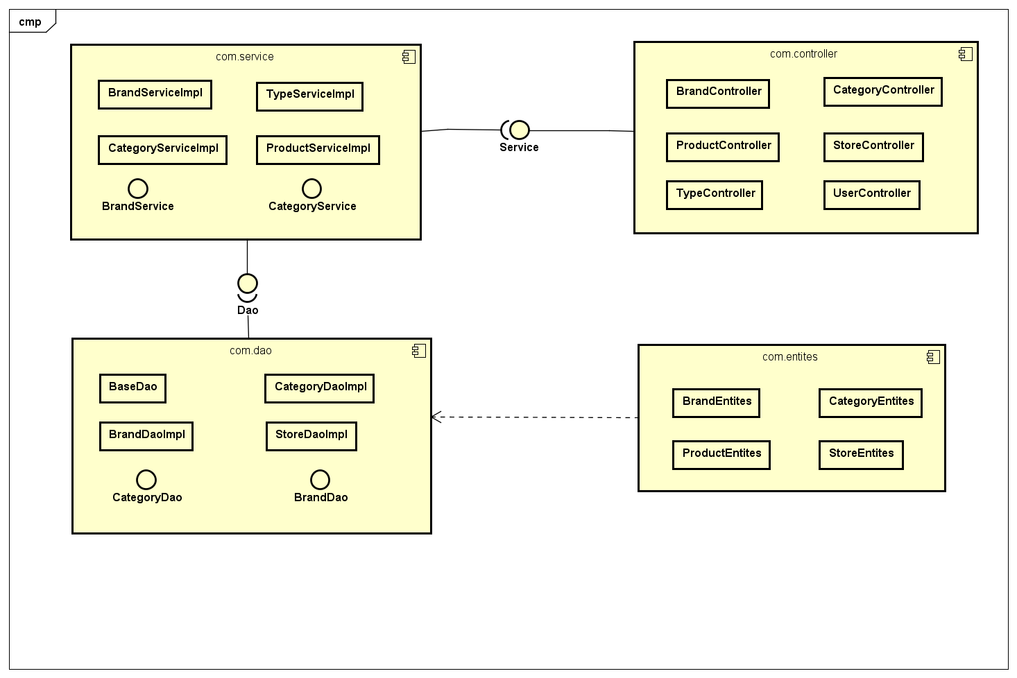

***Figure 4-3 :*** *Back-end Component Diagram*

## Detailed Description of Components

### CRC Cards (Class-Responsibility Collaborators)

|  |  |
| --- | --- |
| **Item** | |
| product\_id  product\_name  brand\_name  description  category\_name  type\_name  image\_path  price  promotion | CategoryDisplayPage  APIService  SearchProductAddToStore  SearchProductPageListViewAdapter |

|  |  |
| --- | --- |
| **CategoryDisplayPage** | |
| recyclerView  adapter  categoryList  apiService  loadingBar  imgBack  imgBarCode  searchedProduct | Category  APIService  CategoryCustomCardviewAdapter |

|  |  |
| --- | --- |
| **OrderDetail** | |
| orderCode  productName  quantity  orderDate  name  phoneNumber  address  price  storeName  storeId | OrderPage |

*CRC Cards examples*

* + The attached file is available in below link : <https://drive.google.com/file/d/1Ko4j_Nfe7JbFtcz3R6vNvNyavgvTiNMR/view>

### Class Diagram

#### Class Diagram

##### Login

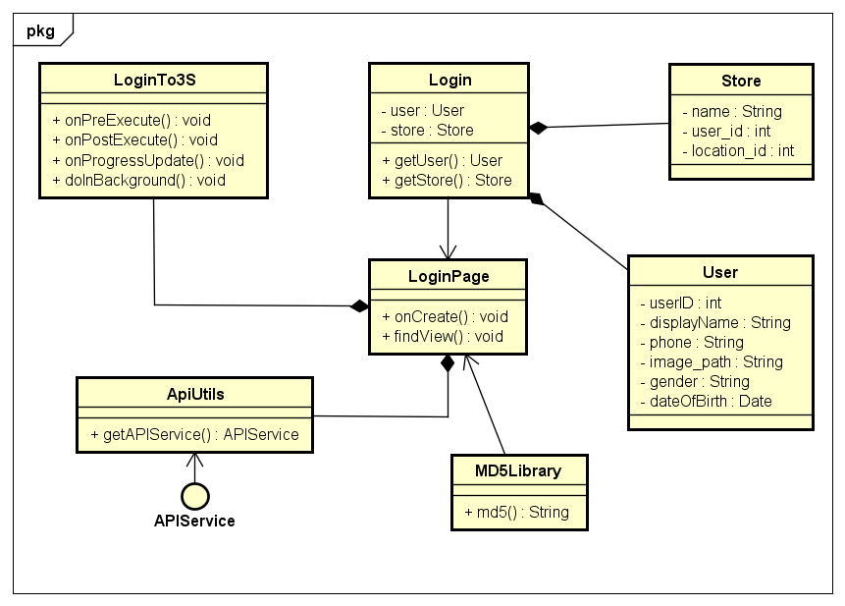

***Figure 4-4 :*** *Login Class Diagram*

|  |  |  |  |  |
| --- | --- | --- | --- | --- |
| **Class** | **User** | | | |
| Description | Object contains user information | | | |
| Base Class | Serializable | | | |
| Constructor | User()  User(int id, String name, String img)  User (int userId) | | | |
| Prototype | N/A | | | |
| Source File | User.java | | | |
| Package | Project.model | | | |
| **Attribute** | **Name** | **Type** | **Description** | |
| userID | int | Id of user | |
| firstName | String | First name of user | |
| lastName | String | Last name of user | |
| phone | String | Phone number of user | |
| deviceId | String | Id of current mobile device | |
| gender | String | Gender of user | |
| image\_path | String | User image path | |
| dateOfBirth | String | DOB of user | |
| email | String | Email of user | |
| username | String | Login username of user | |
| roleId | String | Role of user | |
| hasStore | int | User has store or not | |
| password | String | Login password of user | |
| displayName | String | Display name of user | |
| **Method** | **Name** | **Output** | **Input** | **Description** |
| toString | String | N/A | N/A |

|  |  |  |  |  |
| --- | --- | --- | --- | --- |
| **Class** | **Store** | | | |
| Description | Object contains store information | | | |
| Base Class | Serializable | | | |
| Constructor | Store()  Store(int id,String name, String phone,String image\_path) | | | |
| Prototype | N/A | | | |
| Source File | Store.java | | | |
| Package | Project.model | | | |
| **Attribute** | **Name** | **Type** | **Description** | |
| name | String | Name of store | |
| user\_id | int | Id of store owner | |
| location\_id | int | Id of store location | |
| address | String | Address of store | |
| longtitude | String | Longtitude in map of store | |
| latitude | String | Latitude in map of store | |
| phone | String | Phone number of store | |
| image\_path | String | Store avatar image path | |
| id | int | Id of store | |
| status | int | Store is closed or not | |
| registerLog | String | Register date of store | |
| user\_name | String | Name of store owner | |
| **Method** | **Name** | **Output** | **Input** | **Description** |
| toString | String | N/A | N/A |

|  |  |  |  |  |
| --- | --- | --- | --- | --- |
| **Class** | **Login** | | | |
| Description | Object contains login session information | | | |
| Base Class | Serializable | | | |
| Constructor | Login() | | | |
| Prototype | N/A | | | |
| Source File | Login.java | | | |
| Package | Project.model | | | |
| **Attribute** | **Name** | **Type** | **Description** | |
| user | User | N/A | |
| store | Store | N/A | |
| **Method** | **Name** | **Output** | **Input** | **Description** |
| N/A | N/A | N/A | N/A |

|  |  |  |  |  |
| --- | --- | --- | --- | --- |
| **Class** | **MD5Library** | | | |
| Description | Class includes functions to support in encrypting account password | | | |
| Base Class | N/A | | | |
| Constructor | MD5Library() | | | |
| Prototype | N/A | | | |
| Source File | MD5Library | | | |
| Package | Project.view.util | | | |
| **Attribute** | **Name** | **Type** | **Description** | |
| N/A | N/A | N/A | |
| **Method** | **Name** | **Output** | **Input** | **Description** |
| md5 | String | String | N/A |

|  |  |  |  |  |
| --- | --- | --- | --- | --- |
| **Class** | **LoginTo3S** | | | |
| Description | Asynctask supports asynchronize login and get data from server | | | |
| Base Class | Asynctask | | | |
| Constructor | LoginTo3S() | | | |
| Prototype | N/A | | | |
| Source File | LoginPage.java | | | |
| Package | Project.view.gui | | | |
| **Attribute** | **Name** | **Type** | **Description** | |
| N/A | N/A | N/A | |
| **Method** | **Name** | **Output** | **Input** | **Description** |
| onPreExecute | void | N/A | N/A |
| onProgressUpdate | void | Void… | N/A |
| doInBackground | Login | Call… | N/A |
| onPostExecute | void | Login | N/A |

|  |  |  |  |  |
| --- | --- | --- | --- | --- |
| **Class** | **ApiUtils** | | | |
| Description | Create Retrofit client | | | |
| Base Class | N/A | | | |
| Constructor | ApiUtils() | | | |
| Prototype | N/A | | | |
| Source File | ApiUtils.java | | | |
| Package | Project.retrofit | | | |
| **Attribute** | **Name** | **Type** | **Description** | |
| BASE\_URL | String | N/A | |
| BASE\_URL\_GOOGLE\_MAP | String | N/A | |
| **Method** | **Name** | **Output** | **Input** | **Description** |
| getAPIService | APIService | N/A | N/A |
| getAPIServiceMap | APIService | N/A | N/A |

|  |  |  |  |  |
| --- | --- | --- | --- | --- |
| **Class** | **LoginPage** | | | |
| Description | Activity of “Đăng nhập” screen | | | |
| Base Class | BasePage  AppCompatActivity | | | |
| Constructor | LoginPage() | | | |
| Prototype | N/A | | | |
| Source File | LoginPage.java | | | |
| Package | Project.view.gui | | | |
| **Attribute** | **Name** | **Type** | **Description** | |
| scroll | ScrollView | N/A | |
| loginBtn | Button | N/A | |
| loginFBBtn | Button | N/A | |
| loginGPBtn | Button | N/A | |
| toForgetPasswordPage | TextView | N/A | |
| toRegisterPage | TextView | N/A | |
| errorMessage | TextView | N/A | |
| usernameValue | TextView | N/A | |
| passwordValue | TextView | N/A | |
| mAPI | APIService | N/A | |
| callbackManager | CallbackManager | N/A | |
| loadingBar | ProgressBar | N/A | |
| main\_layout | RelativeLayout | N/A | |
| database | FirebaseDatabase | N/A | |
| myRef | DatabaseReference | N/A | |
| mGoogleSignInClient | GoogleSignInClient | N/A | |
| RX\_SIGN\_IN | int | request code to Google+ signin | |
| **Method** | **Name** | **Output** | **Input** | **Description** |
| onCreate | void | Bundle | N/A |
| findView | void | N/A | N/A |
| savingPreferences | Login | User, Store | N/A |
| configGoogleLogin | void | N/A | N/A |
| signIn | void | N/A | N/A |

##### Manage Account

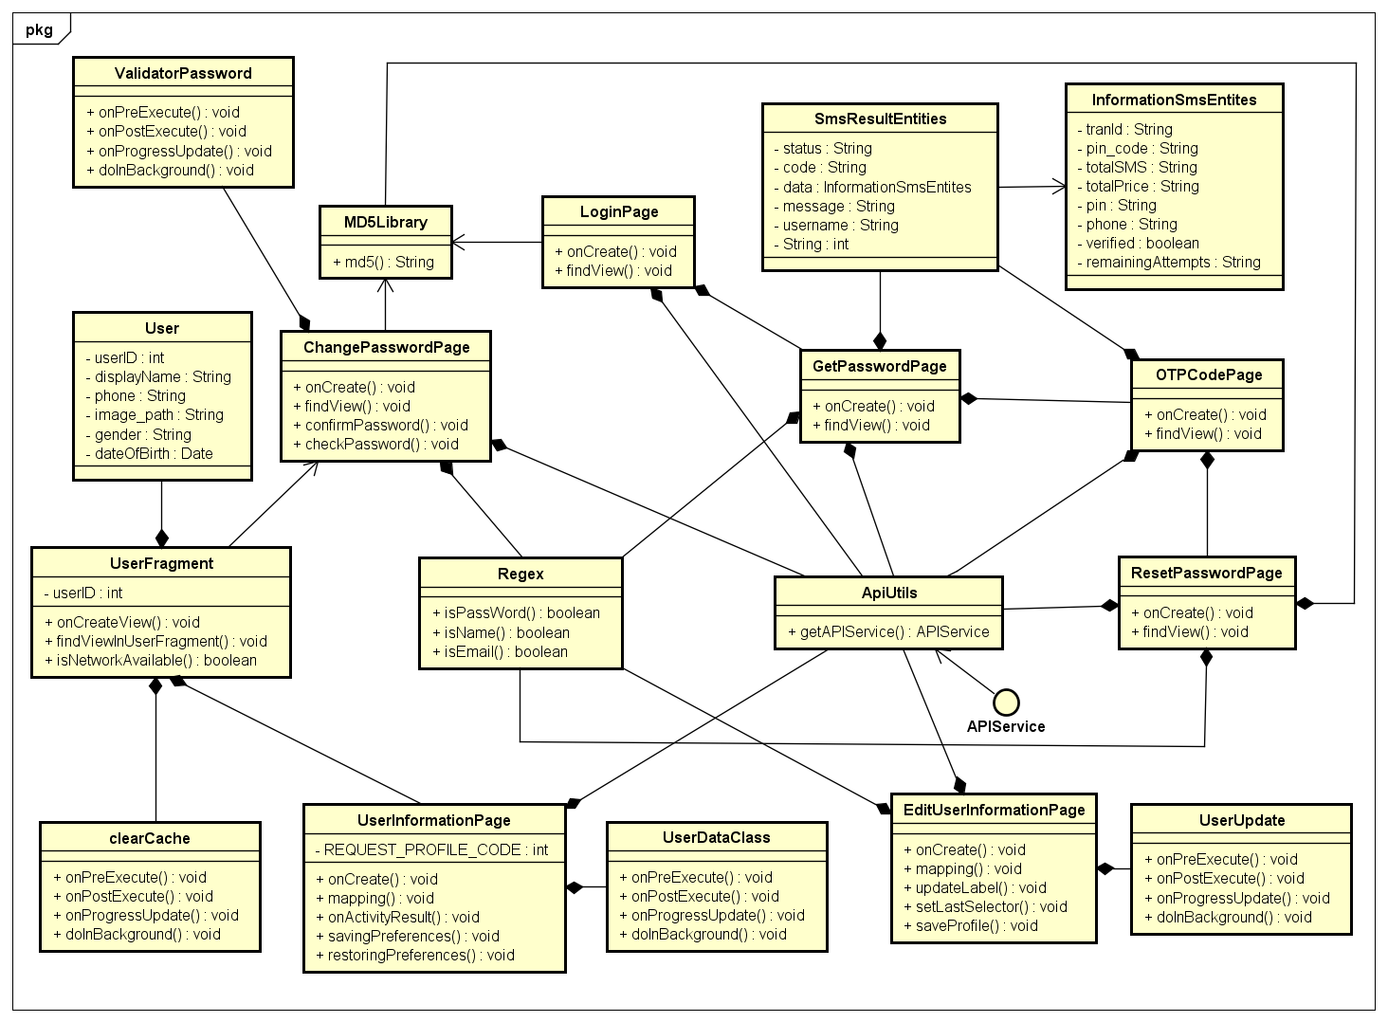

***Figure 4-5 :*** *Manage Account Class Diagram*

|  |  |  |  |  |
| --- | --- | --- | --- | --- |
| **Class** | **UserFragment** | | | |
| Description | Fragment of “Người dùng” screen in Home Activity | | | |
| Base Class | Fragment  NetworkStateReceiver.NetworkStateReceiverListener | | | |
| Constructor | UserFragment() | | | |
| Prototype | N/A | | | |
| Source File | UserFragment.java | | | |
| Package | Project.view.fragment.home | | | |
| **Attribute** | **Name** | **Type** | **Description** | |
| view | View | N/A | |
| toolbar | Toolbar | N/A | |
| btnLogout | Button | N/A | |
| loginBtn | Button | N/A | |
| tvUserName | TextView | N/A | |
| profile\_image | CircleImageView | N/A | |
| changePasswordLayout | LinearLayout | N/A | |
| userInfoLayout | LinearLayout | N/A | |
| cartLayout | LinearLayout | N/A | |
| orderLayout | LinearLayout | N/A | |
| userID | int | Id of user | |
| storageReference | StorageReference | N/A | |
| fullName | String | Name of user | |
| userAvatarPath | String | User avatar image path | |
| user | User | Object user | |
| **Method** | **Name** | **Output** | **Input** | **Description** |
| onCreateView | void | LayoutInflater, ViewGroup, Bundle | N/A |
| findViewInUserFragment | void | N/A | N/A |
| findViewInNotLoginnedLayout | void | N/A | N/A |

|  |  |  |  |  |
| --- | --- | --- | --- | --- |
| **Class** | **ClearCache** | | | |
| Description | Asynctask supports asynchronize logout and clean cache in device | | | |
| Base Class | Asynctask | | | |
| Constructor | ClearCache() | | | |
| Prototype | N/A | | | |
| Source File | ClearCache.java | | | |
| Package | Project.view.fragment.home | | | |
| **Attribute** | **Name** | **Type** | **Description** | |
| N/A | N/A | N/A | |
| **Method** | **Name** | **Output** | **Input** | **Description** |
| onPreExecute | void | N/A | N/A |
| doInBackground | Void | Void… | N/A |
| onPostExecute | void | Void | N/A |
| onProgressUpdate | void | Void… | N/A |

|  |  |  |  |  |
| --- | --- | --- | --- | --- |
| **Class** | **ChangePasswordPage** | | | |
| Description | Activity of “Thay đổi mật khẩu” screen | | | |
| Base Class | BasePage  AppCompatActivity | | | |
| Constructor | ChangePasswordPage() | | | |
| Prototype | N/A | | | |
| Source File | ChangePasswordPage.java | | | |
| Package | Project.view.gui | | | |
| **Attribute** | **Name** | **Type** | **Description** | |
| N/A | N/A | N/A | |
| btnChangePass | Button | N/A | |
| tvOldPass | TextView | N/A | |
| tvConfirmPass | TextView | N/A | |
| tvNewPass | TextView | N/A | |
| oldPass | TextInputEditText | N/A | |
| newPass | TextInputEditText | N/A | |
| confirmPass | TextInputEditText | N/A | |
| etPasswordLayout | TextInputLayout | N/A | |
| loadingBar | ProgressBar | N/A | |
| main\_layout | RelativeLayout | N/A | |
| apiService | APIService | N/A | |
| username | String | Login username of user | |
| regex | Regex | N/A | |
| isNewPass | boolean | is new password or not | |
| isOldPass | boolean | is old password or not | |
| isConfirm | boolean | is confirm password or not | |
| checkPassword | boolean | password is valid or not | |
| **Method** | **Name** | **Output** | **Input** | **Description** |
| onCreate | void | Bundle | N/A |
| customView | void | N/A | N/A |
| findView | void | N/A | N/A |

|  |  |  |  |  |
| --- | --- | --- | --- | --- |
| **Class** | **ValidatorPassword** | | | |
| Description | Asynctask supports asynchronize get account password from server and validate | | | |
| Base Class | Asynctask | | | |
| Constructor | ValidatorPassword() | | | |
| Prototype | N/A | | | |
| Source File | ChangePasswordPage.java | | | |
| Package | Project.view.gui | | | |
| **Attribute** | **Name** | **Type** | **Description** | |
| N/A | N/A | N/A | |
| **Method** | **Name** | **Output** | **Input** | **Description** |
| onPreExecute | void | N/A | N/A |
| doInBackground | User | Call... | N/A |
| onPostExecute | void | User | N/A |
| onProgressUpdate | void | Void… | N/A |

|  |  |  |  |  |
| --- | --- | --- | --- | --- |
| **Class** | **UserInformationPage** | | | |
| Description | Activity of “Thông tin người dùng” screen | | | |
| Base Class | BasePage  AppCompatActivity | | | |
| Constructor | UserInformationPage() | | | |
| Prototype | N/A | | | |
| Source File | UserInformationPage.java | | | |
| Package | Project.view.gui | | | |
| **Attribute** | **Name** | **Type** | **Description** | |
| txtName | TextView | N/A | |
| txtPhone | TextView | N/A | |
| txtEmail | TextView | N/A | |
| txtGender | TextView | N/A | |
| txtDob | TextView | N/A | |
| btnBack | ImageView | N/A | |
| btnEditInfo | Button | N/A | |
| REQUEST\_PROFILE\_CODE | int | request code from EditUserInformationPage | |
| apiService | APIService | N/A | |
| nameDisplay | String | N/A | |
| **Method** | **Name** | **Output** | **Input** | **Description** |
| onCreate | void | Bundle | N/A |
| mapping | void | N/A | N/A |

|  |  |  |  |  |
| --- | --- | --- | --- | --- |
| **Class** | **UserDataClass** | | | |
| Description | Asynctask supports asynchronize get user information from server | | | |
| Base Class | Asynctask | | | |
| Constructor | UserDataClass() | | | |
| Prototype | N/A | | | |
| Source File | UserInformationPage.java | | | |
| Package | Project.view.gui | | | |
| **Attribute** | **Name** | **Type** | **Description** | |
| N/A | N/A | N/A | |
| **Method** | **Name** | **Output** | **Input** | **Description** |
| onPreExecute | void | N/A | N/A |
| doInBackground | Void | Call... | N/A |
| onPostExecute | void | Void | N/A |
| onProgressUpdate | void | User... | N/A |

|  |  |  |  |  |
| --- | --- | --- | --- | --- |
| **Class** | **SmsResultEntities** | | | |
| Description | Object contains OPT result code SMS information | | | |
| Base Class | Serializable | | | |
| Constructor | SmsResultEntities() | | | |
| Prototype | N/A | | | |
| Source File | SmsResultEntities.java | | | |
| Package | Project.view.model | | | |
| **Attribute** | **Name** | **Type** | **Description** | |
| status | String | Status of SMS | |
| code | String | Code of SMS | |
| message | String | Message content of SMS | |
| username | String | Name of user | |
| phoneUser | String | Phone number of user | |
| data | InformationSmsEntites | Information of SMS | |
| **Method** | **Name** | **Output** | **Input** | **Description** |
| N/A | N/A | N/A | N/A |

|  |  |  |  |  |
| --- | --- | --- | --- | --- |
| **Class** | **InformationSmsEntites** | | | |
| Description | Object contains sending OPT SMS information | | | |
| Base Class | Serializable | | | |
| Constructor | InformationSmsEntites() | | | |
| Prototype | N/A | | | |
| Source File | InformationSmsEntites.java | | | |
| Package | Project.view.model | | | |
| **Attribute** | **Name** | **Type** | **Description** | |
| pin\_code | String | Code of verifying | |
| tranId | String | Status of SMS | |
| totalSMS | String | Total of received SMS | |
| totalPrice | String | Total of price | |
| pin | String | Code which user enter to verify | |
| phone | String | Phone number of user | |
| verified | boolean | is verified or not | |
| remainingAttempts | String | wrong code enter number | |
| **Method** | **Name** | **Output** | **Input** | **Description** |
| N/A | N/A | N/A | N/A |

|  |  |  |  |  |
| --- | --- | --- | --- | --- |
| **Class** | **GetPasswordPage** | | | |
| Description | Activity of “Đặt lại mật khẩu” screen | | | |
| Base Class | AppCompatActivity | | | |
| Constructor | GetPasswordPage() | | | |
| Prototype | N/A | | | |
| Source File | GetPasswordPage.java | | | |
| Package | Project.view.gui | | | |
| **Attribute** | **Name** | **Type** | **Description** | |
| main\_layout | RelativeLayout | N/A | |
| tvSendCodeMess | TextView | N/A | |
| etUsername | TextInputEditText | N/A | |
| btn | Button | N/A | |
| apiService | APIService | N/A | |
| **Method** | **Name** | **Output** | **Input** | **Description** |
| onCreate | void | Bundle | N/A |
| findView | void | N/A | N/A |

|  |  |  |  |  |
| --- | --- | --- | --- | --- |
| **Class** | **OTPCodePage** | | | |
| Description | Activity of “Nhập mã xác thực SMS” screen | | | |
| Base Class | AppCompatActivity | | | |
| Constructor | OTPCodePage() | | | |
| Prototype | N/A | | | |
| Source File | OTPCodePage.java | | | |
| Package | Project.view.gui | | | |
| **Attribute** | **Name** | **Type** | **Description** | |
| main\_layout | RelativeLayout | N/A | |
| rela | RelativeLayout | N/A | |
| etCode | TextInputEditText | N/A | |
| tvConfirmCodeMess | TextView | N/A | |
| tvResend | TextView | N/A | |
| btn | Button | N/A | |
| isCode | Boolean | is verified code or not | |
| username | String | Login username of user | |
| code | String | Verified code number | |
| phone | String | Phone number of user | |
| **Method** | **Name** | **Output** | **Input** | **Description** |
| onCreate | void | Bundle | N/A |
| findView | void | N/A | N/A |

|  |  |  |  |  |
| --- | --- | --- | --- | --- |
| **Class** | **EditUserInformationPage** | | | |
| Description | Activity of “Thay dổi thông tin người dùng” screen | | | |
| Base Class | BasePage  AppCompatActivity | | | |
| Constructor | EditUserInformationPage() | | | |
| Prototype | N/A | | | |
| Source File | EditUserInformationPage.java | | | |
| Package | Project.view.gui | | | |
| **Attribute** | **Name** | **Type** | **Description** | |
| userNameText | EditText | N/A | |
| phoneText | EditText | N/A | |
| emailText | EditText | N/A | |
| dobText | EditText | N/A | |
| usernameError | TextView | N/A | |
| phoneError | TextView | N/A | |
| emailError | TextView | N/A | |
| dobError | TextView | N/A | |
| saveBtn | Button | N/A | |
| cancelBtn | Button | N/A | |
| backBtn | ImageButton | N/A | |
| genderSpinner | Spinner | N/A | |
| profile\_image | CircleImageView | N/A | |
| myCalendar | Calendar | N/A | |
| extras | Bundle | N/A | |
| main\_layout | RelativeLayout | N/A | |
| genderName | String[] | N/A | |
| storeUser | String | N/A | |
| mApi | APIService | N/A | |
| pre | SharedPreferences | N/A | |
| changeImageLayout | LinearLayout | N/A | |
| IMAGE\_CODE | int | Request code to change avatar | |
| imageURI | Uri | User avatar image path | |
| us | User | Object User | |
| checkCall | boolean | is call or not | |
| **Method** | **Name** | **Output** | **Input** | **Description** |
| onCreate | void | N/A | N/A |
| openGalery | void | N/A | N/A |
| mapping | void | N/A | N/A |
| getIncomingIntent | void | N/A | N/A |
| updateLabel | void | N/A | N/A |
| setLastSelector | void | N/A | N/A |
| saveProfile | void | View | N/A |

|  |  |  |  |  |
| --- | --- | --- | --- | --- |
| **Class** | **UserUpdate** | | | |
| Description | Asynctask supports asynchronize update user information data | | | |
| Base Class | Asynctask | | | |
| Constructor | UserUpdate() | | | |
| Prototype | N/A | | | |
| Source File | EditUserInformationPage.java | | | |
| Package | Project.view.gui | | | |
| **Attribute** | **Name** | **Type** | **Description** | |
| N/A | N/A | N/A | |
| **Method** | **Name** | **Output** | **Input** | **Description** |
| onPreExecute | void | N/A | N/A |
| doInBackground | Void | Call... | N/A |
| onPostExecute | void | Void | N/A |
| onProgressUpdate | void | User... | N/A |

|  |  |  |  |  |
| --- | --- | --- | --- | --- |
| **Class** | **ResetPasswordPage** | | | |
| Description | Activity of “Đổi mật khẩu” screen | | | |
| Base Class | AppCompatActivity | | | |
| Constructor | ResetPasswordPage() | | | |
| Prototype | N/A | | | |
| Source File | ResetPasswordPage.java | | | |
| Package | Project.view.gui | | | |
| **Attribute** | **Name** | **Type** | **Description** | |
| btnChangePass | Button | N/A | |
| tvConfirmPass | TextView | N/A | |
| tvNewPass | TextView | N/A | |
| newPass | TextInputEditText | N/A | |
| confirmPass | TextInputEditText | N/A | |
| loadingBar | ProgressBar | N/A | |
| main\_layout | RelativeLayout | N/A | |
| apiService | APIService | N/A | |
| username | String | Login username of user | |
| regex | Regex | N/A | |
| isNewPass | boolean | is new password or not | |
| isConfirm | boolean | is confirm passwordor not | |
| **Method** | **Name** | **Output** | **Input** | **Description** |
| onCreate | void | Bundle | N/A |
| findView | void | N/A | N/A |

##### Manage Store

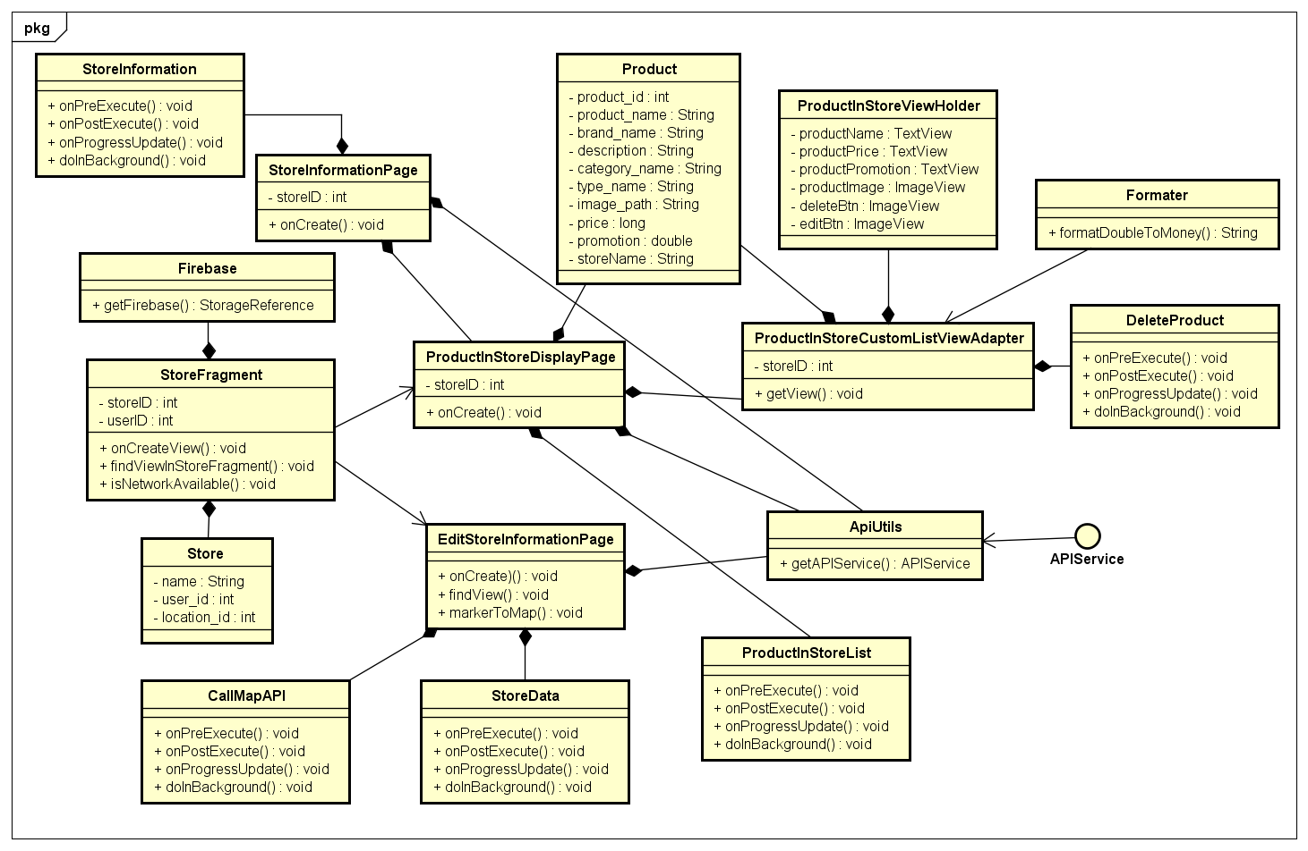

***Figure 4-6 :*** *Manage Store Class Diagram*

|  |  |  |  |  |
| --- | --- | --- | --- | --- |
| **Class** | **Product** | | | |
| Description | Object contains product information | | | |
| Base Class | Serializable | | | |
| Constructor | Product | | | |
| Prototype | N/A | | | |
| Source File | Product.java | | | |
| Package | Project.view.model | | | |
| **Attribute** | **Name** | **Type** | **Description** | |
| store\_id | String | Id of store | |
| product\_id | int | Id of product | |
| product\_name | int | Name of product | |
| brand\_name | String | Name of brand | |
| description | String | Description of product | |
| category\_name | String | Name of category | |
| type\_name | String | Name of type | |
| image\_path | String | Product image path | |
| price | long | Product price | |
| promotion | double | Product promotion | |
| storeName | String | Name of store | |
| **Method** | **Name** | **Output** | **Input** | **Description** |
| toString | String | N/A | N/A |

|  |  |  |  |  |
| --- | --- | --- | --- | --- |
| **Class** | **ProductInStoreViewHolder** | | | |
| Description | Class defines components in product in store listview | | | |
| Base Class | N/A | | | |
| Constructor | ProductInStoreViewHolder | | | |
| Prototype | N/A | | | |
| Source File | ProductInStoreCustomListViewAdapter.java | | | |
| Package | project.view.adapter | | | |
| **Attribute** | **Name** | **Type** | **Description** | |
| productName | TextView | N/A | |
| productPrice | TextView | N/A | |
| productPromotion | TextView | N/A | |
| productImage | ImageView | N/A | |
| deleteBtn | ImageView | N/A | |
| editBtn | ImageView | N/A | |
| **Method** | **Name** | **Output** | **Input** | **Description** |
| N/A | N/A | N/A | N/A |

|  |  |  |  |  |
| --- | --- | --- | --- | --- |
| **Class** | **ProductInStoreCustomListViewAdapter** | | | |
| Description | Class supports in setting listview layout | | | |
| Base Class | ProductInStoreCustomListViewAdapter(Context context, int resource, List<Product> productList) | | | |
| Constructor | ProductInStoreCustomListViewAdapter | | | |
| Prototype | N/A | | | |
| Source File | ProductInStoreCustomListViewAdapter.java | | | |
| Package | project.view.adapter | | | |
| **Attribute** | **Name** | **Type** | **Description** | |
| context | Context | N/A | |
| productList | List<Product> | N/A | |
| storageReference | StorageReference | N/A | |
| storeID | int | Id of store | |
| database | FirebaseDatabase | N/A | |
| myRef | DatabaseReference | N/A | |
| **Method** | **Name** | **Output** | **Input** | **Description** |
| getView | View | int,View,  ViewGroup | N/A |

|  |  |  |  |  |
| --- | --- | --- | --- | --- |
| **Class** | **DeleteProduct** | | | |
| Description | Asynctask supports asynchronize delete product in store | | | |
| Base Class | Asynctask | | | |
| Constructor | DeleteProduct | | | |
| Prototype | N/A | | | |
| Source File | ProductInStoreDisplayPage.java | | | |
| Package | project.view.gui | | | |
| **Attribute** | **Name** | **Type** | **Description** | |
| N/A | N/A | N/A | |
| **Method** | **Name** | **Output** | **Input** | **Description** |
| onPreExecute | void | N/A | N/A |
| doInBackground | boolean | Call... | N/A |
| onPostExecute | void | boolean | N/A |

|  |  |  |  |  |
| --- | --- | --- | --- | --- |
| **Class** | **Formatter** | | | |
| Description | Class includes functions to support in formatting product detail information | | | |
| Base Class | N/A | | | |
| Constructor | Formatter() | | | |
| Prototype | N/A | | | |
| Source File | Formatter.java | | | |
| Package | project.view.util | | | |
| **Attribute** | **Name** | **Type** | **Description** | |
| N/A | N/A | N/A | |
| **Method** | **Name** | **Output** | **Input** | **Description** |
| formatDoubleToMoney | String | String | N/A |
| formatDoubleToInt | String | String | N/A |
| dpToPx | int | int, Resources | N/A |

|  |  |  |  |  |
| --- | --- | --- | --- | --- |
| **Class** | **Firebase** | | | |
| Description | Class includes functions to support in connecting application with Firebase server | | | |
| Base Class | N/A | | | |
| Constructor | Firebase() | | | |
| Prototype | N/A | | | |
| Source File | Firebase.java | | | |
| Package | project.firebase | | | |
| **Attribute** | **Name** | **Type** | **Description** | |
| N/A | N/A | N/A | |
| **Method** | **Name** | **Output** | **Input** | **Description** |
| getFirebase | StorerageReference | String | N/A |
| getDatabase | FirebaseDatabase | String | N/A |

|  |  |  |  |  |
| --- | --- | --- | --- | --- |
| **Class** | **StoreFragment** | | | |
| Description | Fragment of “Cửa hàng” screen in Home Activity | | | |
| Base Class | Fragment | | | |
| Constructor | StoreFragment() | | | |
| Prototype | N/A | | | |
| Source File | StoreFragment.java | | | |
| Package | project.view.fragment.home | | | |
| **Attribute** | **Name** | **Type** | **Description** | |
| storeName | TextView | N/A | |
| ownerName | TextView | N/A | |
| address | TextView | N/A | |
| registerDate | TextView | N/A | |
| phoneText | TextView | N/A | |
| tv\_count\_smile | TextView | N/A | |
| tv\_count\_sad | TextView | N/A | |
| storeImage | ImageView | N/A | |
| btnEdit | ImageView | N/A | |
| errorImage | ImageView | N/A | |
| storeID | int | Id of store | |
| hasStore | int | Register store or not | |
| userID | int | Id of user | |
| latitude | double | Latitude in map of store | |
| longtitude | double | Longtitude in map of store | |
| view | View | N/A | |
| store | Store | N/A | |
| user | User | N/A | |
| btnManagermentProduct | Button | N/A | |
| btnManagermentOrder | Button | N/A | |
| loginBtn | Button | N/A | |
| registerStoreBtn | Button | N/A | |
| storageReference | StorageReference | N/A | |
| mainLayout | SwipeRefreshLayout | N/A | |
| RESULT\_CODE | int | Result code from EditStoreInformationPage | |
| REQUEST\_CODE | int | Request code from EditStoreInformationPage | |
| **Method** | **Name** | **Output** | **Input** | **Description** |
| onCreateView | void | LayoutInflater, ViewGroup, Bundle | N/A |
| findViewInStoreFragment | void | N/A | N/A |
| findViewInNoLogged  InLayout | void | N/A | N/A |
| findViewInNoHave  StoreLayout | void | N/A | N/A |

|  |  |  |  |  |
| --- | --- | --- | --- | --- |
| **Class** | **ProductInStoreDisplayPage** | | | |
| Description | Activity of “Sản phẩm cửa hàng” screen | | | |
| Base Class | BasePage  AppCompatActivity | | | |
| Constructor | ProductInStoreDisplatPage() | | | |
| Prototype | N/A | | | |
| Source File | ProductInStoreDisplatPage.java | | | |
| Package | project.view.gui | | | |
| **Attribute** | **Name** | **Type** | **Description** | |
| adapter | ProductInStoreCustom  ListViewAdapter | N/A | |
| theListView | ListView | N/A | |
| addNewBtn | Button | N/A | |
| mAPI | APIService | N/A | |
| storeID | int | Id of store | |
| nullMessage | TextView | N/A | |
| searchView | SearchView | N/A | |
| tempList | List<Product> | N/A | |
| main\_layout | RelativeLayout | N/A | |
| loadingBar | ProgressBar | N/A | |
| spinnerCategory | Spinner | N/A | |
| spinnerSort | Spinner | N/A | |
| productInStore | List<Product> | N/A | |
| **Method** | **Name** | **Output** | **Input** | **Description** |
| onCreate | void | Bundle | N/A |
| findView | void | N/A | N/A |

|  |  |  |  |  |  |  |  |  |  |  |
| --- | --- | --- | --- | --- | --- | --- | --- | --- | --- | --- |
| **Class** | **ProductInStoreList** | | | | | | | | | |
| Description | Asynctask supports asynchronize get product in store from server | | | | | | | | | |
| Base Class | Asynctask | | | | | | | | | |
| Constructor | ProductInStoreList() | | | | | | | | | |
| Prototype | N/A | | | | | | | | | |
| Source File | ProductInStoreDisplayPage.java | | | | | | | | | |
| Package | project.view.gui | | | | | | | | | |
| **Attribute** | **Name** | | **Type** | | | **Description** | | | | |
| N/A | | N/A | | | N/A | | | | |
| **Method** | **Name** | | **Output** | | | **Input** | | **Description** | | |
| onPreExecute | | void | | | N/A | | N/A | | |
| doInBackground | | void | | | Call… | | N/A | | |
| onPostExecute | | void | | | Void | | N/A | | |
| onProgressUpdate | | Void | | | Void… | | N/A | | |
| **Class** | **EditStoreInformationPage** | | | | | | | | | | |
| Description | Activity of “Thay đổi thông tin cửa hàng” screen | | | | | | | | | | |
| Base Class | BasePage  AppCompatActivity | | | | | | | | | | |
| Constructor | EditStoreInformationPage() | | | | | | | | | | |
| Prototype | N/A | | | | | | | | | | |
| Source File | EditStoreInformationPage.java | | | | | | | | | | |
| Package | project.view.gui | | | | | | | | | | |
| **Attribute** | **Name** | | | **Type** | | **Description** | | | | | |
| userNameText | | | EditText | | N/A | | | | | |
| etStoreName | | | EditText | | N/A | | | | | |
| etPhone | | | EditText | | N/A | | | | | |
| handleAddressText | | | TextView | | N/A | | | | | |
| handleAddresslayout | | | RelativeLayout | | N/A | | | | | |
| switch\_button | | | SwitchButton | | N/A | | | | | |
| storeName | | | String | | Name of store | | | | | |
| address | | | String | | Address of store | | | | | |
| phone | | | String | | Phone number of store | | | | | |
| storeLongtitude | | | double | | Longtitude of store | | | | | |
| storeLatitude | | | double | | Latitude of store | | | | | |
| updateInformationStore | | | Button | | N/A | | | | | |
| location | | | Location | | N/A | | | | | |
| handleLongtitude | | | double | | Manual longtitude of store | | | | | |
| handleLatitude | | | double | | Manual latitude of store | | | | | |
| autoLongtitude | | | double | | Auto longtitude of store | | | | | |
| autoLatitude | | | double | | Auto latitude of store | | | | | |
| mMap | | | GoogleMap | | N/A | | | | | |
| handleLocationPlace | | | String | | Place from Autocomplete | | | | | |
| GOOGLE\_MAP\_API | | | String | | Code to request GM API | | | | | |
| REQUEST\_LOCATION | | | int | | Code to set location | | | | | |
| PLACE\_AUTOCOMPLETE\_  REQUEST\_CODE | | | int | | Request code to Autocomplete | | | | | |
| mAPI | | | APIService | | N/A | | | | | |
| apiService | | | APIService | | N/A | | | | | |
| storeJson | | | String | | JSON contains store link | | | | | |
| userJson | | | String | | JSON contains user link | | | | | |
| RESULT\_CODE | | | int | | N/A | | | | | |
| **Method** | **Name** | | | **Output** | | **Input** | | | **Description** | | |
| onCreate | | | void | | N/A | | | N/A | | |
| getIntentFromStore  FromInformationPage | | | void | | N/A | | | N/A | | |
| findView | | | void | | N/A | | | N/A | | |
| markerToMap | | | void | | double,double  GoogleMap,  String,String | | | N/A | | |
| turnOnLocation | | | void | | N/A | | | N/A | | |
| **Class** | **CallMapAPI** | | | | | | | | |
| Description | Asynctask supports asynchronize call GoogleMap API | | | | | | | | |
| Base Class | Asynctask | | | | | | | | |
| Constructor | CallMapAPI() | | | | | | | | |
| Prototype | N/A | | | | | | | | |
| Source File | EditStoreInformationPage.java | | | | | | | | |
| Package | project.view.gui | | | | | | | | |
| **Attribute** | **Name** | **Type** | | | **Description** | | | | |
| N/A | N/A | | | N/A | | | | |
| **Method** | **Name** | **Output** | | | **Input** | | **Description** | | |
| onPreExecute | void | | | N/A | | N/A | | |
| doInBackground | Location | | | Call… | | N/A | | |
| onPostExecute | void | | | Location | | N/A | | |
| onProgressUpdate | void | | | Void… | | N/A | | |

|  |  |  |  |  |
| --- | --- | --- | --- | --- |
| **Class** | **StoreData** | | | |
| Description | Asynctask supports asynchronize get store information | | | |
| Base Class | Asynctask | | | |
| Constructor | StoreData() | | | |
| Prototype | N/A | | | |
| Source File | EditStoreInformationPage.java | | | |
| Package | project.view.gui | | | |
| **Attribute** | **Name** | **Type** | **Description** | |
| N/A | N/A | N/A | |
| **Method** | **Name** | **Output** | **Input** | **Description** |
| onPreExecute | void | N/A | N/A |
| doInBackground | Store | Call… | N/A |
| onPostExecute | void | Store | N/A |
| onProgressUpdate | void | Void… | N/A |

|  |  |  |  |  |
| --- | --- | --- | --- | --- |
| **Class** | **StoreInformationPage** | | | |
| Description | Activity of “Thông tin cửa hàng” screen | | | |
| Base Class | BasePage/ AppCompatActivity | | | |
| Constructor | StoreInformation() | | | |
| Prototype | N/A | | | |
| Source File | StoreInformation.java | | | |
| Package | project.view.gui | | | |
| **Attribute** | **Name** | **Type** | **Description** | |
| store | Store | N/A | |
| mAPI | APIService | N/A | |
| storeID | int | N/A | |
| backBtn | ImageView | N/A | |
| ownerName | TextView | N/A | |
| address | TextView | N/A | |
| registerDate | TextView | N/A | |
| phoneText | TextView | N/A | |
| **Method** | **Name** | **Output** | **Input** | **Description** |
| onCreate | void | Bundle | N/A |
| findView | findView | N/A | N/A |

##### Manage Order

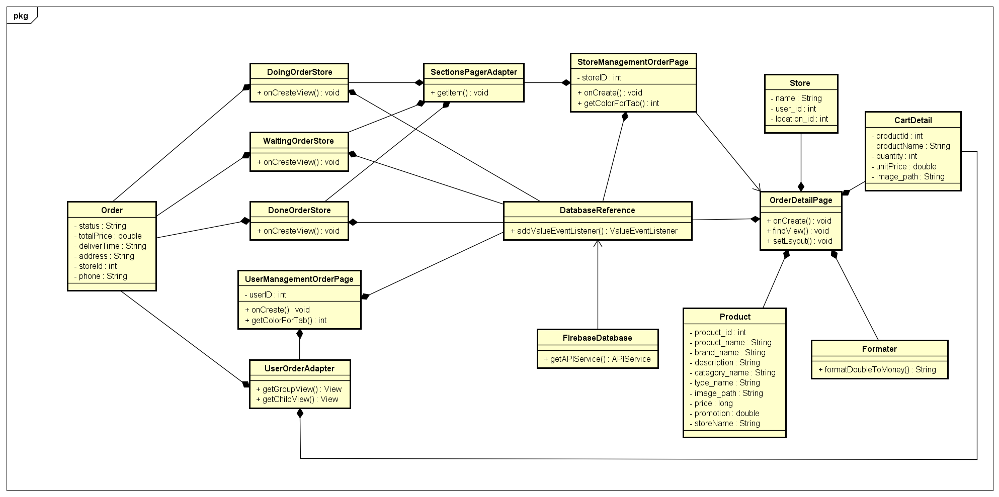

***Figure 4-7 :*** *Manage Order Class Diagram*

|  |  |  |  |  |
| --- | --- | --- | --- | --- |
| **Class** | **Order** | | | |
| Description | Object contains order information | | | |
| Base Class | N/A | | | |
| Constructor | Order | | | |
| Prototype | N/A | | | |
| Source File | Order() / Order(String status, double totalPrice, String deliverTime) | | | |
| Package | project.view.model | | | |
| **Attribute** | **Name** | **Type** | **Description** | |
| status | String | Status of order | |
| totalPrice | double | Total price of order | |
| deliverTime | String | Deliver time of order | |
| address | String | Deliver address of order | |
| storeId | int | Id of store | |
| phone | String | Phone number of customer | |
| **Method** | **Name** | **Output** | **Input** | **Description** |
| toString | String | N/A | N/A |

|  |  |  |  |  |
| --- | --- | --- | --- | --- |
| **Class** | **DoingOrderStore** | | | |
| Description | Fragment “Đơn hàng đang xử lý” tab in “Quản lý đơn hàng”screen in Store role | | | |
| Base Class | Fragment | | | |
| Constructor | DoingOrderStore() | | | |
| Prototype | N/A | | | |
| Source File | DoingOrderStore.java | | | |
| Package | project.view.fragment.manageOrder | | | |
| **Attribute** | **Name** | **Type** | **Description** | |
| lvOrder | ListView | N/A | |
| database | FirebaseDatabase | N/A | |
| myRef | DatabaseReference | N/A | |
| storeId | int | Id of store | |
| order | Order | N/A | |
| list | List<Order> | N/A | |
| adapter | StoreOrderManagementAdapter | N/A | |
| **Method** | **Name** | **Output** | **Input** | **Description** |
| onCreateView | void | LayoutInflater,  ViewGroup,  Bundle | N/A |
| changeListener | ValueEventListener | N/A | N/A |

|  |  |  |  |  |
| --- | --- | --- | --- | --- |
| **Class** | **DoneOrderStore** | | | |
| Description | Fragment “Đơn hàng đã xử lý” tab in “Quản lý đơn hàng”screen in Store role | | | |
| Base Class | Fragment | | | |
| Constructor | DoneOrderStore.java | | | |
| Prototype | N/A | | | |
| Source File | DoneOrderStore.java | | | |
| Package | project.view.fragment.manageOrder | | | |
| **Attribute** | **Name** | **Type** | **Description** | |
| lvOrder | ListView | N/A | |
| database | FirebaseDatabase | N/A | |
| myRef | DatabaseReference | N/A | |
| storeId | int | Id of store | |
| order | Order | N/A | |
| list | List<Order> | N/A | |
| adapter | StoreOrderManagementAdapter | N/A | |
| **Method** | **Name** | **Output** | **Input** | **Description** |
| onCreateView | void | LayoutInflater,  ViewGroup,  Bundle | N/A |
| changeListener | ValueEventListener | N/A | N/A |

|  |  |  |  |  |
| --- | --- | --- | --- | --- |
| **Class** | **WaitingOrderStore** | | | |
| Description | Fragment “Đơn hàng đợi xử lý” tab in “Quản lý đơn hàng”screen in Store role | | | |
| Base Class | Fragment | | | |
| Constructor | WaittingOrderStore.java | | | |
| Prototype | N/A | | | |
| Source File | WaittingOrderStore.java | | | |
| Package | project.view.fragment.manageOrder | | | |
| Attribute | Name | Type | Description | |
| lvOrder | ListView | N/A | |
| database | FirebaseDatabase | N/A | |
| myRef | DatabaseReference | N/A | |
| storeId | int | Id of store | |
| order | Order | N/A | |
| list | List<Order> | N/A | |
| adapter | StoreOrderManagementAdapter | N/A | |
| Method | Name | Output | Input | Description |
| onCreateView | void | LayoutInflater,  ViewGroup,  Bundle | N/A |
| changeListener | ValueEventListener | N/A | N/A |

|  |  |  |  |  |
| --- | --- | --- | --- | --- |
| **Class** | **StoreManagementOrderPage** | | | |
| Description | Activity of “Quản lý đơn hàng” screen in Store role | | | |
| Base Class | BasePage  AppCompatActivity | | | |
| Constructor | StoreManagementOrderPage() | | | |
| Prototype | N/A | | | |
| Source File | StoreManagementOrderPage.java | | | |
| Package | project.view.gui | | | |
| Attribute | Name | Type | Description | |
| mSectionsPagerAdapter | SectionsPagerAdapter | N/A | |
| mViewPager | ViewPager | N/A | |
| toolbar | Toolbar | N/A | |
| tabLayout | TabLayout | N/A | |
| database | FirebaseDatabase | N/A | |
| myRef | DatabaseReference | N/A | |
| storeId | int | Id of store | |
| Method | Name | Output | Input | Description |
| onCreate | void | Bundle | N/A |
| getColorForTab | int | int | N/A |

|  |  |  |  |  |
| --- | --- | --- | --- | --- |
| **Class** | **SectionsPagerAdapter** | | | |
| Description | Class supports in setting layout in tabs | | | |
| Base Class | FragmentStatePagerAdapter | | | |
| Constructor | SectionsPagerAdapter() | | | |
| Prototype | N/A | | | |
| Source File | SectionsPagerAdapter.java | | | |
| Package | project.view.adapter | | | |
| **Attribute** | **Name** | **Type** | **Description** | |
| N/A | N/A | N/A | |
| **Method** | **Name** | **Output** | **Input** | **Description** |
| getItem | Fragment | N/A | N/A |
| getCount | Fragment | N/A | N/A |

|  |  |  |  |  |
| --- | --- | --- | --- | --- |
| **Class** | **UserManagementOrderPage** | | | |
| Description | Activity of “Quản lý đơn hàng” screen in User role | | | |
| Base Class | BasePage  AppCompatActivity | | | |
| Constructor | UserManagementOrderPage() | | | |
| Prototype | N/A | | | |
| Source File | UserManagementOrderPage.java | | | |
| Package | project.view.gui | | | |
| **Attribute** | **Name** | **Type** | **Description** | |
| orderListView | ExpandableListView | N/A | |
| list | List<Order> | N/A | |
| noOrder | RelativeLayout | N/A | |
| adapter | UserOrderAdapter | N/A | |
| database | FirebaseDatabase | N/A | |
| myRef | DatabaseReference | N/A | |
| userId | int | Id of user | |
| shoppingBtn | Button | N/A | |
| status | String | Status of order | |
| **Method** | **Name** | **Output** | **Input** | **Description** |
| onCreate | void | Bundle | N/A |
| changeListener | ValueEventListener | int | N/A |

|  |  |  |  |  |
| --- | --- | --- | --- | --- |
| **Class** | **UserOrderAdapter** | | | |
| Description | Class supports in setting layout in listview | | | |
| Base Class | BaseExpandableListAdapter | | | |
| Constructor | UserOrderAdapter | | | |
| Prototype | N/A | | | |
| Source File | UserOrderAdapter.java | | | |
| Package | project.view.adapter | | | |
| **Attribute** | **Name** | **Type** | **Description** | |
| context | Context | N/A | |
| list | List<Order> | N/A | |
| userId | int | Id of user | |
| storageReference | StorageReference | N/A | |
| **Method** | **Name** | **Output** | **Input** | **Description** |
| getGroupView | View | int, boolean,  View, ViewGroup | N/A |
| getChildView | View | int, int, boolean,View, ViewGroup | N/A |

|  |  |  |  |  |
| --- | --- | --- | --- | --- |
| **Class** | **OrderDetailPage** | | | |
| Description | Activity of “Thông tin đơn hàng” screen in User role | | | |
| Base Class | BasePage  AppCompatActivity | | | |
| Constructor | OrderDetailPage() | | | |
| Prototype | N/A | | | |
| Source File | OrderDetailPage.java | | | |
| Package | project.view.gui | | | |
| **Attribute** | **Name** | **Type** | **Description** | |
| usernameTV | TextView | N/A | |
| phoneTV | TextView | N/A | |
| totalTV | TextView | N/A | |
| deliveryTimeTV | TextView | N/A | |
| deliveryAddressTV | TextView | N/A | |
| productListView | ListView | N/A | |
| acceptBtn | TextView | N/A | |
| rejectBtn | TextView | N/A | |
| closeBtn | TextView | N/A | |
| waittingOrderButton  Layout | LinearLayout | N/A | |
| processingOrderButton  Layout | LinearLayout | N/A | |
| buttonLayout | RelativeLayout | N/A | |
| adapter | OrderDetailCustom  ListViewAdapter | N/A | |
| productList | ArrayList<Product> | N/A | |
| isWaittingOrder | boolean | is waiting order or not | |
| isProcessingOrder | boolean | is processing order or not | |
| isDoneOrder | boolean | is done order or not | |
| orderId | String | Id of order | |
| database | FirebaseDatabase | N/A | |
| myRef | DatabaseReference | N/A | |
| ref | DatabaseReference | N/A | |
| order | Order | Object Order | |
| store | Store | Object Store | |
| **Method** | **Name** | **Output** | **Input** | **Description** |
| onCreate | void | Bundle | N/A |
| findView | void | N/A | N/A |
| setLayout | void | boolean, Boolean,  Boolean,  RelativeLayout,  LinearLayout,  LinearLayout, | N/A |
| changeListener | ValueEventListener | N/A | N/A |
| changeListener1 | N/A | N/A | N/A |

##### Order Product

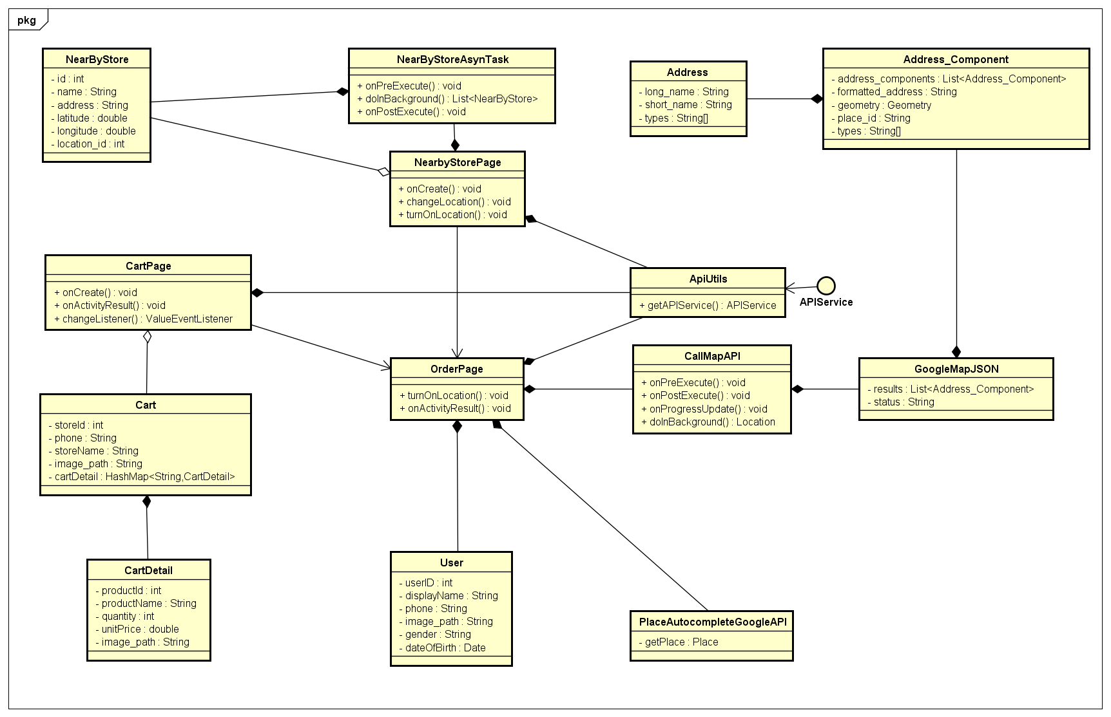

***Figure 4-8 :*** *Order Product Class Diagram*

|  |  |  |  |  |
| --- | --- | --- | --- | --- |
| **Class** | **NearByStore** | | | |
| Description | Object contains nearby store information | | | |
| Base Class | Serializable | | | |
| Constructor | NearByStore | | | |
| Prototype | N/A | | | |
| Source File | NearByStore.java | | | |
| Package | project.view.model | | | |
| **Attribute** | **Name** | **Type** | **Description** | |
| id | int | Id of store | |
| name | String | Name of store | |
| address | String | Address of store | |
| latitude | double | Latitude in map of store | |
| longtitude | double | Longtitude in map of store | |
| location\_id | int | Id of store location | |
| user\_id | int | Id of user | |
| user\_name | String | Name of user | |
| phone | String | Phone number of store | |
| registerLog | String | Register date of store | |
| promotion | double | Product promotion | |
| price | long | Product price | |
| distance | double | Distance from user to store | |
| image\_path | String | Store avatar image path | |
| **Method** | **Name** | **Output** | **Input** | **Description** |
| toString | String | N/A | N/A |

|  |  |  |  |  |
| --- | --- | --- | --- | --- |
| **Class** | **NearByStoreAsynTask** | | | |
| Description | Asynctask supports asynchronize find nearby store | | | |
| Base Class | Asynctask | | | |
| Constructor | NearByStoreAsynTask() | | | |
| Prototype | N/A | | | |
| Source File | NearByStorePage.java | | | |
| Package | project.view.gui | | | |
| **Attribute** | **Name** | **Type** | **Description** | |
| N/A | N/A | N/A | |
| **Method** | **Name** | **Output** | **Input** | **Description** |
| onPreExecute | void | N/A | N/A |
| doInBackground | List<NearByStore> | Call... | N/A |
| onPostExecute | void | List<NearByStore> | N/A |

|  |  |  |  |  |
| --- | --- | --- | --- | --- |
| **Class** | **Address** | | | |
| Description | Object contains address information | | | |
| Base Class | Serializable | | | |
| Constructor | Address() | | | |
| Prototype | N/A | | | |
| Source File | Address.java | | | |
| Package | project.googleMapAPI | | | |
| **Attribute** | **Name** | **Type** | **Description** | |
| long\_name | String | Full name of address | |
| short\_name | String | Short name of address | |
| types | String[] | Type of address | |
| **Method** | **Name** | **Output** | **Input** | **Description** |
| toString | String | N/A | N/A |

|  |  |  |  |  |
| --- | --- | --- | --- | --- |
| **Class** | **Address\_Component** | | | |
| Description | Object contains address component information | | | |
| Base Class | Serializable | | | |
| Constructor | Address\_Component() | | | |
| Prototype | N/A | | | |
| Source File | Address\_Component.java | | | |
| Package | project.googleMapAPI | | | |
| **Attribute** | **Name** | **Type** | **Description** | |
| address\_components | List<Address> | Address list | |
| formatted\_address | String | N/A | |
| geometry | Geometry | N/A | |
| place\_id | String | Id of address place | |
| types | String | N/A | |
| **Method** | **Name** | **Output** | **Input** | **Description** |
| toString | String | N/A | N/A |
| getAddressList | List<Address> | N/A | N/A |

|  |  |  |  |  |
| --- | --- | --- | --- | --- |
| **Class** | **GoogleMapJSON** | | | |
| Description | Object contains Google Map information in JSON parse | | | |
| Base Class | Serializable | | | |
| Constructor | GoogleMapJSON() | | | |
| Prototype | N/A | | | |
| Source File | GoogleMapJSON.java | | | |
| Package | project.googleMapAPI | | | |
| **Attribute** | **Name** | **Type** | **Description** | |
| results | List<Address\_Component> | N/A | |
| status | String | Status of getting JSON | |
| **Method** | **Name** | **Output** | **Input** | **Description** |
| toString | String | N/A | N/A |

|  |  |  |  |  |
| --- | --- | --- | --- | --- |
| **Class** | **Cart** | | | |
| Description | Object contains user cart information | | | |
| Base Class | N/A | | | |
| Constructor | Cart()  Cart(int storeId, String phone, String storeName)  Cart(int storeId, String phone, String storeName, HashMap<String,CartDetail> cartDetail) | | | |
| Prototype | N/A | | | |
| Source File | Cart.java | | | |
| Package | project.view.model | | | |
| **Attribute** | **Name** | **Type** | **Description** | |
| store\_id | int | Id of store | |
| phone | String | Phone number of user | |
| storeName | String | Name of store | |
| image\_path | String | Product image path | |
| cartDetail | HashMap<String,CartDetail> | N/A | |
| **Method** | **Name** | **Output** | **Input** | **Description** |
| toString | String | N/A | N/A |

|  |  |  |  |  |
| --- | --- | --- | --- | --- |
| **Class** | **OrderDetailPage** | | | |
| Description | Activity of “Thông tin đơn hàng” screen in User role | | | |
| Base Class | BasePage  AppCompatActivity | | | |
| Constructor | OrderDetailPage() | | | |
| Prototype | N/A | | | |
| Source File | OrderDetailPage.java | | | |
| Package | project.view.gui | | | |
| **Attribute** | **Name** | **Type** | **Description** | |
| storeListView | ListView | N/A | |
| adapter | NearByStoreListView  Adapter | N/A | |
| list | List<NearByStore> | N/A | |
| main\_layout | LinearLayout | N/A | |
| mMap | GoogleMap | N/A | |
| locationManager | LocationManager | N/A | |
| productId | int | Id of product | |
| searchView | SearchView | N/A | |
| loadingBar | ProgressBar | N/A | |
| textContent | TextView | N/A | |
| noHaveStore | TextView | N/A | |
| database | FirebaseDatabase | N/A | |
| myRef | DatabaseReference | N/A | |
| myRef1 | DatabaseReference | N/A | |
| listerner | ValueEventListener | N/A | |
| suggestions | List<String> | N/A | |
| searchedList | List<String> | N/A | |
| latitude | double | Latitude of deliver address | |
| longtitude | double | Longtitude of deliver address | |
| REQUEST\_LOCATION | int | N/A | |
| footerView | View | N/A | |
| p | Product | Object Product | |
| productName | String | Name of product | |
| **Method** | **Name** | **Output** | **Input** | **Description** |
| onCreate | void | Bundle | N/A |
| changeLocation | void | GoogleMap | N/A |
| turnOnLocation | void | N/A | N/A |

|  |  |  |  |  |
| --- | --- | --- | --- | --- |
| **Class** | **CartDetail** | | | |
| Description | Object contains user cart detail information | | | |
| Base Class | N/A | | | |
| Constructor | CartDetail() / CartDetail(int productId, String productName, int quantity, double unitPrice) / CartDetail(int productId, String productName, int quantity, double unitPrice, String image\_path) | | | |
| Prototype | N/A | | | |
| Source File | CartDetail.java | | | |
| Package | project.view.model | | | |
| **Attribute** | **Name** | **Type** | **Description** | |
| productId | int | Id of product | |
| productName | String | Name of product | |
| quantity | int | Quantity of product | |
| unitPrice | doube | Product price | |
| image\_path | String | Product image path | |
| **Method** | **Name** | **Output** | **Input** | **Description** |
| toString | String | N/A | N/A |

|  |  |  |  |  |
| --- | --- | --- | --- | --- |
| **Class** | **CartPage** | | | |
| Description | Activity of “Giỏ hàng” screen | | | |
| Base Class | BasePage  AppCompatActivity | | | |
| Constructor | CartPage() | | | |
| Prototype | N/A | | | |
| Source File | CartPage.java | | | |
| Package | project.view.gui | | | |
| **Attribute** | **Name** | **Type** | **Description** | |
| lvPhones | ExpandableListView | N/A | |
| list | List<Cart> | N/A | |
| cart | Cart | N/A | |
| database | FirebaseDatabase | N/A | |
| myRef | DatabaseReference | N/A | |
| phoneListAdapter | CartAdapter | N/A | |
| noCart | RelativeLayout | N/A | |
| totalCart | TextView | N/A | |
| checkoutAllbtn | Button | N/A | |
| shoppingBtn | Button | N/A | |
| loadingBar | ProgressBar | N/A | |
| buyLinearLayout | LinearLayout | N/A | |
| userId | int | Id of user | |
| **Method** | **Name** | **Output** | **Input** | **Description** |
| onCreate | void | Bundle | N/A |
| changeListerner | ValueEventListerner | N/A | N/A |
| startService | void | N/A | N/A |

|  |  |  |  |  |
| --- | --- | --- | --- | --- |
| **Class** | **OrderPage** | | | |
| Description | Activity of “Giỏ hàng” screen | | | |
| Base Class | BasePage  AppCompatActivity | | | |
| Constructor | OrderPage() | | | |
| Prototype | N/A | | | |
| Source File | OrderPage.java | | | |
| Package | project.view.gui | | | |
| **Attribute** | **Name** | **Type** | **Description** | |
| productName | TextView | N/A | |
| productPrice | TextView | N/A | |
| salePrice | TextView | N/A | |
| promotionPercent | TextView | N/A | |
| sumOrder | TextView | N/A | |
| txBuyerNameError | TextView | N/A | |
| etphone | TextView | N/A | |
| handleAddressText | TextView | N/A | |
| etBuyerName | TextView | N/A | |
| decreaseBtn | Button | N/A | |
| increaseBtn | Button | N/A | |
| orderBtn | Button | N/A | |
| switch\_button | SwitchButton | N/A | |
| productImage | ImageView | N/A | |
| productDetailLayout | RelativeLayout | N/A | |
| handleAddressLayout | RelativeLayout | N/A | |
| userID | int | Id of user | |
| location | Location | N/A | |
| PLACE\_AUTOCOMPLETE\_  REQUEST\_CODE | int | N/A | |
| locationManager | LocationManager | N/A | |
| handleLongtitude | double | Manual longtitude of order | |
| handleLatitude | double | Manual latitude of order | |
| autoLongtitude | double | Auto longtitude of order | |
| autoLatitude | double | Auto longtitude of order | |
| GOOGLE\_MAP\_KEY | String | Key to use GoogleMap API | |
| REQUEST\_LOCATION | int | N/A | |
| googleMap | GoogleMap | N/A | |
| handleLocationPlace | String | Place from Autocomplete | |
| user | User | Object User | |
| isCart | boolean | is order from cart or not | |
| price | long | Product price | |
| salesPrice | long | N/A | |
| promotion | double | N/A | |
| product | Product | N/A | |
| mYear | int | N/A | |
| mMonth | int | N/A | |
| mDay | int | N/A | |
| mHour | int | N/A | |
| mMinute | int | N/A | |
| storageReference | StorageReference | N/A | |
| **Method** | **Name** | **Output** | **Input** | **Description** |
| onCreate | void | Bundle | N/A |
| getSalesPrice | long | long, double | N/A |
| mapping | void | N/A | N/A |
| increaseQuantity | void | N/A | N/A |
| decreaseQuantity | void | N/A | N/A |
| markerToMap | void | double, double,  GoogleMap  String | N/A |
| defaultView | void | N/A | N/A |
| turnOnLocation | void | N/A | N/A |

##### Register Account

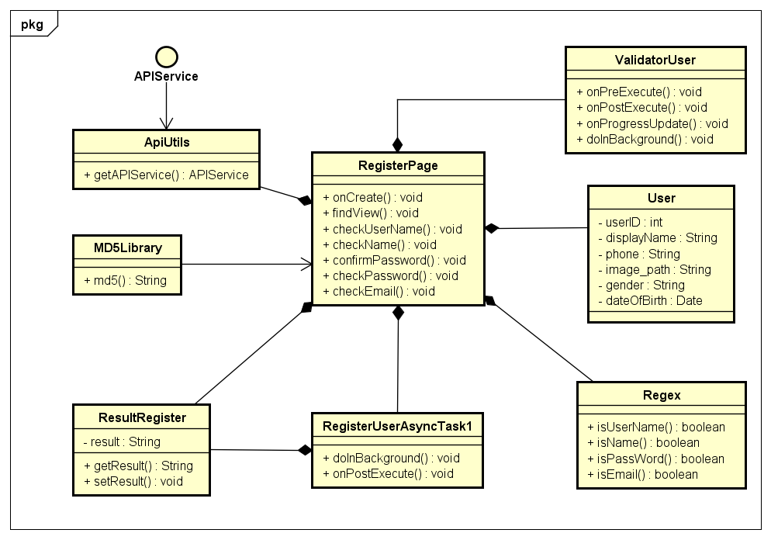

***Figure 4-9 :*** *Register Account Class Diagram*

|  |  |  |  |  |
| --- | --- | --- | --- | --- |
| **Class** | **RegisterPage** | | | |
| Description | Activity of “Đăng kí” screen | | | |
| Base Class | AppCompatActivity | | | |
| Constructor | Register() | | | |
| Prototype | N/A | | | |
| Source File | RegisterPage.java | | | |
| Package | project.view.gui | | | |
| **Attribute** | **Name** | **Type** | **Description** | |
| etUserName | TextInputEditText | N/A | |
| etName | TextInputEditText | N/A | |
| etPassword | TextInputEditText | N/A | |
| etConfirmPassword | TextInputEditText | N/A | |
| etEmail | TextInputEditText | N/A | |
| etPhoneNumber | TextInputEditText | N/A | |
| tvUserName | TextView | N/A | |
| tvName | TextView | N/A | |
| tvPassword | TextView | N/A | |
| tvConfirmPassword | TextView | N/A | |
| tvEmail | TextView | N/A | |
| tvPhoneNumber | TextView | N/A | |
| toLoginPageBtn | TextView | N/A | |
| btnRegister | Button | N/A | |
| isUserName | boolean | is valid username or not | |
| isName | boolean | is valid name or not | |
| isPassword | boolean | is valid password or not | |
| confirm | boolean | confirm username or not | |
| isEmail | boolean | is valid email or not | |
| isPhone | boolean | is valid phone no or not | |
| apiUserService | APIService | N/A | |
| us | User | N/A | |
| main\_layout | RelaytiveLayout | N/A | |
| **Method** | **Name** | **Output** | **Input** | **Description** |
| onCreate | void | Bundle | N/A |
| findView | void | N/A | N/A |
| checkUsername | void | String | N/A |
| checkName | void | String | N/A |
| confirmPassword | void | String | N/A |
| checkPassword | void | String | N/A |
| checkEmail | void | String | N/A |

|  |  |  |  |  |
| --- | --- | --- | --- | --- |
| **Class** | **ValidatorUser** | | | |
| Description | Asynctask supports asynchronize validate user information | | | |
| Base Class | Asynctask | | | |
| Constructor | ValidatorUser() | | | |
| Prototype | N/A | | | |
| Source File | RegisterPage.java | | | |
| Package | project.view.gui | | | |
| **Attribute** | **Name** | **Type** | **Description** | |
| N/A | N/A | N/A | |
| **Method** | **Name** | **Output** | **Input** | **Description** |
| onPreExecute | void | N/A | N/A |
| doInBackground | Void | Call… | N/A |
| onPostExecute | void | Void | N/A |
| onProgressUpdate | void | String… | N/A |

|  |  |  |  |  |
| --- | --- | --- | --- | --- |
| **Class** | **Regex** | | | |
| Description | Class supports in checking validate data | | | |
| Base Class | N/A | | | |
| Constructor | Regex() | | | |
| Prototype | N/A | | | |
| Source File | Regex.java | | | |
| Package | project.view.util | | | |
| **Attribute** | **Name** | **Type** | **Description** | |
| pattern | Pattern | N/A | |
| PASSWORD\_PATTERN | String | contains password regex | |
| USERNAME\_PATTERN | String | contains username regex | |
| STORENAME\_PATTERN | String | contains storename regex | |
| NAME\_PATTERN | String | contains name regex | |
| EMAIL\_PATTERN | String | contains email regex | |
| **Method** | **Name** | **Output** | **Input** | **Description** |
| isPassword | boolean | String | N/A |
| isUserName | boolean | String | N/A |
| isName | boolean | String | N/A |
| isStoreName | boolean | String | N/A |
| isEmail | boolean | String | N/A |

|  |  |  |  |  |
| --- | --- | --- | --- | --- |
| **Class** | **RegisterUserAsyncTask1** | | | |
| Description | Asynctask supports asynchronize register new account | | | |
| Base Class | Asynctask | | | |
| Constructor | RegisterUserAsyncTask1() | | | |
| Prototype | N/A | | | |
| Source File | RegisterPage.java | | | |
| Package | project.view.gui | | | |
| **Attribute** | **Name** | **Type** | **Description** | |
| N/A | N/A | N/A | |
| **Method** | **Name** | **Output** | **Input** | **Description** |
| doInBackground | String | Call… | N/A |
| onPostExecute | void | String | N/A |

|  |  |  |  |  |
| --- | --- | --- | --- | --- |
| **Class** | **ResultRegister** | | | |
| Description | Object contains result of register process | | | |
| Base Class | Serializable | | | |
| Constructor | ResultRegister() | | | |
| Prototype | N/A | | | |
| Source File | ResultRegister.java | | | |
| Package | project.view.model | | | |
| **Attribute** | **Name** | **Type** | **Description** | |
| result | String | N/A | |
| **Method** | **Name** | **Output** | **Input** | **Description** |
| N/A | N/A | N/A | N/A |

##### Register Store

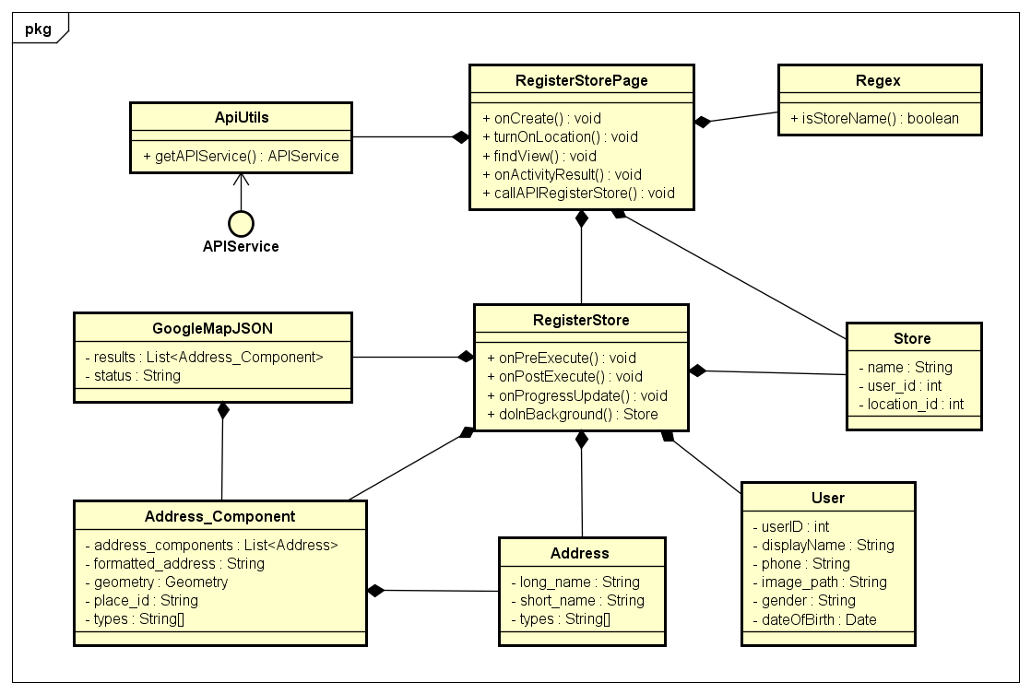

***Figure 4-10 :*** *Register Store Class Diagram*

|  |  |  |  |  |
| --- | --- | --- | --- | --- |
| **Class** | **RegisterStorePage** | | | |
| Description | Activity of “Đăng kí cửa hàng” screen | | | |
| Base Class | BasePageAppCompatActivity | | | |
| Constructor | RegisterStorePage() | | | |
| Prototype | N/A | | | |
| Source File | RegisterStorePage.java | | | |
| Package | project.view.gui | | | |
| **Attribute** | **Name** | **Type** | **Description** | |
| GOOGLE\_MAP\_KEY | String | N/A | |
| REQUEST\_LOCATION | int | N/A | |
| PLACE\_AUTOCOMPLETE  \_REQUEST\_CODE | int | N/A | |
| mAPI | APIService | N/A | |
| mMap | GoogleMap | N/A | |
| locationManager | LocationManager | N/A | |
| handleAddressLayout | RelativeLayout | N/A | |
| registerBtn | Button | N/A | |
| handleAddressText | TextView | N/A | |
| tvStoreNameError | TextView | N/A | |
| tvPhoneError | TextView | N/A | |
| tvLocationError | TextView | N/A | |
| etStoreName | EditText | N/A | |
| etPhone | EditText | N/A | |
| handleLocationPlace | String | N/A | |
| iconSwitch | SwitchButton | N/A | |
| location | Location | N/A | |
| handleLongtitude | double | Manual longtitude of store | |
| handleLatitude | double | Manual latitude of store | |
| autoLatitude | double | Auto longtitude of store | |
| autoLongtitude | double | Auto latitude of store | |
| main\_layout | RelativeLayout | N/A | |
| loadingBar | ProgressBar | N/A | |
| isPhone | boolean | is valid phone no or not | |
| isStoreName | boolean | is valid store name or not | |
| isLocation | boolean | is valid location no or not | |
| **Method** | **Name** | **Output** | **Input** | **Description** |
| onCreate | void | Bundle | N/A |
| findView | void | N/A | N/A |
| turnOnLocation | void | N/A | N/A |
| markerToMap | void | double  double  GoogleMap  String | N/A |
| callAPIRegisterStore | void | Store  Location | N/A |

|  |  |  |  |  |
| --- | --- | --- | --- | --- |
| **Class** | **RegisterStore** | | | |
| Description | Asynctask supports asynchronize register a new store | | | |
| Base Class | Asynctask | | | |
| Constructor | RegisterStore() | | | |
| Prototype | N/A | | | |
| Source File | RegisterStorePage.java | | | |
| Package | project.view.gui | | | |
| **Attribute** | **Name** | **Type** | **Description** | |
| N/A | N/A | N/A | |
| **Method** | **Name** | **Output** | **Input** | **Description** |
| onPreExecute | void | N/A | N/A |
| doInBackground | Void | Call… | N/A |
| onPostExecute | void | Store | N/A |
| onProgressUpdate | void | Void… | N/A |

##### Search Product By User

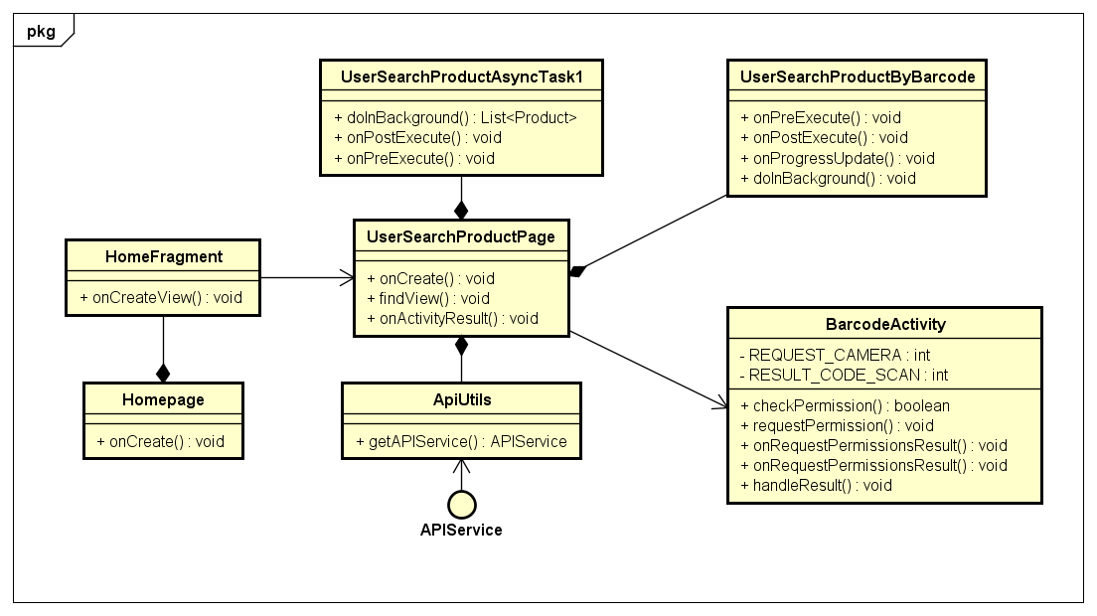

***Figure 4-11 :*** *Search Product By User Class Diagram*

|  |  |  |  |  |
| --- | --- | --- | --- | --- |
| **Class** | **Homepage** | | | |
| Description | Home Activity | | | |
| Base Class | BasePage  AppCompatActivity | | | |
| Constructor | HomePage() | | | |
| Prototype | N/A | | | |
| Source File | HomePage.java | | | |
| Package | project.view.gui | | | |
| **Attribute** | **Name** | **Type** | **Description** | |
| bottomNavigationView | BottomNavigationView | N/A | |
| viewPager | ViewPager | N/A | |
| prevMenuItem | MenuItem | N/A | |
| userJSON | String | N/A | |
| storeJSON | String | N/A | |
| adapter | ViewPagerAdapter | N/A | |
| **Method** | **Name** | **Output** | **Input** | **Description** |
| onCreate | void | Bundle | N/A |
| setupViewPager | void | N/A | N/A |
| getAuthen | void | N/A | N/A |
| restoringPreferences | void | N/A | N/A |

|  |  |  |  |  |
| --- | --- | --- | --- | --- |
| **Class** | **UserSearchProductAsyncTask1** | | | |
| Description | Asynctask supports asynchronize get product from server | | | |
| Base Class | Asynctask | | | |
| Constructor | UserSearchProductAsyncTask1 | | | |
| Prototype | N/A | | | |
| Source File | UserSearchProductPage.java | | | |
| Package | project.view.gui | | | |
| **Attribute** | **Name** | **Type** | **Description** | |
| N/A | N/A | N/A | |
| **Method** | **Name** | **Output** | **Input** | **Description** |
| onPreExecute | void | N/A | N/A |
| doInBackground | List<Product> | Call… | N/A |
| onPostExecute | void | List<Product> | N/A |

|  |  |  |  |  |
| --- | --- | --- | --- | --- |
| **Class** | **HomeFragment** | | | |
| Description | Fragment of “Trang chủ” screen in Home Page | | | |
| Base Class | Fragment | | | |
| Constructor | HomeFragment() | | | |
| Prototype | N/A | | | |
| Source File | HomeFragment.java | | | |
| Package | project.view.fragment.home | | | |
| **Attribute** | **Name** | **Type** | **Description** | |
| recyclerViewCategories | RecyclerView | N/A | |
| recyclerViewBrands | RecyclerView | N/A | |
| recyclerViewSaleProduct | RecyclerView | N/A | |
| categoryAdapter | CategoryRecycle  ViewAdapter | N/A | |
| brandAdapter | BrandRecycle  ViewAdapter | N/A | |
| saleProductCustom  CardviewAdapter | SaleProductCustom  CardviewAdapter | N/A | |
| apiService | APIService | N/A | |
| swipeRefreshLayout | SwipeRefreshLayout | N/A | |
| linearLayoutManager  Category | LinearLayoutManager | N/A | |
| tv\_more\_category | TextView | N/A | |
| tv\_more\_brand | TextView | N/A | |
| tv\_more\_sale | TextView | N/A | |
| view | View | N/A | |
| viewPager | ViewPager | N/A | |
| sliderDotspanel | LinearLayout | N/A | |
| dotscount | int | chosen image slider | |
| dots | ImageView[] | N/A | |
| linearLayoutManagerBrand | LinearLayoutManager | N/A | |
| imgBarCode | ImageButton | N/A | |
| searchLayout | CardView | N/A | |
| toolbar | Toolbar | N/A | |
| scroll | NestedScrollView | N/A | |
| loadingBar | ProgressBar | N/A | |
| **Method** | **Name** | **Output** | **Input** | **Description** |
| onCreateView | void | LayoutInflater  ViewGroup  Bundle | N/A |
| findView | void | N/A | N/A |

|  |  |  |  |  |
| --- | --- | --- | --- | --- |
| **Class** | **UserSearchProductPage** | | | |
| Description | Activity of “Tìm kiếm sản phẩm” screen | | | |
| Base Class | BasePage  AppCompatActivity | | | |
| Constructor | UserSearchProductPage() | | | |
| Prototype | N/A | | | |
| Source File | UserSearchProductPage.java | | | |
| Package | project.view.gui | | | |
| Attribute | **Name** | **Type** | **Description** | |
| searchView | SearchView | N/A | |
| productListView | ListView | N/A | |
| imgBack | ImageView | N/A | |
| imgBarCode | ImageView | N/A | |
| noHaveProduct | TextView | N/A | |
| haveProduct | LinearLayout | N/A | |
| loadingBar | ProgressBar | N/A | |
| adapter | UserSearchProduct  ListViewCustomAdapter | N/A | |
| main\_layout | RelativeLayout | N/A | |
| footerView | View | N/A | |
| productList | List<Product> | Product list | |
| mAPI | APIService | N/A | |
| page | int | Current page data | |
| query | String | String to submit | |
| isLoading | boolean | is loading data or not | |
| mHandle | Handler | N/A | |
| locationManager | LocationManager | N/A | |
| REQUEST\_LOCATION | int | Code request location | |
| currentLatitude | double | N/A | |
| currentLongtitude | double | N/A | |
| RESULT\_CODE\_SCAN | int | Code result scan barcode | |
| REQUEST\_CODE\_SCAN | int | Code request scan barcode | |
| database | FirebaseDatabase | N/A | |
| suggestions | List<String> | N/A | |
| searchedList | List<String> | N/A | |
| suggestionAdapter | CursorAdapter | N/A | |
| myRef | DatabaseReference | N/A | |
| myRef1 | DatabaseReference | N/A | |
| listener | ValueEventListener | N/A | |
| **Method** | **Name** | **Output** | **Input** | **Description** |
| onCreateView | void | LayoutInflater  ViewGroup  Bundle | N/A |
| findView | void | N/A | N/A |
| setLayout | void | N/A | N/A |
| restoringPreferences | void | TextView  LinearLayout | N/A |
| getMoreData | void | TextView  LinearLayout | N/A |
| setQuery | void | String | N/A |
| callAPI | void | String | N/A |
| turnOnLocation | void | N/A | N/A |

|  |  |  |  |  |
| --- | --- | --- | --- | --- |
| **Class** | **UserSearchWithBarcode** | | | |
| Description | Asynctask supports asynchronize get product from server | | | |
| Base Class | Asynctask | | | |
| Constructor | UserSearchWithBarcode() | | | |
| Prototype | N/A | | | |
| Source File | UserSearchProductPage.java | | | |
| Package | project.view.gui | | | |
| **Attribute** | **Name** | **Type** | **Description** | |
| N/A | N/A | N/A | |
| **Method** | **Name** | **Output** | **Input** | **Description** |
| onPreExecute | void | N/A | N/A |
| doInBackground | Void | Call… | N/A |
| onPostExecute | void | Void | N/A |
| onProgressUpdate | void | List<Product>... | N/A |

|  |  |  |  |  |
| --- | --- | --- | --- | --- |
| **Class** | **BarcodeActivity** | | | |
| Description | Activity of Scan Barcode screen | | | |
| Base Class | BasePage  AppCompatActivity | | | |
| Constructor | BarcodeActivity() | | | |
| Prototype | N/A | | | |
| Source File | BarcodeActivity.java | | | |
| Package | project.view.gui | | | |
| **Attribute** | **Name** | **Type** | **Description** | |
| REQUEST\_CAMERA | int | Code request access camera | |
| scannerView | ZXingScannerView | N/A | |
| RESULT\_CODE\_SCAN | int | Code result scan barcode | |
| REQUEST\_CODE\_SCAN | int | Code request scan barcode | |
| **Method** | **Name** | **Output** | **Input** | **Description** |
| onCreateView | void | LayoutInflater  ViewGroup  Bundle | N/A |
| checkPermission | boolean | N/A | N/A |
| requestPermission | void | N/A | N/A |
| showMessageOKCancel | void | String  OnClickListener | N/A |

##### View Product

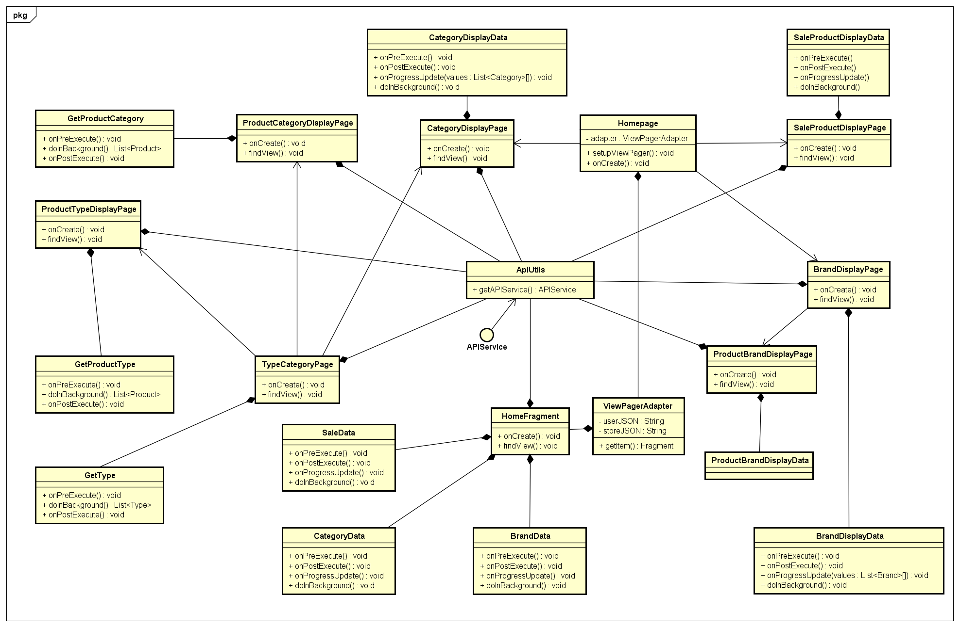

***Figure 4-12 :*** *View Product Class Diagram*

|  |  |  |  |  |
| --- | --- | --- | --- | --- |
| **Class** | **TypeDisplayPage** | | | |
| Description | Activity of “Chủng loại sản phẩm” screen | | | |
| Base Class | BasePage  AppCompatActivity | | | |
| Constructor | TypeDisplayPage() | | | |
| Prototype | N/A | | | |
| Source File | TypeDisplayPage.java | | | |
| Package | project.view.gui | | | |
| **Attribute** | **Name** | **Type** | **Description** | |
| recyclerView | RecyclerView | N/A | |
| adapter | TypePageListViewAdapter | N/A | |
| categoryId | int | Id of category | |
| mAPI | APIService | N/A | |
| tv\_brand\_title | TextView | N/A | |
| loadingBar | ProgressBar | N/A | |
| searchView | SearchView | N/A | |
| imgBack | ImageButton | N/A | |
| imgBarCode | ImageButton | N/A | |
| searchedProduct | List<Type> | N/A | |
| productList | List<Product> | N/A | |
| main\_layout | CoordinatorLayout | N/A | |
| btnViewAll | Button | N/A | |
| **Method** | **Name** | **Output** | **Input** | **Description** |
| onCreate | void | Bundle | N/A |
| setCoverImg | void | N/A | N/A |
| findView | void | N/A | N/A |
| dpToPx | int | int | N/A |

|  |  |  |  |  |
| --- | --- | --- | --- | --- |
| **Class** | **GetType** | | | |
| Description | Asynctask supports asynchronize get type product from server | | | |
| Base Class | Asynctask | | | |
| Constructor | GetType() | | | |
| Prototype | N/A | | | |
| Source File | TypeDisplayPage.java | | | |
| Package | project.view.gui | | | |
| **Attribute** | **Name** | **Type** | **Description** | |
| N/A | N/A | N/A | |
| **Method** | **Name** | **Output** | **Input** | **Description** |
| onPreExecute | void | N/A | N/A |
| doInBackground | List<Type> | Call… | N/A |
| onPostExecute | void | List<Type> | N/A |

|  |  |  |  |  |
| --- | --- | --- | --- | --- |
| **Class** | **ProductTypeDisplayPage** | | | |
| Description | Activity of “Sản phẩm chủng loại” screen | | | |
| Base Class | BasePage  AppCompatActivity | | | |
| Constructor | ProductTypeDisplayPage() | | | |
| Prototype | N/A | | | |
| Source File | ProductTypeDisplayPage.java | | | |
| Package | project.view.gui | | | |
| **Attribute** | **Name** | **Type** | **Description** | |
| productList | List<Product> | Product list | |
| tempProduct | List<Product> | Product list | |
| recyclerView | RecyclerView | N/A | |
| adapter | ProductTypeCustomCardViewAdapter | N/A | |
| filterLable | TextView | N/A | |
| spinnerCategory | Spinner | N/A | |
| spinnerBrand | Spinner | N/A | |
| productFilter | ProductFilter | N/A | |
| **Method** | **Name** | **Output** | **Input** | **Description** |
| onCreate | void | Bundle | N/A |
| findView | void | N/A | N/A |

| **Class** | **GetProductType** | | | |
| --- | --- | --- | --- | --- |
| Description | Asynctask supports asynchronize get products of type from server | | | |
| Base Class | Asynctask | | | |
| Constructor | GetProductType | | | |
| Prototype | N/A | | | |
| Source File | ProductTypeDisplayPage.java | | | |
| Package | project.view.gui | | | |
| **Attribute** | **Name** | **Type** | **Description** | |
| N/A | N/A | N/A | |
| **Method** | **Name** | **Output** | **Input** | **Description** |
| onPreExecute | void | N/A | N/A |
| doInBackground | List<Product> | Call… | N/A |
| onPostExecute | void | List<Product> | N/A |
| onProgressUpdate | void | Void… | N/A |

|  |  |  |  |  |
| --- | --- | --- | --- | --- |
| **Class** | **ProductCategoryDisplayPage** | | | |
| Description | Activity of “Sản phẩm danh mục” screen | | | |
| Base Class | BasePage  AppCompatActivity | | | |
| Constructor | ProductCategoryDisplayPage() | | | |
| Prototype | N/A | | | |
| Source File | ProductCategoryDisplayPage.java | | | |
| Package | project.view.gui | | | |
| **Attribute** | **Name** | **Type** | **Description** | |
| emulatorLoadMoreFaild | boolean | is need to load more | |
| mAPI | APIService | N/A | |
| recyclerView | RecyclerView | N/A | |
| adapter | ProductInCategory  RecyclerViewAdapter | N/A | |
| currentPage | int | current data page | |
| categoryId | int | Id of category | |
| product | List<Product> | Product list | |
| productsLoadMore | List<Product> | Load more product list | |
| mLayoutManager | RecyclerView.LayoutManager | N/A | |
| **Method** | **Name** | **Output** | **Input** | **Description** |
| onCreate | void | Bundle | N/A |
| loadMore | void | int | N/A |

|  |  |  |  |  |  |  |  |
| --- | --- | --- | --- | --- | --- | --- | --- |
| **Class** | **GetProductCategory** | | | | | | |
| Description | Asynctask supports asynchronize get products of cateogry from server | | | | | | |
| Base Class | Asynctask | | | | | | |
| Constructor | GetProductCategory | | | | | | |
| Prototype | N/A | | | | | | |
| Source File | ProductCategoryDisplayPage.java | | | | | | |
| Package | project.view.gui | | | | | | |
| **Attribute** | **Name** | | **Type** | **Description** | | | |
| N/A | | N/A | N/A | | | |
| **Method** | **Name** | | **Output** | **Input** | | **Description** | |
| onPreExecute | | void | N/A | | N/A | |
| doInBackground | | List<Product> | Call… | | N/A | |
| onPostExecute | | void | List<Product> | | N/A | |
| onProgressUpdate | | void | Void… | | N/A | |
| **Class** | **CategoryDisplayPage** | | | | | | |
| Description | Activity of “Danh mục sản phẩm” screen | | | | | | |
| Base Class | BasePage  AppCompatActivity | | | | | | |
| Constructor | CategoryDisplayPage() | | | | | | |
| Prototype | N/A | | | | | | |
| Source File | CategoryDisplayPage.java | | | | | | |
| Package | project.view.gui | | | | | | |
| **Attribute** | **Name** | **Type** | | | **Description** | | |
| main\_layout | CoordinatorLayout | | | N/A | | |
| apiService | APIService | | | N/A | | |
| recyclerView | RecyclerView | | | N/A | | |
| adapter | CategoryCustomCardviewAdapter | | | N/A | | |
| categoryList | List<Category> | | | Category list | | |
| loadingBar | ProgressBar | | | N/A | | |
| searchView | SearchView | | | N/A | | |
| imgBack | ImageButton | | | N/A | | |
| imgBarCode | ImageButton | | | N/A | | |
| searchedProduct | List<Category> | | | Category list | | |
| **Method** | **Name** | **Output** | | | **Input** | | **Description** |
| onCreate | void | | | Bundle | | N/A |
| findView | void | | | N/A | | N/A |

|  |  |  |  |  |
| --- | --- | --- | --- | --- |
| **Class** | **CategoryDisplayData** | | | |
| Description | Asynctask supports asynchronize get products of category from server | | | |
| Base Class | Asynctask | | | |
| Constructor | CategoryDisplayData | | | |
| Prototype | N/A | | | |
| Source File | CategoryDisplayPage.java | | | |
| Package | project.view.gui | | | |
| **Attribute** | **Name** | **Type** | **Description** | |
| N/A | N/A | N/A | |
| **Method** | **Name** | **Output** | **Input** | **Description** |
| onPreExecute | void | N/A | N/A |
| doInBackground | Void | Call… | N/A |
| onPostExecute | void | Void | N/A |
| onProgressUpdate | void | List<Category>... | N/A |

|  |  |  |  |  |
| --- | --- | --- | --- | --- |
| **Class** | **CategoryData** | | | |
| Description | Asynctask supports asynchronize get top 20 categories from server | | | |
| Base Class | Asynctask | | | |
| Constructor | N/A | | | |
| Prototype | N/A | | | |
| Source File | HomePage.java | | | |
| Package | project.view.gui | | | |
| **Attribute** | **Name** | **Type** | **Description** | |
| N/A | N/A | N/A | |
| **Method** | **Name** | **Output** | **Input** | **Description** |
| onPreExecute | void | N/A | N/A |
| N/A | Void | Call… | N/A |
| onPostExecute | void | Void | N/A |
| onProgressUpdate | void | List<Category>... | N/A |

|  |  |  |  |  |
| --- | --- | --- | --- | --- |
| **Class** | **SaleData** | | | |
| Description | Asynctask supports asynchronize get top 20 sale products from server | | | |
| Base Class | Asynctask | | | |
| Constructor | N/A | | | |
| Prototype | N/A | | | |
| Source File | HomePage.java | | | |
| Package | project.view.gui | | | |
| **Attribute** | **Name** | **Type** | **Description** | |
| N/A | N/A | N/A | |
| **Method** | **Name** | **Output** | **Input** | **Description** |
| onPreExecute | void | N/A | N/A |
| doInBackground | Void | Call… | N/A |
| onPostExecute | void | Void | N/A |
| onProgressUpdate | void | List<Product>... | N/A |

|  |  |  |  |  |
| --- | --- | --- | --- | --- |
| **Class** | **BrandData** | | | |
| Description | Asynctask supports asynchronize get top 20 brands from server | | | |
| Base Class | Asynctask | | | |
| Constructor | N/A | | | |
| Prototype | N/A | | | |
| Source File | HomePage.java | | | |
| Package | project.view.gui | | | |
| **Attribute** | **Name** | **Type** | **Description** | |
| N/A | N/A | N/A | |
| **Method** | **Name** | **Output** | **Input** | **Description** |
| onPreExecute | void | N/A | N/A |
| doInBackground | Void | Call… | N/A |
| onPostExecute | void | Void | N/A |
| onProgressUpdate | void | List<Brand>... | N/A |

|  |  |  |  |  |
| --- | --- | --- | --- | --- |
| **Class** | **BrandDisplayPage** | | | |
| Description | Activity of “Thương hiệu” screen | | | |
| Base Class | BasePage  AppCompatActivity | | | |
| Constructor | BrandDisplayPage() | | | |
| Prototype | N/A | | | |
| Source File | BrandDisplayPage.java | | | |
| Package | project.view.gui | | | |
| **Attribute** | **Name** | **Type** | **Description** | |
| main\_layout | CoordinatorLayout | N/A | |
| recyclerView | RecyclerView | N/A | |
| adapter | BrandCustomCardviewAdapter | N/A | |
| brandList | List<Brand> | Brand list | |
| apiService | APIService | N/A | |
| loadingBar | ProgressBar | N/A | |
| searchView | SearchView | N/A | |
| imgBack | ImageButton | N/A | |
| imgBarCode | ImageButton | N/A | |
| searchedProduct | List<Brand> | Brand list | |
| **Method** | **Name** | **Output** | **Input** | **Description** |
| onCreate | void | Bundle | N/A |
| findView | void | N/A | N/A |
| dpToPx | int | int | N/A |

|  |  |  |  |  |
| --- | --- | --- | --- | --- |
| **Class** | **ProductBrandDisplayPage** | | | |
| Description | Activity of “Sản phẩm thương hiệu” screen | | | |
| Base Class | BasePage  AppCompatActivity | | | |
| Constructor | ProductBrandDisplayPage() | | | |
| Prototype | N/A | | | |
| Source File | ProductBrandDisplayPage.java | | | |
| Package | project.view.gui | | | |
| **Attribute** | **Name** | **Type** | **Description** | |
| theListView | ListView | N/A | |
| brandID | int | Id of brand | |
| adapter | ProductBrandDisplay  ListViewAdapter | N/A | |
| list | List<Product> | Product list | |
| apiService | APIService | N/A | |
| brandName | String | Name of brand | |
| searchView | SearchView | N/A | |
| main\_layout | RelativeLayout | N/A | |
| loadingBar | ProgressBar | N/A | |
| locationManager | LocationManager | N/A | |
| REQUEST\_LOCATION | int | Code request location | |
| **Method** | **Name** | **Output** | **Input** | **Description** |
| onCreate | void | Bundle | N/A |
| turnOnLocation | void | N/A | N/A |

|  |  |  |  |  |
| --- | --- | --- | --- | --- |
| **Class** | **ViewPagerAdapter** | | | |
| Description | Class supports in setting layout | | | |
| Base Class | FragmentStatePagerAdapter | | | |
| Constructor | ViewPagerAdapter(FragmentManager manager, String userJSON,String storeJSON) | | | |
| Prototype | N/A | | | |
| Source File | ViewPagerAdapter.java | | | |
| Package | project.view.adapter | | | |
| **Attribute** | **Name** | **Type** | **Description** | |
| mFragmentList | List<Fragment> | Fragment list | |
| userJSON | String | N/A | |
| storeJSON | String | N/A | |
| **Method** | **Name** | **Output** | **Input** | **Description** |
| getItem | void | int | N/A |
| addFragment | void | Fragment | N/A |

|  |  |  |  |  |
| --- | --- | --- | --- | --- |
| **Class** | **ProductBrandDisplayData** | | | |
| Description | Asynctask supports asynchronize get products of brands from server | | | |
| Base Class | Asynctask | | | |
| Constructor | ProductBrandDisplayData() | | | |
| Prototype | N/A | | | |
| Source File | ProductBrandDisplayPage.java | | | |
| Package | project.view.gui | | | |
| **Attribute** | **Name** | **Type** | **Description** | |
| N/A | N/A | N/A | |
| **Method** | **Name** | **Output** | **Input** | **Description** |
| onPreExecute | void | N/A | N/A |
| doInBackground | Void | Call… | N/A |
| onPostExecute | void | Void | N/A |
| onProgressUpdate | void | Void… | N/A |

|  |  |  |  |  |  |  |  |
| --- | --- | --- | --- | --- | --- | --- | --- |
| **Class** | **SaleProductDisplayPage** | | | | | | |
| Description | Activity of “Sản phẩm giảm giá” screen | | | | | | |
| Base Class | BasePage  AppCompatActivity | | | | | | |
| Constructor | SaleProductDisplayPage() | | | | | | |
| Prototype | N/A | | | | | | |
| Source File | SaleProductDisplayPage.java | | | | | | |
| Package | project.view.gui | | | | | | |
| **Attribute** | **Name** | | **Type** | | **Description** | | |
| imgBarCode | | ImageView | | N/A | | |
| recycler\_view | | RecyclerView | | N/A | | |
| saleProductCustom  CardviewAdapter | | ProductBrandDisplay  ListViewAdapter | | N/A | | |
| backBtn | | ImageView | | N/A | | |
| apiService | | APIService | | N/A | | |
| spinnerCategory | | Spinner | | N/A | | |
| spinnerSort | | Spinner | | N/A | | |
| products | | List<Product> | | Product list | | |
| main\_layout | | CoordinatorLayout | | N/A | | |
| searchView | | SearchView | | N/A | | |
| tempProductInStore | | List<Product> | | Product list | | |
| productFilter | | ProductFilter | | N/A | | |
| loadingBar | | ProgressBar | | N/A | | |
| **Method** | **Name** | | **Output** | | **Input** | **Description** | |
| onCreate | | void | | Bundle | N/A | |
| turnOnLocation | | void | | N/A | N/A | |
| findView | | void | | N/A | N/A | |
| customView | | void | | N/A | N/A | |
| **Class** | **SaleProductDisplayData** | | | | | | |
| Description | Asynctask supports asynchronize get sale products from server | | | | | | |
| Base Class | Asynctask | | | | | | |
| Constructor | SaleProductDisplayData() | | | | | | |
| Prototype | N/A | | | | | | |
| Source File | SaleProductDisplayPage.java | | | | | | |
| Package | project.view.gui | | | | | | |
| **Attribute** | **Name** | **Type** | | **Description** | | | |
| N/A | N/A | | N/A | | | |
| **Method** | **Name** | **Output** | | **Input** | | | **Description** |
| onPreExecute | void | | N/A | | | N/A |
| doInBackground | Void | | Call… | | | N/A |
| onPostExecute | void | | Void | | | N/A |
| onProgressUpdate | void | | List<Product>… | | | N/A |

##### Find Nearby Store By Product

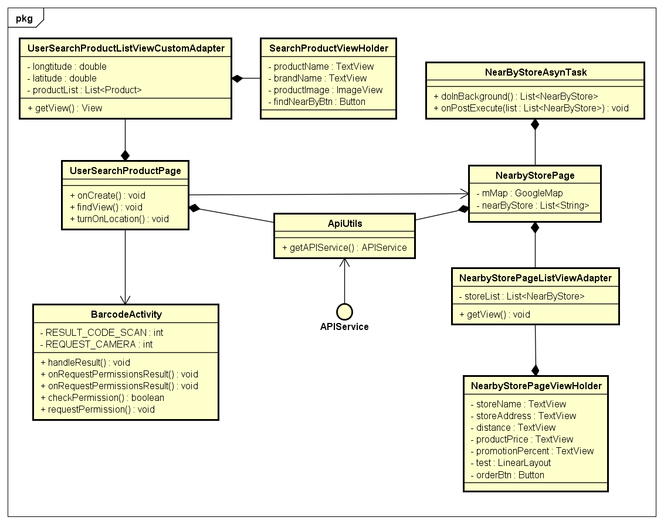

***Figure 4-13 :*** *Find Nearby Store By Product Class Diagram*

|  |  |  |  |  |
| --- | --- | --- | --- | --- |
| **Class** | **UserSearchProductListViewCustomAdapter** | | | |
| Description | Class supports in setting layout int listview | | | |
| Base Class | ArrayAdapter | | | |
| Constructor | N/A | | | |
| Prototype | N/A | | | |
| Source File | UserSearchProductListViewCustomAdapter.java | | | |
| Package | project.view.adapter | | | |
| **Attribute** | **Name** | **Type** | **Description** | |
| context | Context | N/A | |
| productList | List<Product> | N/A | |
| storageReference | StorageReference | N/A | |
| longtitude | double | Longtitude of store | |
| latitude | double | Latitude of store | |
| **Method** | **Name** | **Output** | **Input** | **Description** |
| getView | View | int  View  ViewGroup | N/A |

|  |  |  |  |  |
| --- | --- | --- | --- | --- |
| **Class** | **SearchProductViewHolder** | | | |
| Description | Class defines components in searched product listview | | | |
| Base Class | N/A | | | |
| Constructor | SearchProductViewHolder | | | |
| Prototype | N/A | | | |
| Source File | UserSearchProductListViewCustomAdapter.java | | | |
| Package | project.view.adapter | | | |
| **Attribute** | **Name** | **Type** | **Description** | |
| productName | TextView | N/A | |
| brandName | TextView | N/A | |
| productImage | ImageView | N/A | |
| findNearByBtn | Button | N/A | |
| **Method** | **Name** | **Output** | **Input** | **Description** |
| N/A | N/A | N/A | N/A |

|  |  |  |  |  |
| --- | --- | --- | --- | --- |
| **Class** | **NearbyStorePageListViewAdapter** | | | |
| Description | Class supports in setting layout int listview | | | |
| Base Class | ArrayAdapter | | | |
| Constructor | NearByStoreListViewAdapter() | | | |
| Prototype | N/A | | | |
| Source File | NearByStoreListViewAdapter.java | | | |
| Package | project.view.adapter | | | |
| **Attribute** | **Name** | **Type** | **Description** | |
| context | Context | N/A | |
| storeList | List<NearByStore> | N/A | |
| product | Product | N/A | |
| myStore | Store | N/A | |
| **Method** | **Name** | **Output** | **Input** | **Description** |
| getView | View | int  View  ViewGroup | N/A |
| restoringPreferences | void | N/A | N/A |

|  |  |  |  |  |
| --- | --- | --- | --- | --- |
| **Class** | **NearbyStorePageViewHolder** | | | |
| Description | Class defines components in nearbt store listview | | | |
| Base Class | N/A | | | |
| Constructor | NearbyStorePageViewHolder() | | | |
| Prototype | N/A | | | |
| Source File | NearByStoreListViewAdapter.java | | | |
| Package | project.view.adapter | | | |
| **Attribute** | **Name** | **Type** | **Description** | |
| storeName | TextView | N/A | |
| storeAddress | TextView | N/A | |
| distance | TextView | N/A | |
| productPrice | TextView | N/A | |
| promotionPercent | TextView | N/A | |
| saleProduct | TextView | N/A | |
| orderBtn | Button | N/A | |
| **Method** | **Name** | **Output** | **Input** | **Description** |
| N/A | N/A | N/A | N/A |

##### Manage Feedback

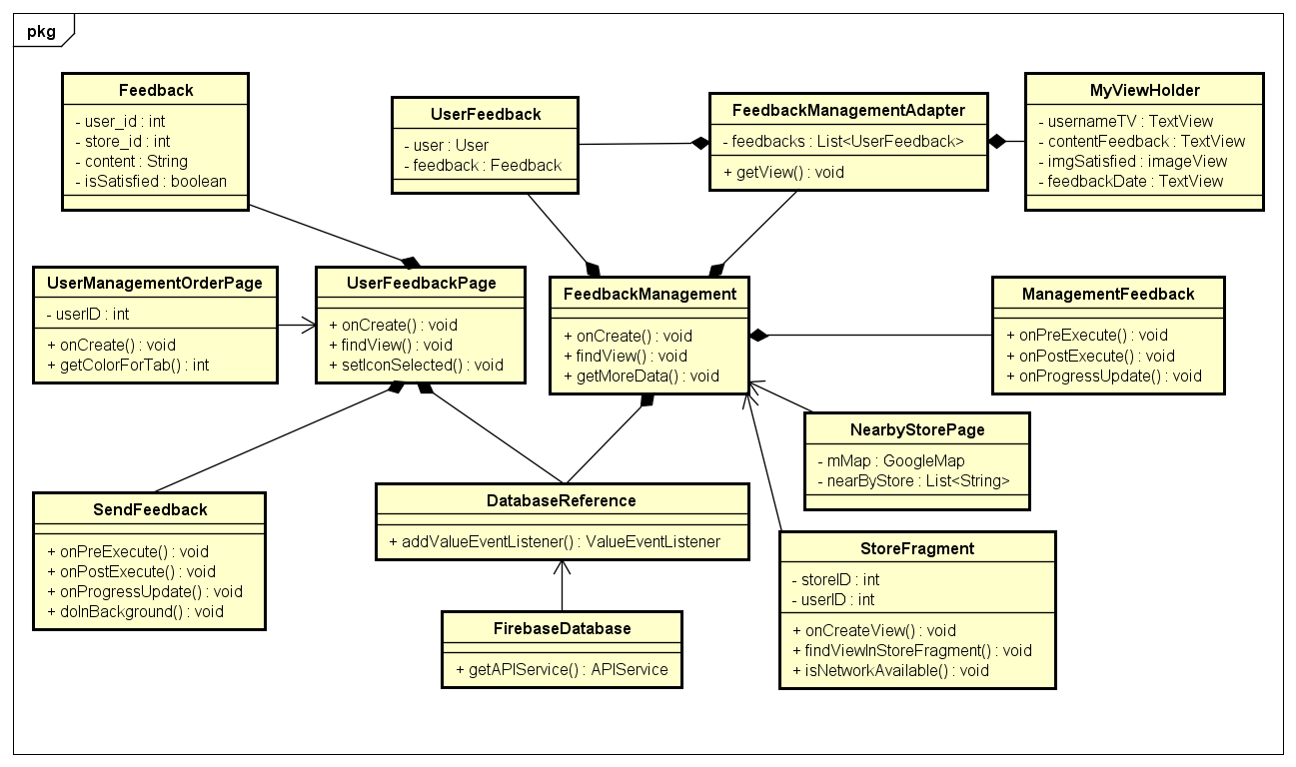

***Figure 4-14 :*** *Manage Feedback Class Diagram*

|  |  |  |  |  |  |
| --- | --- | --- | --- | --- | --- |
| **Class** | **SendFeedback** | | | | |
| Description | Asynctask supports asynchronize get products of type from server | | | | |
| Base Class | Asynctask | | | | |
| Constructor | SendFeedback() | | | | |
| Prototype | N/A | | | | |
| Source File | UserFeedbackPage.java | | | | |
| Package | project.view.gui | | | | |
| **Attribute** | **Name** | | **Type** | **Description** | |
| N/A | | N/A | N/A | |
| **Method** | **Name** | | **Output** | **Input** | **Description** |
| onPreExecute | | void | N/A | N/A |
| doInBackground | | Boolean | Call… | N/A |
| onPostExecute | | result | Boolean | N/A |
| onProgressUpdate | | void | Void… | N/A |
| **Class** | **UserFeedbackPage** | | | | |
| Description | Activity of “Đánh giá cửa hàng” screen | | | | |
| Base Class | BasePage  AppCompatActivity | | | | |
| Constructor | UserFeedbackPage () | | | | |
| Prototype | N/A | | | | |
| Source File | UserFeedbackPage.java | | | | |
| Package | project.view.gui | | | | |
| **Attribute** | **Name** | **Type** | | **Description** | |
| main\_layout | LinearLayout | | N/A | |
| isSmile | boolean | | is satisfied or not | |
| isSad | boolean | | is satisfied or not | |
| smile\_checked | ImageView | | N/A | |
| sad\_checked | ImageView | | N/A | |
| back\_btn | ImageView | | N/A | |
| tv\_feedback\_status | TextView | | N/A | |
| error\_mess | TextView | | N/A | |
| btn\_send\_feedback | Button | | N/A | |
| content\_feedback | EditText | | N/A | |
| loadingBar | ProgressBar | | N/A | |
| userId | int | | Id of user | |
| storeId | int | | Id of store | |
| database | FirebaseDatabase | | N/A | |
| myRef | DatabaseReference | | N/A | |
| orderId | String | | Id of order | |
| **Method** | **Name** | **Output** | | **Input** | **Description** |
| onCreate | void | | Bundle | N/A |
| dialog | void | | N/A | N/A |
| findView | void | | N/A | N/A |
| setIconSelected | void | | N/A | N/A |

|  |  |  |  |  |
| --- | --- | --- | --- | --- |
| **Class** | **Feedback** | | | |
| Description | Object contains feedback information | | | |
| Base Class | Serializable | | | |
| Constructor | Feedback() | | | |
| Prototype | N/A | | | |
| Source File | Feedback.java | | | |
| Package | Project.model | | | |
| **Attribute** | **Name** | **Type** | **Description** | |
| user\_id | int | Id of user | |
| store\_id | int | Id of store | |
| content | String | Content of feedback | |
| isSatisfied | boolean | is satisfied or not | |
| **Method** | **Name** | **Output** | **Input** | **Description** |
| N/A | N/A | N/A | N/A |

|  |  |  |  |  |
| --- | --- | --- | --- | --- |
| **Class** | **FeedbackManagement** | | | |
| Description | Activity of “Đánh giá về cửa hàng” screen | | | |
| Base Class | BasePage  AppCompatActivity | | | |
| Constructor | ViewStoreFeedbackPage () | | | |
| Prototype | N/A | | | |
| Source File | FeedbackManagement.java | | | |
| Package | project.view.gui | | | |
| **Attribute** | **Name** | **Type** | **Description** | |
| list | List<UserFeedback> | UserFeedback list | |
| storeId | int | Id of store | |
| feedbackManagementAdapter | FeedbackManagement  Adapter | N/A | |
| listView | ListView | N/A | |
| footerView | View | N/A | |
| isLoading | boolean | is loading data or not | |
| page | int | current page data | |
| mHandle | Handler | N/A | |
| **Method** | **Name** | **Output** | **Input** | **Description** |
| onCreate | void | Bundle | N/A |
| findView | void | N/A | N/A |

|  |  |  |  |  |
| --- | --- | --- | --- | --- |
| **Class** | **FeedbackManagementAdapter** | | | |
| Description | Class supports in setting layout int listview | | | |
| Base Class | ArrayAdapter | | | |
| Constructor | N/A | | | |
| Prototype | N/A | | | |
| Source File | FeedbackManagementAdapter.java | | | |
| Package | project.view.adapter | | | |
| **Attribute** | **Name** | **Type** | **Description** | |
| context | Context | N/A | |
| feedbacks | List<UserFeedback> | UserFeedback list | |
| **Method** | **Name** | **Output** | **Input** | **Description** |
| getView | View | int  View  ViewGroup | N/A |

|  |  |  |  |  |
| --- | --- | --- | --- | --- |
| **Class** | **MyViewHolder** | | | |
| Description | Class defines components in feedback listview | | | |
| Base Class | N/A | | | |
| Constructor | MyViewHolder () | | | |
| Prototype | N/A | | | |
| Source File | MyViewHolder.java | | | |
| Package | project.view.adapter | | | |
| **Attribute** | **Name** | **Type** | **Description** | |
| usernameTV | TextView | N/A | |
| contentFeedback | TextView | N/A | |
| imgSatisfied | ImageView | N/A | |
| feedbackDate | TextView | N/A | |
| **Method** | **Name** | **Output** | **Input** | **Description** |
| N/A | N/A | N/A | N/A |

|  |  |  |  |  |
| --- | --- | --- | --- | --- |
| **Class** | **UserFeedback** | | | |
| Description | Object contains user feedback information | | | |
| Base Class | Serializable | | | |
| Constructor | UserFeedback() | | | |
| Prototype | N/A | | | |
| Source File | UserFeedback.java | | | |
| Package | Project.model | | | |
| **Attribute** | **Name** | **Type** | **Description** | |
|  | user | User | Object User | |
|  | feedback | Feedback | Object Feedback | |
| **Method** | **Name** | **Output** | **Input** | **Description** |
| N/A | N/A | N/A | N/A |

## Sequence Diagram

### Logout

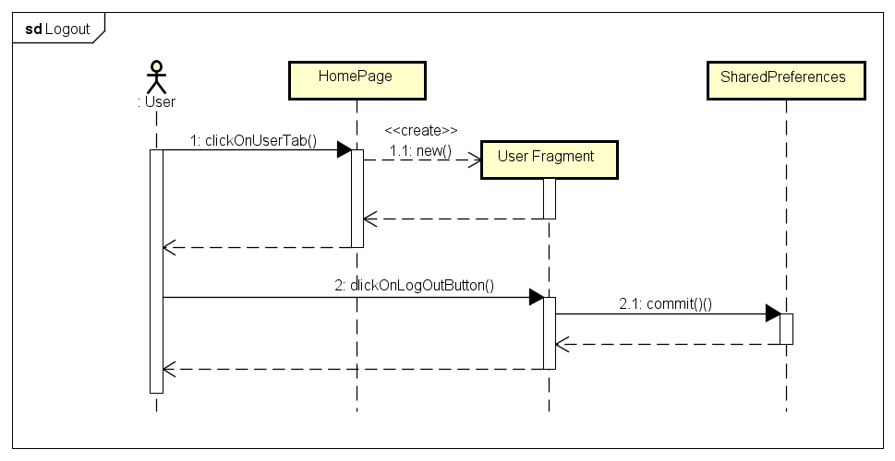

***Figure 4-15 :*** *Logout Sequence Diagram*

* 1. User clicks on “Người dùng” tab with icon in Home screen.



* 1. User clicks on “Đăng xuất” button in “Người dùng” screen.

### Login with 3S account

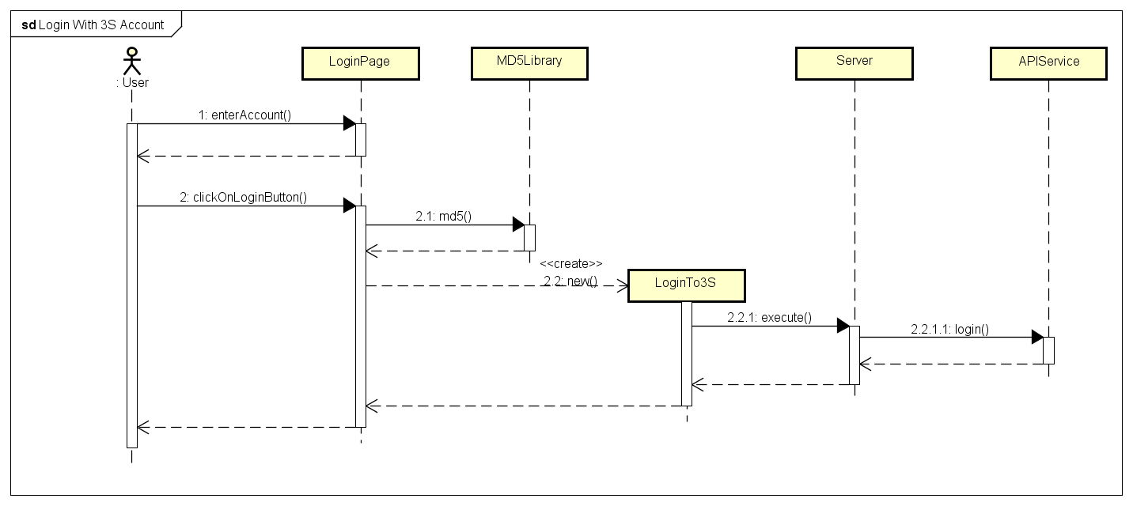

***Figure 4-16 :*** *Login With 3S Account Sequence Diagram*

* 1. User enter 3S account to login form in “Đăng nhập” screen.
  2. User clicks on “Đăng nhập” button in “Đăng nhập” screen.

### Login With Facebook Account

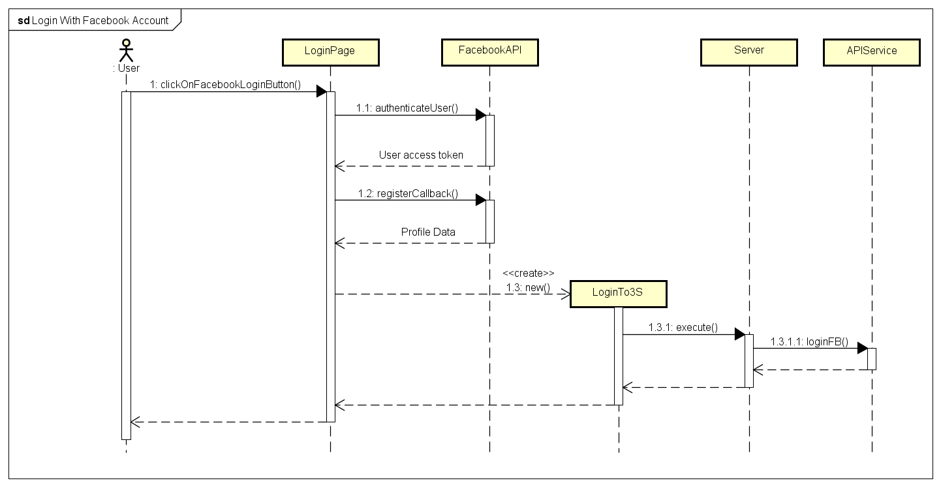

***Figure 4-17 :*** *Login With Facebook Account Sequence Diagram*

* 1. User clicks on “Đăng nhập với tài khoản Facebook” button in “Đăng nhập” screen.

### View User Order History

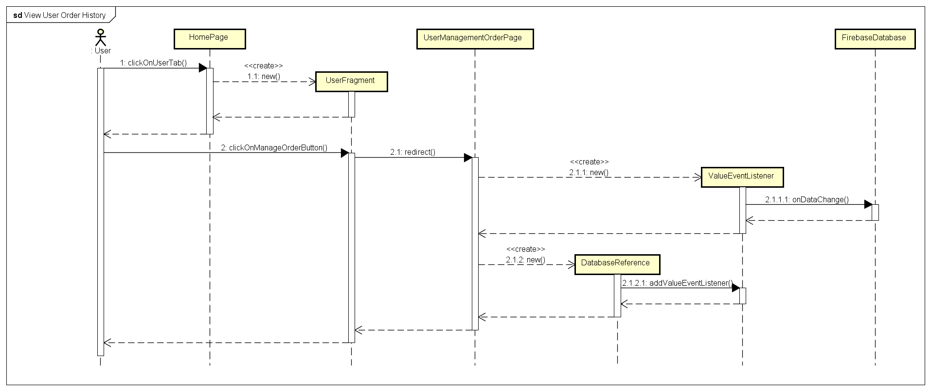

***Figure 4-18 :*** *ViewUser Order History Sequence Diagram*

* 1. User clicks on “Người dùng” tab with  icon in Home screen.
  2. Users clicks on “Quản lý đơn hàng” button in “Người dùng” screen.
  3. “Quản lý đơn hàng” in User role is displayed.

### View Store Order History

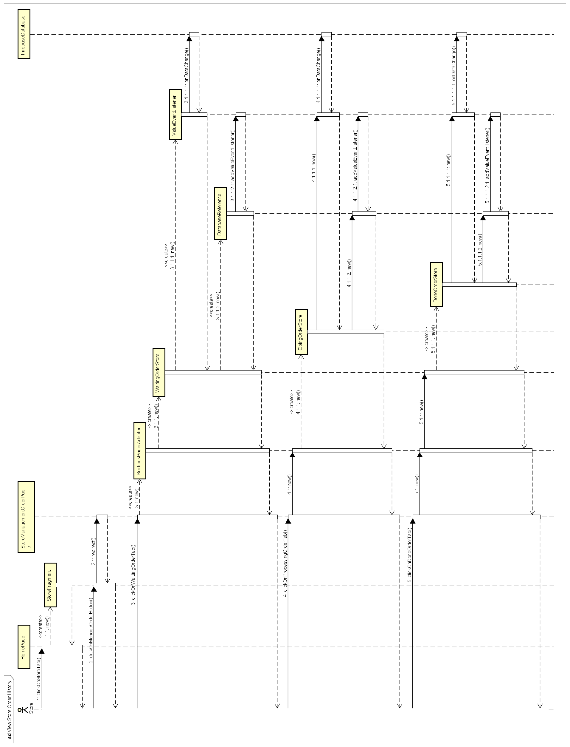

***Figure 4-18 :*** *View Store Order History Sequence Diagram*

* 1. Store clicks on “Cửa hàng” tab with icon in Home screen.



* 1. Store clicks on “Quản lý đơn hàng” in “Cửa hàng” screen.
  2. “Quản lý đơn hàng” in Store role is displayed.

### Cancel Order

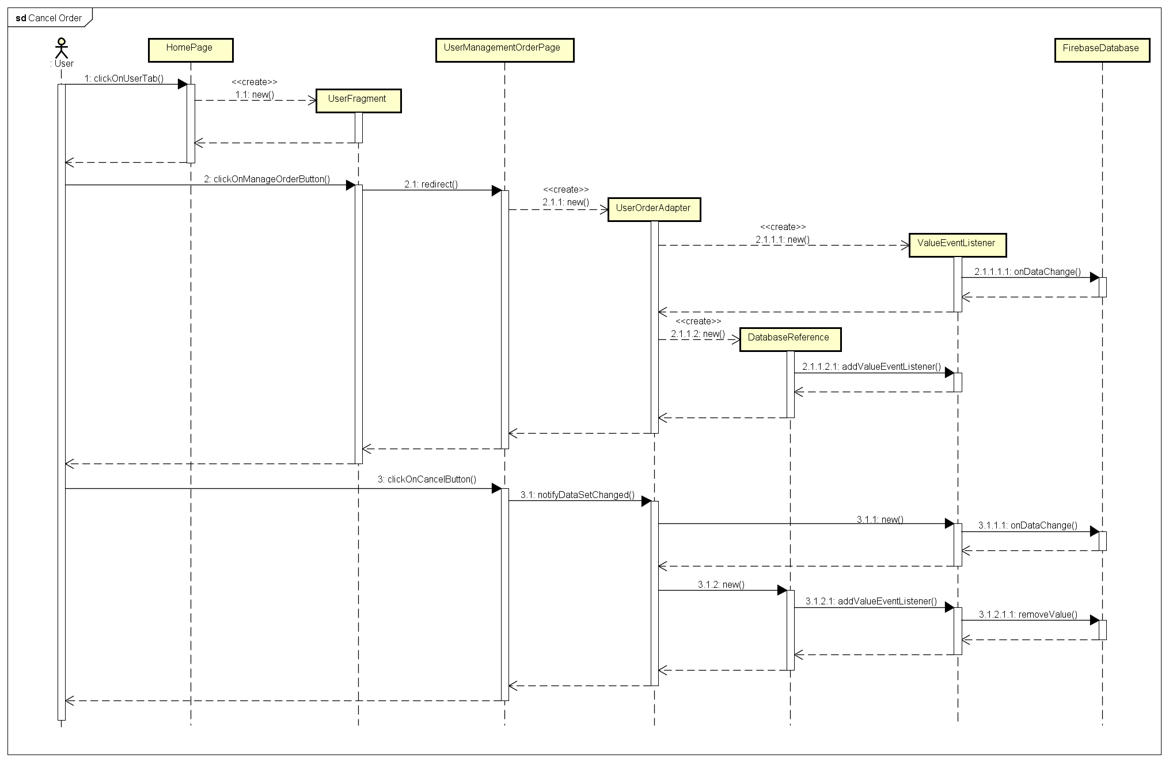

***Figure 4-20 :*** *Cancel Order Sequence Diagram*

* 1. User clicks on “Người dùng” tab with  icon in Home screen.
  2. User clicks on “Quản lý đơn hàng” button in “Người dùng” screen.
  3. User clicks on “Hủy đơn hàng” button in waitting order detail layout.

### Accept Order

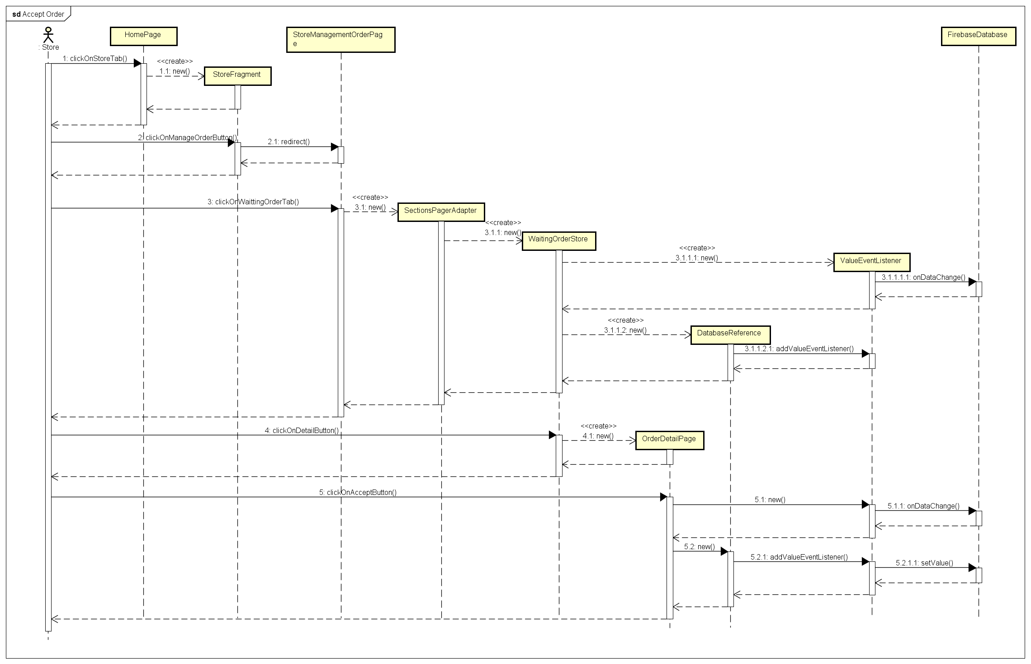

***Figure 4-21 :*** *Accept Order Sequence Diagram*

* 1. Store clicks on “Cửa hàng” tab with  icon in Home screen.
  2. Store clicks on “Quản lý đơn hàng” in “Cửa hàng” screen.
  3. Store clicks on “Chi tiết” borderless button in “Đợi xử lý” tab.
  4. Store clicks on “Chấp thuận” button in “Thông tin đơn hàng” screen.
  5. Store clicks on “Đồng ý” button in confirm dialog.

### Reject Order

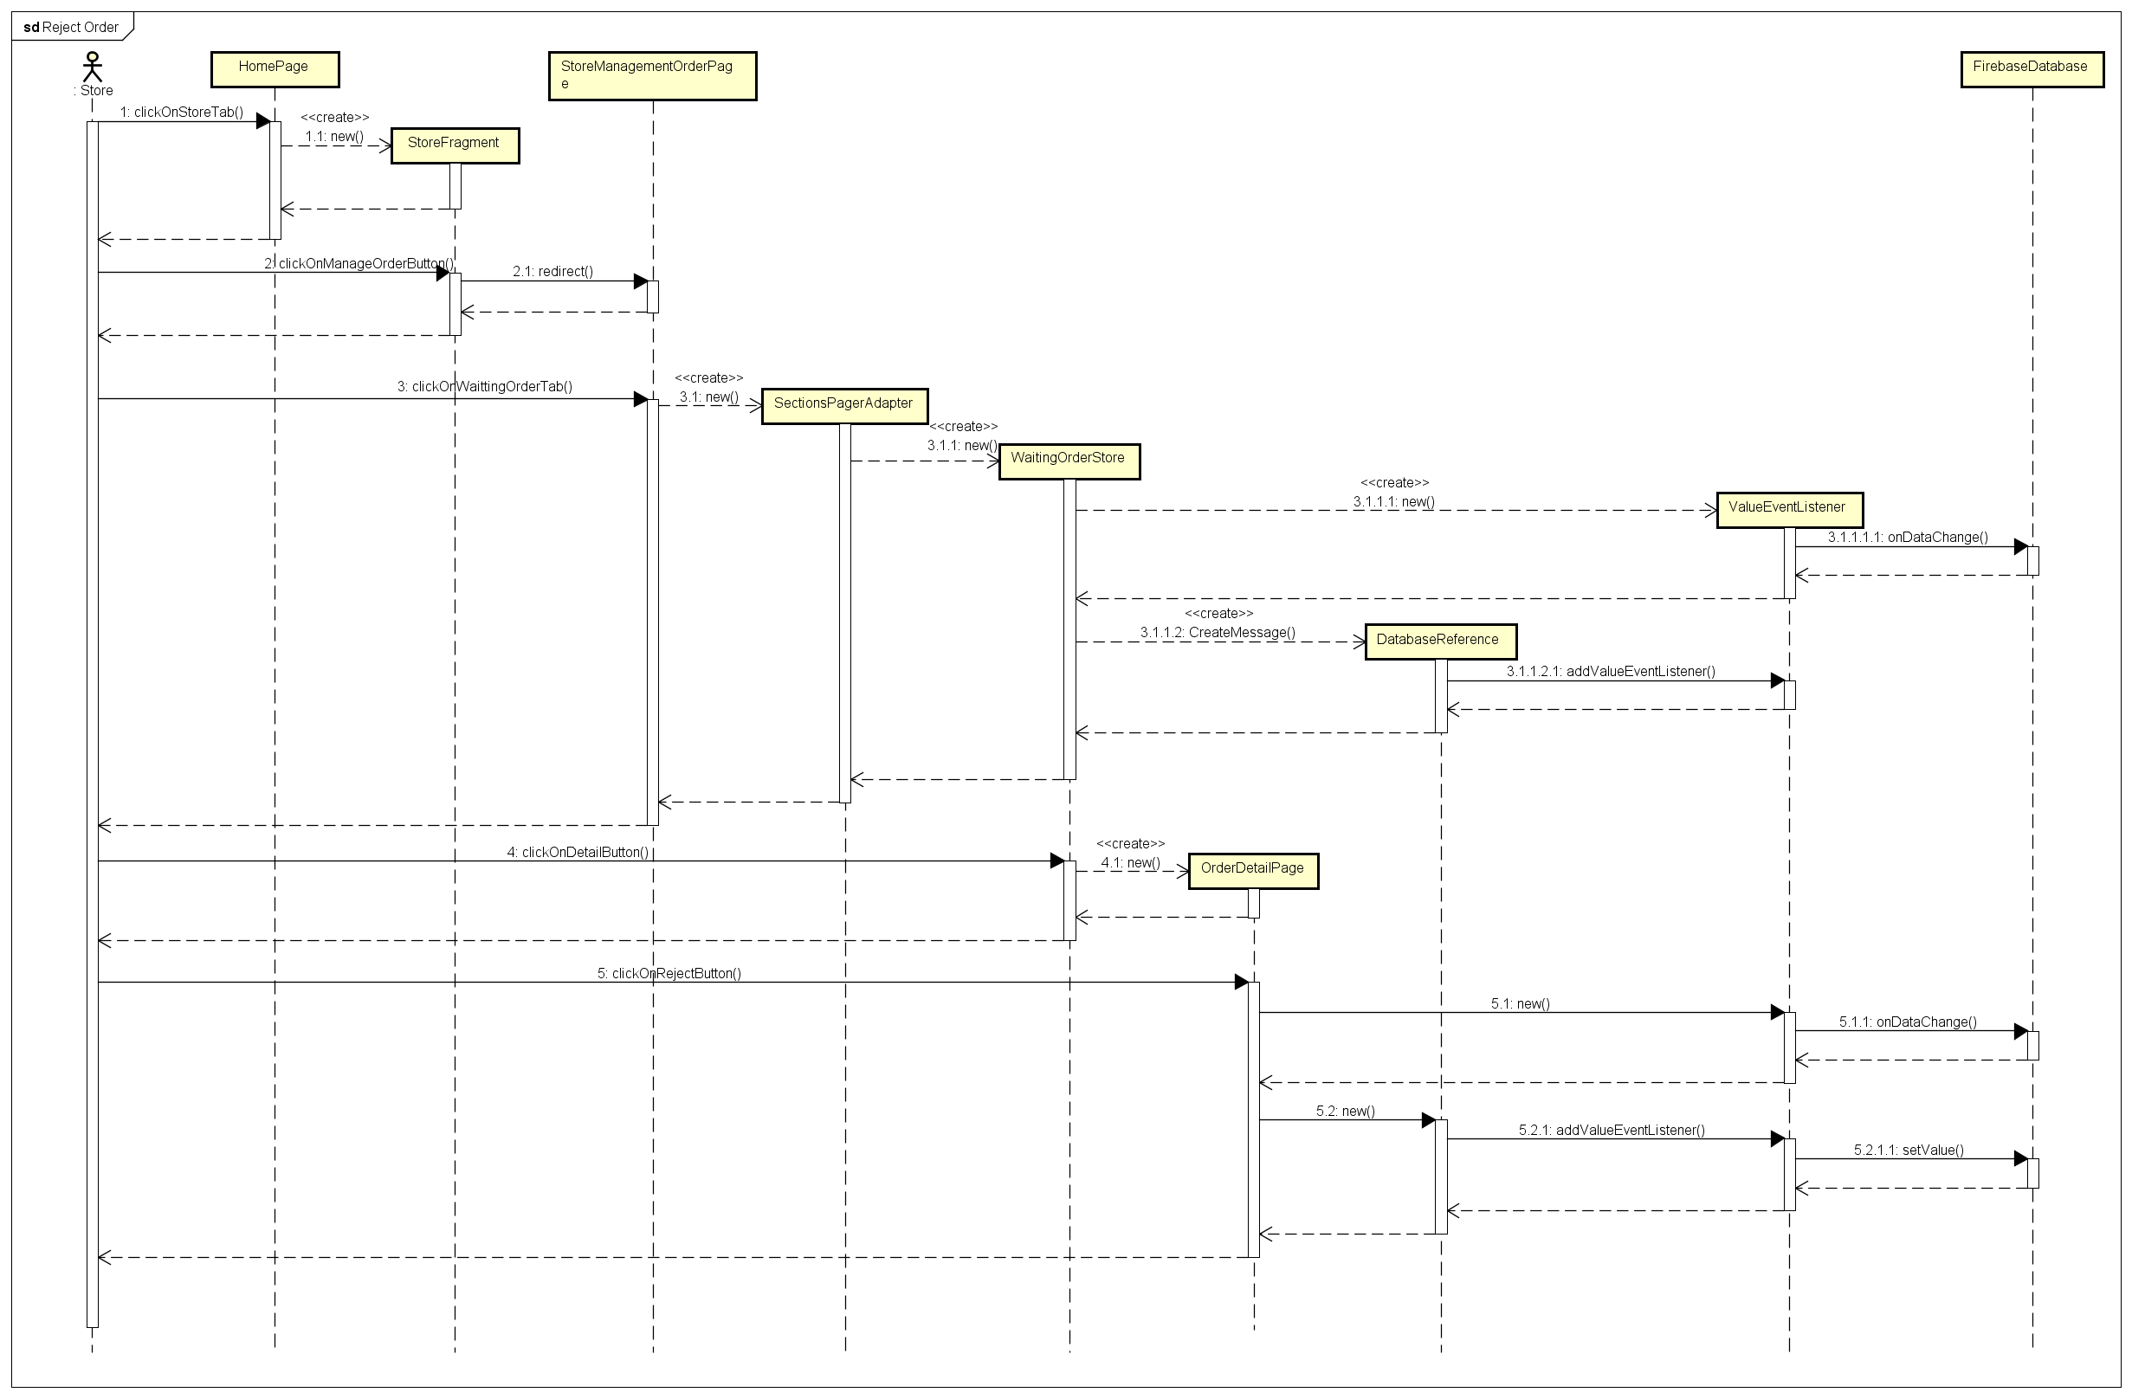

***Figure 4-22 :*** *Reject Order Sequence Diagram*

* 1. Store clicks on “Cửa hàng” tab with  icon in Home screen.
  2. Store clicks on “Quản lý đơn hàng” in “Cửa hàng” screen.
  3. Store clicks on “Chi tiết” borderless button in “Đợi xử lý” tab.
  4. Store clicks on “Từ chối” button in “Thông tin đơn hàng” screen.
  5. Store clicks on “Đồng ý” button in confirm dialog.

### Close Order

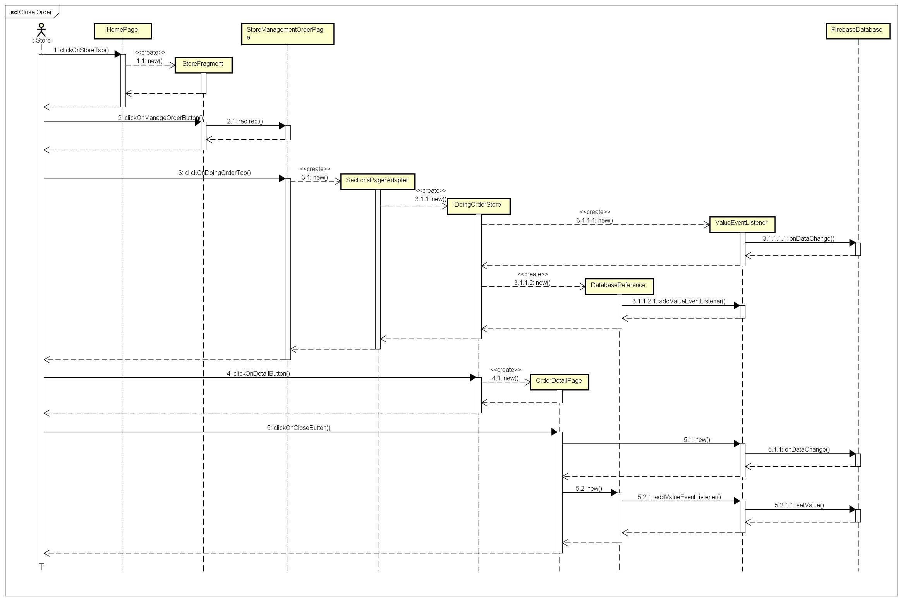

***Figure 4-23 :****Close Order Sequence Diagram*

* 1. Store clicks on “Cửa hàng” tab with  icon in Home screen.
  2. Store clicks on “Quản lý đơn hàng” button in “Cửa hàng” screen.
  3. Store clicks on “Chi tiết” borderless button in “Đang xử lý” tab.
  4. Store clicks on “Đã giao hàng” button in “Thông tin đơn hàng” screen.
  5. Store clicks on “Đồng ý” button in confirm dialog.

### Register a New Store

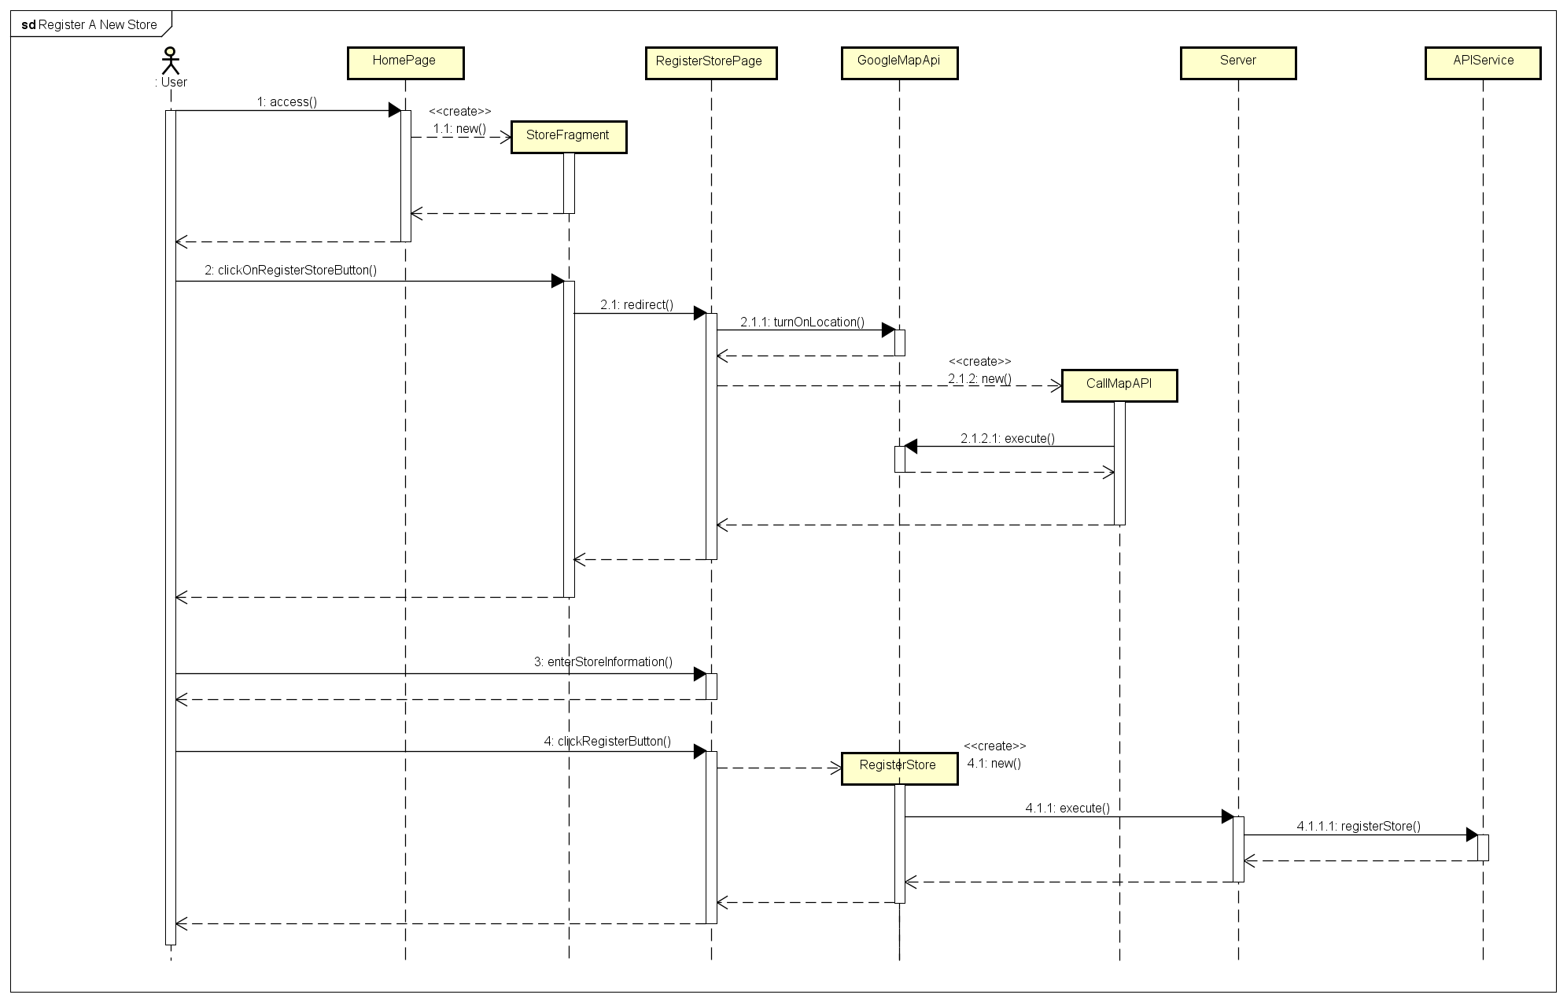

***Figure 4-24 :*** *Register A New Store Sequence Diagram*

* 1. User clicks on “Cửa hàng” tab with  icon in Home screen.
  2. User clicks on “Đăng kí cửa hàng” button in “Cửa hàng” screen.
  3. User fill out register store form in “Đăng kí cửa hàng” screen.
  4. User clicks on “Đăng kí” in “Đăng kí cửa hàng” screen.

### View Store Information by User

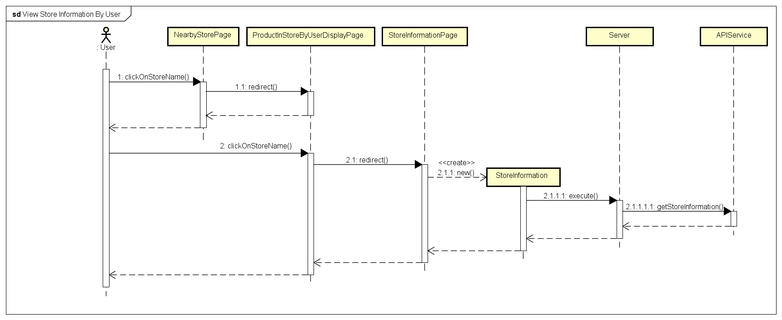

***Figure 4-25 :*** *View Store Information By User Sequence Diagram*

* 1. User clicks on store name in store detail layout in “Cửa hàng gần đây” screen.

### View Store Information by Store

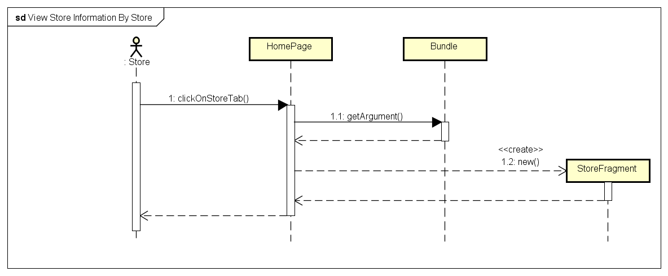

***Figure 4-26 :*** *View Store Information By Store Sequence Diagram*

* 1. Store clicks on “Cửa hàng” tab with  icon in Home screen.

### Change Store Information

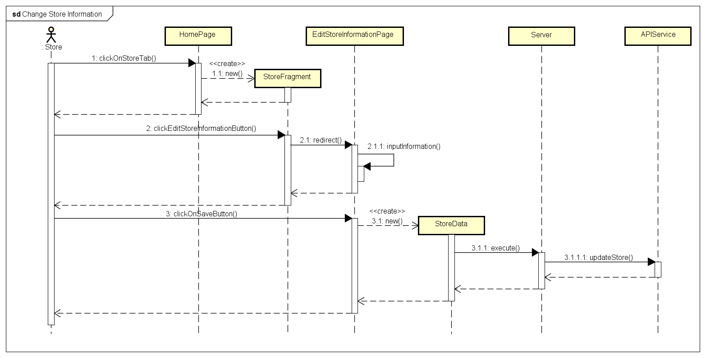

***Figure 4-27 :*** *Change Store Information Sequence Diagram*

* 1. Store clicks on “Cửa hàng” tab with  icon in Home screen.
  2. Store clicks on “Thay đổi thông tin cửa hàng” button with in “Cửa hàng” screen.



* 1. Store enters needed-change informations to form
  2. Store clicks on “Lưu thay đổi” button

### View User Information

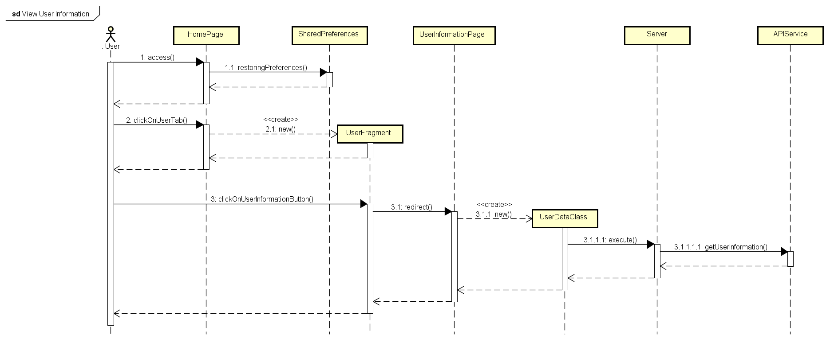

***Figure 4-28 :*** *View User Information Sequence Diagram*

* 1. User clicks on “Người dùng” tab with icon in Home screen.



* 1. User clicks on “Thông tin tài khoản” layout in “Người dùng” screen.

### Change Account Information

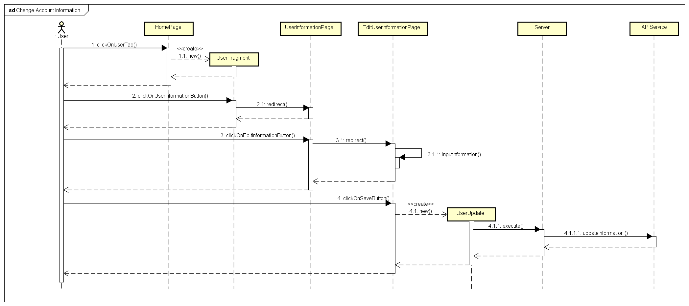

***Figure 4-29 :*** *Change Account Information Sequence Diagram*

* 1. User clicks on “Người dùng” tab with  icon in Home screen.
  2. User clicks on “Thông tin tài khoản” layout in “Người dùng” screen.
  3. User clicks on “Thay đổi thông tin” button in “Thông tin tài khoản” screen.
  4. User enters needed-change information to form.
  5. User clicks on “Lưu thay đổi” button in “Thay đổi thông tin người dùng” screen.

### Register a New Account

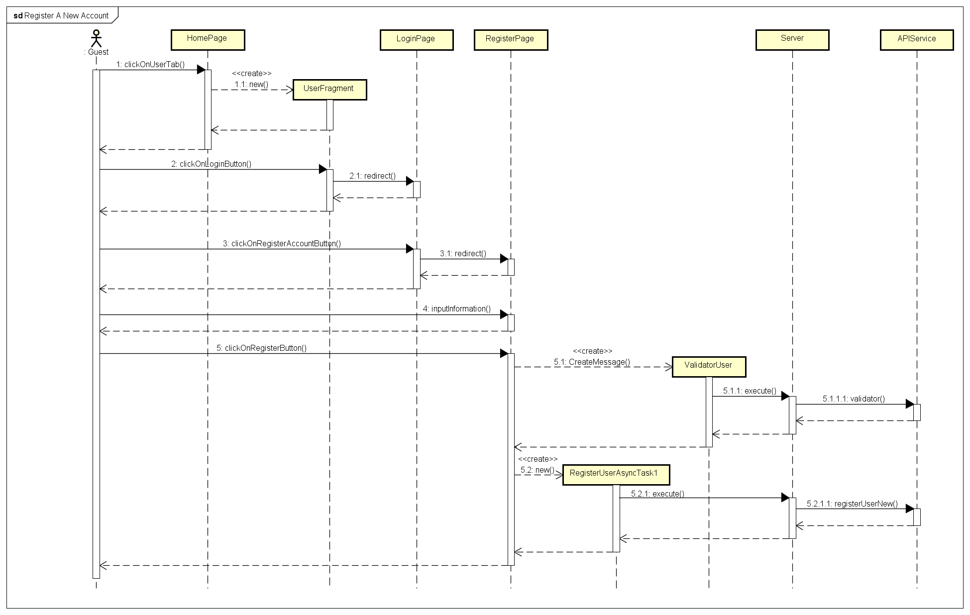

***Figure 4-30 :*** *Register A New Account Sequence Diagram*

* 1. User clicks on “Người dùng” tab with  icon in Home screen.
  2. User clicks on “Đăng nhập” layout in “Người dùng” screen.
  3. User clicks on “Đăng kí” button in “Đăng nhập” screen.
  4. User fills out register account form in valid data.
  5. User clicks on “Đăng kí” button.

### Find Nearby Store by Product With Barcode

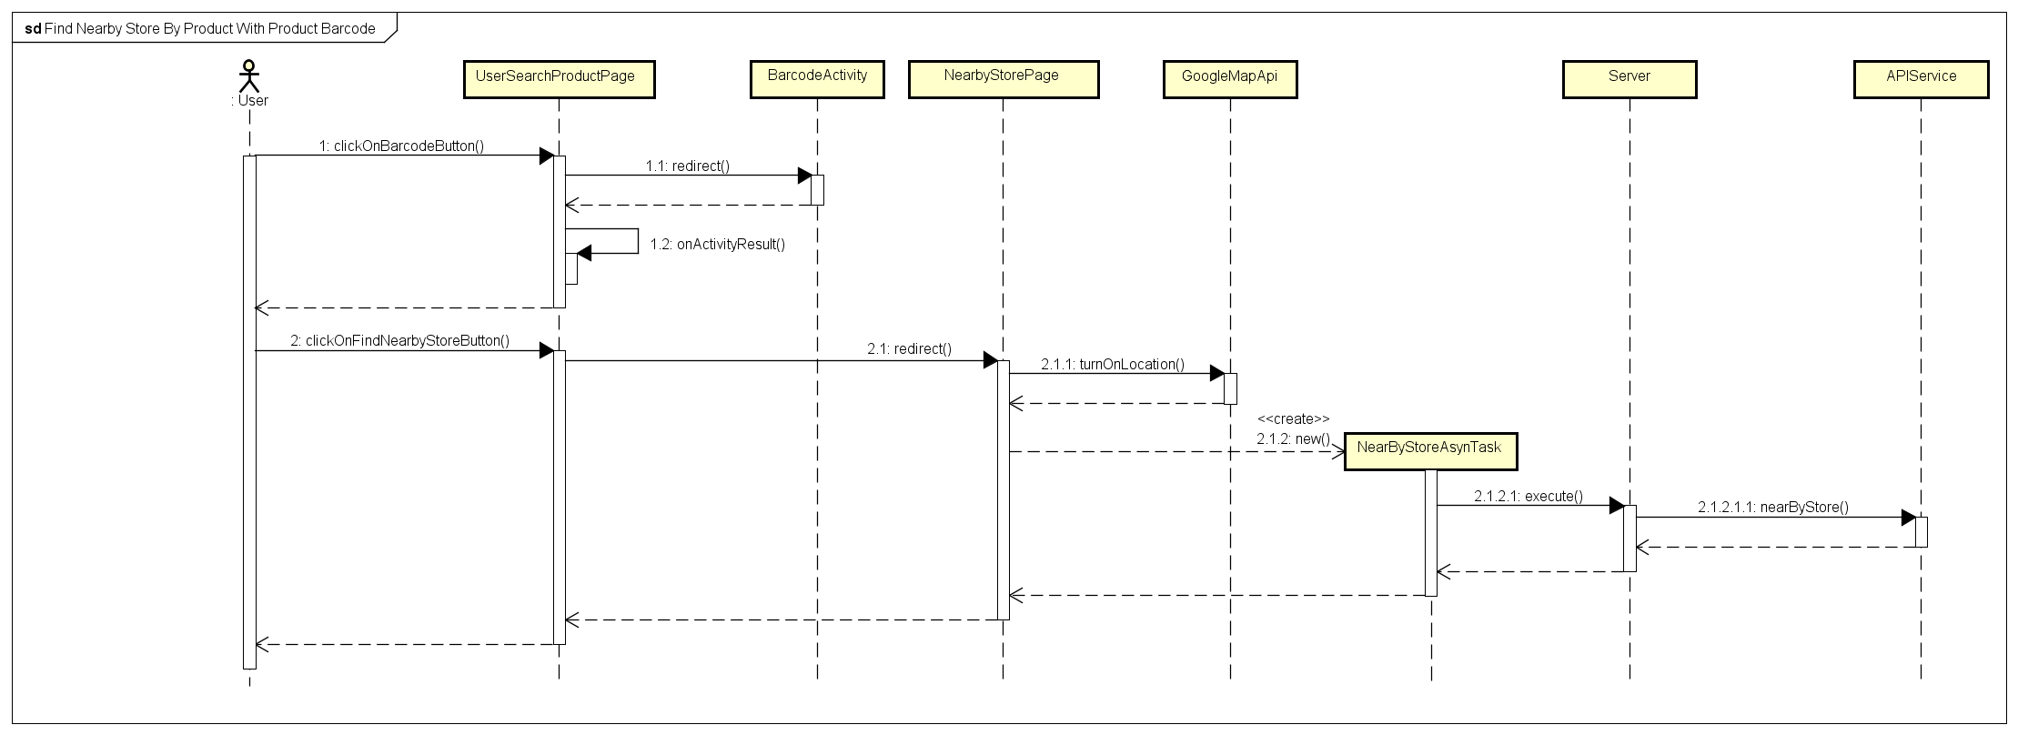

***Figure 4-31 :*** *Find Nearby Store by Product With Barcode Sequence Diagram*

* 1. User clicks on “Scan Barcode” button with icon in “Tìm kiếm sản phẩm” screen.



* 1. User scans product barcode
  2. User clicks on “Tìm cửa hàng” button in product layout.

### Find Nearby Store by Product with Name

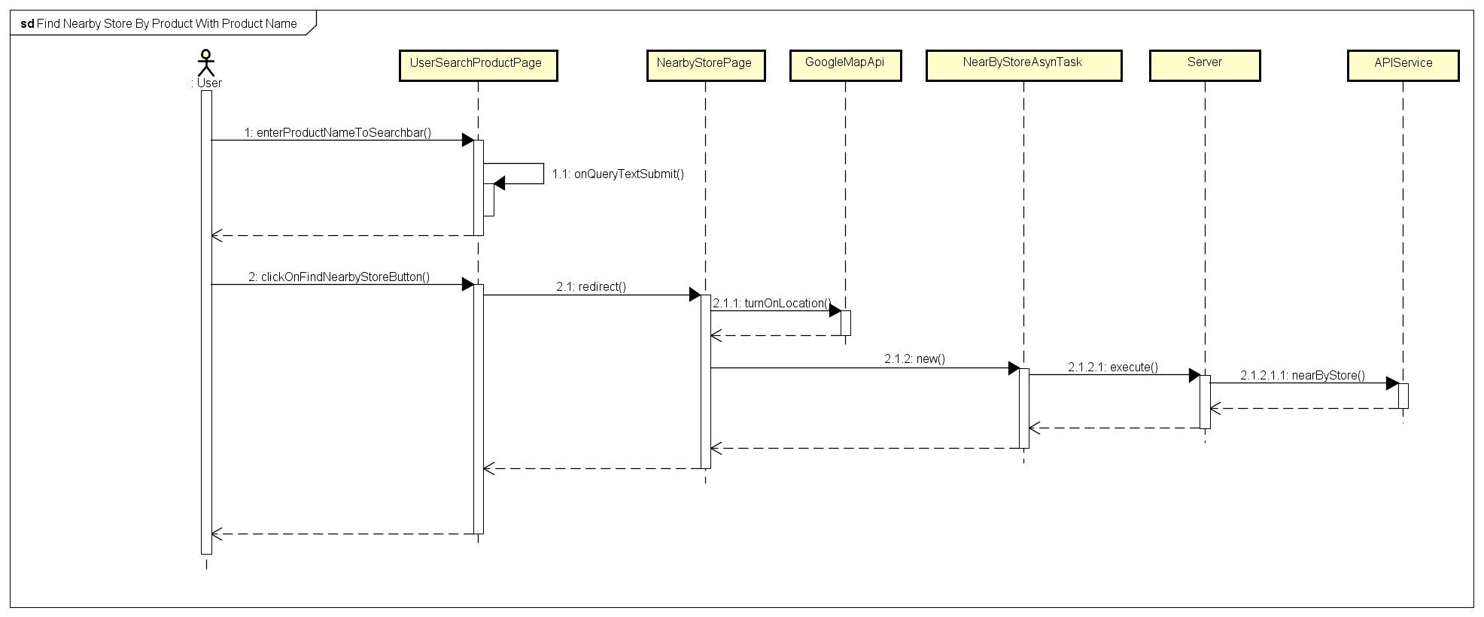

***Figure 4-32 :*** *Find Nearby Store by Product With Name Sequence Diagram*

* 1. User enters product name to search bar in “Tìm kiếm sản phẩm” screen, then submit.
  2. User clicks on “Tìm cửa hàng” button in product layout.

### Search Product by Name

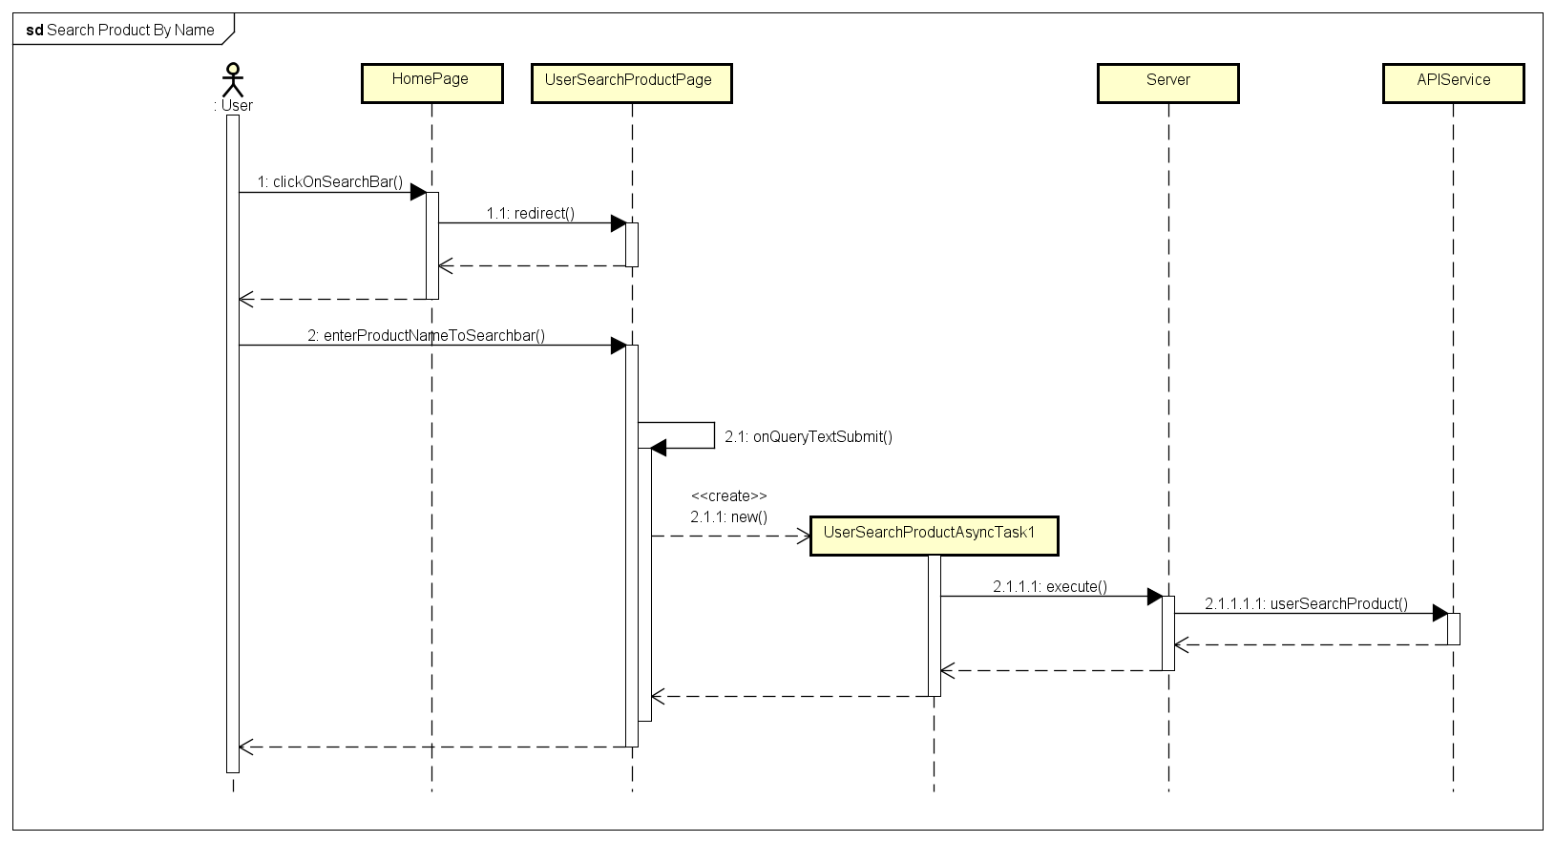

***Figure 4-33 :*** *Search Product By Name Sequence Diagram*

* 1. User clicks on search bar in Home screen.
  2. User enters product name to search bar in “Tìm kiếm sản phẩm” screen, then submit.

### Search Product by Barcode

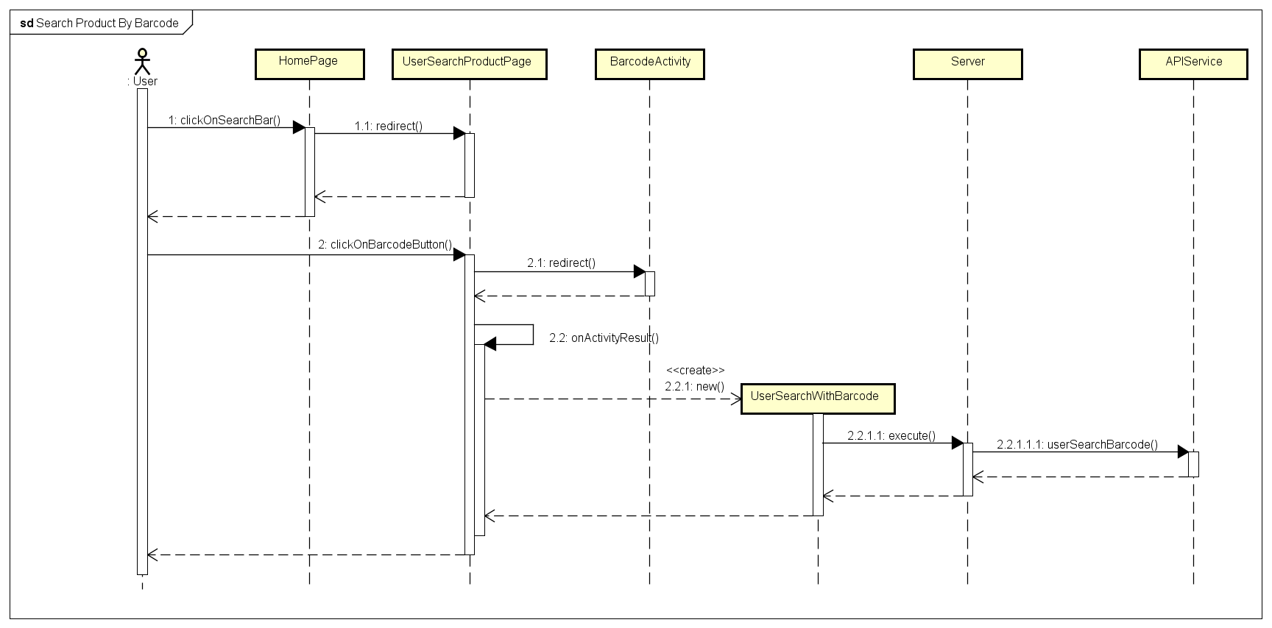

***Figure 4-34 :*** *Search product By Barcode Sequence Diagram*

* 1. User clicks on search bar in Home screen.
  2. User clicks on “Scan Barcode” button with  icon in “Tìm kiếm sản phẩm” screen.
  3. User scans product barcode

### View Product Detail

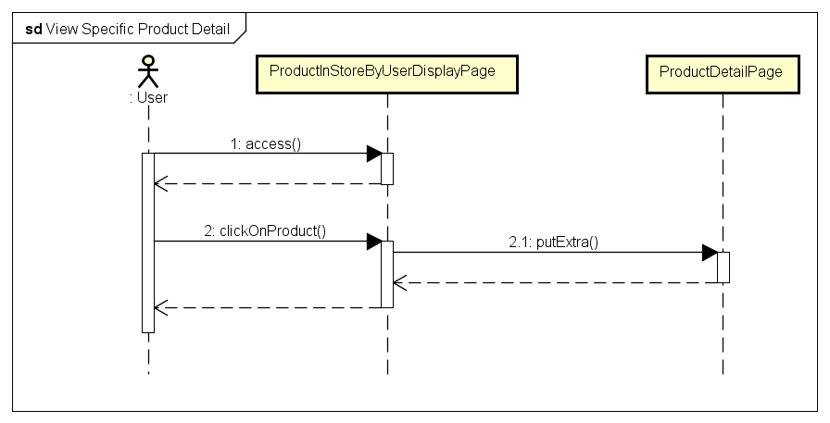

***Figure 4-35 :*** *View Specific Product Detail Sequence Diagram*

* 1. User clicks on product name or product image in “Sản phẩm cửa hàng” screen.

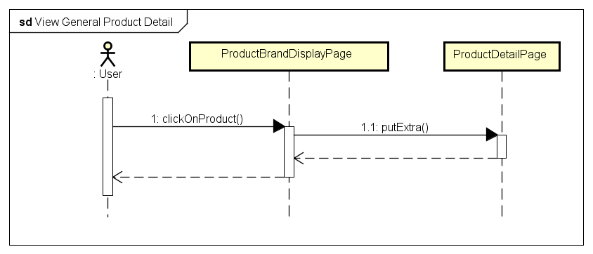

***Figure 4-36 :*** *View General Product Detail Sequence Diagram*

* 1. User clicks on product name or product image in “Sản phẩm thương hiệu” screen.

### View Product in Category

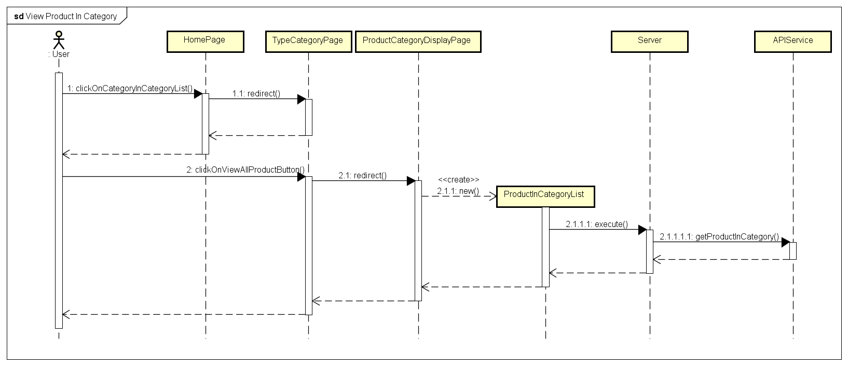

***Figure 4-37 :*** *View Product In Category Sequence Diagram*

* 1. User clicks on any one category in “Danh mục sản phẩm” layout in Home screen.
  2. User clicks on “Xem tất cả sản phẩm” button in “Chủng loại danh mục” screen.

### View Product in Type

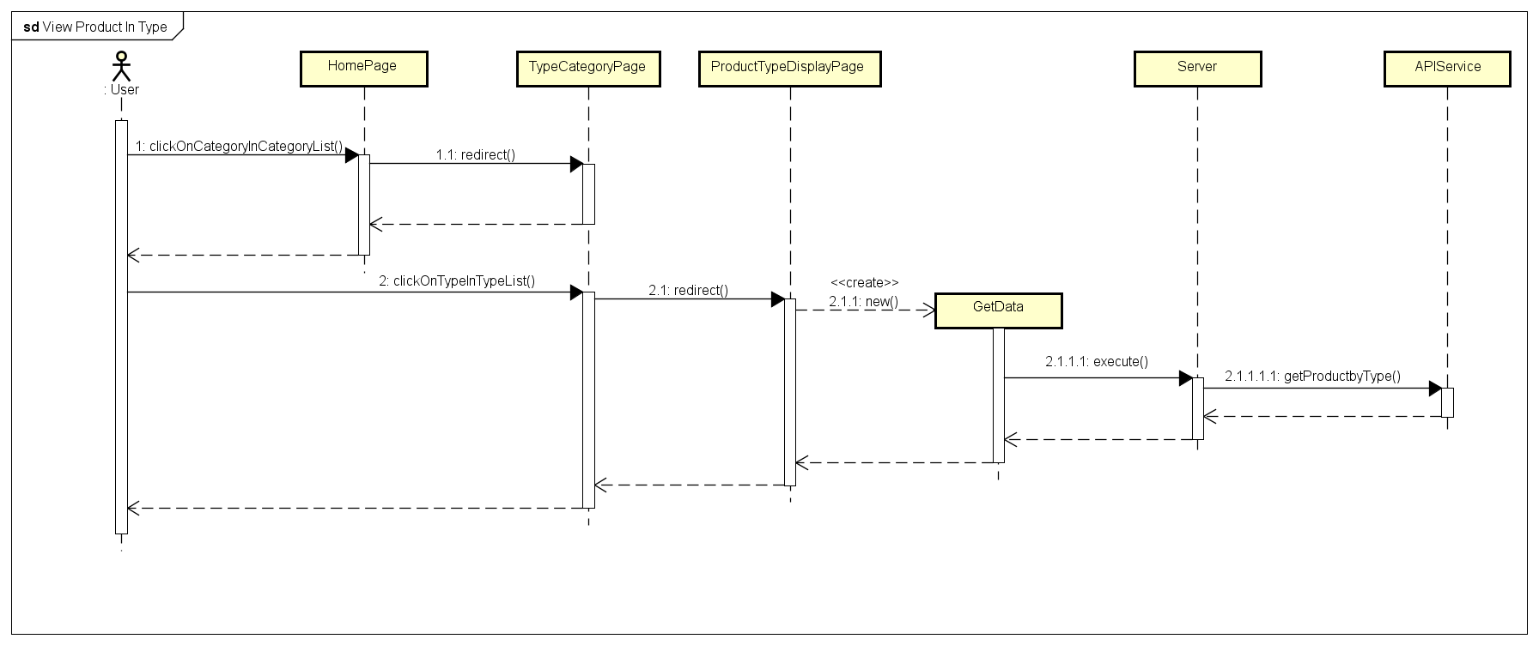

***Figure 4-38 :*** *View Product In Type Sequence Diagram*

* 1. User clicks on any one category in “Danh mục sản phẩm” layout in Home screen.
  2. User clicks on any one type in “Chủng loại danh mục” screen.

### View Product in Brand

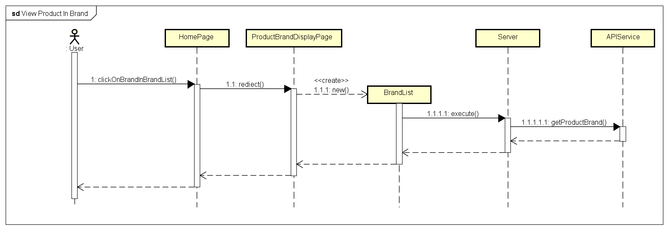

***Figure 4-39 :*** *View Product In Brand Sequence Diagram*

1. User clicks on any one brand in “Thương hiệu” layout in Home screen.

### View Product on Sale

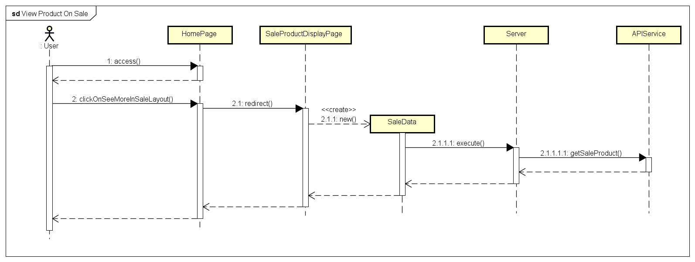

***Figure 4-40 :*** *View Product On SaleSequence Diagram*

* 1. User clicks on “Xem thêm” button in “Sản phẩm giảm giá” layout in Home screen.

### View Product in Store

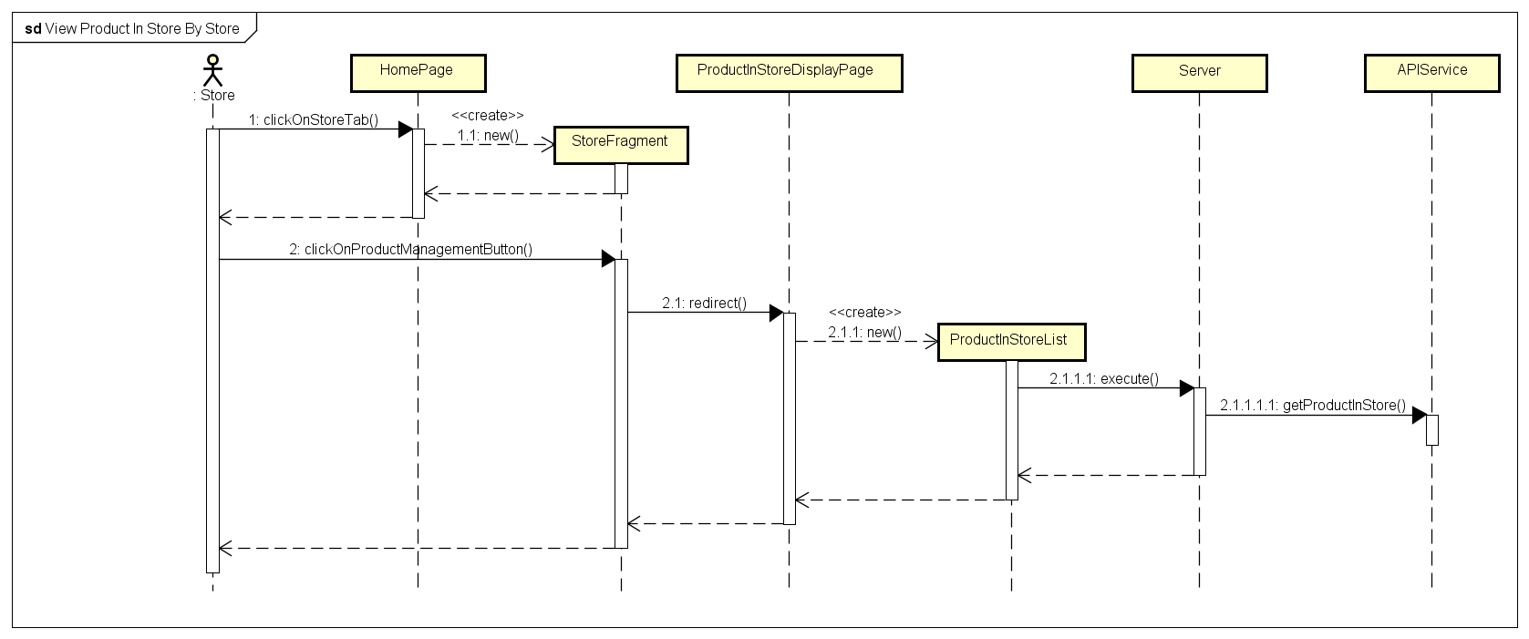

***Figure 4-41 :*** *View Product In Store Sequence Diagram*

* 1. Store clicks on “Cửa hàng” tab with  icon in Home screen.
  2. Store clicks on “Quản lý sản phẩm” button in “Cửa hàng” screen.

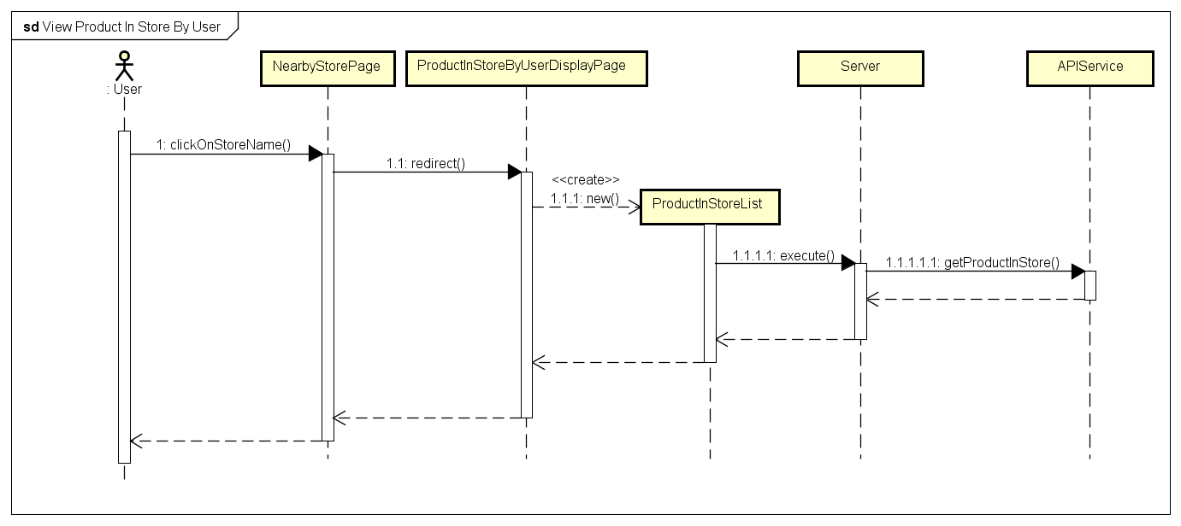

***Figure 4-42 :*** *View Product In Store Sequence Diagram*

* 1. User clicks on store name in store detail layout in “Cửa hàng gần đây” screen.

### Add Product by Name

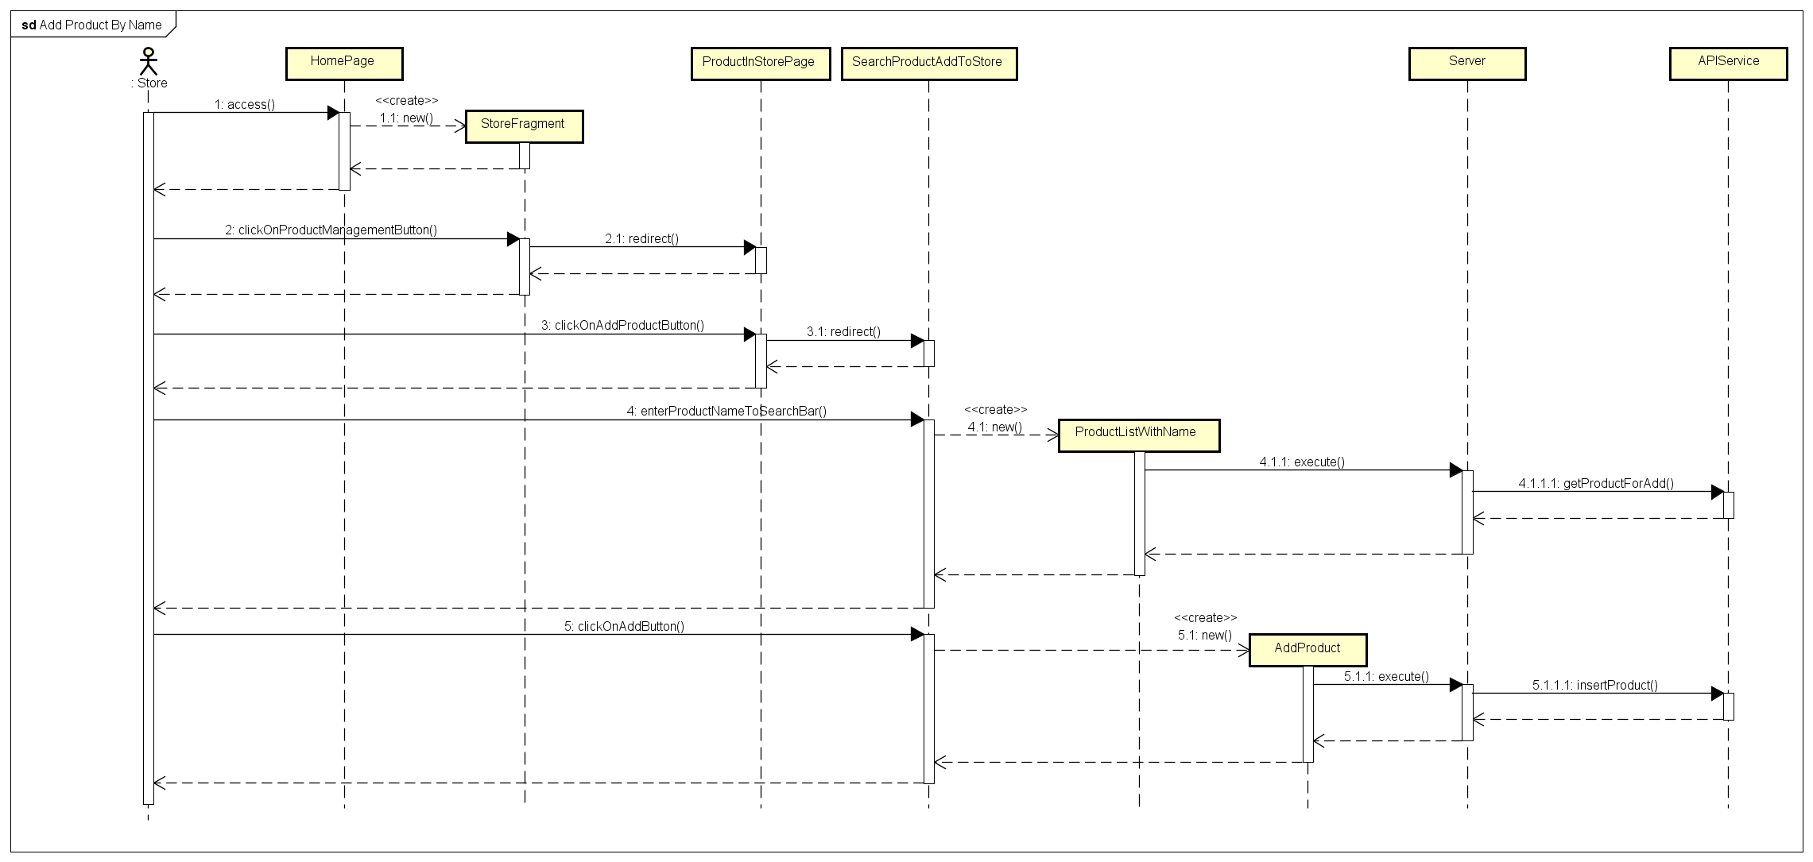

### Add Product by Barcode

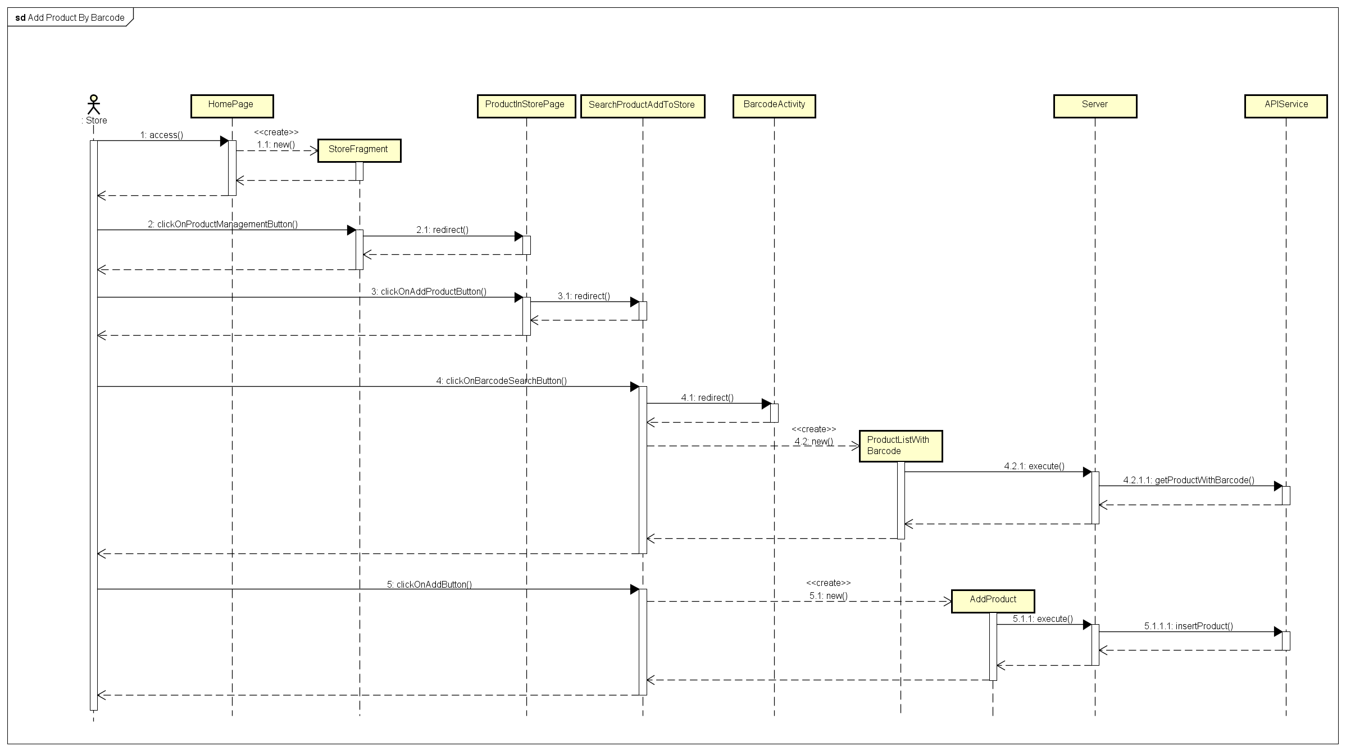

***Figure 4-43 + 4-44 :*** *Add product To Store Sequence Diagram*

1. Store clicks on “Cửa hàng” tab with  icon in Home screen.
2. Store clicks on “Quản lý sản phẩm” button in “Cửa hàng” screen.
3. Store clicks on “Thêm sản phẩm” button.
4. Store searchs products by name or barcode
5. Store clicks on “Thêm sản phâm vào cửa hàng” button in product detail layout.
6. Store enters product price and product promotion to option form dialog.
7. Store clicks on “Thêm tùy chọn” button in dialog.

### Delete Product in Store

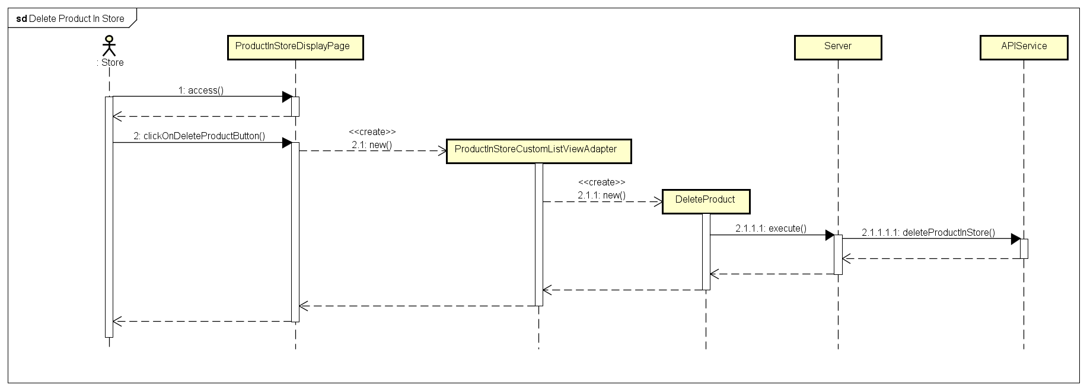

***Figure 4-45 :*** *Delete Product In Store Sequence Diagram*

1. Store clicks on “Cửa hàng” tab with  icon in Home screen.
2. Store clicks on “Quản lý sản phẩm” button in “Cửa hàng” screen.
3. Store clicks on “Xóa sản phẩm” button with icon in product detail layout.



1. Store clicks on “Đồng ý” button in confirm dialog

### Change Product Information in Store

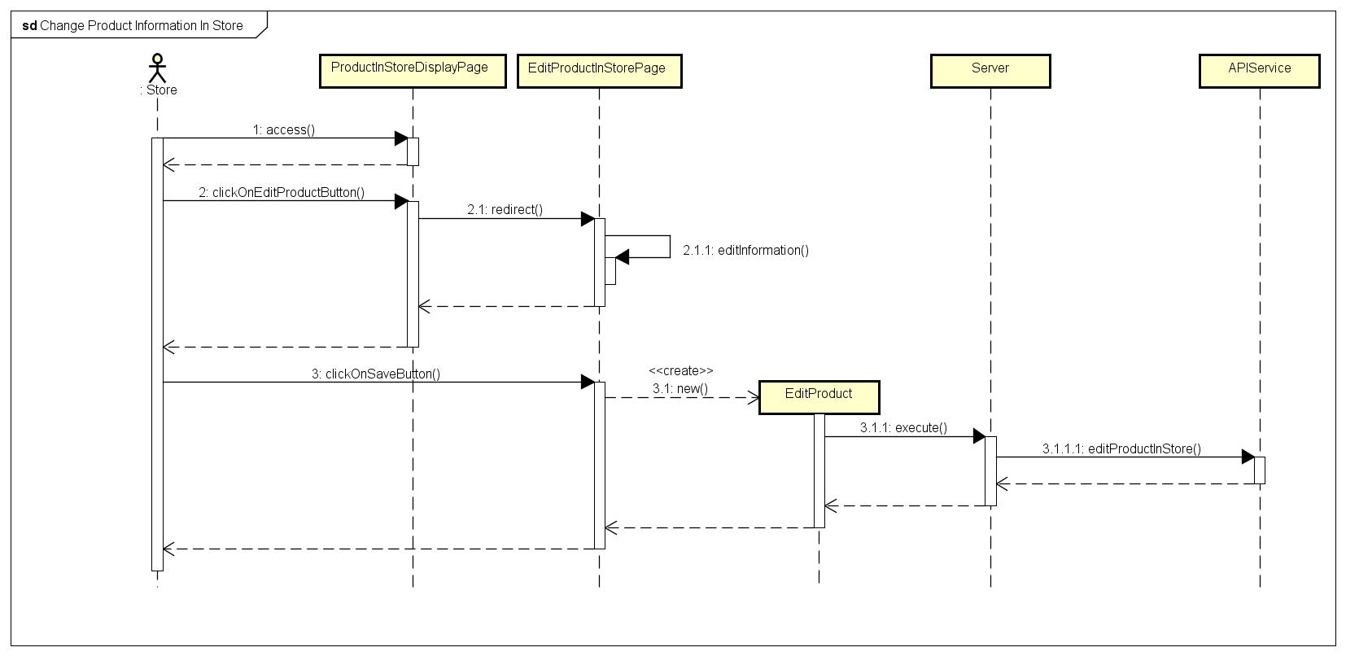

***Figure 4-46 :*** *Change Product Information In Store Sequence Diagram*

1. Store clicks on “Cửa hàng” tab with  icon in Home screen.
2. Store clicks on “Quản lý sản phẩm” button in “Cửa hàng” screen.
3. Store clicks on “Thay đổi thông tin sản phẩm” button with icon in product detail layout.



1. Store enters new price or new promotion, then clicks on “Lưu thay đổi” button.

## User Interface Design

### Home screen

#### Screen Images

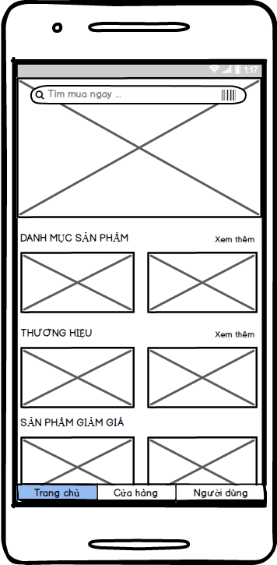

***Figure 4-47 :*** *Home screen*

#### Objects and Actions

* + - Screen displays some categories, some brands, some sale products and some advertisement images.
    - Screen is initial screen of application.

### View Categories Screen

#### Screen Images

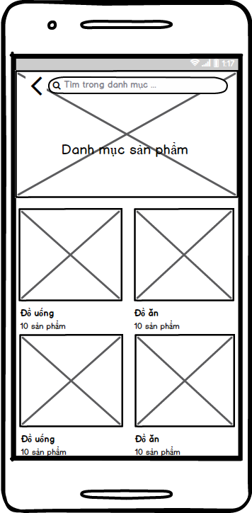

***Figure 4-48 :*** *View Category screen*

#### Objects and Actions

* + - Screen displays all categories in application.

### View Types Screen

#### Screen Images

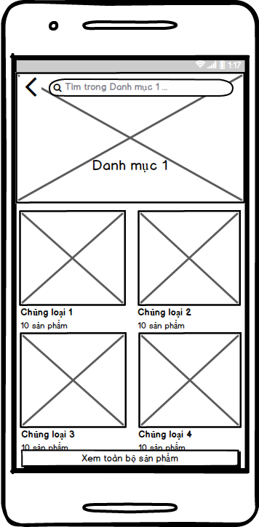

***Figure 4-49 :*** *View Types screen*

#### Objects and Actions

* + - Screen displays all types of any one category in application.

### View Brands Screen

#### Screen Images

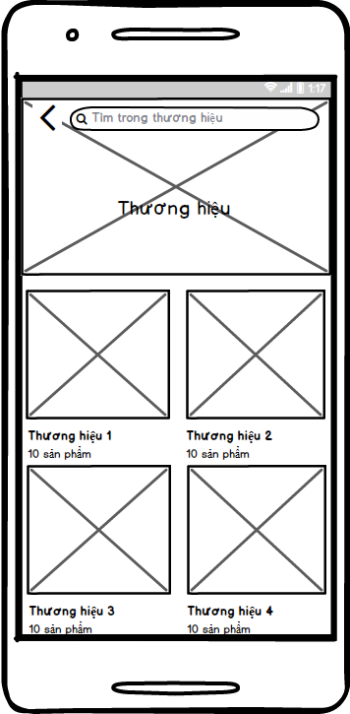

***Figure 4-50 :*** *View Brands screen*

#### Objects and Actions

* + - Screen displays all brands in application.

### View Products in Category Screen

#### Screen Images

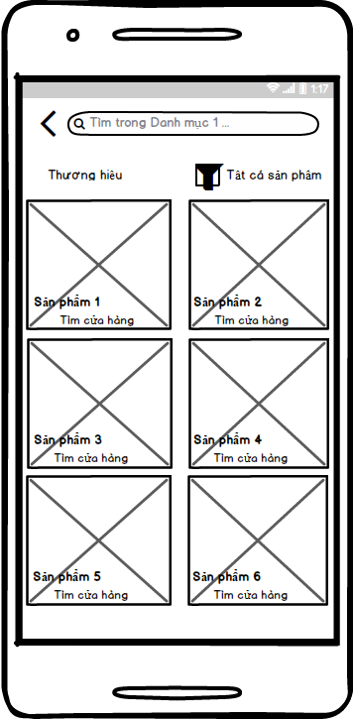

***Figure 4-51 :*** *View Products In Category screen*

#### Objects and Actions

* + - Screen displays all products in any one category in application.

### View Products In Type Screen

#### Screen Images

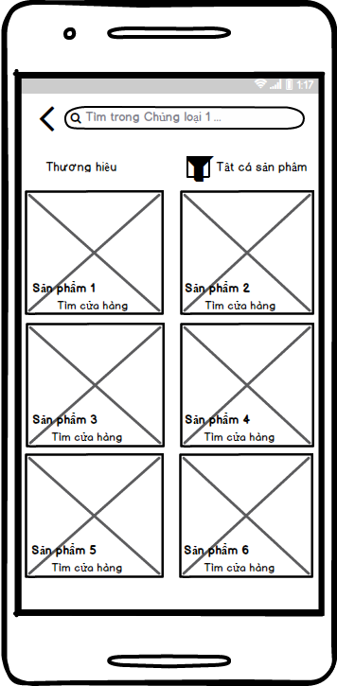

***Figure 4-52 :*** *View Products In Type screen*

#### Objects and Actions

* + - Screen displays all products in any one type in application.

### View Products in Brand Screen

#### Screen Images

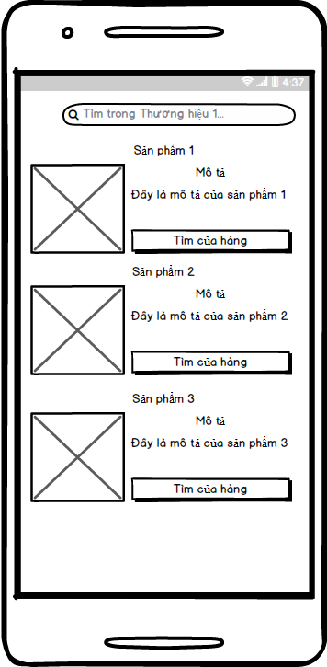

***Figure 4-53 :*** *View Products In Brand screen*

#### Objects and Actions

* + - Screen displays all brands in application.

### View Sale Products Screen

#### Screen Images

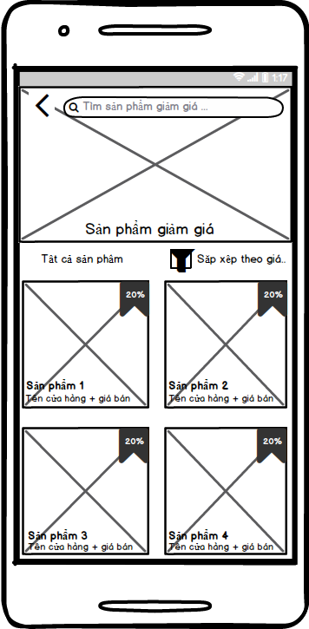

***Figure 4-54 :*** *View Sale Products screen*

#### Objects and Actions

* + - Screen displays all sale products in application.

### View Store Information By Store Screen

#### Screen Images

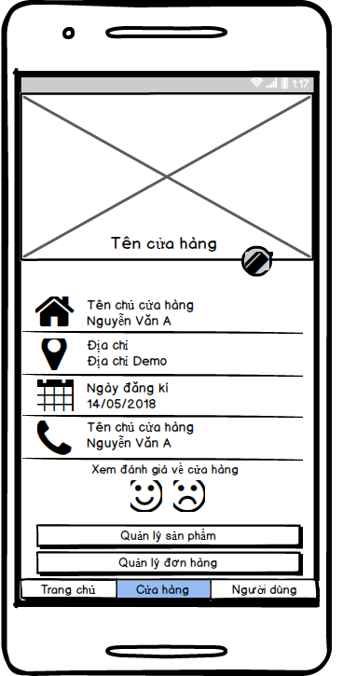

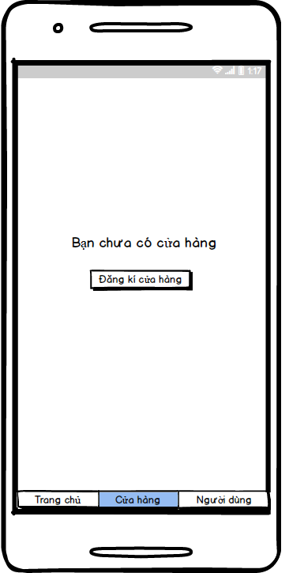

***Figure 4-55 :*** *View Store Information By Store screen*

#### Objects and Actions

* + - Screen allows Store to view own store information.
    - Screen is initial screen in management store process.

### View User Functional Management Screen

#### Screen Images

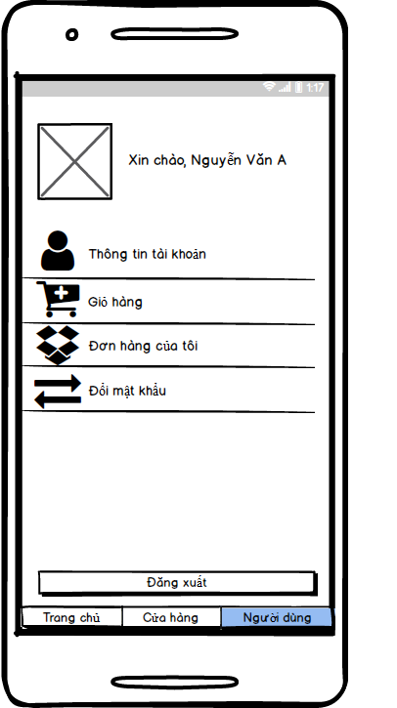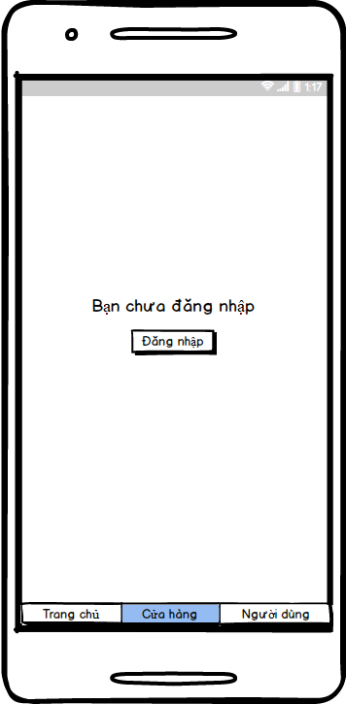

***Figure 4-56 :*** *View User Functional Management screen*

#### Objects and Actions

* + - Screen displays account functional management which is viewed by User.
    - Screen is initial screen in management account process.

### Login Screen

#### Screen Images

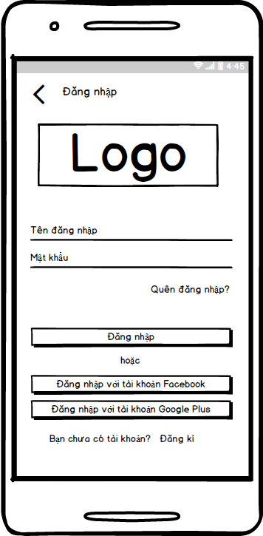

***Figure 4-57 :*** *Login screen*

#### Objects and Actions

* + - Screen allows User to login to application with 3S account, Facebook account and Google+ account.

### Register Account Screen

#### Screen Images

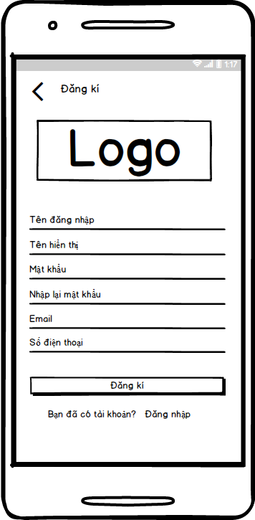

***Figure 4-58 :*** *Register Account screen*

#### Objects and Actions

* + - Screen allows User to register a new account.

### View User Information Screen

#### Screen Images

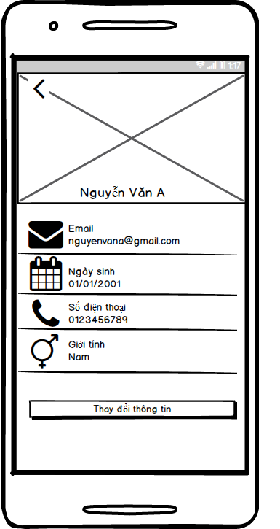

***Figure 4-59 :*** *View User Information screen*

#### Objects and Actions

* + - Screen displays user account information.

### Edit User Account Information Screen

#### Screen Images

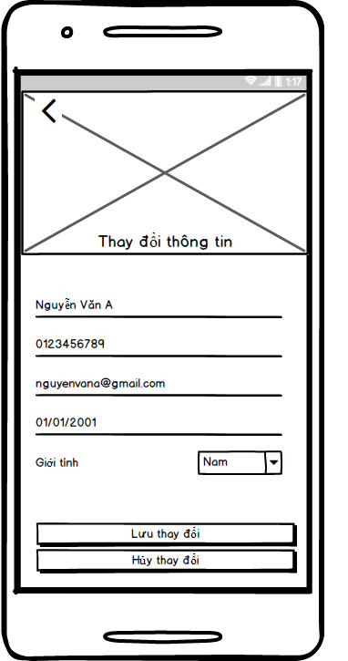

***Figure 4-60 :*** *Edit User Account Information screen*

#### Objects and Actions

* + - Screen allows User to edit account information.

### Change Password Screen

#### Screen Images

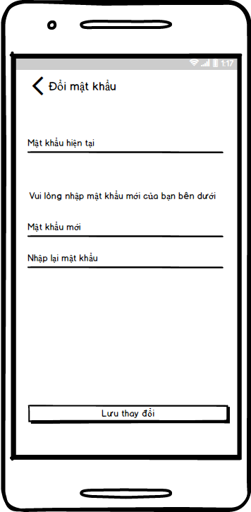

***Figure 4-61 :*** *Change Password screen*

#### Objects and Actions

* + - Screen allows User change user 3S account password.

### Edit Store Information Screen

#### Screen Images

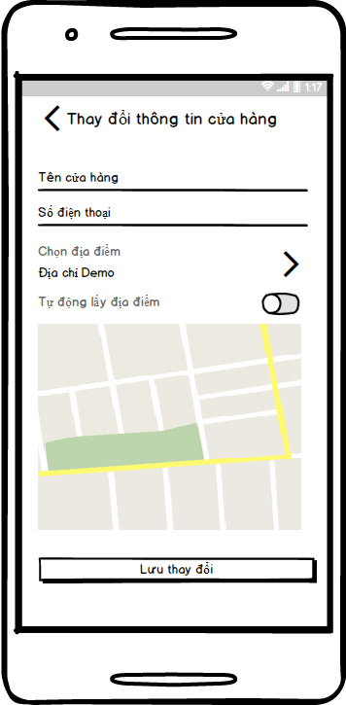

***Figure 4-62 :*** *Edit Store Information screen*

#### Objects and Actions

* + - Screen allows Store to edit store information.

### View User Order History Screen

#### Screen Images

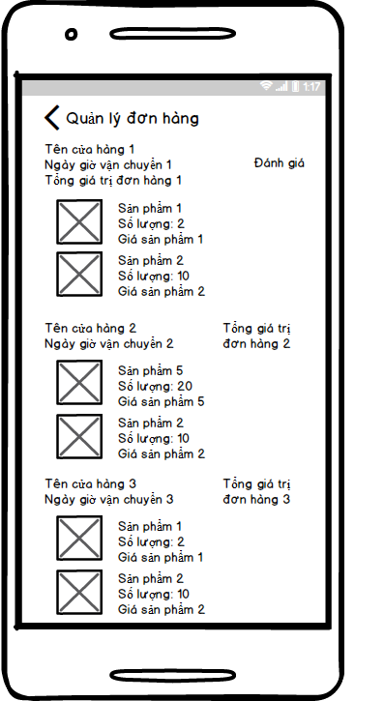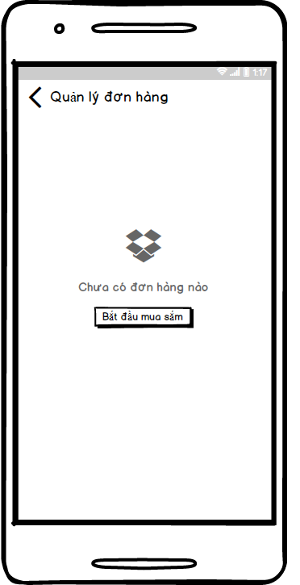

***Figure 4-63 :*** *View User Order History screen*

#### Objects and Actions

* + - Screen displays user own order history.

### View Product Detail Screen

#### Screen Images

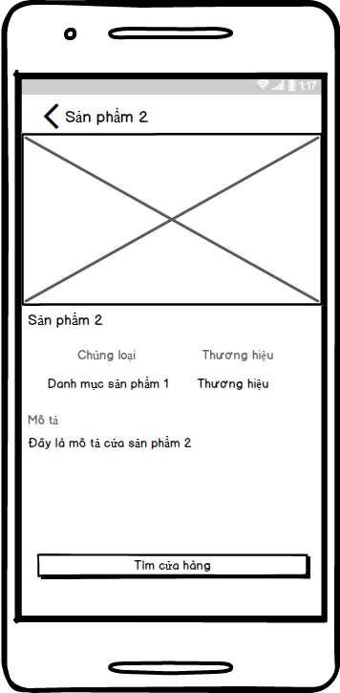

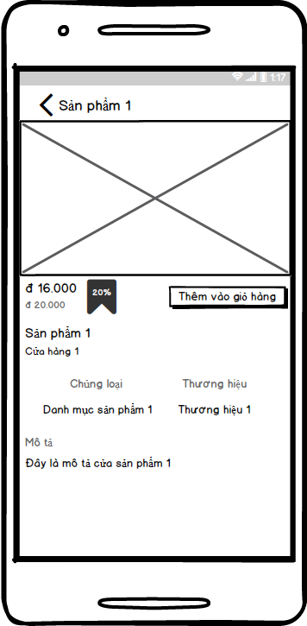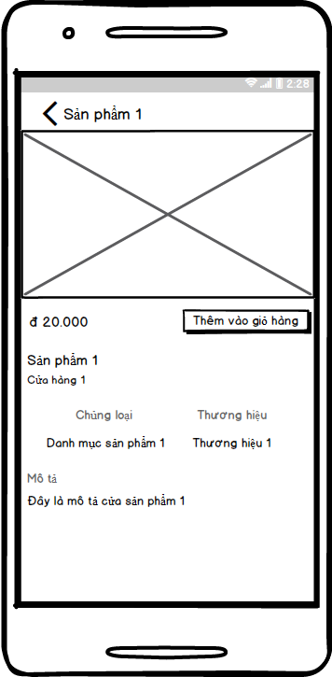

***Figure 4-64 :*** *View Product Detail screen*

#### Objects and Actions

* + - Screen displays detail information of any one product in application.

### Order Screen

#### Screen Images

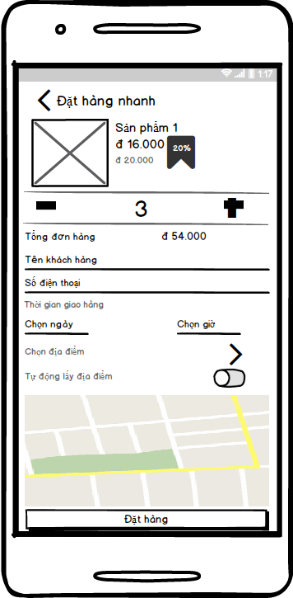

***Figure 4-65 :*** *Order screen*

#### Objects and Actions

* + - Screen allows User to provide order information.

### View Product In Store By User Screen

#### Screen Images

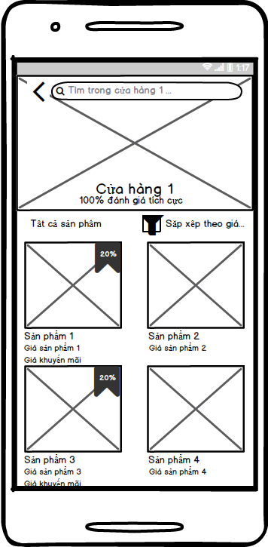

***Figure 4-66 :*** *View Product In Store By User screen*

#### Objects and Actions

* + - Screen allows User to view products in store .

### View Nearby Store Screen

#### Screen Images

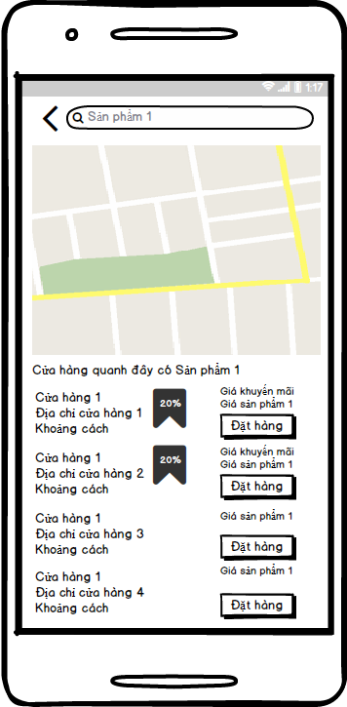

***Figure 4-67 :*** *View Nearby Store screen*

#### Objects and Actions

* + - Screen allows User to view nearby store list which have user-needed product.

### User Search Product Screen

#### Screen Images

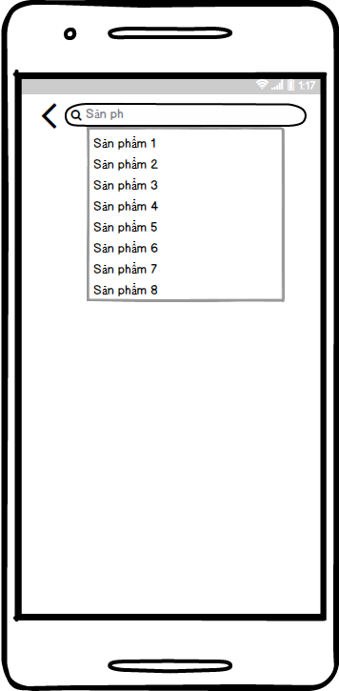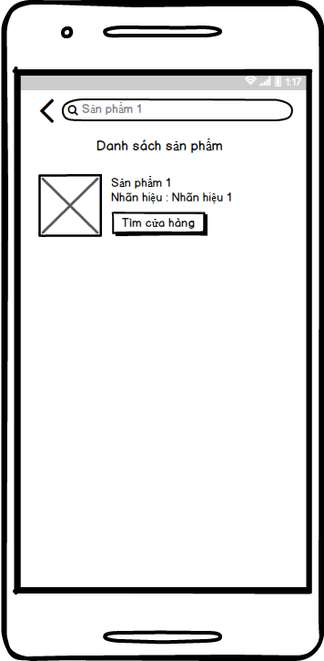

***Figure 4-68 :*** *User Search Product screen*

#### Objects and Actions

* + - Screen allows User search products and displays searched product list.

### Add Product To Store Screen

#### Screen Images

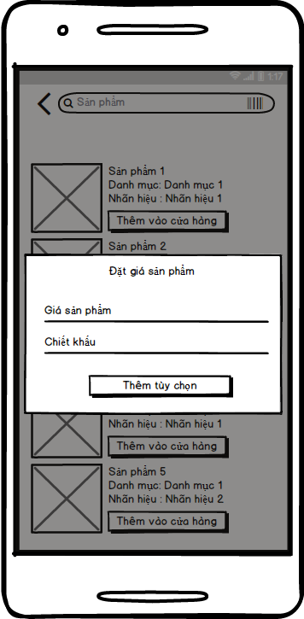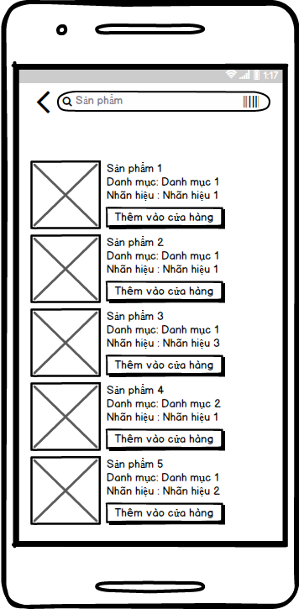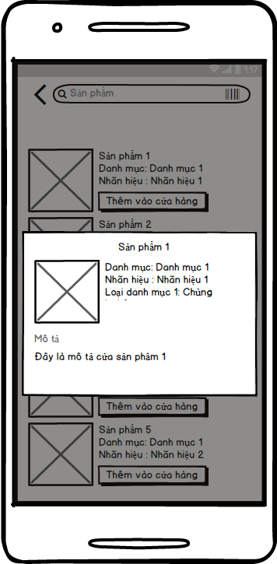

***Figure 4-69 :*** *Add Product To Store screen*

#### Objects and Actions

* + - Screen allows Store to view product detail and add new products to store.

### View User Cart Screen

#### Screen Images

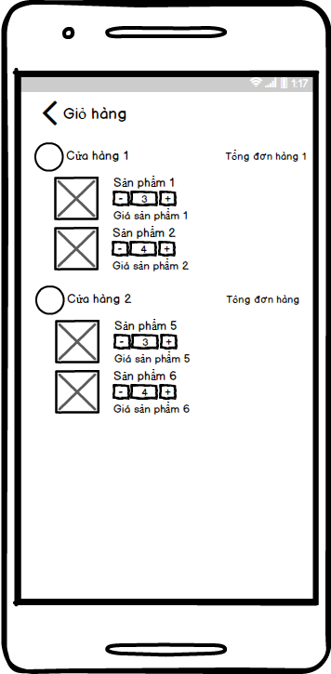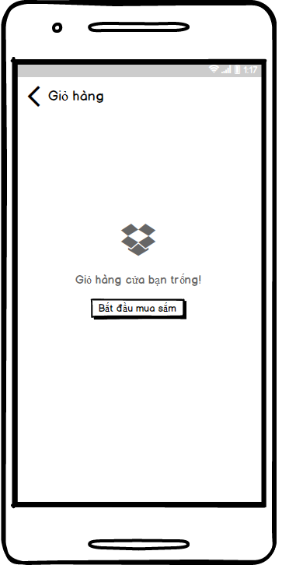

***Figure 4-70 :*** *View User Cart screen*

#### Objects and Actions

* + - Screen allows User to view current cart which is do-not-checked-out-yet order.

### Forget Password Screen

#### Screen Images

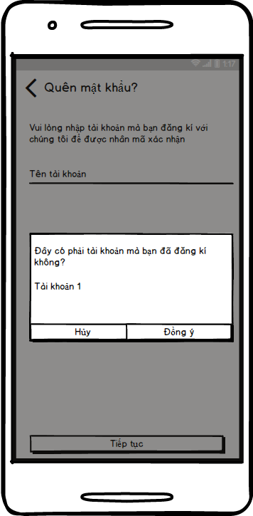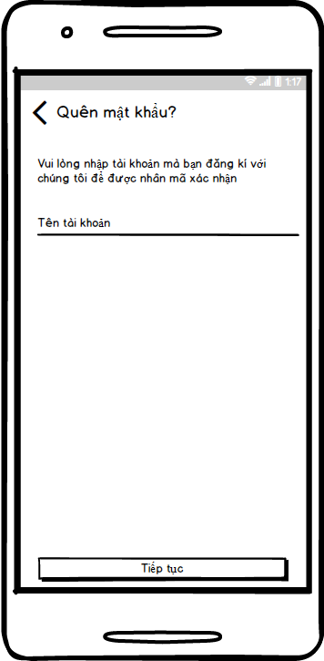

***Figure 4-71 :*** *Forget Password screen*

#### Objects and Actions

* + - Screen allows User to request getting OTP Code to support reset account password process.
    - Screen is initial screen in reset account password process.

### OTP Code Screen

#### Screen Images

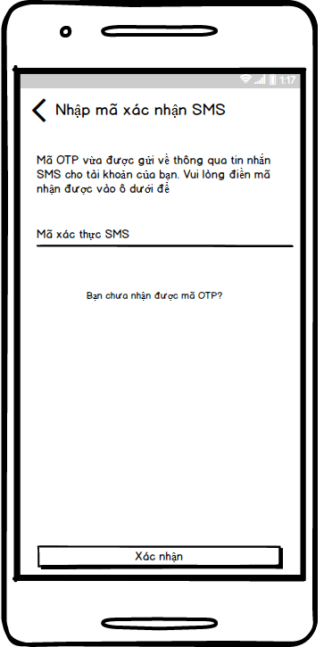

***Figure 4-72 :*** *OTP Code screen*

#### Objects and Actions

* + - Screen allows User to confirm received OTP Code to support reset account password process.

### View Product In Store By Store

#### Screen Images

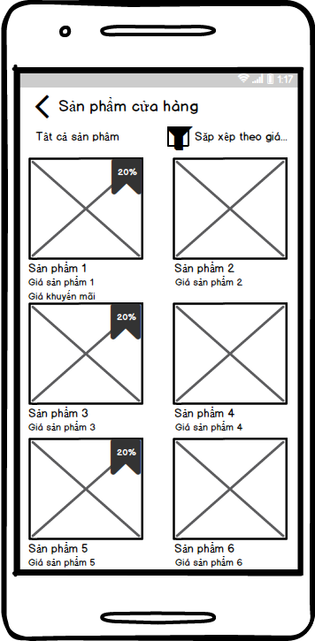

***Figure 4-73 :*** *View Product In Store By User screen*

#### Objects and Actions

* + - Screen allows Store to view products in own store .

### View Store Order History Screen

#### Screen Images

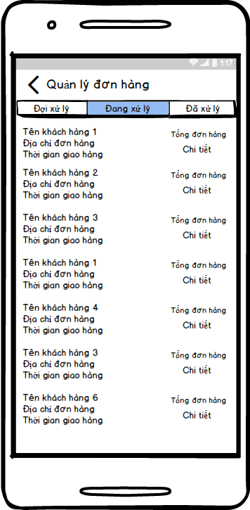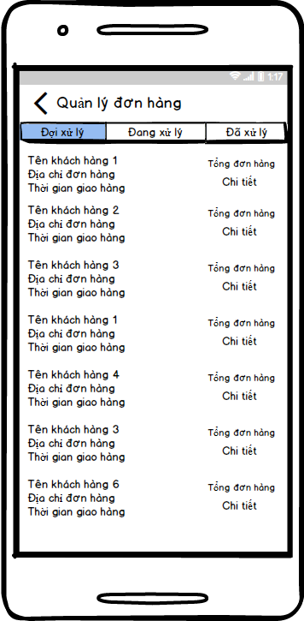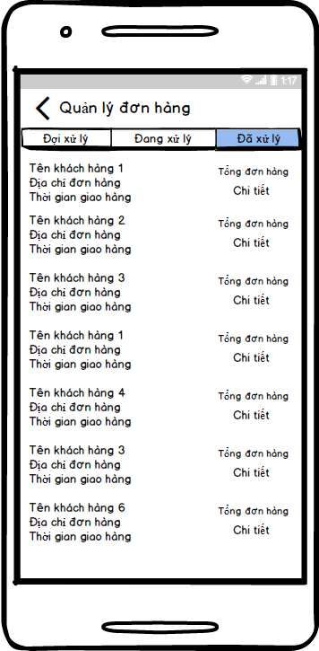

***Figure 4-74 :*** *View Store Order History screen*

#### Objects and Actions

* + - Screen allows Store to view store order history.

### View Order Detail Screen

#### Screen Images

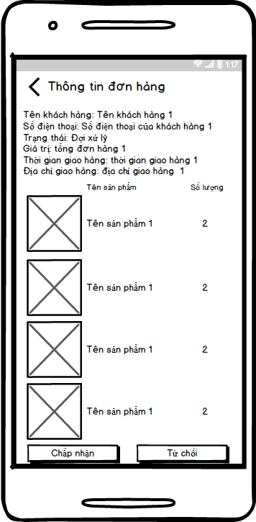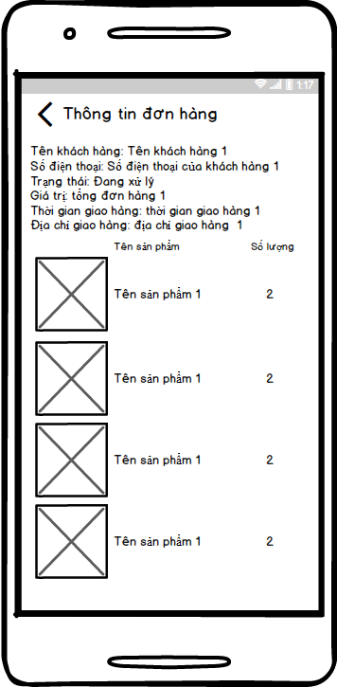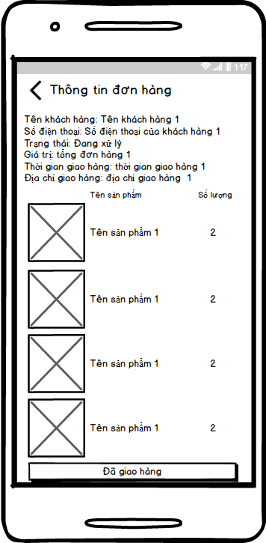

***Figure 4-75 :*** *View Order Detail screen*

#### Objects and Actions

* + - Screen allows Store to view detail information of store’s orders.

### View Direction of Order Screen

#### Screen Images

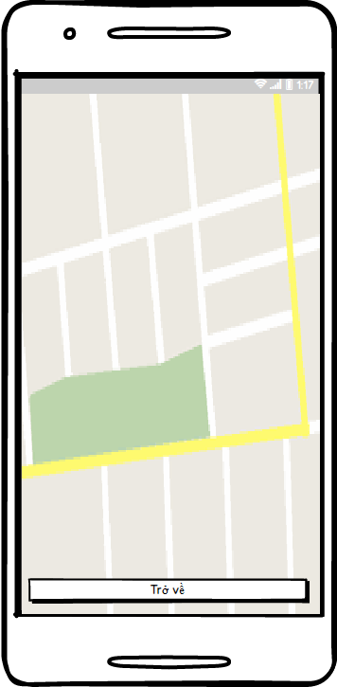

***Figure 4-76 :*** *View Direction Of Order screen*

#### Objects and Actions

* + - Screen allows Store to view direction from store address to order delivery address.

### User Feedback Store Screen

#### Screen Images

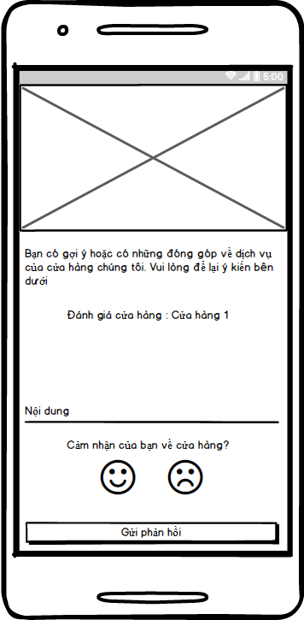

***Figure 4-77 :*** *User Feedback Store screen*

#### Objects and Actions

* + - Screen allows User to feedback Store service.

### View Store Feedback Screen

#### Screen Images

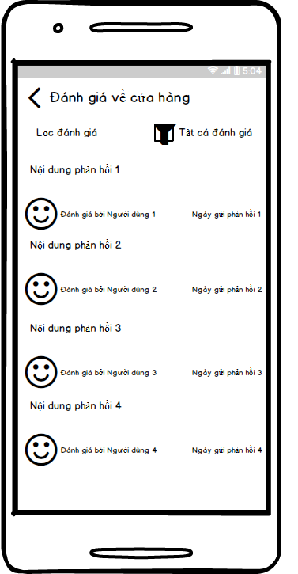

***Figure 4-78 :*** *View Store Feedback screen*

#### Objects and Actions

* + - Screen allows User to view Store feedback history.

## Database Design or Data Structures

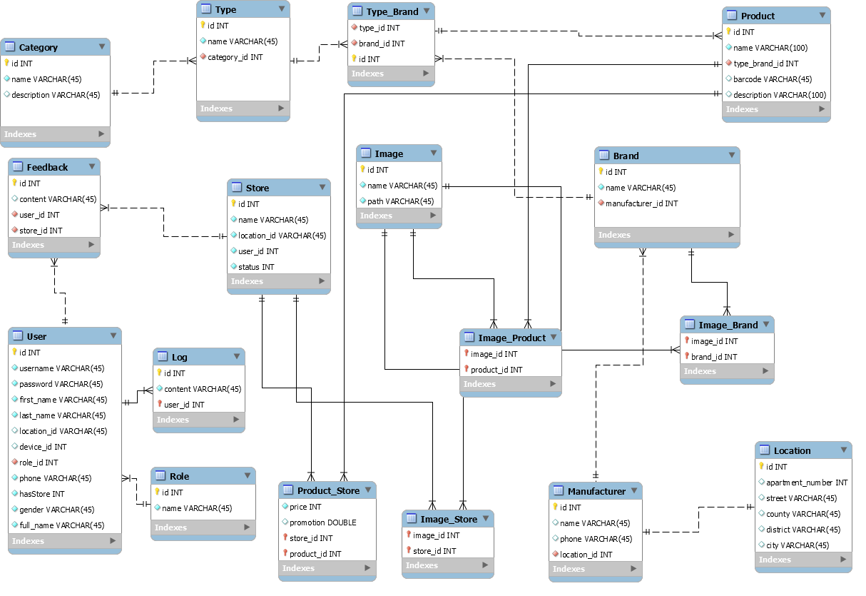

***Figure 4-79 :*** *Database Diagram*

|  |  |  |  |
| --- | --- | --- | --- |
| **Brand** | | | |
| **Field Name** | **Type** | **Null** | **Description** |
| **id** | INT | No | Primary key  ID of Brand. |
| name | VARCHAR | No | Name of Brand |
| manufacturerr\_id | INT | No | ID of Manufacturerr of Brand |

|  |  |  |  |
| --- | --- | --- | --- |
| **Category** | | | |
| **Field Name** | **Type** | **Null** | **Description** |
| **id** | INT | No | Primary key  ID of Brand. |
| name | VARCHAR | No | Name of Category. |
| description | VARCHAR | Yes | Description of Category. |

|  |  |  |  |
| --- | --- | --- | --- |
| **Feedback** | | | |
| **Field Name** | **Type** | **Null** | **Description** |
| **id** | INT | No | Primary key  ID of Feedback. |
| content | VARCHAR | Yes | Content of Feedback. |
| user\_id | INT | No | ID of user who is Feedback. |
| store\_id | INT | No | ID of store have Feedback |
| satisfied | INT | No | Feedback is satisfied. |

|  |  |  |  |
| --- | --- | --- | --- |
| **Image** | | | |
| **Field Name** | **Type** | **Null** | **Description** |
| **id** | INT | No | Primary key  ID of Image. |
| name | VARCHAR | No | Name of Image. |
| path | VARCHAR | No | Path of Image. |

|  |  |  |  |
| --- | --- | --- | --- |
| **Image\_Brand** | | | |
| **Field Name** | **Type** | **Null** | **Description** |
| **image\_id** | INT | No | Primary key  ID of Image. |
| **brand\_id** | INT | No | Primary key  ID of Brand. |

|  |  |  |  |
| --- | --- | --- | --- |
| **Image\_Category** | | | |
| **Field Name** | **Type** | **Null** | **Description** |
| **image\_id** | INT | No | Primary key  ID of Image. |
| **category\_id** | INT | No | Primary key  ID of Category. |

|  |  |  |  |
| --- | --- | --- | --- |
| **Image\_Product** | | | |
| **Field Name** | **Type** | **Null** | **Description** |
| **image\_id** | INT | No | Primary key  ID of Image. |
| **product\_id** | INT | No | Primary key  ID of Product. |

|  |  |  |  |
| --- | --- | --- | --- |
| **Image\_Store** | | | |
| **Field Name** | **Type** | **Null** | **Description** |
| **image\_id** | INT | No | Primary key  ID of Image. |
| **store\_id** | INT | No | Primary key  ID of Store. |

|  |  |  |  |
| --- | --- | --- | --- |
| **Location** | | | |
| **Field Name** | **Type** | **Null** | **Description** |
| **id** | INT | No | Primary key  ID of Feedback. |
| apartment\_number | VARCHAR | Yes | Apartment number of Location. |
| street | VARCHAR | Yes | Street number of Location |
| county | VARCHAR | Yes | County number of Location |
| district | VARCHAR | Yes | District number of Location |
| city | VARCHAR | Yes | City number of Location |
| longitude | VARCHAR | No | Longitude number of Location |
| latitude | VARCHAR | No | Latitude number of Location |

|  |  |  |  |
| --- | --- | --- | --- |
| **Log** | | | |
| **Field Name** | **Type** | **Null** | **Description** |
| **id** | INT | No | Primary key  ID of Log. |
| content | VARCHAR | No | Content of Log (history search). |
| user\_id | INT | No | ID of User. |

|  |  |  |  |
| --- | --- | --- | --- |
| [**Manufacturer**](http://150.95.111.195/phpMyAdmin/sql.php?db=3sproject&table=Manufacturer&token=90e2ab0e4b65849f14065efc914186d8) | | | |
| **Field Name** | **Type** | **Null** | **Description** |
| **id** | INT | No | Primary key  Id of Manufacturer |
| name | VARCHAR | Yes | Name of Manufacturerr |
| phone | VARCHAR | Yes | Phone number of Manufacturerr |
| location\_id | INT | No | Address of Manufacturerr |

|  |  |  |  |
| --- | --- | --- | --- |
| [**Product**](http://150.95.111.195/phpMyAdmin/sql.php?db=3sproject&table=Manufacturer&token=90e2ab0e4b65849f14065efc914186d8) | | | |
| **Field Name** | **Type** | **Null** | **Description** |
| **id** | INT | No | Primary key  Id of product |
| name | VARCHAR | Yes | Name of product |
| barcode | VARCHAR | Yes | Barcode number of Product |
| description | VARCHAR | No | Information of Product |
| type\_band\_id | INT | No | Id of brand product |

|  |  |  |  |
| --- | --- | --- | --- |
| [**Product\_Store**](http://150.95.111.195/phpMyAdmin/sql.php?db=3sproject&table=Manufacturer&token=90e2ab0e4b65849f14065efc914186d8) | | | |
| **Field Name** | **Type** | **Null** | **Description** |
| price | BIGINT | No | Price of product in store |
| promotion | INT | Yes | Promotion of product |
| **store\_id** | INT | No | Primary key  Id of store |
| **product\_id** | INT | No | Primary key  Id of product |

|  |  |  |  |
| --- | --- | --- | --- |
| [**Role**](http://150.95.111.195/phpMyAdmin/sql.php?db=3sproject&table=Manufacturer&token=90e2ab0e4b65849f14065efc914186d8) | | | |
| **Field Name** | **Type** | **Null** | **Description** |
| **id** | INT | No | Primary key  Id of role |
| name | VARCHAR | No | Name of role |

|  |  |  |  |
| --- | --- | --- | --- |
| [**Ship**](http://150.95.111.195/phpMyAdmin/sql.php?db=3sproject&table=Manufacturer&token=90e2ab0e4b65849f14065efc914186d8) | | | |
| **Field Name** | **Type** | **Null** | **Description** |
| **id** | INT | No | Primary key  Id of ship |
| name | VARCHAR | No | Name of ship |

|  |  |  |  |
| --- | --- | --- | --- |
| [**Store**](http://150.95.111.195/phpMyAdmin/sql.php?db=3sproject&table=Manufacturer&token=90e2ab0e4b65849f14065efc914186d8) | | | |
| **Field Name** | **Type** | **Null** | **Description** |
| **id** | INT | No | Primary key  Id of store |
| name | VARCHAR | Yes | Name of store |
| location\_id | VARCHAR | Yes | Id of location store |
| user\_id | INT | No | Id of store owing user |
| phone | VARCHAR | Yes | Phone number of store |
| status | INT | No | Status active of store |
| registerLog | DATE | Yes | Time register of store |

|  |  |  |  |
| --- | --- | --- | --- |
| [**Type**](http://150.95.111.195/phpMyAdmin/sql.php?db=3sproject&table=Manufacturer&token=90e2ab0e4b65849f14065efc914186d8) | | | |
| **Field Name** | **Type** | **Null** | **Description** |
| **id** | INT | No | Primary key  Id of Type Product |
| name | VARCHAR | No | Name of Type Product |
| category\_id | INT | No | Id of category prodcut |
| image\_id | INT | No | Id of image product |

|  |  |  |  |
| --- | --- | --- | --- |
| [**Type\_Brand**](http://150.95.111.195/phpMyAdmin/sql.php?db=3sproject&table=Manufacturer&token=90e2ab0e4b65849f14065efc914186d8) | | | |
| **Field Name** | **Type** | **Null** | **Description** |
| type\_id | INT | No | Id of type product |
| Brand\_id | INT | No | Id of brand product |
| **id** | INT | No | Primary key  Id of product |

|  |  |  |  |
| --- | --- | --- | --- |
| [**User**](http://150.95.111.195/phpMyAdmin/sql.php?db=3sproject&table=Manufacturer&token=90e2ab0e4b65849f14065efc914186d8) | | | |
| **Field Name** | **Type** | **Null** | **Description** |
| **id** | INT | No | Primary key  Id of user |
| username | VARCHAR(100) | Yes | Name account of user |
| password | VARCHAR(100) | Yes | Password account of user |
| first\_name | VARCHAR(100) | Yes | Frist Name of user |
| last\_name | VARCHAR(100) | Yes | Last Name of user |
| email | VARCHAR(100) | Yes | Email of user |
| device\_id | VARCHAR(100) | Yes | Id device of user |
| role\_id | INT | No | Id of role user |
| phone | VARCHAR(100) | Yes | Phone number of user |
| hasStore | INT | No | Status of store |
| gender | VARCHAR(100) | Yes | Gender of user |
| image\_id | INT | Yes | Id of image user |
| facebook\_id | VARCHAR(100) | Yes | Id facebook of user |
| google\_id | VARCHAR(100) | Yes | Id google of user |
| dateOfBirth | DATE | Yes | Birth day of user |
| full\_name | VARCHAR(100) | Yes | Name display of username |

# Software Test Description (STD)

## Purpose

* + This chapter purpose is to detect software failures so that defects may be discovered and correct to ensure that our project is thoroughly tested and resulting in a successful implementation of a new social application we are developing. It contains the following sections:
    - Scope of testing.
    - Testing tools and environment.
    - Resources and responsibilities.
    - Test strategy: Test approach, test plan.
    - Features to be tested, features not to be tested.
    - Defects log
    - Test report

## Introduction

### Scope of testing

|  |  |  |  |
| --- | --- | --- | --- |
| **No.** | **Test stages** | **Description** | **Implementer** |
| **1** | **Unit testing** | Unit testing will be done by developers and approved by team leader. | Developers |
| **2** | **Integration testing** | Integration testing allows individuals the opportunity to combine all of the units within a program and test them as a group. This testing level is designed to find interface defects between modules/functions. It is particularly beneficial because it determines how efficiently the units are running together. | Testers |
| **3** | **System testing** | System testing is the first level in which the complete application is tested as a whole. The goal at this level is to evaluate whether the system has complied with all of the outlined requirements and to see that it meets Quality Standards or not.  Testers | Testers, Technical leader |
| **4** | **Acceptance test** | Acceptance testing will be executed by all team members in view of end-user. It determines whether system satisfies requirements specified in the requirement analysis phase. Finding defect is not the main task in this stage. Acceptance test will access the system’s readiness for deployment and using | End-users |

### Types of testing

|  |  |  |
| --- | --- | --- |
| **No.** | **Test types** | **Description** |
| **1** | **Function test** | * + Functional testing is a type of software testing whereby the system is tested against the functional requirements or specifications.   + Functions (or features) are tested by feeding them input and examining the output. Functional testing ensures that the requirements are properly satisfied by the application. This type of testing is not concerned with how processing occurs, but rather, with the results of processing.   + During functional testing, Black box testing technique is used in which the internal logic of the system being tested is not known to the tester. |
| **2** | **GUI test** | * + GUI testing is the process of ensuring proper functionality of the graphical user interface (GUI) for a given application and making sure it conforms to its written specifications.   + GUI testing evaluates design elements such as layout, colors, fonts, font sizes, labels, text boxes, text formatting, captions, buttons, lists, icons, links and contents. |
| **3** | **Performance test** | * + Performance testing is the process of determining the speed or effectiveness of a computer, network, software program or device. This process can involve quantitative tests done in a lab, such as measuring the response time or the number of frames per second at which a system functions. |

### Range of testing

* + Team performs all functions defined in the SRS based on the approved version.

## Test plan

### Testing tools and environment

#### Testing tools

* + Microsoft Excel 2017: Excel is used to manage test cases and manage bugs.
  + Netbean: Unit test.

#### Testing environment

* + Android 8.0.0:

|  |  |  |
| --- | --- | --- |
| Thông số | **Samsung Galaxy Note 8** | **Samsung A5 2017** |
| Màn hình | * 6.3 inch | 5.2 inch |
| Độ phân giải màn hình | Full HD+ (2220 x 1080) | Full HD (1920 x 1080) |
| RAM | 6 Gb | 3 Gb |
| CPU | Exynos 8895 8 core 64-bit | Exynos 7880 8 core 64-bit |

* + Android 6.0.0 Marshmallow

|  |  |
| --- | --- |
| Thông số | **Nexus 5x** |
| Màn hình | * 5.2 inch |
| Độ phân giải màn hình | Full HD (1920 x 1080) |
| RAM | 3 Gb |
| CPU | Snapdragon 808 16 core 64-bit |

#### Resources and responsibilities

|  |  |  |
| --- | --- | --- |
| **No.** | **Resources** | **Responsibilities** |
| **1** | **Project manager** | * + Reviewing test case and report |
| **2** | **Tester** | * + Performing the actual system testing.   + Managing test resource and assign test tasks.   + Creating test plan.   + Creating test cases.   + Creating test report.   + Executing test and testing log report. |
| **3** | **Developer** | * + Creating unit test.   + Fixing bugs |

#### Test strategy

##### Test model

* + - Our project follows V-Model process to implement testing. V-Model is abbreviation of Verification and Validation model. In software development, the V-Model represents a development process that may be considered as an extension of the waterfall model, and is an example of the more general V-Model. Instead of moving down in a linear way, the process steps are bent upwards after the coding phase, to form the V shape.
    - The V-Model demonstrates the relationships between each phase of the development life cycle and its associated phase of testing. The horizontal and vertical axes represent time or project completeness (left-to-right) and level of abstraction. Advances in the production of executable requirements, architectures, and designs enable testing to begin much earlier on the left side of the V so that requirements, architecture, and design defects can be found and fixed early before they can propagate into downstream work products.

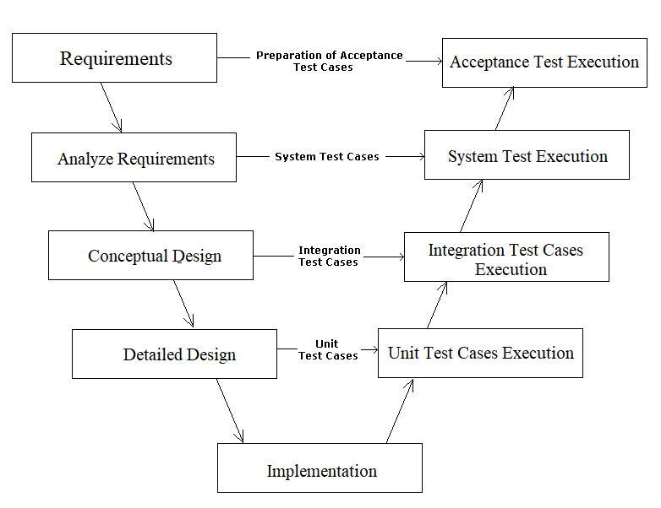

***Figure 5-1 :*** *V-Model Test Model*

* + - Our project uses V-Model because:
      * It works well for small projects where requirements are easy-to-understand.
      * It is simple and easy-to-use.
      * It saves time because testing activities like planning, test designing happens well before coding.
      * It has proactive defect tracking that defects are found at early stages.
      * It help to avoid the downward flow of the defects.

##### Test stage

|  |  |  |  |  |
| --- | --- | --- | --- | --- |
| **Types of test** | **Stages of test** | | | |
| **Unit test** | **Intergration test** | **System test** | **Acceptance test** |
| **Function test** |  |  |  |  |
| **GUI test** |  |  |  |  |
| **Performance test** |  |  |  |  |

### Features to be tested

* + - All functions that are listed in Use case.
    - Performance specifications: Load time, Memory, Time of censoring.
    - GUI of the Android application.

### Features not to be tested

* + - Functions that are not listed in Use case.
    - Functions that are out of scope.

## Test case

* + The OAL test case attached file is available in below link : <https://drive.google.com/open?id=1FJk_RgRNWu0BdpMnNTFzdY4vlo9YyWPX>

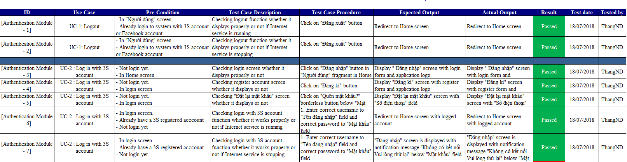

***Figure 5-2 :*** *Test case example*

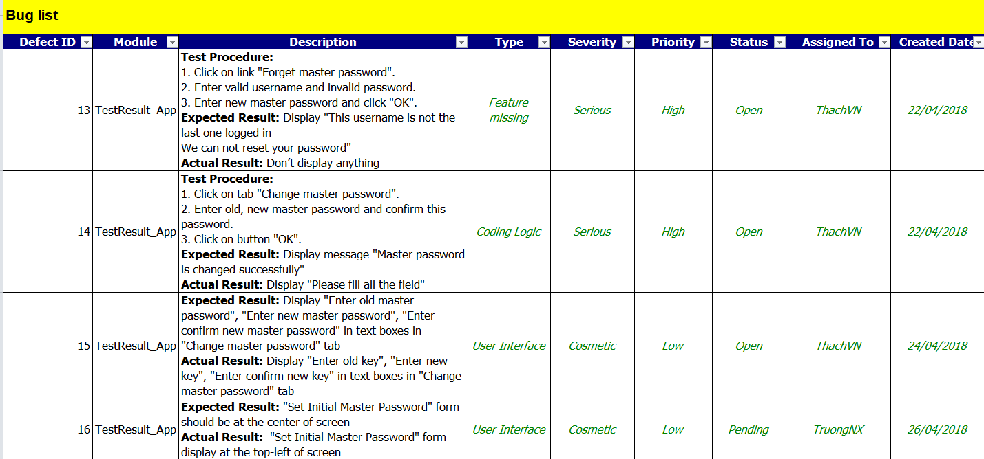

***Figure 5-2 :*** *Defect log example*

## Test Report

### Iteration 1

#### Phase 1: Test

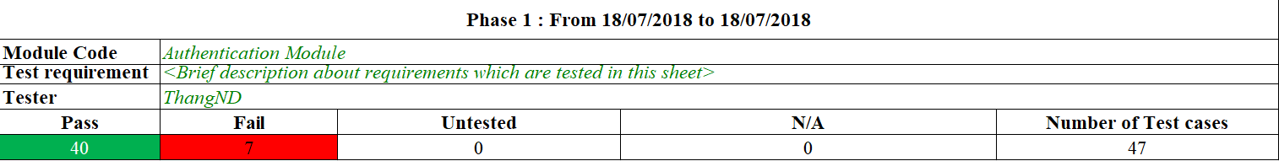

***Figure 5-3 :*** *Test result of Authentication Module*

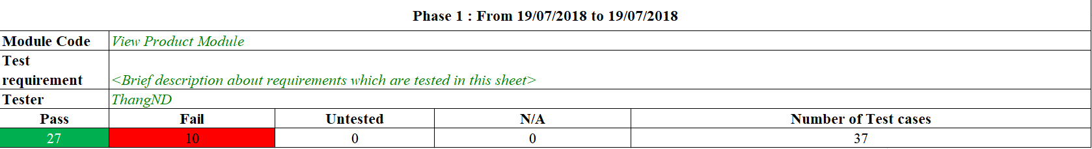

***Figure 5-4 :*** *Test result of View Product Module*

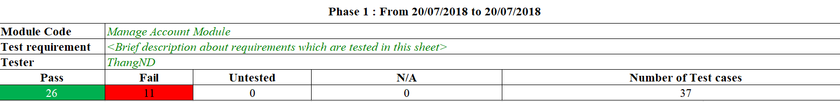

***Figure 5-5 :*** *Test result of Manage Account Module*

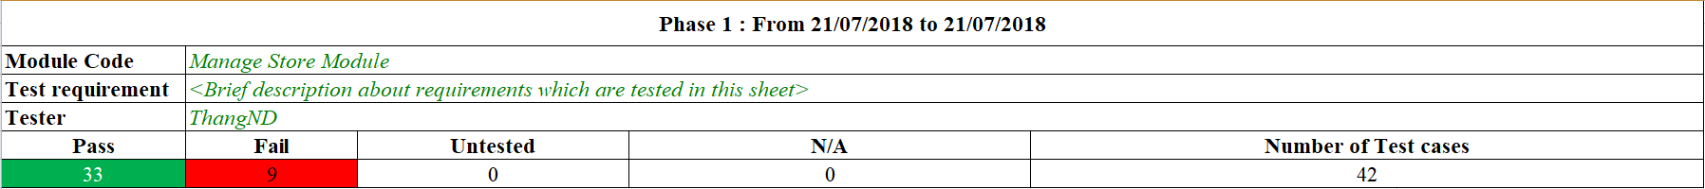

***Figure 5-6 :*** *Test result of Manage Store Module*

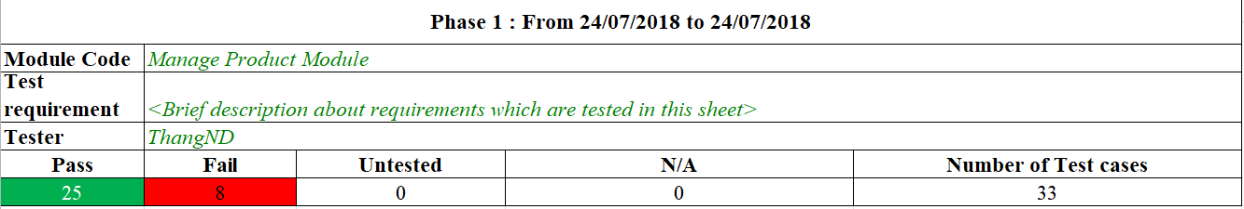

***Figure 5-7 :*** *Test result of Manage Product Module*

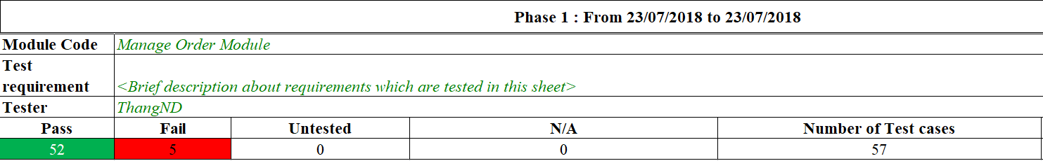

***Figure 5-8 :*** *Test result of Manage Order Module*

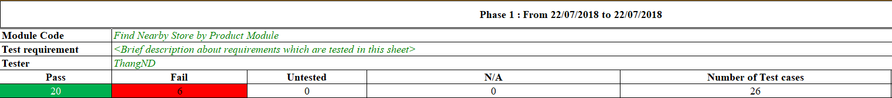

***Figure 5-9 :*** *Test result of Find Nearby Store by Product Module*

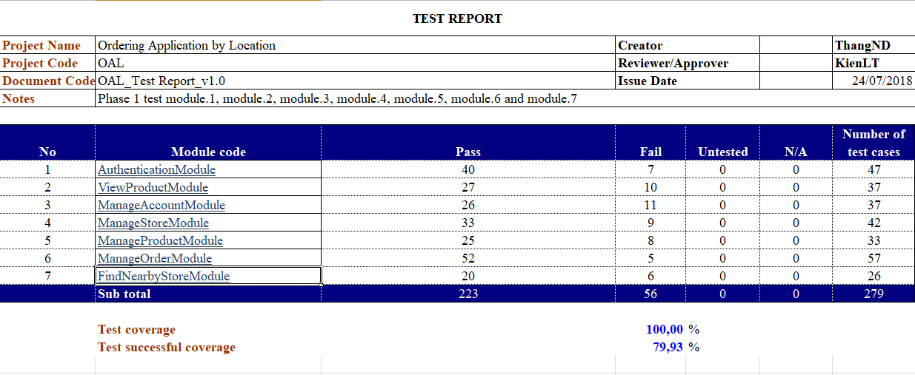

***Figure 5-10 :*** *Test report of Phase 1 in Iteration 1*

#### Phase 2: Re-test

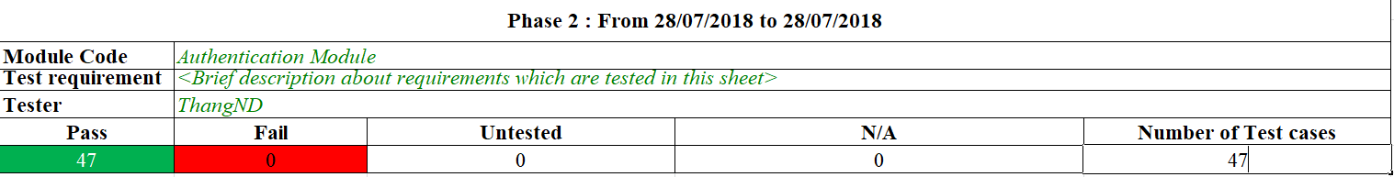

***Figure 5-11 :*** *Test result of Authentication Module*

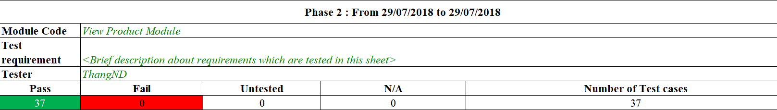

***Figure 5-12 :*** *Test result of View Product Module*

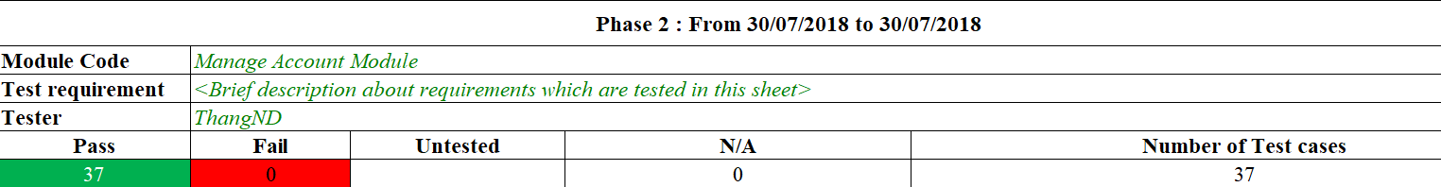

***Figure 5-13 :*** *Test result of Manage Account Module*

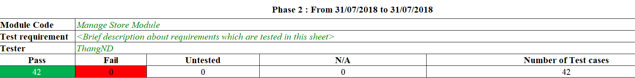

***Figure 5-14 :*** *Test result of Manage Store Module*

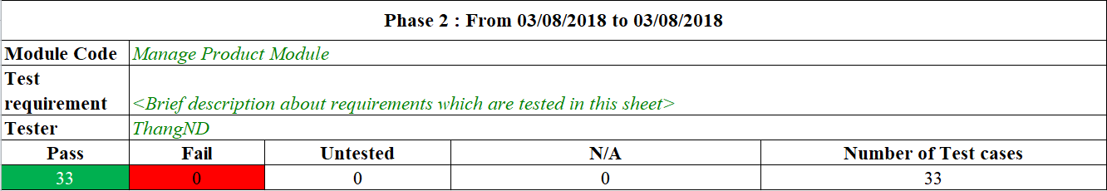

***Figure 5-15 :*** *Test result of Manage Product Module*

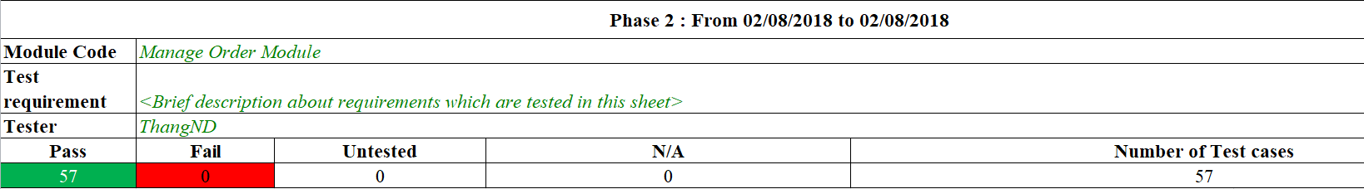

***Figure 5-16 :*** *Test result of Manage Order Module*

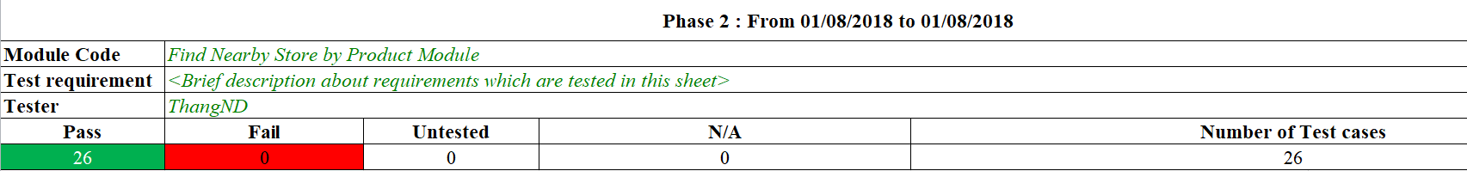

***Figure 5-17 :*** *Test result of Find Nearby Store by Product Module*

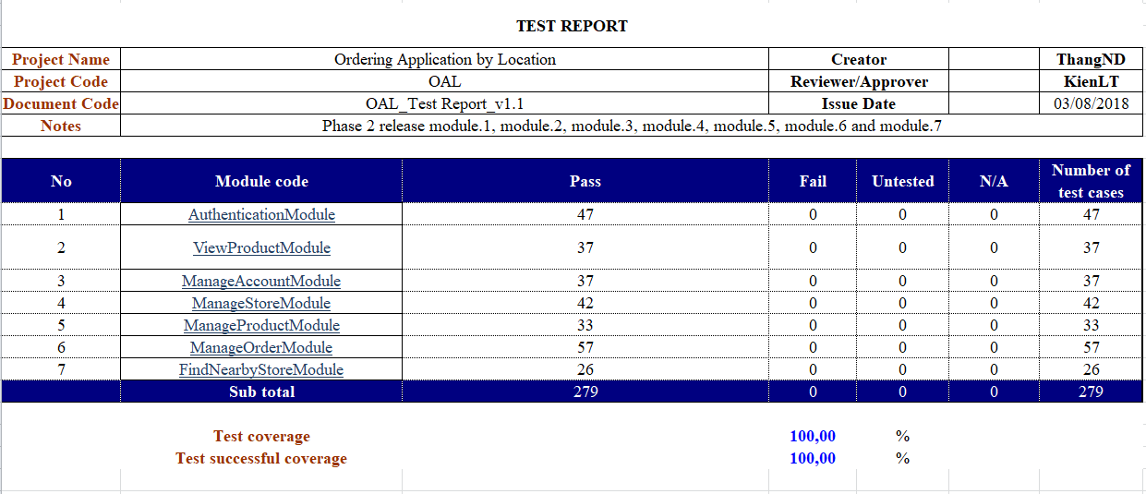

***Figure 5-18 :*** *Test report of Phase 2 in Iteration 1*

### Iteration 2

#### Phase 1: Test

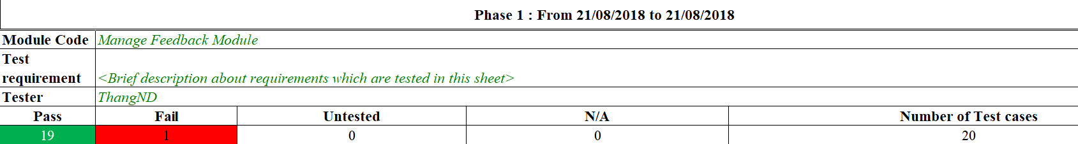

***Figure 5-19 :*** *Test result of Manage Feedback Module*

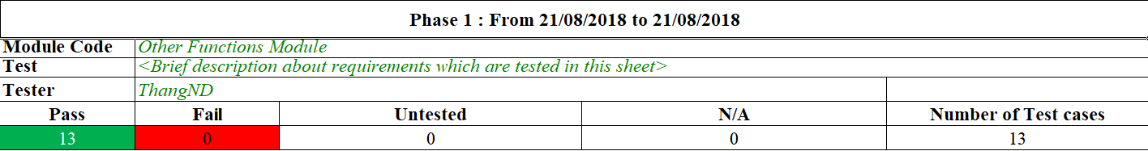

***Figure 5-20 :*** *Test result of Other Functions Module*

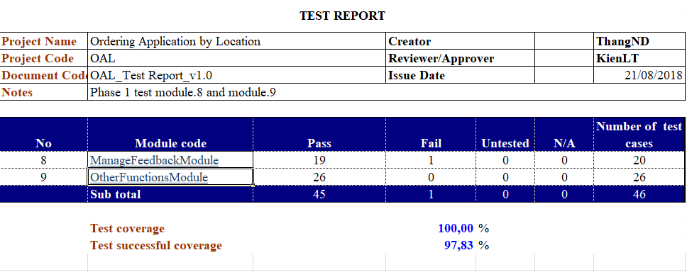

***Figure 5-21 :*** *Test report of Phase 1 in Iteration 2*

#### Phase 2: Re-test

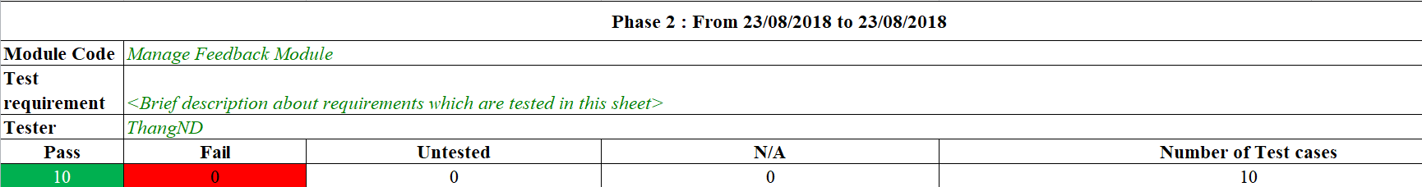

***Figure 5-22 :*** *Test result of Manage Feedback Module*

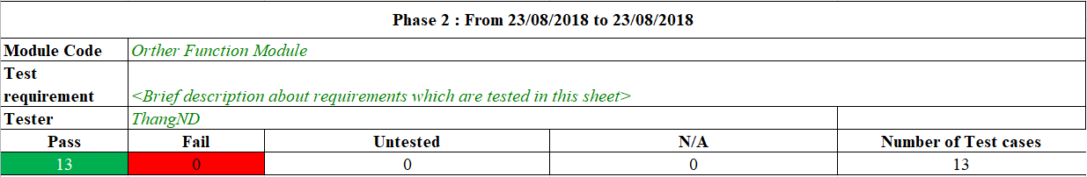

***Figure 5-23 :*** *Test result of Other Functions Module*

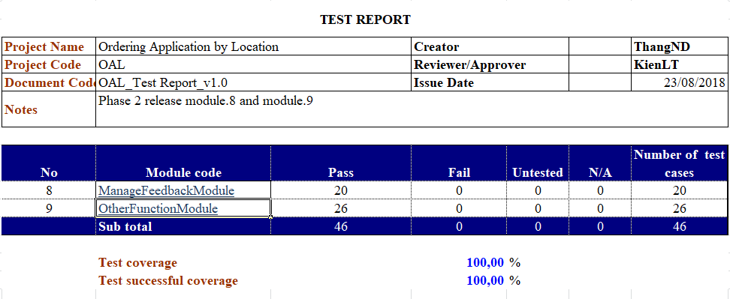

***Figure 5-24 :*** *Test report of Phase 2 in Iteration 2*

# Software User Manual

## Deployment Guideline

## User Guideline

### Installment

#### Installment

### Application opening and running

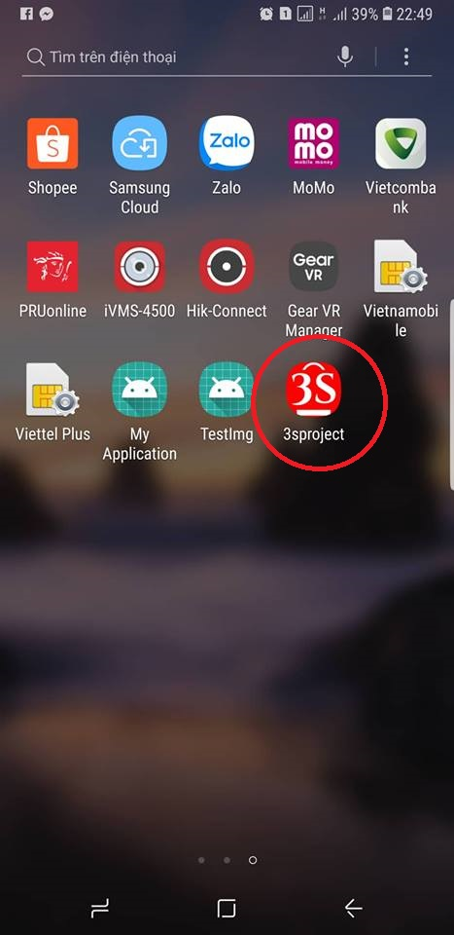

***Figure 6-1 :*** *Application opening*

***Step 1*:** User clicks on the logo of the application on Moblie screen.

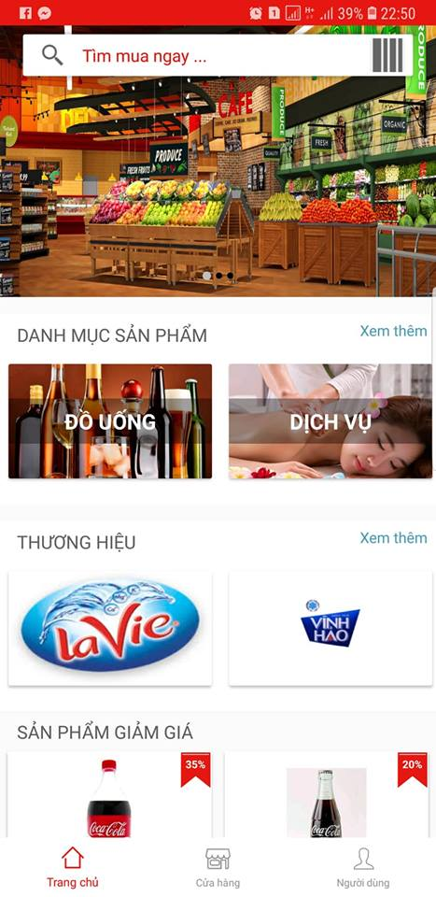

***Figure 6-2 :*** *Home screen*

***Step 2*:** User can see Home screen after clicks on the logo of application. The Home screen is displayed for the first time using application.

#### User Functions

##### Register Account

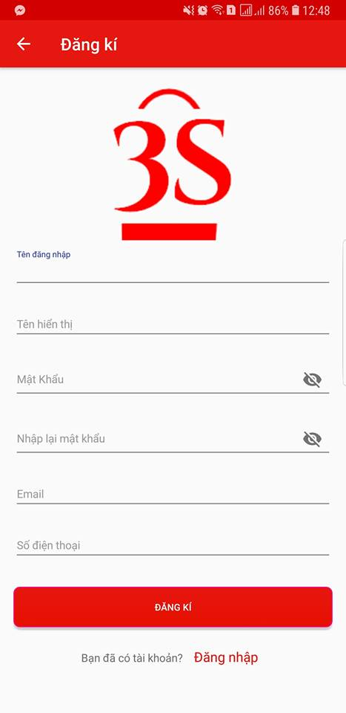

***Figure 6-3 :*** *Register Account Screen*

***Step 1*:** User is in “Đăng kí” screen.

***Step 2*:** After filling all the textboxes, User clicks on “Đăng kí” button.

***Step 3*:** System redirects to the “Đăng nhập” screen.

##### Login

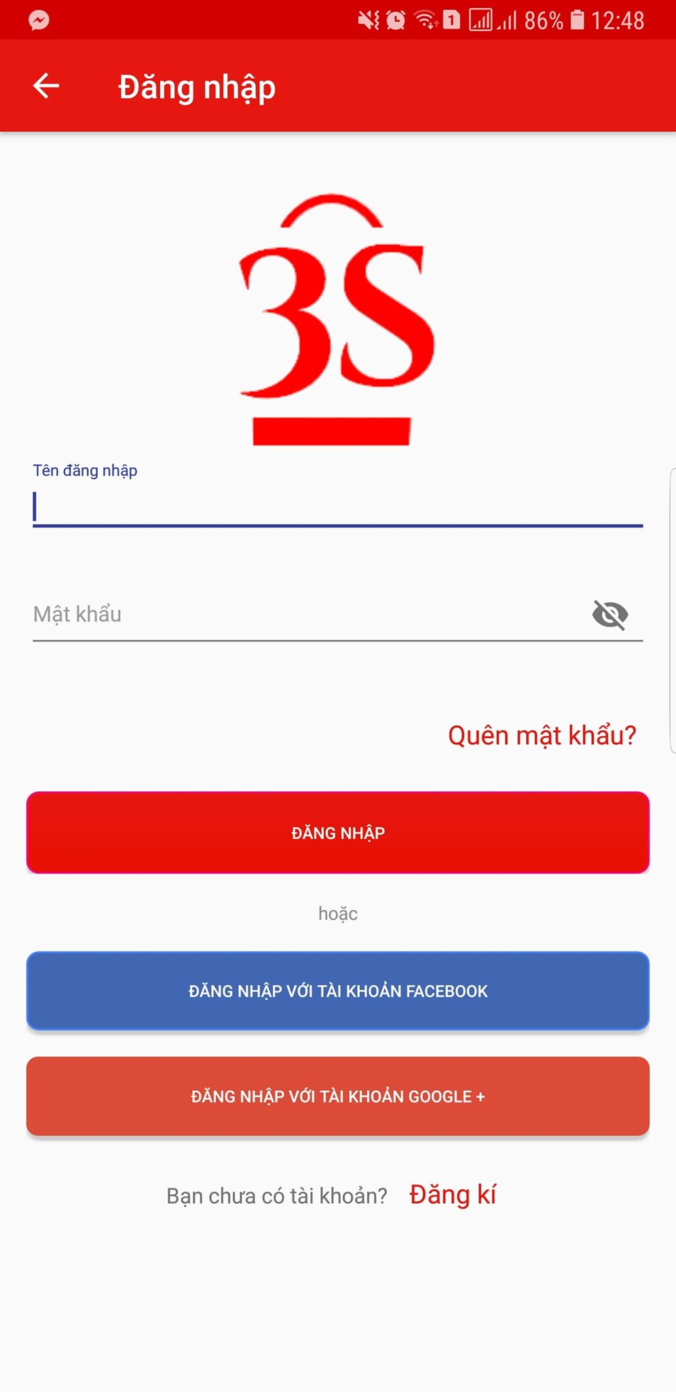

***Figure 6-4 :*** *Login Screen*

***Step 1*:** User is in “Đăng nhập” screen.

***Step 2:*** User enters username and password, clicks on button “Đăng nhập” button.

***Step 3*:** User can login in clicks on the button “Đăng nhập”,”Đăng nhập với tài khoản Facebook” and “Đăng nhập với tài khoản Google”.

##### Management Account

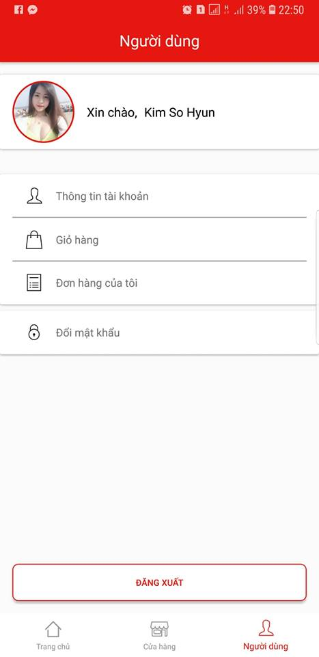

***Figure 6-5 :*** *Management Account Screen*

***Step 1*:** User is in “Người dùng“ screen

***Step 2*:** User can view own information by clicking on “Thông tin tài khoản“ button, can view cart by clicking on “Giỏ hàng“ button, can view own order history by clicking on “Đơn hàng của tôi” button, can change account password by clicking on “Đổi mật khẩu” button and User can logout by clicking on “Đăng xuất” button.

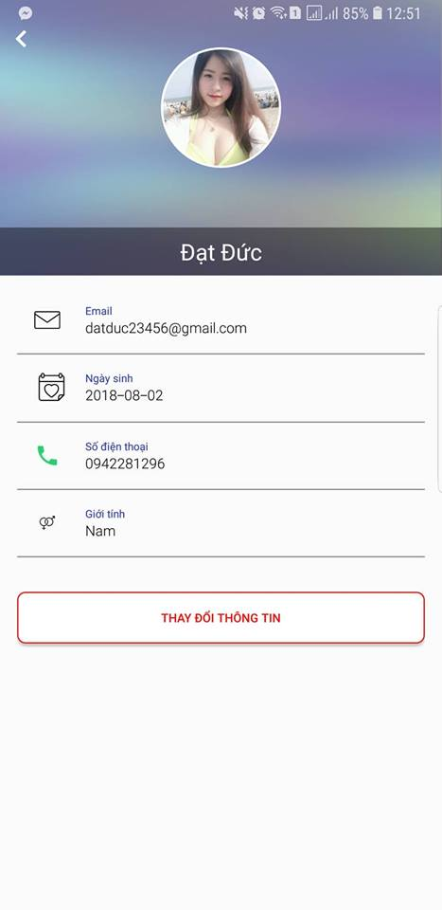

***Figure 6-5 :*** *User Information Screen*

***Step 3* :** User is in “Thông tin người dùng“ screen.

***Step 4* :** Screen is displayed with user information.

***Step 5* :** When user clicks on “Thay đổi thông tin” button

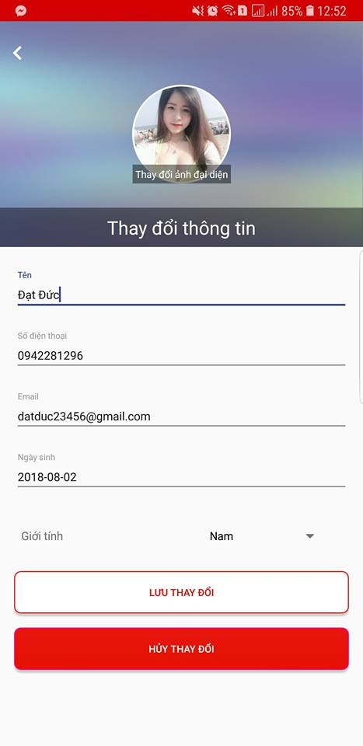

***Figure 6-6 :*** *Change Account Information Screen*

***Step 6*:** User is in “Thay đổi thông tin người dùng” screen.

***Step 7*:** User enters information to need-changed field in change information form, then clicks on “Lưu thay đổi” button

***Step 8*:** User changes information.

##### Management Cart and Order

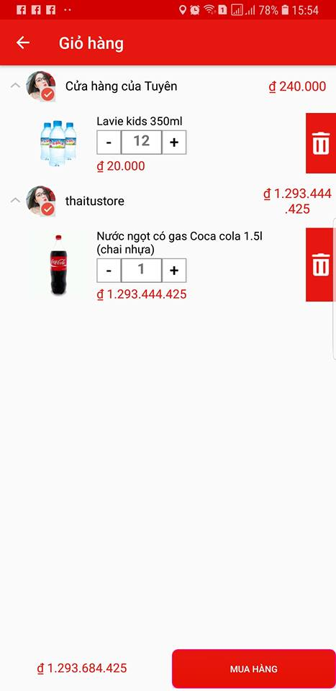

***Figure 6-6 :*** *Cart Screen*

***Step 1*:** User is in “Giỏ hàng“ screen.

***Step 2*:** Screen is displayed with all order which have not been checked out yet.

***Step 3*:**.User can click on button “+” to increase product quantity and button “-“ to decrease product quantity and clicks on button “Delete” to delete product

***Step 4*:**. User click on button “Mua hàng“ to checkout all of order in cart

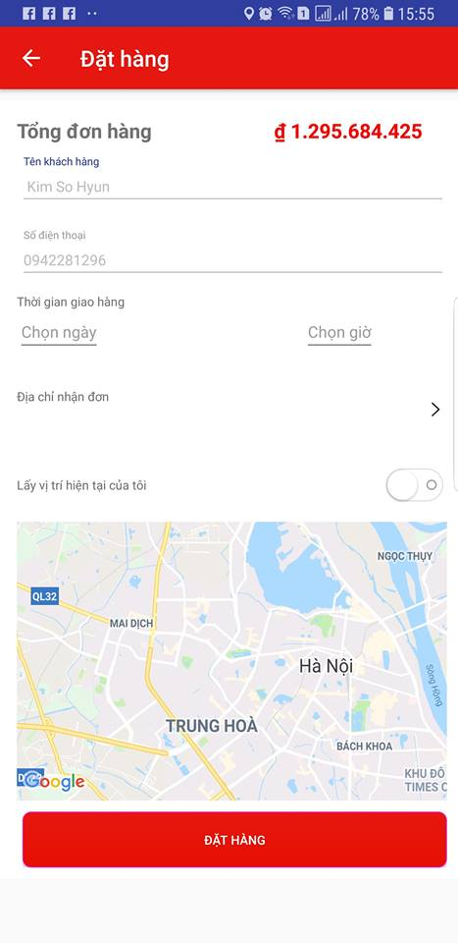

***Figure 6-7 :*** *User Order Product In Cart Screen*

***Step 5***: “Đặt hàng“ screen is displayed.

***Step 6*:** After filling all the textboxes, User clicks on “Đặt hàng” button.

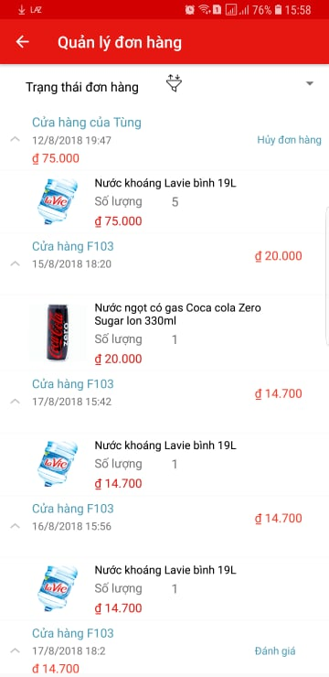

***Figure 6-8 :*** *User Order History Screen*

***Step 7***: User clicks on “Đơn hàng của tôi” button in “Người dùng” screen.

***Step 8*:** “Quản lý đơn hàng” screen is displayed with user order history list.

##### Log Out

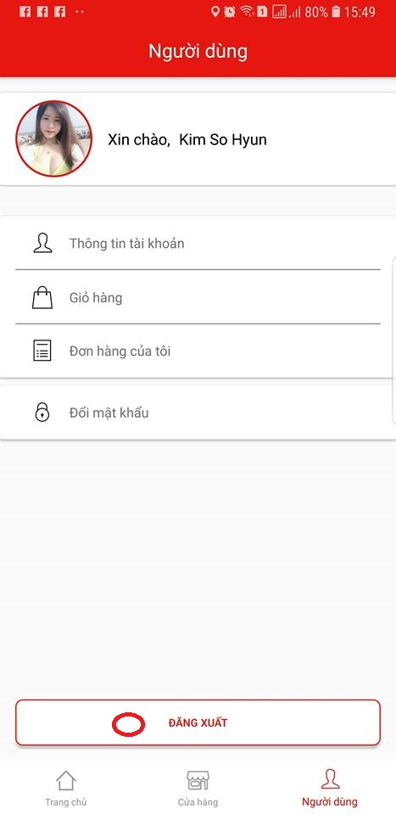

***Figure 6-9 :*** *Log Out*

***Step 1*:** User is in “Người dùng“screen.

***Step 2*:** User chooses “Đăng xuất” button which is on bottom of the screen.

##### Change Account Password

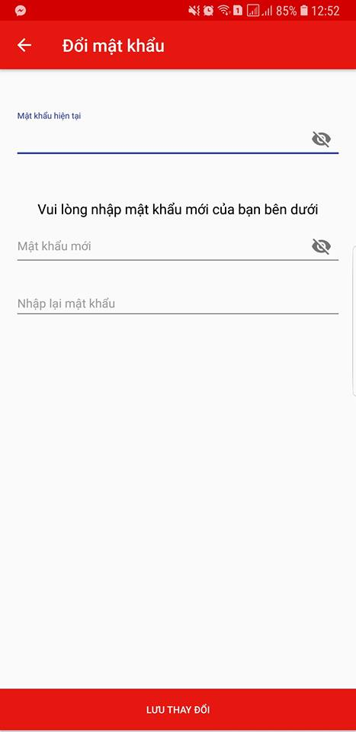

***Figure 6-10 :*** *Change password Screen*

***Step 1*:** User is in “Đổi mật khẩu” screen after clicked on button “Đổi mật khẩu” in “Người dùng” screen.

***Step 2*:** “Đổi mật khẩu” screen is displayed with change password form.

***Step 3*:** User enters old password and new password then clicks on “Lưu thay đổi” button.

##### User Search Product by Name

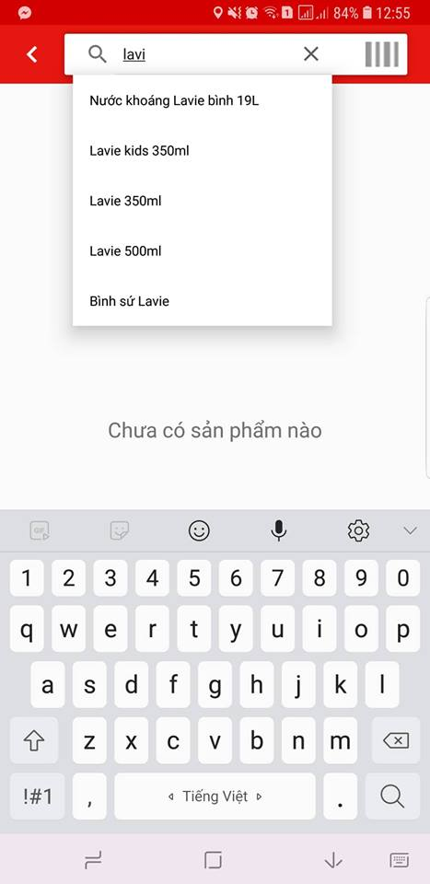

***Figure 6-11 :*** *User search product by Name*

***Step 1*:** User is in “Tìm kiếm cửa hàng” screen.

***Step 2*:** User enters product name which User wants to search.

***Step 3*:** System returns product list which is equivelent with search value.

##### User Search Product by Barcode

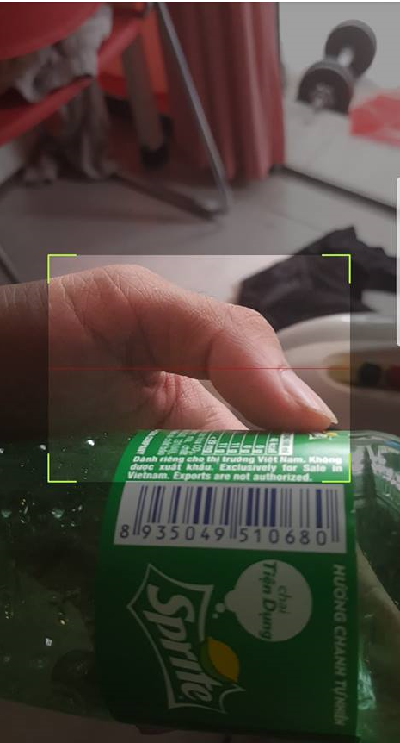

***Figure 6-12 :*** *User search Product by Barcode*

***Step 1*:** Scan Barcode screen is displayed when user clicked search barcode button.

***Step 2*:** User scan barcode.

***Step 3*:** System returns product list which is equivelent with search value.

##### User Register Store

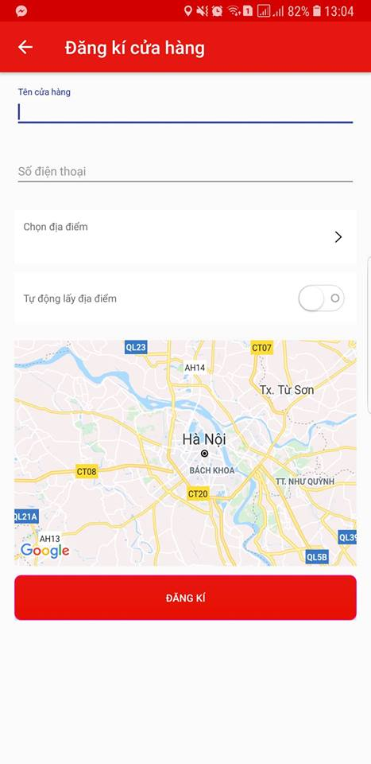

***Figure 6-13 :*** *Register Store Screen*

***Step 1:***Store is in “Đăng kí cửa hàng“screen.

***Step 2:*** After filling all the textboxes, Store clicks “Đăng kí” button.

***Step 3*:** System redirects to Home screen.

#### Store Functions

##### Store Management Information

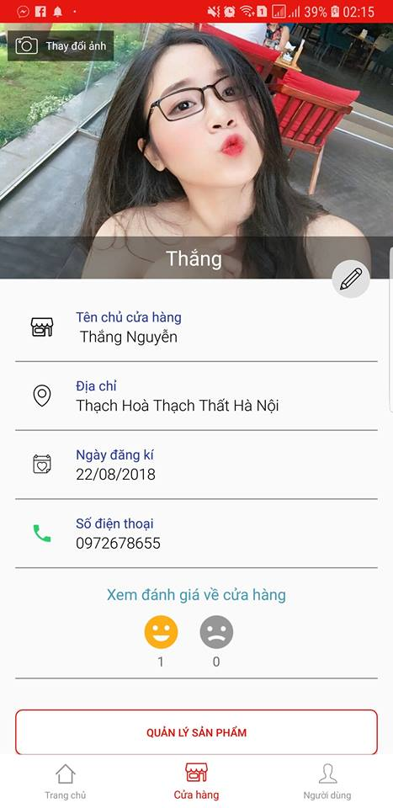

***Figure 6-14 :*** *Store Information Screen*

***Step 1*:** Store is in “Thông tin cửa hàng“screen.

***Step 2:*** Store can edit store information by clicking on “Thay đổi thông tin cửa hàng” button with  icon, can view product in store by clicking on “Quản lý sản phẩm” button, can view store order history by clicking on “Quản lý đơn hàng” button and Store can view store feedback by clicking on “Xem đánh giá về cửa hàng” button.

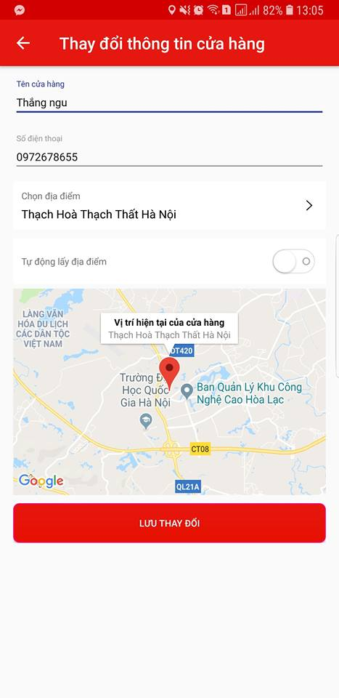

***Figure 6-15 :*** *Store Change Information Screen*

***Step 3*:** Store clicks on “Thay đổi thông tin cửa hàng” button with  icon, then “Thay đổi thông tin cửa hàng” screen is displayed.

***Step 4*:** Store enters new information to need-changed field, then clicks on “Lưu hay đổi” button

***Step 6*:** System redirects to “Cửa hàng” screen with changed information.

##### Store Management Product in Store

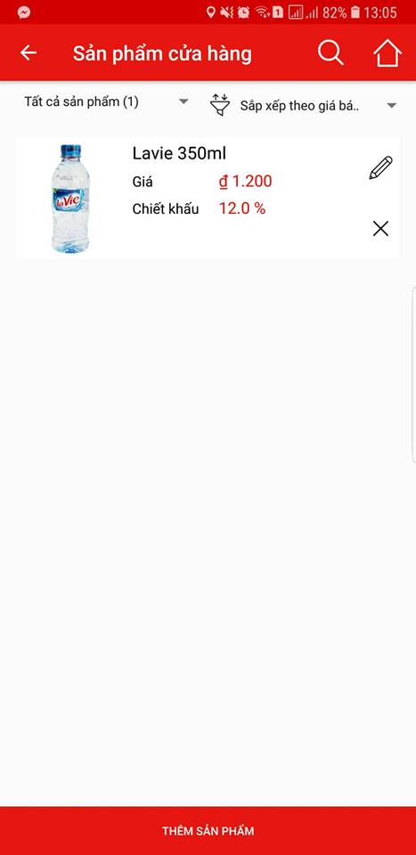

***Figure 6-16 :*** *Management Product In Product Screen*

***Step 1*:** Store clicks on “Quản lí sản phẩm“in “Cửa hàng” screen.

***Step 2*:**”Sản phẩm cửa hàng” screen is displayed with all product of store.

***Step 3*:** Store can edit product information by clicking on “Sửa thông tin” button with  icon and can delete product from product by clicking on “Xóa sản phẩm” button with  icon.

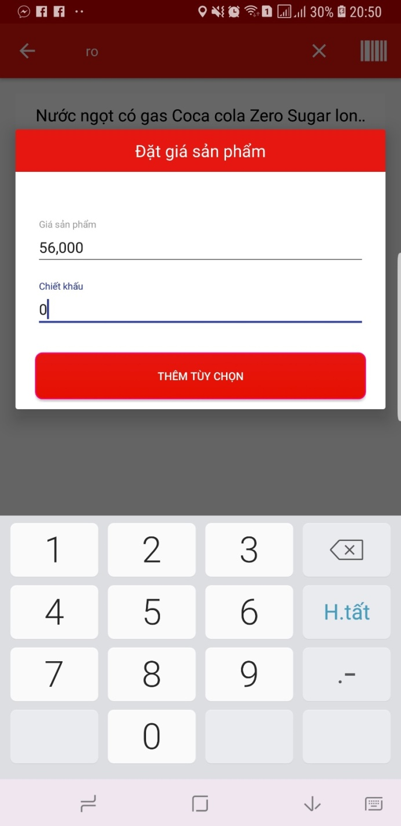

***Figure 6-17 :*** *Change Information of Product Dialog*

***Step 4*:** “Tìm kiếm sản phẩm” screen is displayed when Store clicks on “Thêm sản phẩm” button.

***Step 5*:** Store choose product and enter product detail information, then clicks on “Thêm tùy chọn” button.

***Step 6*:** System redirects to “Sản phẩm cửa hàng” screen with product in store list.

##### Store Management Order

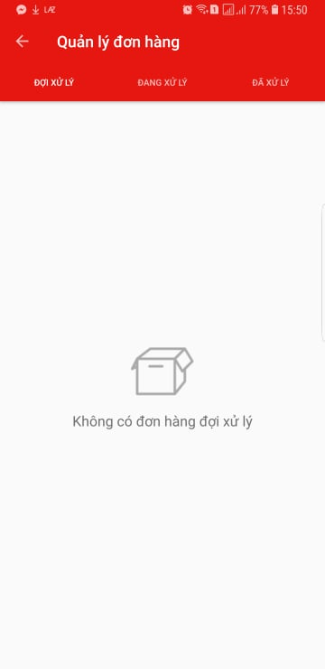

***Figure 6-18 :*** *Store Management Order Screen*

***Step 1*:** Store clicks on “Quản lý đơn hàng“button in”Cửa hàng” screen.

***Step 2*:** System display “Quản lý đơn hàng“screen with 3 tabs equivelent with 3 order statuses. Initital tab is “Đợi xử lý” tab with waiting order list.

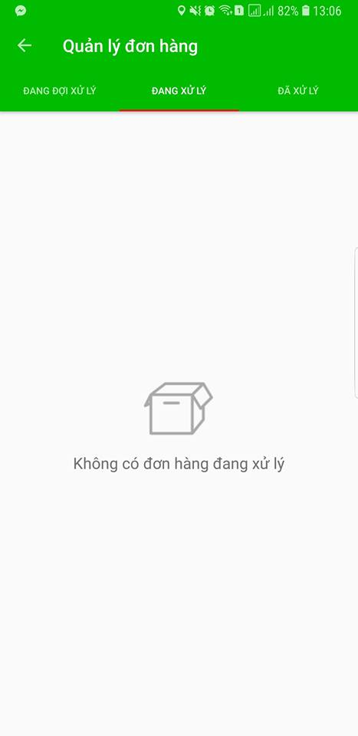

***Figure 6-19 :*** *Store Management Order Screen*

***Step 3*:** Store clicks on “Đang xử lý” tab in “Quản lý đơn hàng” screen.

***Step 4*:**  System display “Đang xử lý” tab with processing order list.

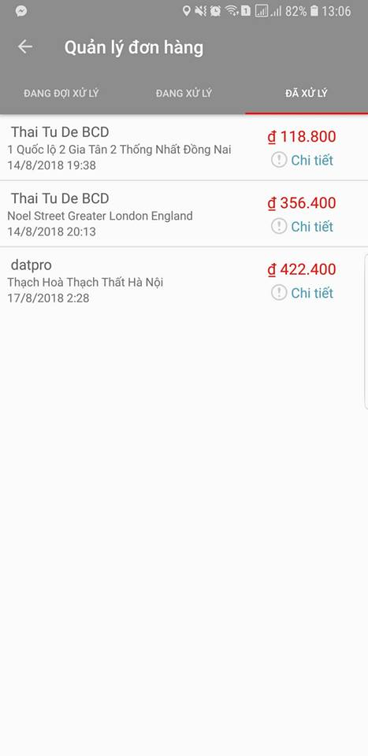

***Figure 6-20 :*** *Store Management Order Screen*

***Step 5*:** Store clicks on “Đã xử lý” tab in “Quản lý đơn hàng” screen.

***Step 6*:** System display “Đã xử lý” tab with processing order list.

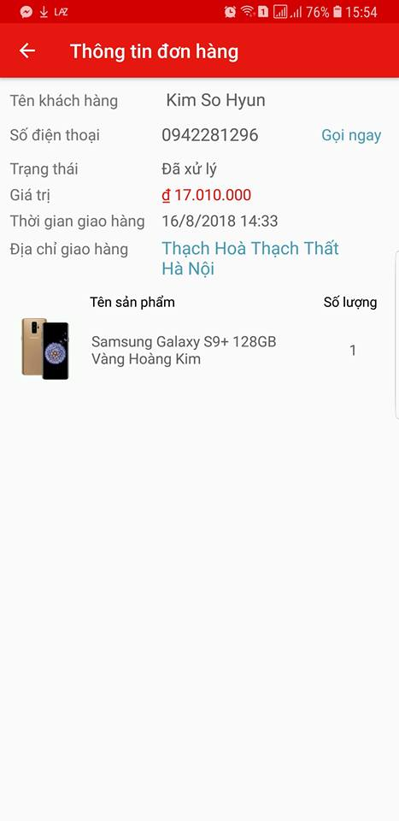

***Figure 6-21 :*** *Store Management Order Screen*

***Step 1*:** Store can view order details when clicks on “Chi tiết” button in each tab.

***Step 2*:**”Thông tin đơn hàng” screen is displayed.

***Step 3*:** Store can call to customer by clicking on “Gọi ngay” button and can show way direction from store to delivery address by clicking on address.

**REFERENCES**

* 1. Android Programming Cookbook. [Online] Available at: <http://enos.itcollege.ee/~jpoial/allalaadimised/reading/Android-Programming-Cookbook.pdf>
  2. Spring Framework Cookbook. [Online] Avaiable at :

<https://www.javacodegeeks.com/wp-content/uploads/2017/01/Spring-Framework-Cookbook.pdf>

* 1. Firebase Tutorialspoint. [Online] Avaiable at :

<https://www.tutorialspoint.com/firebase/firebase_tutorial.pdf>

* 1. Firebase Realtime Database. [Online] Avaiable at :

<https://www2.cs.duke.edu/courses/spring17/compsci290.3/notes/april6/firebase-db-spring17.pdf>

* 1. Google Maps Android API V2. [Online] Avaiable at :

<http://grail.cba.csuohio.edu/~matos/notes/cis-493/lecture-notes/slides/Android-Chapter25-GoogleMaps-Handout.pdf>

* 1. Essential Android Technologies and Google Maps APIs for Location-Based Services. [Online] Avaiable at :

<http://www.micsymposium.org/mics2014/ProceedingsMICS_2014/mics2014_submission_39.pdf>